**Microprocessor Lab**

Laboratory Activity No. 2

**Arduino and Tinkercad Interface**

|  |
| --- |
|  |

Score

*Submitted by:*

**Castro, Jhun Cidrek V.**

**<Saturday 1pm to 7pm> / <Block 2>**

*Date Submitted*

**30-09-2023**

*Submitted to:*

**Engr. Maria Rizette H. Sayo**

I. Objectives

This laboratory activity aims to implement the principles and techniques of hardware programming using Arduino through:

- creating an Arduino programming and circuit diagram.

II. Method/s

- Perform a task problem given in the presentation.

- Write a code and perform an Arduino circuit diagram of a ring counter that display

eight (8)LEDs starting from left.

III. Results

**TinkerCad**

**Exercise 1: Write a code that does a ring counter display for eight (8) LEDs starting from left.**

[*https://www.tinkercad.com/things/e9uGIWFZJsp-grand-crift-duup/editel?sharecode=73XU9NzXvUOF6BWrmCm7lBamMxTxE8SXPshRkI3RDxM*](https://www.tinkercad.com/things/e9uGIWFZJsp-grand-crift-duup/editel?sharecode=73XU9NzXvUOF6BWrmCm7lBamMxTxE8SXPshRkI3RDxM)

Figure No.1 Ring Counter Display Circuit Diagram

**Components Used**

1. 8 LEDs
2. Resistor
3. Breadboard

**CODE:**

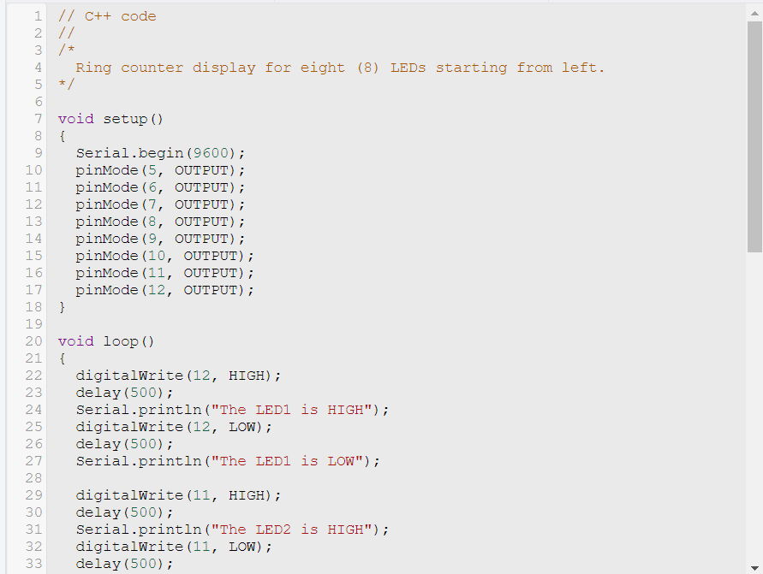

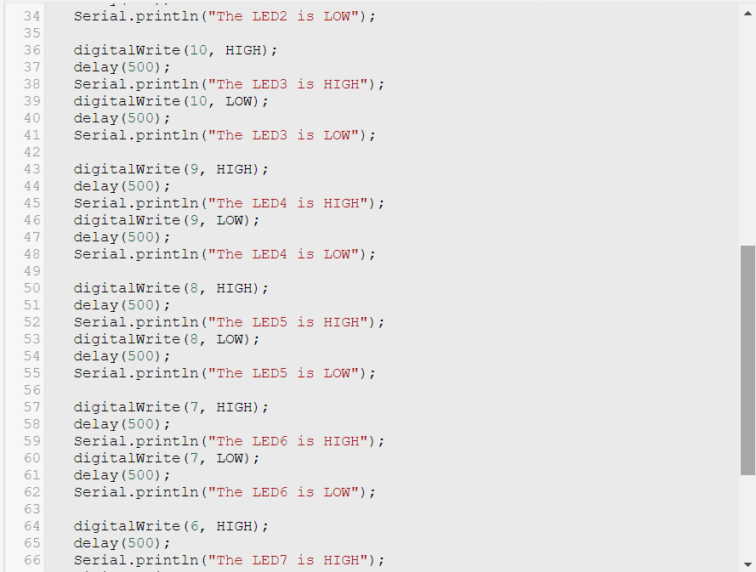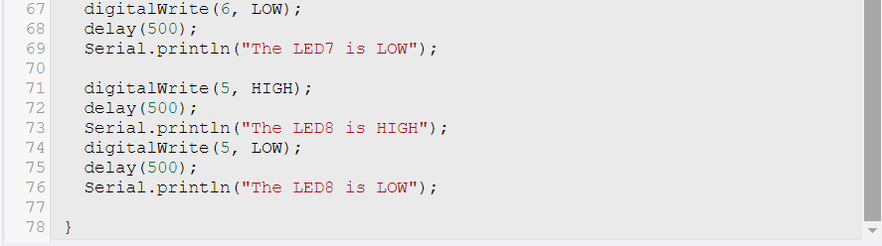

IV. Conclusion

*In this laboratory activity, the principles and techniques of hardware programming using Arduino were implemented by creating an Arduino programming and circuit diagram of a ring counter that displays eight (8) LEDs starting from the left. The task problem given in the presentation was performed by first understanding what a ring counter is and how it works. A ring counter is a digital circuit that cycles through a sequence of states. In this case, the sequence of states is the LEDs being turned on and off in order. Once the ring counter was understood, the code was written. The code for the ring counter is simple and straightforward. It first initializes the LEDs to be off. Then, it loops through the eight LEDs, turning each one on and off in order.*

*After the code was written, the Arduino circuit diagram was created. The circuit diagram shows how to connect the LEDs to the Arduino board. It also shows how to connect a switch to the Arduino board. When the Arduino board was switched on, the ring counter began to work. The LEDs turned on and off in order, starting from the left. This laboratory activity was a valuable learning experience as it helped to understand the principles and techniques of hardware programming using Arduino. The ability to use Arduino to create simple digital circuits has been gained, and the confidence to learn to create more complex circuits in the future is present.*

**References**

[1] D.J.D. Sayo. “University of the City of Manila Computer Engineering Department Honor Code,” PLM-CpE Departmental Policies, 2020.

*<This is in a separate page>*

*Monk, S. (2013). Programming Arduino: Getting started with sketches. McGraw-Hill Education*

*Gammon, P. (2015). Programming Arduino: Next steps beyond the playground. O'Reilly Media.*