## Title

**Some content[2], some content[1].**

**正文[15]，正文[10][11]。**

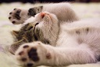

Fig1. Some cat[12]

## Reference

[1] 2nd reference

[2] 1st reference

[3] not used reference

[15] 3rd reference

[11] 5th reference

[10] 4th reference

[12] (6th) https://www.pexels.com/photo/kitten-lying-on-surface-416160