# Title

Some content[2], some content[1].

正文[15]，正文[10][11]。

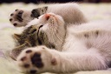

Fig1. Some cat[12]

# Reference

[1] reference 1

[2] reference 2

[15] reference 15

[11] reference 11

[10] reference 10

[12] https://www.pexels.com/photo/kitten-lying-on-surface-416160