## Title

**Some content[1], some content[2].**

**正文[3]，正文[4][5]。**

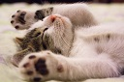

Fig1. Some cat[6]

## Reference

[2] 2nd reference

[1] 1st reference

[7] not used reference

[3] 3rd reference

[5] 5th reference

[4] 4th reference

[6] (6th) https://www.pexels.com/photo/kitten-lying-on-surface-416160