Motivation

Simcenter Amesim is a system simulation platform which allows you developing a Digital Twin of a product which behaves very similar to a real product. During the development phase of a product you can use Simcenter Amesim to

* define and verify an architecture of a product
* size the various components of which the product is assembled
* supply a proper physical plant model for control development

Since today’s coffee machines are complex mechatronic devices Simcenter Amesim is a valuable tool for you to master this complexity and balance all the dependencies between functions, parameters and design goals. Thus, you can reduce development costs and risk.  
This is the first article in a series where I will show you how such a Digital Twin is being build.  
If you would like to have a closer look into the Simcenter Amesim models I have developed, please do not hesitate to contact me. I will send you the models.

How a coffee-machine works

Modern coffee-machines can prepare coffee of various kinds. Espresso, Cappuccino, American Coffee represent only a small choice of possibilities.

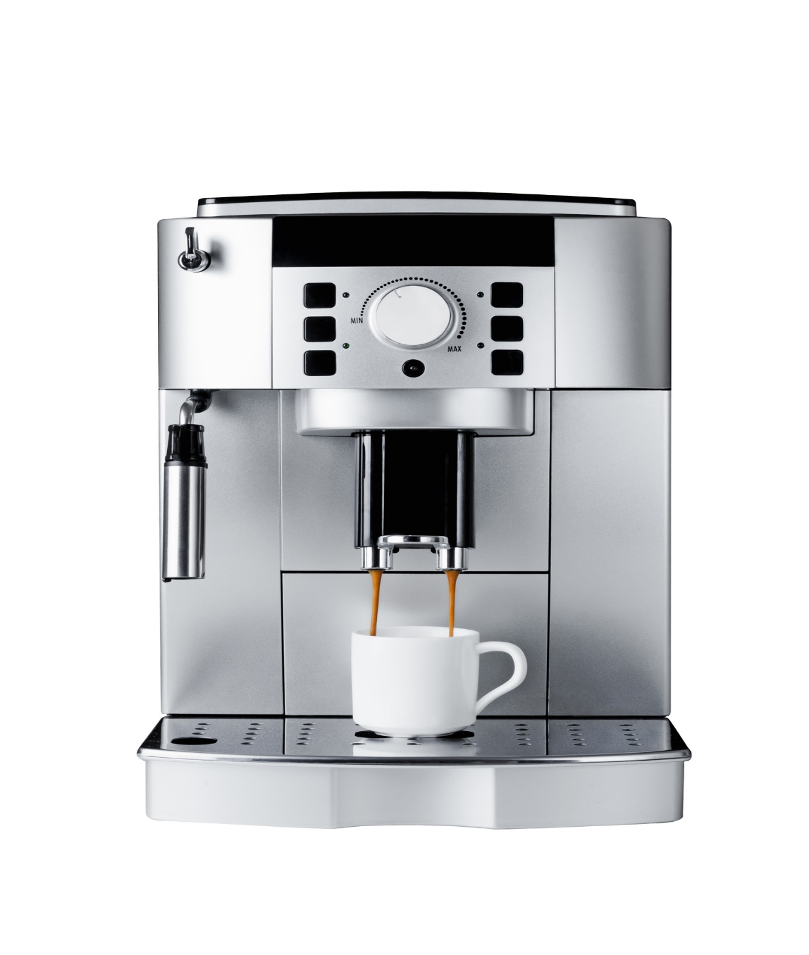  
*Figure 1 Siemens EQ9 coffee machine*

Such a machine is built from components which are orchestrated by a control algorithm in order to prepare all the different types of coffee with a single machine. These components are:

* Various reservoirs for coffee beans, water, milk and sugar
* A crushing mill which grinds the coffee beans to coffee powder
* A device which transports the coffee powder into the brewer
* A brewer which presses hot water through the coffee powder
* A milk frother. Water steam sucks cold milk in a jet pump and mixes the hot milk with air in order to produce milk foam
* A device which puts sugar into the coffee
* A heater which supplies the brewer and the milk frother with heat
* A control device which controls each step of a brewing process. Dependent on the coffee choice:
  + Offer a comfortable user interface
  + When and how long should the different components operate?
  + Which components must be used to prepare a certain choice of coffee?
  + Which process parameters must be controlled and monitored?
  + Monitor the amount of ingredients available in the reservoirs and give notice to the user if an ingredient must be refilled
  + Monitor the amount of waste and give notice to the user if the waste reservoir must be emptied.

Building a Simcenter Amesim model

In this first article I will focus on modeling the individual components of a coffee machine.

Goals of this modeling exercise

I have several goals which I would like to achieve

* Build component models at an intermediate level of detail so that I can
  + look into some physical behavior of the components
  + assess energy consumption
  + look at how many of a certain coffee variety is produced
* Build a simple control
* Build a statechart in order to mimic a user interface and program a simple control algorithm

Libraries needed

The libraries you will need depend on the type you have to model. It also depends on the level of detail you would like to model and if you need to concentrate on a certain component. For example, the electrical motors which drive the crushing mill or the pump (or pumps) can be modeled applying

* rotational speed sources
* simplistic electrical motors which supply a rotational speed and need some efficiency data
* electrical motors with simple or complex efficiency maps which are supplied with an electrical current
  + with or without various levels of detail of the needed power electronics and speed/torque control
  + with or without a controlled current source

For the model shown we will need the following libraries

* Signal and Control
* 1D Mechanical
* Thermal
* Thermal Hydraulic
* Two-Phase-Flow
* Electrical Basics
* Electrical Motors and Drives

Modeling approach

You should adapt a methodology which starts from simple, functional models of each of the above-mentioned components. You should verify their functioning before you increase the level of detail and before you switch from functional to physics-based modeling.

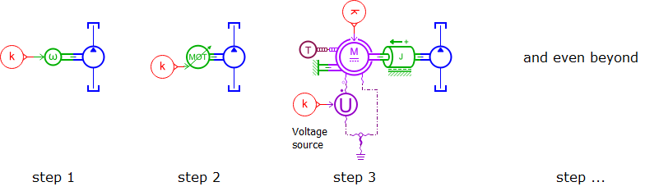  
*Figure 2 Modeling approach: start from simple models before adding details*

After you have modeled each component you can start to assemble the complete coffee machine and add a control module.  
In a last step you may add some interactive elements to your model in order to use the model as you are using your real coffee machine. A state chart will help you programming the control logic.