**Instructions to run the code:**

1. **Go to folder finalHouse (cd finalHouse)**
2. **From command line, run “http-server” to start a simple node server**

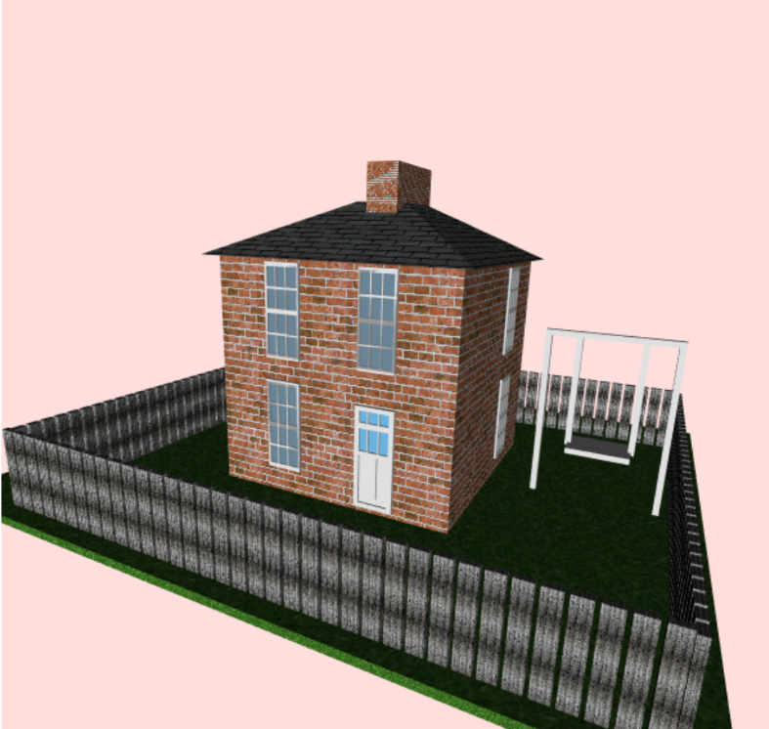

Not in the real life example, but added on the model just for the sake of animation (moving object)

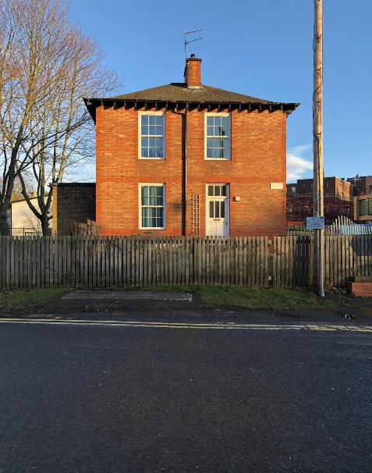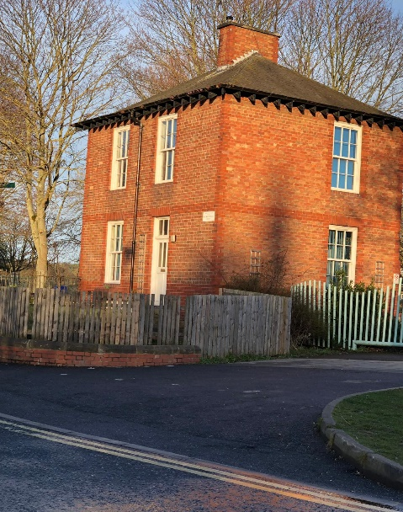

1. **Go to 127.0.0.1:8080 and click on the html file.**

**Main features of the implementation:**

Directional lighting

5 textures (grass, brick wall, fence, roof, water like effect behind the transparent windows)

Transparent windows (alpha value 0.4)

I used WebGL only to design all the environment models. The main objects modelled are a cube, and a cut pyramid for the roof. The rest of the objects are made by applying transformations to the cube.

The moving object – the swing rotates 30 degrees in both directions (positive and negative) of the WebGL x axis.

Different shader programs for textured objects and non-textured objects:

* Vertex and Fragment shader for single colour drawing (***SOLID_VSHADER_SOURCE***, ***SOLID_FSHADER_SOURCE***)
* Vertex and Fragment shader for texture drawing (***TEXTURE_VSHADER_SOURCE***, ***TEXTURE_FSHADER_SOURCE)***