Task a

SELECT name, telegram_contact
FROM student
WHERE city IN ( 'Казань', 'Москва' )
ORDER BY name DESC;

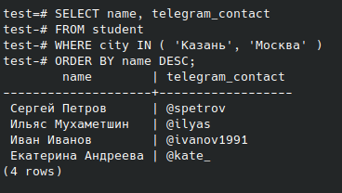

Task b

SELECT FORMAT( 'университет: %s; количество студентов: %s', name, size ) AS "полная информация"
FROM college
ORDER BY 1;

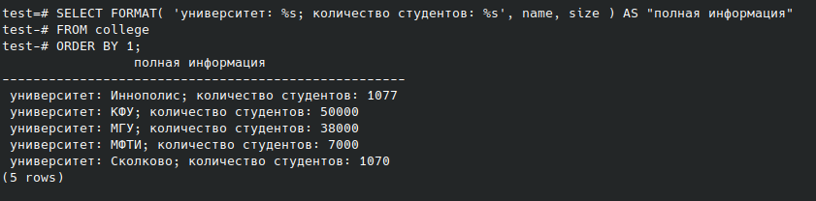

Task c

SELECT name, size
FROM college
WHERE id IN ( 10, 30, 50 )
ORDER BY size, name;

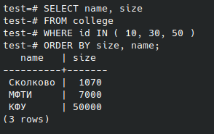

Task d

SELECT name, size
FROM college
WHERE id NOT IN ( 10, 30, 50 )
ORDER BY size, name;

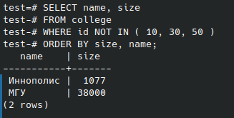

Task e

SELECT name, amount_of_students
FROM course
WHERE amount_of_students BETWEEN 27 AND 310 AND is_online
ORDER BY name DESC, amount_of_students DESC;

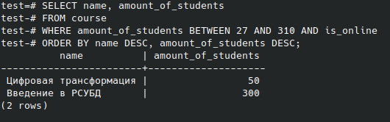

Task f

SELECT name
FROM student
UNION
SELECT name
FROM course
ORDER BY name DESC;

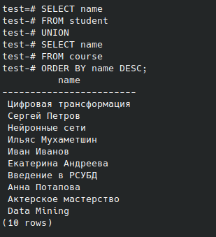

Task g

SELECT name, 'университет' AS object_type
FROM college
UNION
SELECT name, 'курс'
FROM course
ORDER BY object_type DESC, name;

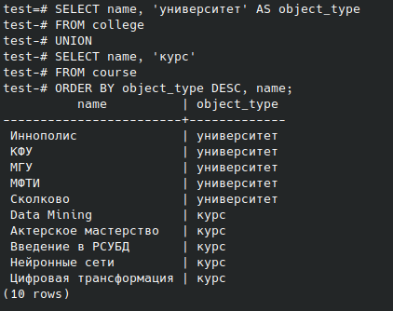
Task h

SELECT name, amount_of_students
FROM course
ORDER BY CASE WHEN amount_of_students = 300 THEN 0 ELSE 1 END, amount_of_students
LIMIT 3;

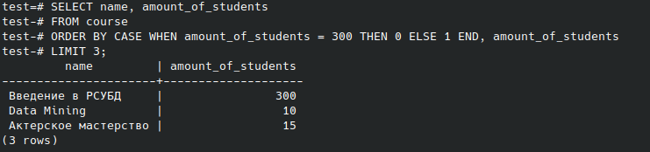

Task i

INSERT INTO course
SELECT 60, 'Machine Learning', FALSE, 17, ( SELECT college_id FROM course WHERE name = 'Data Mining' );
SELECT * FROM course;

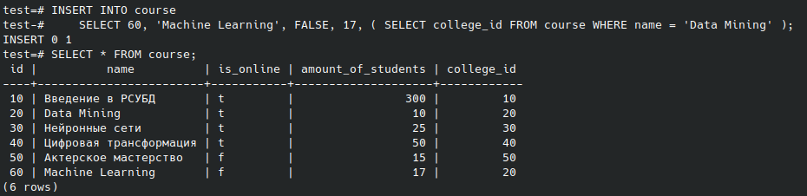

Task j

( SELECT id FROM course EXCEPT SELECT id FROM student_on_course )
UNION
( SELECT id FROM student_on_course EXCEPT SELECT id FROM course )
ORDER BY id;

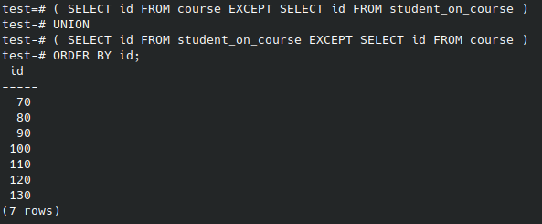

Task k

SELECT
s.name AS student_name,
c.name AS course_name,
c2.name AS student_college,
student_rating
FROM student_on_course
JOIN student s ON student_on_course.student_id = s.id
JOIN course c ON student_on_course.course_id = c.id
JOIN college c2 ON s.college_id = c2.id
WHERE student_rating > 50 AND size > 5000
ORDER BY student_name, course_name;

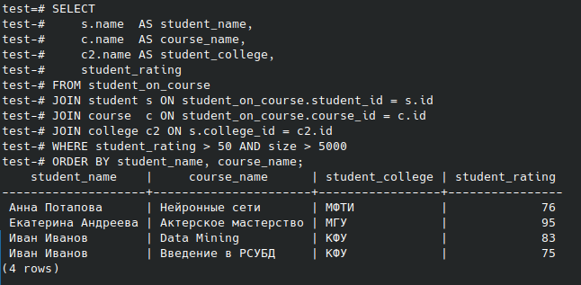

Task l

SELECT
s1.name AS student_1,
s2.name AS student_2,
s1.city
FROM student s1
JOIN student s2 ON s1.city = s2.city AND s1.name > s2.name
ORDER BY student_1;

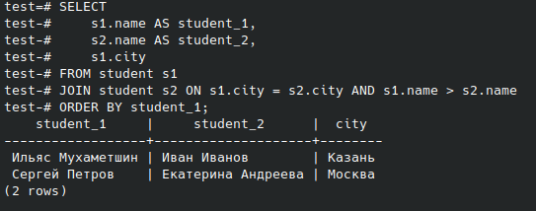

Task m

SELECT
CASE
WHEN student_rating < 30
THEN 'неудовлетворительно'
WHEN student_rating >= 30 AND student_rating < 60
THEN 'удовлетворительно'
WHEN student_rating >= 60 AND student_rating < 85
THEN 'хорошо'
ELSE 'отлично' END AS "оценка",
COUNT( * ) AS "количество студентов"
FROM student_on_course
GROUP BY 1
ORDER BY 1;

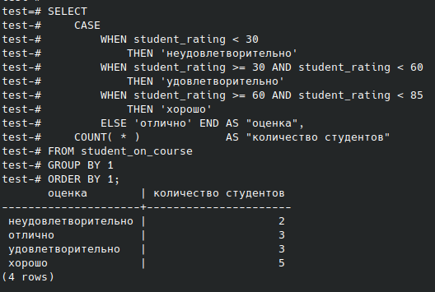

Task n

SELECT
c.name,
CASE
WHEN student_rating < 30
THEN 'неудовлетворительно'
WHEN student_rating >= 30 AND student_rating < 60
THEN 'удовлетворительно'
WHEN student_rating >= 60 AND student_rating < 85
THEN 'хорошо'
ELSE 'отлично' END AS "оценка",
COUNT( * ) AS "количество студентов"
FROM student_on_course
JOIN course c ON student_on_course.course_id = c.id
GROUP BY 1, 2
ORDER BY 1, 2;

