**Task a**

SELECT name, telegram_contact

FROM student

WHERE city IN ( 'Казань', 'Москва' )

ORDER BY name DESC;

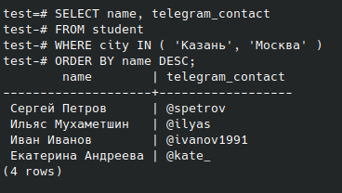

**Task b**

SELECT FORMAT( 'университет: %s; количество студентов: %s', name, size ) AS "полная информация"

FROM college

ORDER BY 1;

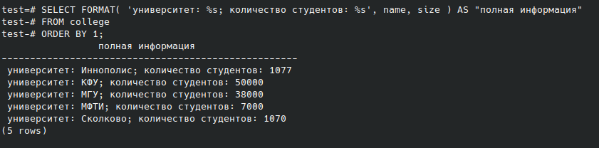

**Task c**

SELECT name, size

FROM college

WHERE id IN ( 10, 30, 50 )

ORDER BY size, name;

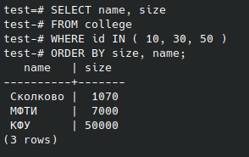

**Task d**

SELECT name, size

FROM college

WHERE id NOT IN ( 10, 30, 50 )

ORDER BY size, name;

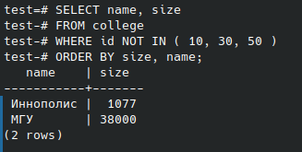

**Task e**

SELECT name, amount_of_students

FROM course

WHERE amount_of_students BETWEEN 27 AND 310 AND is_online

ORDER BY name DESC, amount_of_students DESC;

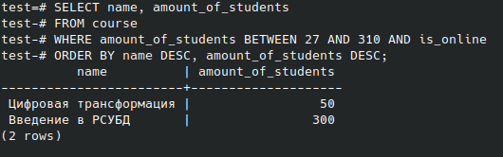

**Task f**

SELECT name

FROM student

UNION

SELECT name

FROM course

ORDER BY name DESC;

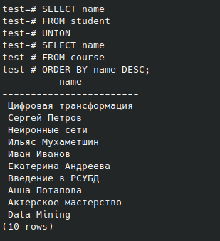

**Task g**

SELECT name, 'университет' AS object_type

FROM college

UNION

SELECT name, 'курс'

FROM course

ORDER BY object_type DESC, name;

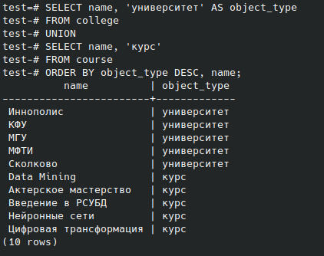

**Task h**

SELECT name, amount_of_students

FROM course

ORDER BY CASE WHEN amount_of_students = 300 THEN 0 ELSE 1 END, amount_of_students

LIMIT 3;

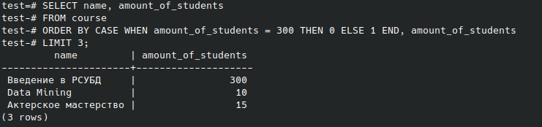

**Task i**

INSERT INTO course

SELECT 60, 'Machine Learning', FALSE, 17, ( SELECT college_id FROM course WHERE name = 'Data Mining' );

SELECT * FROM course;

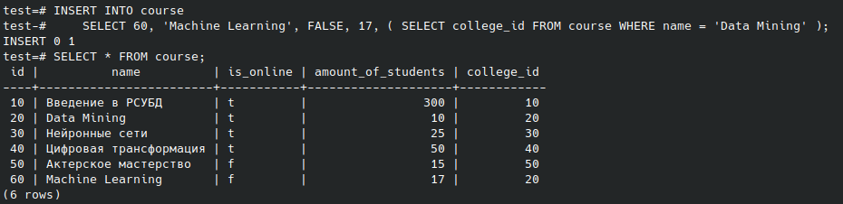

**Task j**

( SELECT id FROM course EXCEPT SELECT id FROM student_on_course )

UNION

( SELECT id FROM student_on_course EXCEPT SELECT id FROM course )

ORDER BY id;

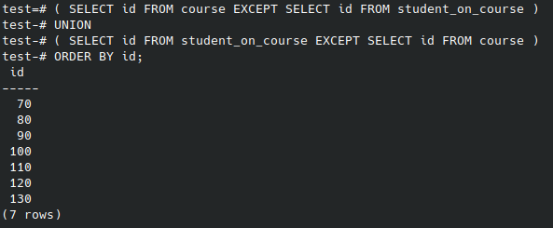

**Task k**

SELECT

s.name AS student_name,

c.name AS course_name,

c2.name AS student_college,

student_rating

FROM student_on_course

JOIN student s ON student_on_course.student_id = s.id

JOIN course c ON student_on_course.course_id = c.id

JOIN college c2 ON s.college_id = c2.id

WHERE student_rating > 50 AND size > 5000

ORDER BY student_name, course_name;

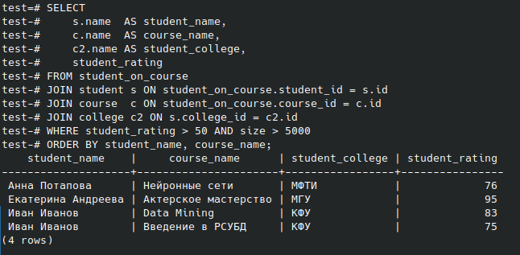

**Task l**

SELECT

s1.name AS student_1,

s2.name AS student_2,

s1.city

FROM student s1

JOIN student s2 ON s1.city = s2.city AND s1.name > s2.name

ORDER BY student_1;

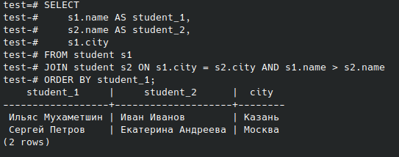

**Task m**

SELECT

CASE

WHEN student_rating < 30

THEN 'неудовлетворительно'

WHEN student_rating >= 30 AND student_rating < 60

THEN 'удовлетворительно'

WHEN student_rating >= 60 AND student_rating < 85

THEN 'хорошо'

ELSE 'отлично' END AS "оценка",

COUNT( * ) AS "количество студентов"

FROM student_on_course

GROUP BY 1

ORDER BY 1;

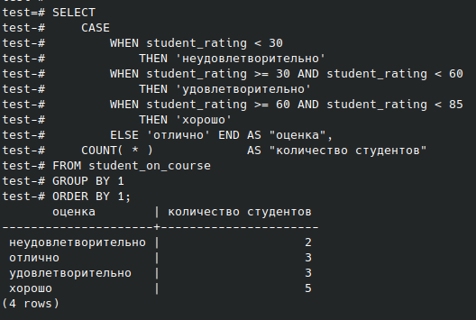

**Task n**

SELECT

c.name,

CASE

WHEN student_rating < 30

THEN 'неудовлетворительно'

WHEN student_rating >= 30 AND student_rating < 60

THEN 'удовлетворительно'

WHEN student_rating >= 60 AND student_rating < 85

THEN 'хорошо'

ELSE 'отлично' END AS "оценка",

COUNT( * ) AS "количество студентов"

FROM student_on_course

JOIN course c ON student_on_course.course_id = c.id

GROUP BY 1, 2

ORDER BY 1, 2;

