Virtual Chemistry Lab
Jeremy Greenburg, Angela McCabe
{jerrgree, angcmcca}@ut.utm.edu

Abstract—With the Virtual Chemistry Lab, students will be able to simulate a graphical interaction environment to better understand the inorganic qualitative analysis and identification of 12 cations and five anions. These groups of ions are used by the UT Martin General Chemistry 122
labs, and are commonly used by other universities as well.
The Virtual Chemistry Lab will be useful to any UTM students taking Chemistry 122 because the qualitative analysis lab takes place over 7 weeks and is a difficult, time consuming process with little forgiveness in regards to errors. A mistake could set you back an entire week. Our virtual lab will allow students to experience the entire qualitative analysis lab in less than an hour, allowing easy practice of the procedures before they are required in a physical lab.
This project was developed in Visual Studios using C# and OpenTK, and is designed to run on Windows machines.
Keywords- learning software, chemistry, qualitative analysis, inorganic compounds, virtual laboratory
INTRODUCTION

Qualitative Analysis of Inorganic Compounds
Nearly 200 students take General Chemistry 122 each year at UT Martin. These students perform the qualitative analysis lab over seven weeks during the semester [1]. During this lab, students receive solutions containing multiple ions, and must perform various tests to determine which ions were present in the given solution. The identification of these ion groups is governed by solubility rules learned in lecture. The lab manuals contain step-by-step instructions, but do not have images for expected results.

Virtual Chemistry Lab
The Virtual Chemistry Lab allows students to quickly and easily run through the qualitative analysis process without any additional cost overhead. By working in a virtual environment, students bypass many of the bottlenecks for time and resources, and may study at their convenience.

BACKGROUND
The development of this project was motivated by performing the qualitative analysis lab in Chemistry 122 class at UT Martin. The procedural nature was immediately apparent, and the initial development was simply a side project to learn graphics programming. After taking a prototype to Dr. Abigail Shelton from the UT Martin Chemistry department, the project received university backing, and we were allowed to use the UTM chemistry research lab to document and better analyze the procedure. After spending a semester in the research lab, we moved to C# development and began drawing the lab space, equipment, and reactions. All graphics in the game are hand-drawn in Adobe Photoshop.

DEVELOPMENT TOOLS

Visual Studio
We decided to use Microsoft Visual Studio due to familiarity with the IDE, its ease of use with Github, and ability to add a Windows installer. The Windows installer provides an abstracted layout of the target computer’s file system, and allows any necessary dll’s to be installed on the target computer as part of prepackaged “Merge Modules” so that the end user doesn’t need to do anything other than run the installer.

C#
The prototype for this project was initially programmed in C++, but we decided to move to C# for full object oriented features. C# was developed by Microsoft, and runs on the .NET framework. The .NET framework provides a virtual execution system and a unified set of class libraries that conforms to a set of standards, and allows the program to interact with other .NET versions of Visual Basic, C++, or any other CTS-compliant language [2]. C# was an excellent choice for us because we were able to encapsulate various components inside of their own structures. Its standard library complimented many of OpenTK’s needs, and had native support for bitmap images.

OpenTK
This Open Toolkit library is a fast, low-level C# wrapper for OpenGL. It can be used standalone or inside a GUI on Windows, Linux, Mac, Android and iOS [3]. Unfortunately, OpenTK provides no solid interface or functionality for object interaction. It works at a lower level with graphics and input, and all objects have to be designed within the program instead of rendered by OpenTK. We had to create our own functionality for button presses, moving objects, and object interaction. However, OpenTK worked great with binding bitmap images to unique identifiers to be used as in-game objects.

APPLICATION FEATURES
This application has two major features: ion generation and reagent testing. The ions generated at the beginning of the simulation will determine the blocks that the reagent testing will build upon.

Ion Generation
Ion generation is the first step in running this simulation. The user will select which group of ions he or she wishes to use, and a solution will be randomly generated containing one or more ions from the selected groups. Figure 1 shows the main screen for ion selection:
Figure 1.
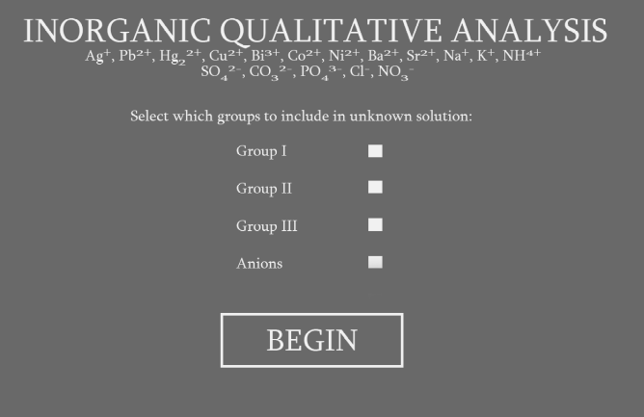

Reagent Testing
We decided to create a two dimensional matrix containing all of the reaction data. This data is stored in a dictionary, where a key of both the ion and the reagent yield their reaction. For example, adding ammonia to a solution containing silver ions will show a value of “blackPpt” in the matrix since the reaction produces a black precipitate. In order to graphically show this, we used pictures and videos from the research lab and drew test tubes with all of the possible reactions. In the above example, blackPpt would have a corresponding image that will change the solution in the active test tube to a black color. Figure 2 illustrates this reaction:
Figure 2.
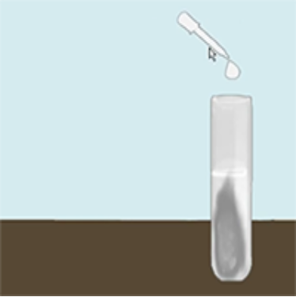

SUMMARY
Virtual Chemistry Lab is a simulator for analyzing chemical reactions of ions using the procedures set up by the UT Martin Chemistry department. Our program allows students to study this lab before it is performed, and will hopefully help minimize mistakes made in the physical lab.

FUTURE DEVELOPMENT
Our Virtual Chemistry Lab has high potential as a learning tool for students, but needs a few more safeguards in place before being released for public use. An immediate concern would be security. Currently every reaction and generated solution is stored in a .csv file, and loaded into memory; any individual could modify these files. In order to make these files secure, an encryption scheme would need to be implemented.
Another future development goal is the addition of animated graphics. Currently, the images are static, and have quick transitions rather than any sort of animation. Animating reagent addition, Bunsen burner flame movement, and chemical reactions are the current action items for introducing more graphical interaction.
A third possibility to consider is adding more options for ions to be generated in the solution. The way the groups are set up was made to be in line with that of the UT Martin Chemistry department’s, but this application could be used at other universities if the ion generation and reaction matrix are tweaked.
A final consideration is saving the game and continuing later. While the lab takes relatively little time to perform in the program, it is conceivable that a user would wish to save and return at some later point. The program keeps track of all solutions, and could be exported/imported with a bit of modification.
The next step to continue development would be to enlist students as beta testers and collect feedback on the program. We are particularly interested in feedback regarding ease of use, instruction comprehension, and similarity to the procedures performed in the physical lab.

References
- Dr. Abigail Shelton, Personal Interview (11/2/2016)
- Microsoft Developer Network, website, https://msdn.microsoft.com/en-us/library/z1zx9t92.aspx (11/30/2016)
- OpenTK, website, https://github.com/opentk/opentk (11/30/2016)

