ANA 515 Week 5

Catherine Liao

2023

#Visualization 1 #This histogram shows the distributions of the number of appearances for characters in the Avengers.

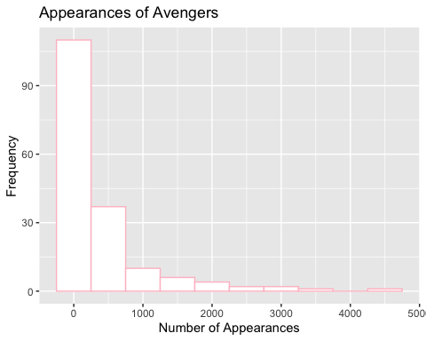

#Visualization 2 #This histogram shows the distributions of the Avengers by their genders.

