1. **ECE569- Setting Up HPC Accounts**

We will start with setting up your HPC accounts and basic file transfer information. Main source for hpc access information:

<https://public.confluence.arizona.edu/display/UAHPC/HPC+Documentation>

Account creation:

<https://public.confluence.arizona.edu/display/UAHPC/Account+Creation>

Go to “Sponsored HPC Account Instructions” section or use the following link:

<https://public.confluence.arizona.edu/display/UAHPC/Account+Creation#AccountCreation-SponsoredHPCAccountInstructions>

Getting access to HPC requires two steps:

**Step 1: Create an HPC Account**

Browse to <https://portal.hpc.arizona.edu/> log in using your NetID+

That's it! You now have an HPC account and are in your user portal.

**Step 2: Get your sponsor/PI/Faculty Member to Add You to Their HPC Group Account**

Once you have an account, you will need a research sponsor to start using HPC. A research sponsor is a university member or affiliate with faculty status. This could be your advisor, professor, or lab's PI. You can be added to your research sponsor's group in one of two ways:

Tell your sponsor (PI or Faculty member) to add you to their HPC allocation group. Or you may send your sponsor/PI/Faculty member a request by visiting [**https://portal.hpc.arizona.edu/portal/sendlink.php**](https://portal.hpc.arizona.edu/portal/sendlink.php).

On the right-hand side, enter your sponsor's email address and click send. Your sponsor will then receive an email to authorize your account. Once your request has been authorized, you will receive an email with instructions for accessing the HPC systems.

If you request access with a sponsor who has already approved you, it will not warn you and will send them another email notification.

Note that it may take up to 15 minutes to receive a confirmation email and for your account to be officially activated.

If you do not receive an email verification after 15 minutes, you should contact your sponsor and confirm receipt and approval of the HPC account request. If your account has been approved but you have not received the verification, you should contact HPC Consulting at [hpc-consult@list.arizona.edu](mailto:hpc-consult@list.arizona.edu) and provide your NetID+, your name, and the email address of your sponsor.

**After setting up your account**

Accessing the system and transferring files:

<https://public.confluence.arizona.edu/display/UAHPC/System+Access>

Please read the instructions carefully. HPC systems require 2-factor authentication.

Go over the following three topics carefully: Accessing Software, Transferring Files, Running Jobs

1. **Transferring files**:

<https://softwarelicense.arizona.edu/other-ssh-clients>

Install the ones that work for you. I use both PuTTY and WinSCP.

**In WinSCP:**

Use host name: [sftp.hpc.arizona.edu](mailto:username@login.hpc.arizona.edu) and login with your netid.

You can drag and drop files and folders in WinSCP.

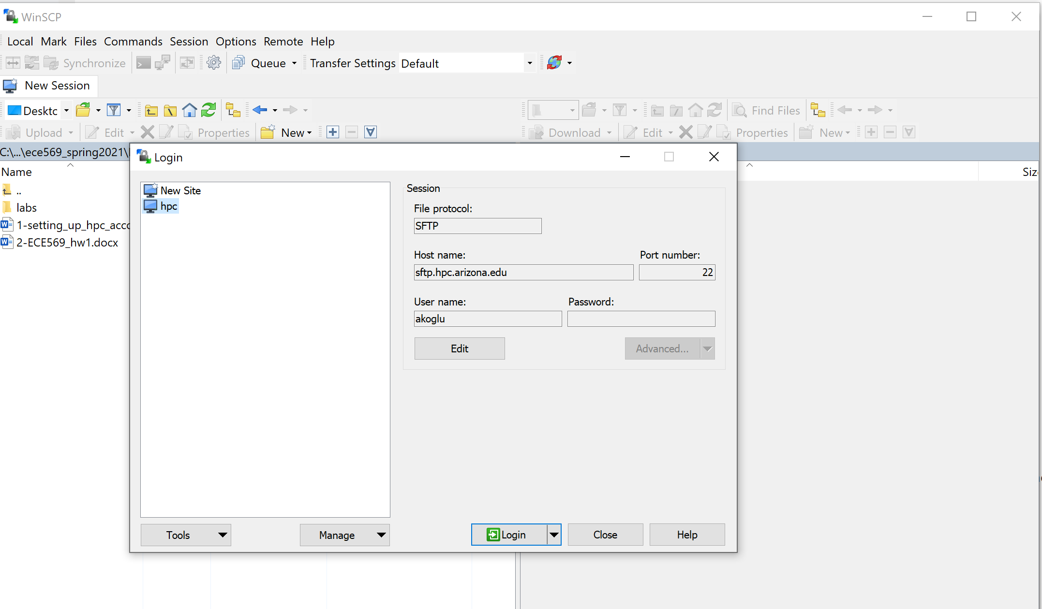

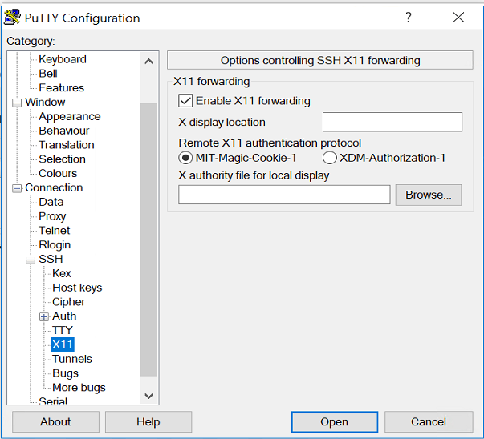**if you are using putty, first login to hpc.arizona.edu**

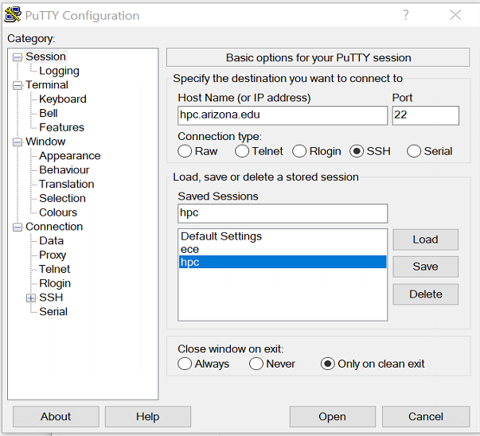

Make sure to enable X11 if you are going to use Xserver

1. **Accessing Ocelote**

**First read the info at:** <https://public.confluence.arizona.edu/display/UAHPC/System+Access>

**When you login to hpc,.arizona.edu** you will be at the frontend (“netid@gatekeeper”). You will then connect to Puma as the default.

**Use the –X option for X11 forwarding above when connecting.**

**$puma -X**

You can change your cluster to Ocelote or Elgato.

**$ocelote -X**

Now let’s start setting up your directory and transferring hw1 related files and folders to the HPC.

Ok, let’s build our directories for the assignments. In your putty shell on Ocelote:

$ mkdir ece569

$ mkdir ece569/build_dir

Copy the "labs" folder posted on d2l in hw1 into the ece569/ folder. You may want to use WinSCP for copying the entire folder conveniently. After copying the folder, you should have build_dir and labs directories in your 569 folder.

1. **Running your first program**

The command line setup through putty may become a convenient way of submitting large scale jobs later in the semester. Now we can move onto compiling and executing the device query program that will allow you to collect GPU configuration information. We will use the virtual desktop setup for getting access to the GPU system. Note that in this setup you have direct access to a GPU as part of the desktop configuration.

The web interface, Open OnDemand, provides access to HPC's three clusters. This service is available from [https://ood.hpc.arizona.edu/](https://ood.hpc.arizona.edu/pun/sys/dashboard)

You can request a virtual desktop with a GPU configuration using the “Interactive Desktop”

Then configure with a single GPU and make sure to use “ece569” as the PI group.

You can read more about HPC access using the following link: [https://public.confluence.arizona.edu/display/UAHPC/System+Access#](https://public.confluence.arizona.edu/display/UAHPC/System+Access) Scroll to the “Web Access” portion

After your session starts, on your virtual desktop explore the tools you have access to. Use the terminal icon to start the command line.

On the command line terminal

Change your home directory to ece569/build_dir

$ cd ece569/build_dir

Then run the following two commands:

$module load cuda11/11.0

$CC=gcc cmake3 ../labs

You should see the following screen flow.

Then run the following command:

$make

You should see the following screen flow.

The makefile compiles and generates the executable “DeviceQuery_Solution” in the build-dir directory.

$ls

With this command, you should see the following files in your build_dir directory:

CMakeCache.txt CMakeFiles cmake_install.cmake DeviceQuery_Solution libwb.a Makefile

You can directly run the device query solution on the GPU using the following command

./DeviceQuery_Solution > output.txt

And observe the contents of the output file. After completion, “output.txt” will include P100 GPU information if you used the Ocelote system.

Later you will need to run multiple jobs. For this you will need to use a script to submit jobs.

A template file for running the jobs on ocelote is given in the “labs” folder named “run_hw1.slurm”

Assuming you are in the build_dir directory copy the “run_hw1_slurm” file from the labs folder into your current build_dir directory. This script is needed to launch your jobs on the HPC system.

$cp ../labs/run_hw1.slurm ./

Go over the document to see the types of commands issued.

Before executing the script, open the run_hw1.slurm, locate the line #35 that shows as:

cd ~akoglu/class/ece569/build_dir and set the correct path for your “build_dir”

Your group should show as “ece569”. (line 10)

Then execute the following command

$srun run_hw1_slurm

This command submits your job and assigns a unique process id for your job.

Now observe the output generated by this script.

**Note that the source code “template.cu” is located in the labs/hw1/DeviceQuery**

**The code provided queries the GPU hardware on the system. Do not concentrate on the API calls, but on functions starting with `wb`. The `wbLog` function logs hardware features.**

**In the same folder you will find the file “questions.txt”. Insert your solutions and submit the questions.txt file on D2L to the designated folder.**

You should familiarize yourself with the following pages:

<https://public.confluence.arizona.edu/display/UAHPC/Puma+Quick+Start>

step by step job submission

<https://public.confluence.arizona.edu/display/UAHPC/Running+Jobs+with+SLURM>

slurm commands to monitor your jobs.

Key commands to be familiar with are:

srun <options> Submit a job for realtime execution. Can also be used to submit an interactive session

squeue --job <jobid> Check status of a specific job

squeue -u <netid> Check status of jobs specific to user

scancel <jobid> Delete a specific job

scancel -u <netid> Delete all user jobs

Using the ondemand service you can also initiate a shell access

Refer to these useful links:

running jobs

<https://docs.hpc.arizona.edu/display/UAHPC/Running+Jobs>

<https://public.confluence.arizona.edu/pages/viewpage.action?pageId=86409309>

More comprehensive information on this service can be found at:

<https://public.confluence.arizona.edu/display/UAHPC/Open+On+Demand>

Link below is you starting point for information about system access and job submission: <https://public.confluence.arizona.edu/display/UAHPC/User+Guide>

Key part of our assignments will involve submitting jobs to the HPC system with GPU resources allocated. For this you need to learn about running jobs with SLURM using the link below:

<https://public.confluence.arizona.edu/display/UAHPC/Running+Jobs+with+SLURM>

You need to go through the “Running Jobs with SLURM” carefully to find out the best setup for yourself.

The following page is under development but it may have more information as we go through he semester.

<https://ua-researchcomputing-hpc.github.io/>

**Other Peripheral Information**

For ElGato more information is at:

<http://elgato.arizona.edu/getting-started>

Information about GPU nodes on UA HPC

<https://public.confluence.arizona.edu/display/UAHPC/GPU+Nodes>

## **Compute Resources**

More detailed information on system resources can be found on our [Compute Resources page](https://public.confluence.arizona.edu/display/UAHPC/Compute+Resources).

## **Containers with GPU Support**

Singularity containers are available as modules on HPC for GPU-supported workflows. For more information, see our [documentation on Containers](https://public.confluence.arizona.edu/display/UAHPC/Containers).

<https://public.confluence.arizona.edu/display/UAHPC/Containers>

## **Accessing GPUs**

Information on how to request GPUs using SLURM can be found in our [SLURM Documentation](https://public.confluence.arizona.edu/display/UAHPC/Running+Jobs+with+SLURM#RunningJobswithSLURM-GPUJobs).

<https://public.confluence.arizona.edu/display/UAHPC/Running+Jobs+with+SLURM#RunningJobswithSLURM-GPUJobs>

## **Training**

For a list of training resources related to GPU workflows, see our [Training documentation](https://public.confluence.arizona.edu/display/UAHPC/Training#Training-GPU/NvidiaTraining).

https://public.confluence.arizona.edu/display/UAHPC/Training#Training-GPU/NvidiaTraining

### Alternative ways to access the HPC system (Windows, MAC, Linux) https://public.confluence.arizona.edu/display/UAHPC/System+Access

### MobaXterm

MobaXterm is another available SSH Windows client. To connect to HPC, [download and install MobaXterm](https://mobaxterm.mobatek.net/download.html), open the software, select **Session → SSH** and enter **hpc.arizona.edu** under **Remote host**. Next, select the box next to **Specify username** and enter your UArizona NetID. To connect, click OK at the bottom of the screen: