

《大数据可视化》综合设计报告一

题目：基于JiuwenSwarm的Super-Productivity自动规划系统

学 院 计算机科学与技术学院
班 级 2023级大数据一班
姓 名 王志豪
学 号 08232337

中国矿业大学
2026年05月
课程设计报告格式要求：
1.报告中应包含一、二级标题；
2.正文宋体小4号，1.5倍行距；
3.报告正文不少于1000字；
4.上交报告电子版：https://v.wjx.cn/vm/YkiEmj2.aspx，截至5月27日。
课程设计报告评分要点：
- 报告中技术的应用情况（20%）
- 报告中应用功能有效及完整性（40%）
- 报告中的个人总结及体会情况（20%）
- 报告格式规范程度（20%）

评语：

评分： 日期：

目录
目录 2
1. 背景及功能概要 2
1.1背景 2
1.2功能概要 3
1.3项目结构与使用指南 3
2.系统设计 4
2.1 SKILL设计 4
2.2 MCP设计 6
2.3 Super Productivity插件设计 6
3. 实现及功能验证 7
3.1设计分析 7
3.2运行截图 21
4.总结及体会 26

- 背景及功能概要

1.1背景
在当前的个人工作流管理中，任务规划与执行跟踪的脱节是一个普遍痛点。用户通常需要先在AI助手中生成每日计划，再手动将任务条目复制到Super Productivity这类专业待办工具中，整个过程割裂且低效。为消除这一 friction，本项目提出基于JiuwenSwarm智能体框架，构建一套面向Super Productivity的自动规划系统。JiuwenSwarm具备灵活的Cron定时触发、丰富的技能生态及对MCP（Model Context Protocol）的原生支持，为打通“AI规划-任务落地”的闭环提供了理想的技术基座。
本项目的核心目标是实现每日早晨9点，JiuwenSwarm自动执行一次完整的任务规划会话，并直接将生成的结构化任务清单写入Super Productivity。技术实现上，采用Cron表达式精确触发任务，通过JiuwenSwarm内置的MCP工具调用为Super Productivity编写的插件所暴露的API（如create_task、create_projects等），实现任务的批量创建、标签分类、项目归属及时长预估。整个流程无需人工干预，用户打开Super Productivity即可看到已规划好的当日任务，可直接勾选执行。该方案不仅大幅提升了任务管理的自动化程度，也为AI Agent与生产力工具的深度整合提供了一个可复用的参考范式。

1.2功能概要
系统主要提供以下能力：
- 根据用户目标、当前水平、截止日期和每日可用时间生成计划。
- 参考网络经验、官方资料和常见实践方法，综合制定可执行方案。
- 默认只写入未来 7 天详细任务，避免一次性创建过多任务。
- 使用批量计划提交工具 submit_adaptive_plan，避免 Agent 多次调用 create_task 导致卡顿。
- 每日 09:00 通过 cron 触发复盘，读取计划状态并动态调整后续安排。
- 用户可主动修改某一天或某类任务，系统会重新计算滚动 7 天窗口。
- 使用本地索引记录计划任务，减少慢速全量 get_tasks 调用。

1.3项目结构与使用指南
jiuwenswarm/resources/agent/workspace/skills/adaptive-daily-planner/
├── SKILL.md
├── agents/
│ └── openai.yaml
└── references/
├── planning_workflow.md
└── super_productivity_contract.md
使用指南：
用户只需告诉agent自己的目标以及自身的目前的现状即可，例如：我要下个月考雅思，现在大概 5.5，目标 6.5，每天 2 小时，帮我制定计划。
当然，觉得自己的目标过于模糊也不用担心，根据系统的SKILL能力，Agent会主动反问你其余信息，所以完全不用担心自己的目标模糊描述不清的问题。
建议系统能够长期挂载在后台，这样每天早晨9点的时候系统会综合你前一天的任务完成情况自动为你总结然后调整当天和后面几日的计划。

2.系统设计

2.1 SKILL设计
adaptive-daily-planner Skill 采用“主说明 + 引用文档”的结构。SKILL.md 负责定义核心行为：
- 初次建计划
- 每日复盘
- 主动修改日程
- 状态查询
其中最重要的设计变化是：Skill 不再要求 Agent 逐条调用 create_task，而是要求 Agent 先完整生成计划，再构造 adaptive-daily-planner/v1 JSON payload，一次性调用：mcp_super-productivity_submit_adaptive_plan
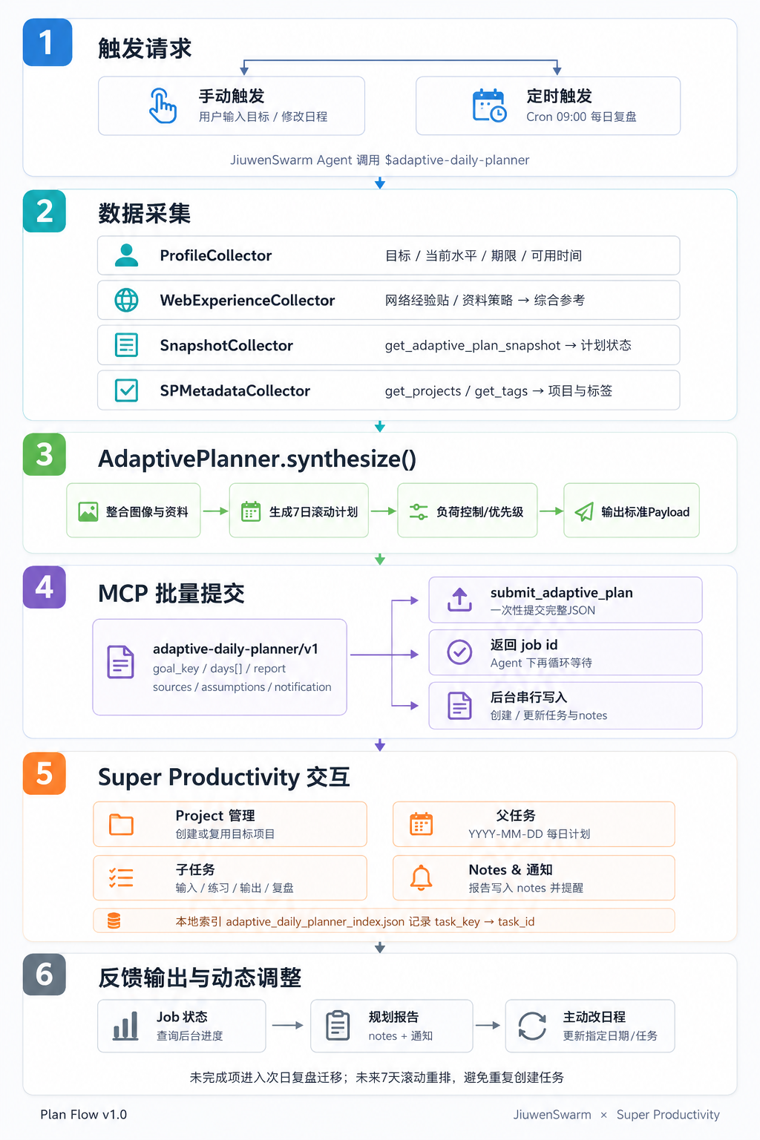
如果批量工具不可用，Skill 明确要求只返回计划草案，不退回到多次创建任务，避免再次出现工具调用长时间阻塞。
planning_workflow.md 负责规划逻辑，包括用户画像采集、网络经验检索、计划合成、负荷控制和动态调整规则。
super_productivity_contract.md 负责 MCP 交互契约，包括批量 payload 格式、任务命名规范、notes 模板、本地索引策略和失败处理方式。

2.2 MCP设计
MCP 由 mcp_server.py 提供，核心目标是把 Agent 的多次细粒度写入，改造成一次批量提交和后台处理。
工具包括：
A．submit_adaptive_plan
B．get_adaptive_plan_job
C．get_adaptive_plan_snapshot
submit_adaptive_plan 接收完整计划 payload，并快速返回 job_id。真实写入 Super Productivity 的过程在后台执行，避免 Agent 会话被长时间阻塞。
MCP 还维护两个本地状态文件：
A．adaptive_daily_planner_index.json
B．adaptive_daily_planner_jobs.json
其中索引用于记录：goal_key / date / task_key -> task_id；这样后续每日复盘或修改计划时，可以优先更新已有任务，而不是重新全量读取和重复创建任务。
MCP 定义了基本的super-productivity的增删改查行为： create_task、update_task、get_projects 等，并增强了 create_task 的超时控制：SP_MCP_CREATE_TASK_TIMEOUT_S
此外，MCP 支持两种运行方式：stdio、streamable-http。默认仍推荐 stdio；如果需要常驻 HTTP 服务，也可以使用 Streamable HTTP 挂载。

2.3 Super Productivity插件设计
Super Productivity 插件承担本地应用与 MCP server 之间的桥接工作。
插件通过文件目录通信：plugin_commands/和plugin_responses/。MCP server 写入 command 文件，Super Productivity 插件轮询并执行对应操作，然后把结果写入 response 文件。
插件侧主要调用 Super Productivity 的 PluginAPI，例如：
- getTasks
- addTask
- updateTask
- addProject
- addTag
- showSnack
在本系统中，插件本身不承担复杂规划逻辑。规划、批量提交、本地索引和任务复用逻辑都放在 MCP server 层完成。这样可以减少对 Super Productivity 插件的侵入，同时保留插件作为稳定执行通道。
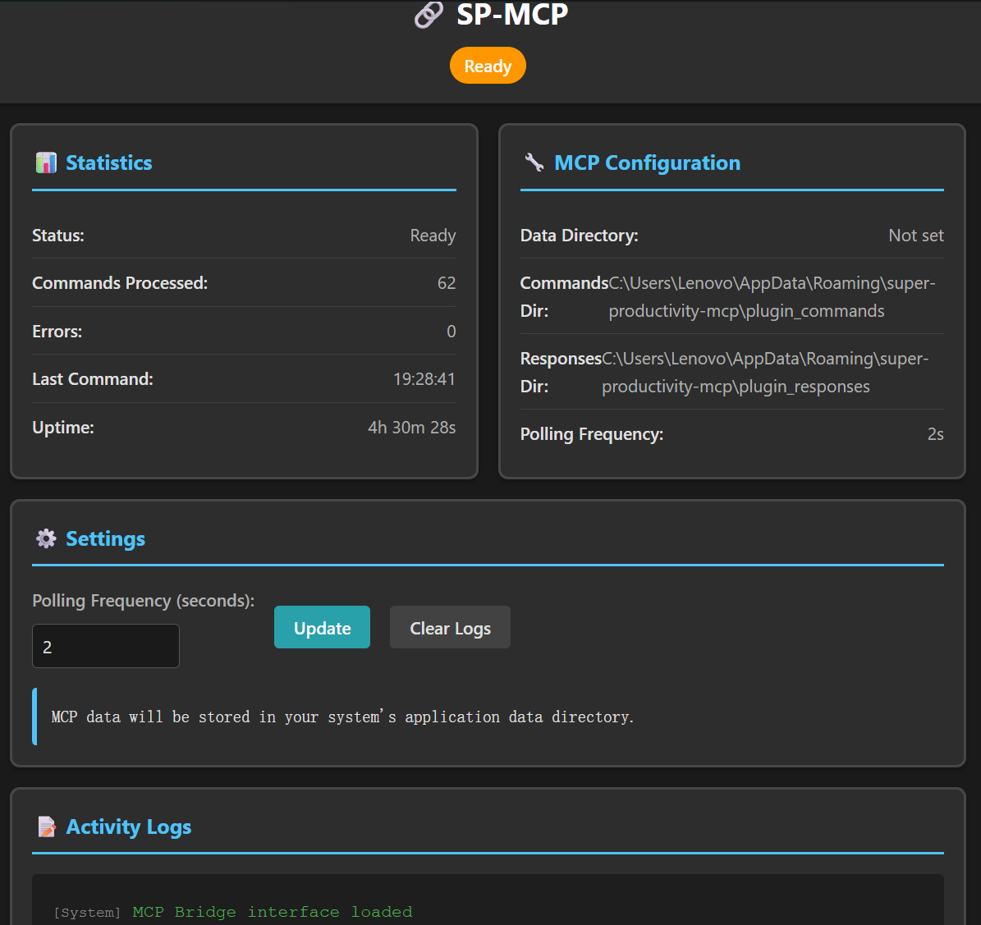

3. 实现及功能验证

3.1设计分析
- SKILL.md
---
name: adaptive-daily-planner
description: 根据用户目标、当前水平、期限和可用时间制定滚动每日计划，并通过 Super Productivity MCP 创建、复盘和动态调整任务。用于备考、学习训练、项目推进、每日计划、补计划、改日程、早晨复盘或状态查询。
---

# Adaptive Daily Planner

把一个目标变成可执行的 7 天滚动计划，并在 Super Productivity 中持续维护它。

核心原则：先完成信息采集、网络检索和计划合成，再把结构化计划一次性提交给 MCP。不要在 Agent 循环里逐条调用 `create_task` 创建每日计划。

## Load First

使用本技能前先读取：

- `references/planning_workflow.md`：目标访谈、网络经验贴检索、计划合成和动态调整规则。
- `references/super_productivity_contract.md`：Super Productivity MCP、cron 工具、任务结构、报告 notes 和无真删除处理。

如果用户只要求改某一天的日程，仍然读取 Super Productivity contract，并读取 planning workflow 中的调整规则。

## Operating Modes

### 初次建计划

当用户要求为某个目标做每日计划、备考计划、训练计划、项目推进计划，或明确要求写入 Super Productivity：

1. 收集目标、截止日期、当前水平、目标水平、每天可用时间、固定事务、偏好强度和不可安排时段。
2. 对目标领域做实时网络检索，优先综合经验贴、官方或权威资料、近期可验证建议；无法联网时说明限制。
3. 先形成完整目标路线和未来 7 天详细计划。
4. 把计划整理为 `adaptive-daily-planner/v1` JSON payload，一次性调用 `mcp_super-productivity_submit_adaptive_plan`。
5. 创建或更新每天 09:00 的 cron 复盘任务。
6. 调用 `mcp_super-productivity_get_adaptive_plan_job` 查询写入结果，并向用户报告 job 状态、成功项和失败项。

如果 `submit_adaptive_plan` 不可用，不要退回到逐条 `create_task` 写入；改为返回格式化计划草案和缺失工具说明，避免长时间卡住。

### 每日 09:00 复盘

当 cron description 或用户说“每日复盘、早上检查、动态调整计划”时：

1. 优先调用 `mcp_super-productivity_get_adaptive_plan_snapshot` 读取本技能本地索引中的计划状态。
2. 只有索引缺失或用户明确要求核对 Super Productivity 全量数据时，才调用 `get_tasks(include_done=true)`。
3. 找到昨天、今天和未来 7 天的每日父任务及子任务。
3. 根据完成情况、未完成项、实际耗时和用户新增约束调整今日及未来窗口。
4. 未完成的高价值任务迁移到今天或未来 7 天，不直接删除。
5. 重新生成 `adaptive-daily-planner/v1` payload，并用 `submit_adaptive_plan` 一次性提交调整结果。
6. 在今日父任务 notes 追加规划报告，并发送一条简短 Super Productivity notification。

### 主动修改日程

当用户要求修改某天、某项、某个时间段或某个任务：

1. 读取相关项目和任务，定位日期、父任务和子任务。
2. 优先读取 `get_adaptive_plan_snapshot`，避免全量 `get_tasks` 卡住。
3. 按用户意图重算滚动 7 天窗口，并生成新的批量 payload。
4. 用 `submit_adaptive_plan` 提交更新；如果只是单个已知任务的小改动，才可直接调用 `update_task`。
5. 如果替换任务，保留变更记录；不要因为“取消”就直接删除，除非用户明确要求归档。

### 状态查询

当用户问“进度怎么样、今天该做什么、有没有落后、下周怎么安排”：

1. 优先读取 `get_adaptive_plan_snapshot` 和最近的 `get_adaptive_plan_job`。
2. 只有本地索引不足以回答时才读取 Super Productivity 全量任务状态。
2. 汇总完成率、主要拖延项、今天重点、未来风险和建议。
3. 只在用户要求或需要修正计划时更新任务。

## Defaults

- 时区默认 `Asia/Shanghai`。
- 计划写入窗口默认未来 7 天。
- 定时复盘默认每天 09:00，cron expression 为 `0 9 * * *`。
- 报告优先写入 Super Productivity 父任务 notes，notification 只放摘要。
- 目标领域不限于雅思；雅思只是典型使用场景。
- 写入 MCP 的默认方式是一次性 `submit_adaptive_plan`，而不是多次 `create_task`。

## Safety And Idempotency

- 提交计划前先生成完整 payload，并让 MCP 通过本地索引复用已有项目、日期父任务和子任务。
- 不要在批量工具不可用时自动逐条创建任务；这种降级会让 Agent 再次长时间阻塞。
- 不要伪造用户当前水平。当前水平缺失时先询问；如果用户希望立即开始，则安排诊断任务并标注假设。
- 网络资料只用于综合策略，不复制大段原文；报告中简要列出参考来源标题或链接。
- Super Productivity MCP 当前不支持真删除。取消或迁移任务时使用更新、标记、归档等可恢复方式。

SKILL.md 是整个能力的“行为入口”和调度说明，定位很清楚：它不直接实现代码，而是约束 Agent 在什么场景下如何行动。它把能力分成初次建计划、每日 09:00 复盘、主动修改日程、状态查询四种模式，并明确要求运行时先读取两个 references。最重要的设计点是把旧的“逐条 create_task 写入”改成“先完成规划，再一次性提交 submit_adaptive_plan payload”，这解决了之前 Agent 多次工具调用卡死的问题。小瑕疵是正文里有少量编号重复，比如每日复盘和状态查询中都出现了重复序号，但不影响语义。
- References
Planning_workflow.md:
# Planning Workflow

Use this reference to turn a user goal into a practical rolling plan. Keep the plan grounded in the user's current level, real constraints, and current web evidence.

## 1. Intake

Collect only missing high-impact details. Prefer concise questions over a long interview.

Required fields:

- Goal: what the user wants to achieve.
- Deadline: exact date or target window.
- Current level: score, baseline, recent result, portfolio state, or self-assessment.
- Target level: desired score, output, milestone, or completion state.
- Availability: daily/weekly time budget and fixed unavailable times.
- Constraints: work, school, health, commute, money, materials, tools, exam date, project dependencies.
- Preferences: intensity, rest days, task granularity, preferred study or work time.

If current level is unknown, ask for it. If the user wants to start anyway, schedule a diagnostic task on day 1 and label assumptions in notes.

For IELTS-like goals, collect current and target bands for listening, reading, writing, and speaking when available. Also ask for test date, daily study time, weak sections, and whether the user can do mock tests.

## 2. Web Research

Search at runtime because advice, resources, exam patterns, and user-shared experience posts change over time.

Recommended search pattern:

- English broad query: goal + "study plan" or "preparation plan" + target level + time window.
- Chinese experience query when relevant: goal + "经验贴" + target score or deadline.
- Official or authoritative query: goal + "official guide" or "scoring criteria".
- Bottleneck query: weakest skill + "improve" + goal.

Use 3-5 sources when available. Blend:

- Official or authoritative rules and scoring criteria.
- Recent detailed experience posts with concrete schedules.
- Practical resource recommendations with clear tradeoffs.

Do not copy long passages. Extract patterns: workload, sequencing, common mistakes, useful drills, review cadence, and mock-test frequency. Record source titles or URLs briefly in the report.

If web search is unavailable, say so in the report and proceed from the user's facts plus general planning principles.

## 3. Plan Synthesis

Build the full route mentally, but write only the next 7 days into Super Productivity.

After synthesis, separate planning from writing:

- First produce the complete 7-day plan and report in memory.
- Then convert it to the `adaptive-daily-planner/v1` payload described in `super_productivity_contract.md`.
- Submit the payload once with `submit_adaptive_plan`; do not create each task with separate MCP calls.

Use this structure:

- Milestones: divide deadline into phases such as diagnose, foundation, targeted practice, simulation, polish.
- Daily plan: one focused priority, 2-5 executable tasks, one review loop.
- Weekly rhythm: at least one review or mock checkpoint when the goal benefits from measurement.
- Buffer: reserve space for carryover and life disruptions.

Workload rules:

- Stay within the user's stated daily availability.
- Keep total estimated time under 85 percent of available time unless the user asks for sprint intensity.
- Prefer consistency over heroic days.
- For a missed day, reduce or redistribute before adding pressure.
- Put the highest-value task first in the day.

Task design rules:

- Use action verbs and measurable outputs.
- Avoid vague tasks like "study reading"; write "finish one timed reading passage and log 3 error patterns".
- Include review tasks, not only input tasks.
- Convert lessons learned into tomorrow's plan.

## 4. Daily Review Adjustment

At daily review time:

1. Read the local adaptive plan snapshot before trying a full task fetch.
2. Classify each child task as done, unfinished, blocked, cancelled, or superseded.
3. Compare estimated time and time spent when available.
4. Identify why work slipped: over-scheduling, unexpected event, unclear task, too hard, low priority, or blocked dependency.
5. Move only the tasks that still matter.
6. Rebalance today's plan and future 7-day window.
7. Submit the adjusted 7-day window as one batch payload.

Carryover rules:

- Carry over high-value unfinished work once.
- If a task is missed twice, split it smaller or replace the strategy.
- If the user repeatedly misses a category, reduce volume and add an easier entry task.
- If the user over-completes two days in a row, increase challenge slightly.
- Keep at least one visible win in today's plan after a missed day.

## 5. Manual Changes

When the user changes a day:

- Treat explicit user constraints as authoritative.
- Move lower-priority tasks before moving core milestones.
- Preserve the reason for the change in notes.
- Recompute the next 7 days, not only the edited task.
- Prefer one batch payload for multi-day changes. Use direct `update_task` only for a single known task.
- If the requested change threatens the deadline, report the tradeoff plainly and propose a mitigation.

## 6. Report Template

Write reports in the daily parent task notes.

```markdown
## Adaptive Planning Report - YYYY-MM-DD

### Summary
- Goal:
- Current phase:
- Today focus:

### Yesterday Review
- Completed:
- Carried forward:
- Blocked or cancelled:
- Adjustment reason:

### Today Plan
- Priority 1:
- Supporting tasks:
- Estimated total:

### Rolling 7-Day Changes
- Added:
- Moved:
- Reduced:

### Evidence Used
- User facts:
- Web sources:
- Assumptions:

### Next Check
- Daily review: 09:00 Asia/Shanghai
```

planning_workflow.md 是规划方法论文档，负责告诉 Agent “怎样把目标变成合理计划”。它强调先采集目标、期限、当前水平、目标水平、可用时间和约束，再结合网络经验贴、官方资料、近期可验证建议来生成计划。它的优点是把计划质量控制写得比较具体，比如任务要可衡量、每日 2-5 个任务、总负荷不超过可用时间的 85%、错过任务后优先重排而不是加压。它还规定了 missed day 的处理逻辑：高价值任务最多结转一次，反复错过就拆小或换策略，这让“动态每日计划”不只是重新排日期，而是能根据执行反馈调整强度。
super_productivity_contract.md:
# Super Productivity Contract

Use this reference whenever the skill writes to or reads from Super Productivity.

## Tools

Use the `super-productivity` MCP tools when available:

- `submit_adaptive_plan`
- `get_adaptive_plan_job`
- `get_adaptive_plan_snapshot`
- `get_projects`
- `create_project`
- `get_tags`
- `create_tag`
- `get_tasks`
- `create_task`
- `update_task`
- `complete_and_archive_task`
- `show_notification`

In Jiuwen/OpenJiuwen, MCP tools may be exposed with namespaced function names
such as `mcp_super-productivity_get_projects`. Always call the exact tool name
shown in the available tools list. Do not call a bare name such as
`get_projects` unless that bare name is actually registered.

Use cron tools for automation when available:

- `cron_list_jobs`
- `cron_create_job`
- `cron_update_job`
- `cron_preview_job`

If a tool is unavailable, explain the missing capability and continue with the closest non-mutating output.

For planning writes, prefer `submit_adaptive_plan`. Do not fall back to calling `create_task` repeatedly for a 7-day plan; repeated tool calls can block the agent. If the batch tool is missing, return the formatted plan draft and state that the batch MCP tool is unavailable.

The default MCP transport can stay as `stdio`. If the user runs the MCP server as a persistent HTTP process, Jiuwen can also mount it with `transport: streamable-http` and `url: http://127.0.0.1:8765/mcp`.

## Project And Tags

Project title:

```text
Adaptive Plan - {goal_short}
```

Create or reuse this project. Prefer reuse if a case-insensitive project title match already exists.

Create or reuse these tags via Super Productivity syntax in task titles:

- `#adaptive-plan` for all tasks managed by this skill.
- `#review` for daily review tasks or reports.
- `#carryover` for unfinished work moved from a previous day.
- `#blocked` for tasks waiting on a dependency or user decision.

## Task Naming

Daily parent task:

```text
[{goal_short}] YYYY-MM-DD 每日计划 @Xdays #adaptive-plan
```

Child task:

```text
[{goal_short}] YYYY-MM-DD {task_action} @Xdays #adaptive-plan
```

Use `@Xdays` relative to the current local date. Today is `@0days`, tomorrow is `@1days`.

Use `time_estimate` in milliseconds when the user provides availability or the plan estimates duration.

## Creation Flow

Initial plan:

1. Build the full plan and convert only the next 7 days into one `adaptive-daily-planner/v1` payload.
2. Call the exact registered `submit_adaptive_plan` tool name, usually `mcp_super-productivity_submit_adaptive_plan`.
3. Call `get_adaptive_plan_job` with the returned `job_id` once near the end of the response.
4. Report queued/running/completed/partial/failed status and any failures. Do not keep polling indefinitely.

Daily review:

1. Read indexed tasks with `get_adaptive_plan_snapshot`.
2. Use `get_tasks(include_done=true)` only if the index is missing, stale, or insufficient.
3. Locate yesterday, today, and the next 7 days by `goal_key`, date, and task keys.
4. Recompute the next 7 days and submit one new `adaptive-daily-planner/v1` payload.
5. Add `#carryover` in moved task titles or notes.
6. Write the report into today's parent notes via the submitted payload.

Manual edit:

1. Locate the affected date and task using `get_adaptive_plan_snapshot`.
2. For a single known task, use `update_task` for title, notes, done state, estimate, or schedule syntax.
3. For any multi-day reschedule, recompute the 7-day window and submit one `adaptive-daily-planner/v1` payload.
4. Create a replacement task only when no existing task should be reused.
5. Update the parent task notes with a change log.

## Batch Plan Payload

Use this payload shape for `submit_adaptive_plan`:

```json
{
"version": "adaptive-daily-planner/v1",
"goal_key": "ielts-2026-06",
"goal_short": "IELTS",
"timezone": "Asia/Shanghai",
"window_start": "YYYY-MM-DD",
"window_days": 7,
"project": {
"title": "Adaptive Plan - IELTS",
"description": "Adaptive daily plan for IELTS",
"color": "#2196F3"
},
"days": [
{
"date": "YYYY-MM-DD",
"key": "day-YYYY-MM-DD",
"title": "[IELTS] YYYY-MM-DD 每日计划 @Xdays #adaptive-plan",
"notes": "Daily report and plan notes",
"tasks": [
{
"key": "listening-drill",
"title": "[IELTS] YYYY-MM-DD listening drill @Xdays #adaptive-plan",
"action": "listening drill",
"notes": "Concrete output and review criteria",
"time_estimate": 1800000
}
]
}
],
"report": "Human-readable planning report",
"sources": ["source title or url"],
"assumptions": ["assumption text"],
"notification": {"message": "IELTS 7 日滚动计划已提交"}
}
```

Limits:

- `window_days` must be at most 7.
- `days` must contain at most 7 entries.
- Each day must contain at most 5 child tasks.
- Use stable `key` values so the MCP index can update existing tasks instead of creating duplicates.

## Cron Job

Create or update one cron job:

```yaml
name: adaptive-daily-planner daily review
cron_expr: 0 9 * * *
timezone: Asia/Shanghai
targets: web
enabled: true
description: Use $adaptive-daily-planner in daily-review mode. Review yesterday's Super Productivity tasks for all projects and tasks marked #adaptive-plan, carry unfinished work forward, update today's parent task notes, keep a rolling 7-day window, and send a Super Productivity notification.
```

Before creating, call `cron_list_jobs` and reuse a job with the same name. If it exists with a different schedule, use `cron_update_job`.

Run `cron_preview_job` after create or update when possible, and mention the next run time in the report.

## Notes Metadata

Add a compact metadata block near the end of each daily parent notes so future reviews can parse intent.

```markdown
<!-- ADAPTIVE_DAILY_PLANNER
goal_short: ...
goal_project: ...
date: YYYY-MM-DD
window_days: 7
phase: ...
generated_at: ISO-8601
sources: title or url list
END_ADAPTIVE_DAILY_PLANNER -->
```

Do not rely only on metadata. Keep the human-readable report above it.

## No True Delete

The current MCP supports completion/archive, not true deletion.

- For a cancelled task, update the title with `[取消]` and explain why in notes, or mark it complete only when the user explicitly wants it cleared.
- For a moved task, update the title schedule and notes instead of creating a duplicate.
- For a superseded task, mark notes with `Superseded by: {new task title}` and add the replacement task if needed.

## Failure Handling

- If `submit_adaptive_plan` returns a `job_id`, report that the write is queued/running and tell the user they can query job status.
- If `submit_adaptive_plan` fails validation, fix the payload once; if still invalid, show the formatted draft.
- If the batch tool is unavailable, do not use repeated `create_task` calls for a full plan. Return a draft plan and explain the missing capability.
- If a project exists but task lookup fails, do not create a large duplicate batch. Ask the user or produce a draft plan.
- If web research fails, still create tasks only from user-provided facts and record the limitation in notes.

super_productivity_contract.md 是 Skill 和 MCP 之间的接口契约，负责把自然语言规划落到可执行的数据结构上。它规定了工具优先级、项目命名、标签、每日父任务和子任务命名、notes 元数据、cron 配置，以及 adaptive-daily-planner/v1 的批量 payload 格式。这个文档最关键的价值是把幂等写入讲清楚了：通过 goal_key、日期、稳定 key 和本地索引复用已有任务，避免重复创建；同时明确 Super Productivity 当前不支持真删除，所以取消、迁移、替换都要用更新、标记、归档等可恢复方式处理。它相当于这个系统的数据协议说明书。
- MCP
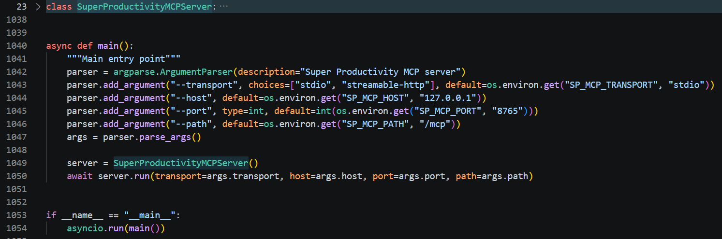
mcp_server.py MCP 服务端实现，承担 JiuwenSwarm Agent 和 Super Productivity 插件之间的桥接。它新增了submit_adaptive_plan、get_adaptive_plan_job、get_adaptive_plan_snapshot 三个核心工具：前者校验完整计划 payload 后快速返回 job_id，后台再串行创建或更新项目、每日父任务、子任务、notes 和通知；后两者分别用于查询后台写入状态和读取本地计划索引。它还维护 adaptive_daily_planner_index.json 和 adaptive_daily_planner_jobs.json，用来降低全量 get_tasks 的依赖
- Plugin
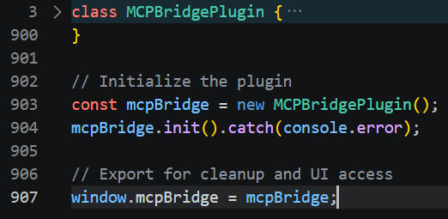
plugin.js是SuperProductivity 的桥接插件，manifest声明 nodeExecution 权限、iframe UI、以及 taskUpdate/taskComplete/taskDelete/currentTaskChange 等 hooks。它的工作方式是轮询本地命令目录，读取 MCP 服务端写入的 JSON command，然后根据 action 调用 Super Productivity 的 PluginAPI，例如 getTasks、addTask、updateTask、addProject、addTag、showSnack，执行完再把 response JSON 写回响应目录。插件本身并不知道 adaptive-daily-planner/v1 这种高层计划语义，它只负责底层任务 API 调用；批量计划、幂等索引、后台 job 都是在 Python MCP 层完成的。

3.2运行截图
这里我们使用规划模式进行测试：“我要下个月考雅思，现在大概 5.5，目标 6.5，每天 2 小时，帮我建计划，我的薄弱项目是说，然后我没有特别要预留的空闲时间，我每天的早上9点半开始学习。考试时间是6月12日，我没有其他的约束，成绩构成是6，5，6，5，口语薄弱”
- SKILL注入
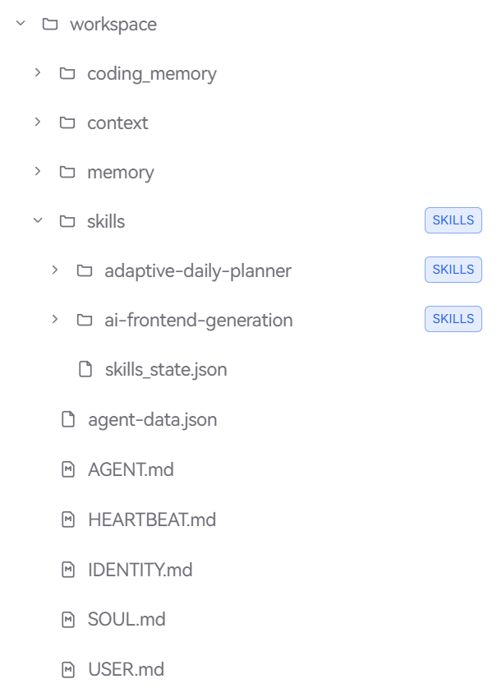
可以手动导入项目文件夹中的skills文件夹中，也可以通过web页面导入，启用后即可
- 工具调用
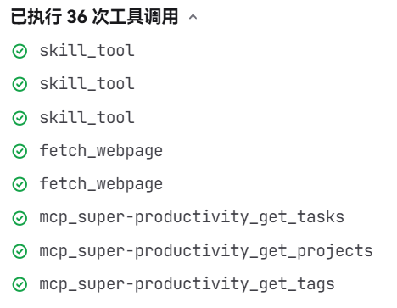
总共调用了36次工具，从开始的确定Skill到最后生成报告，全链路完成。
- 确定备考策略和阶段划分
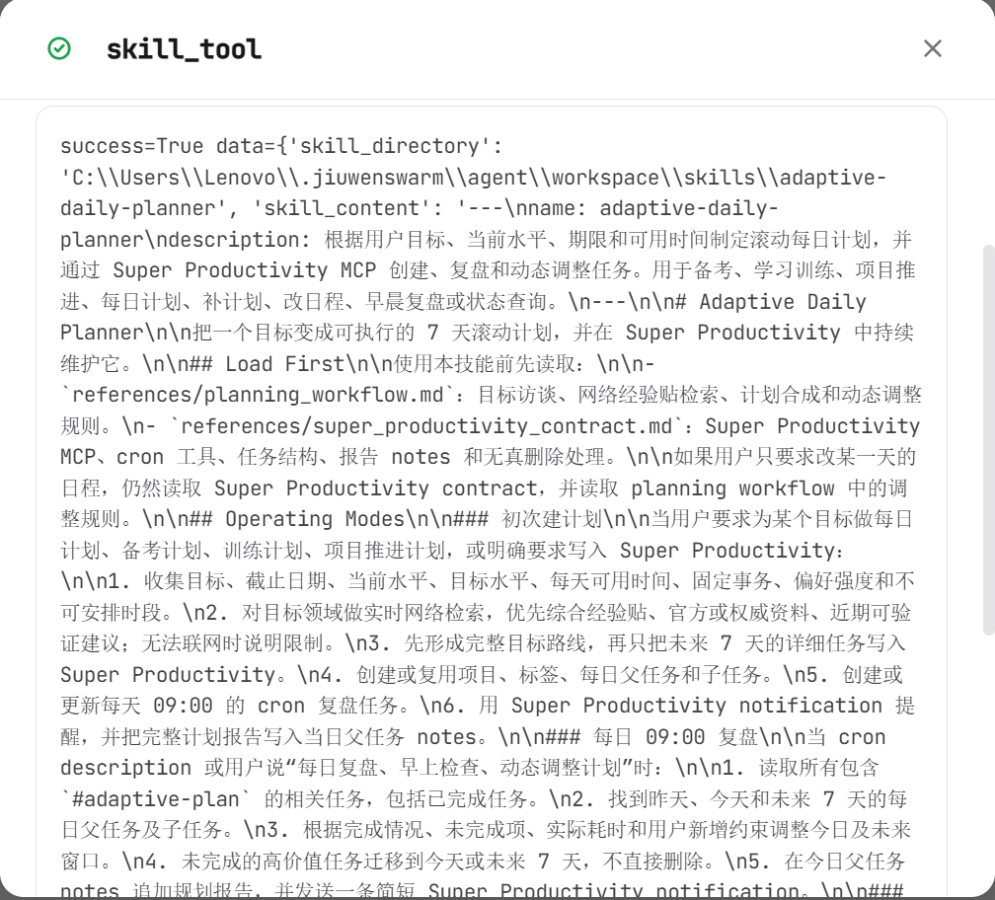
Agent发现是规划任务后调用planner的SKILL，在此之后分别调用了references中的两份文档。
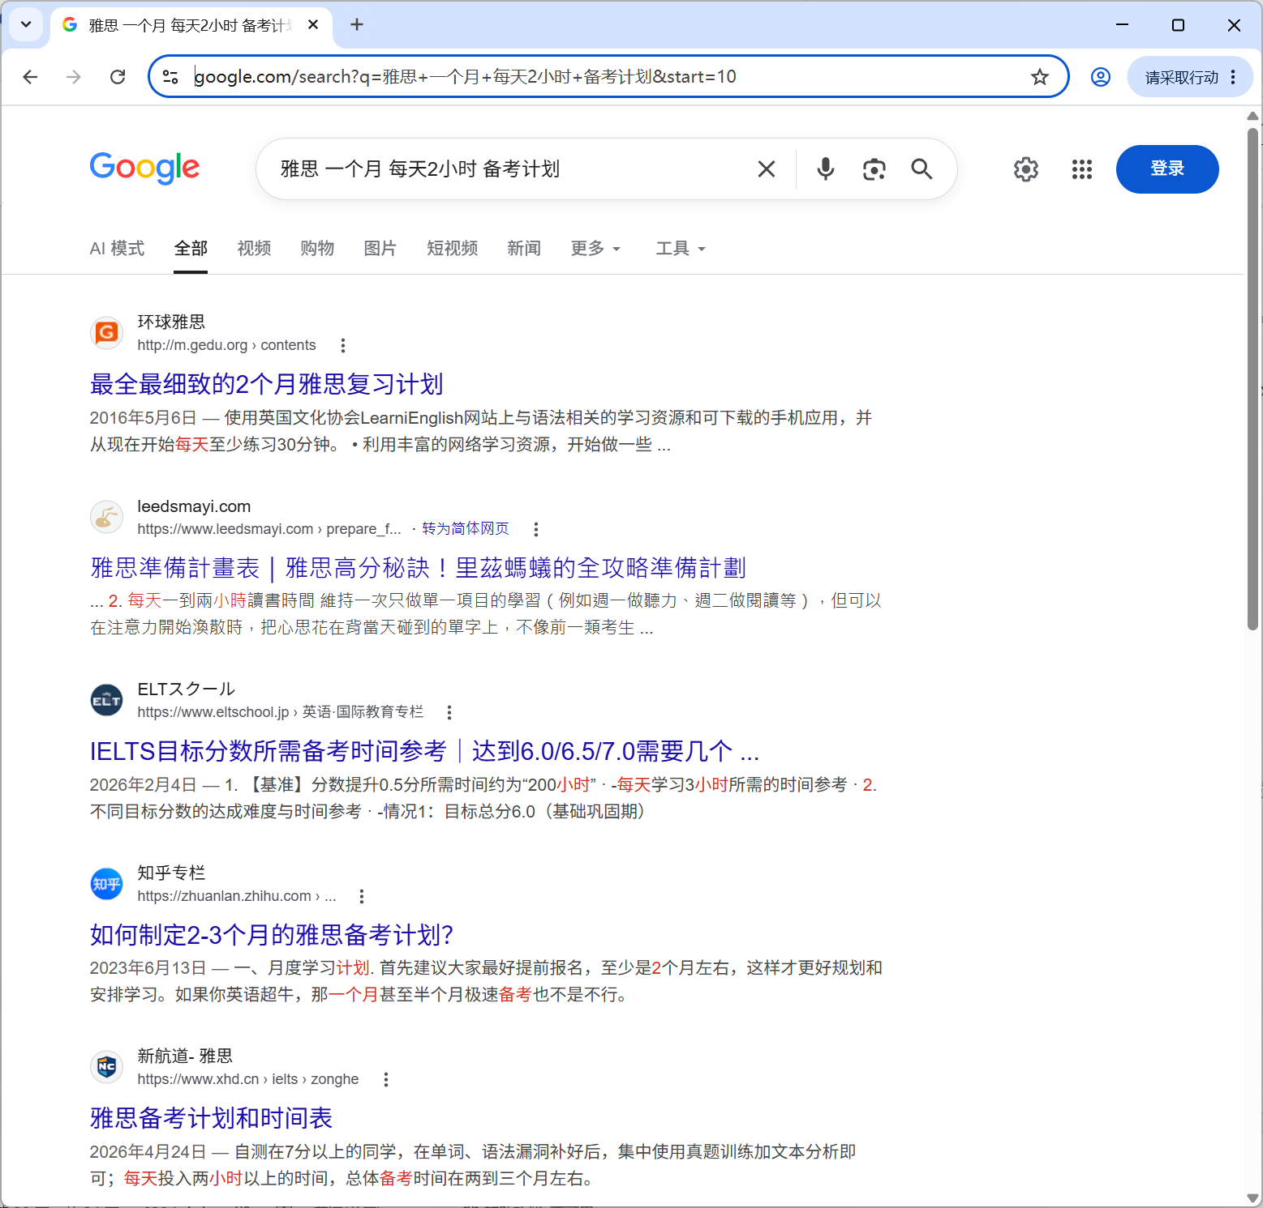
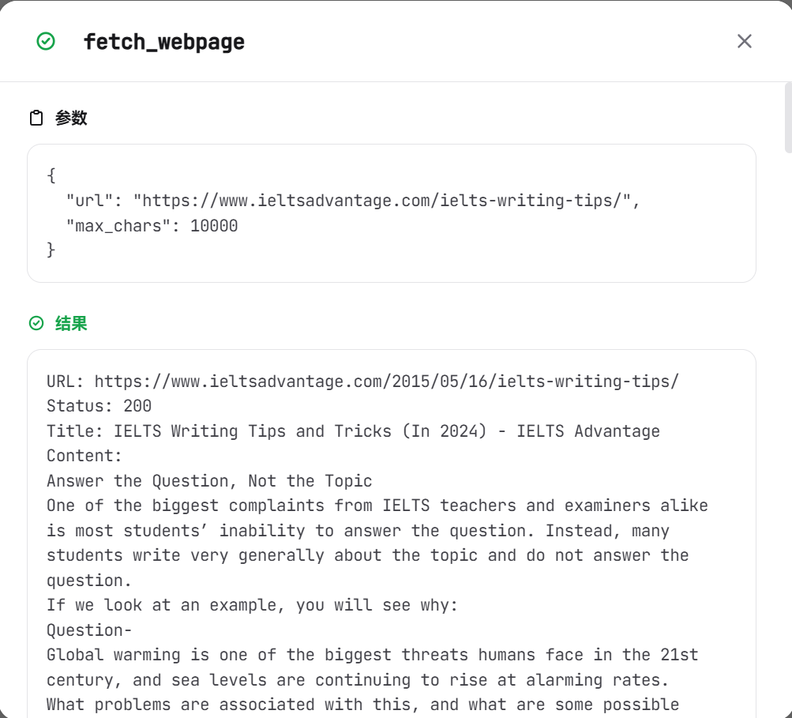
Agent通过fetchwebpage的方法主动根据主题去搜索经验贴，搜得的信息如上所示。
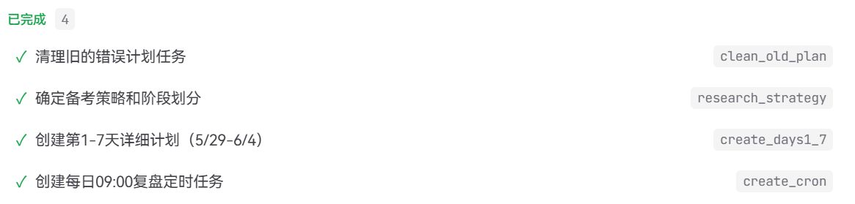
而后Agent生成了一份todo文档，制定后续的pipeline。
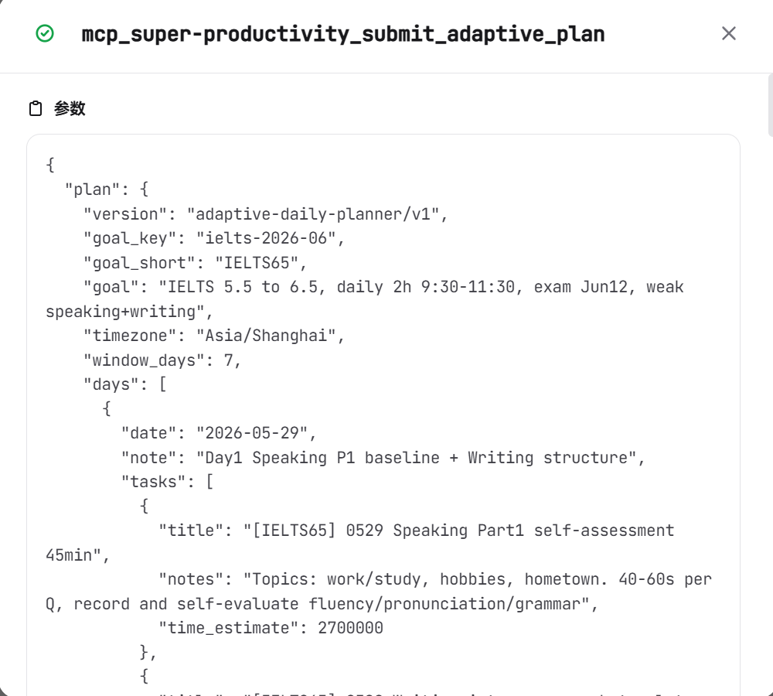
可以看到，Agent将综合了经验贴和对用户prompt的理解的详细计划结果拆分成了结构化的JSON数据，发送给MCP Server，由MCP Server与插件进行后续通信。
- 创建第1-7天详细计划（5/29-6/4）
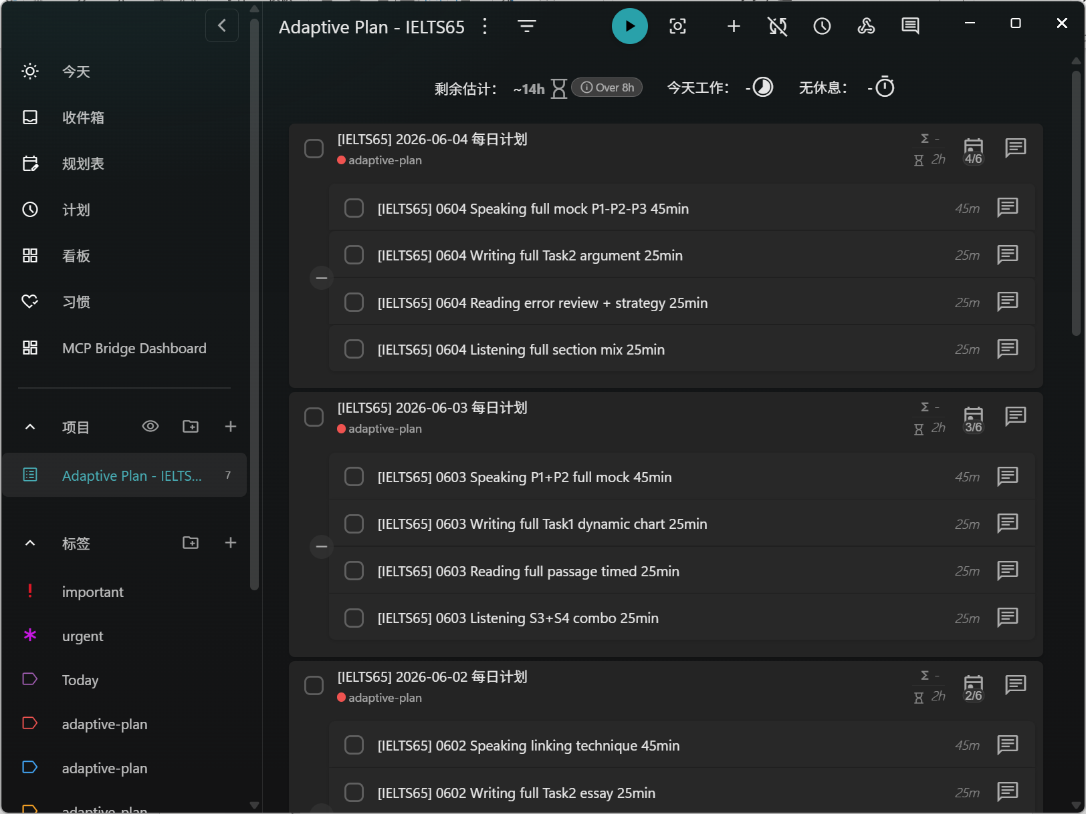
可以看到，项目栏下多出了一个Plan，这就是由Agent间接控制生成的完整计划，每一天的计划都十分严密并且时间分配明晰。
- 创建每日09:00复盘定时任务
当然，不是每个人都可以严格地按照初步的计划严密执行，考虑到每天的计划不一定能做完，所以我利用JiuwenSwarm中强大的Cron机制，为特定的任务设置一个每天运行的“闹铃”，这里设置的就是早上九点，每到早上九点，Agent系统就会主动复盘昨日的任务完成情况，然后动态调整后续的计划。定时任务如下所示：

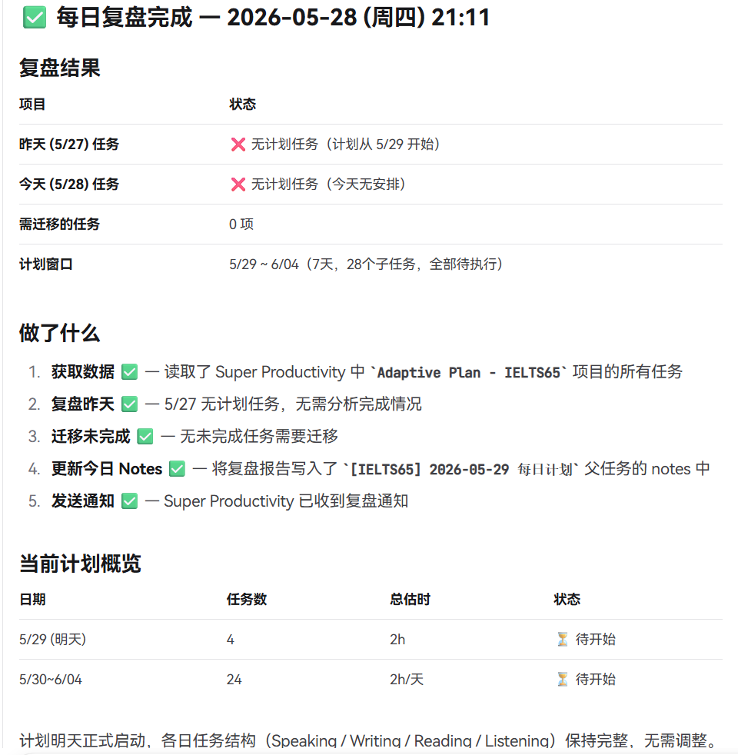
可以从上面的每日复盘报告中看到，Agent会真实地调用昨日Super Productivity的数据来进行分析，不过今日没有计划，因此Agent不对后续的计划进行修改，这也验证了Agent会理解计划后动态地调整计划的机制。

4.总结及体会
本系统将 JiuwenSwarm 的 Skill 能力、MCP 工具调用能力和 Super Productivity 的任务管理能力结合起来，实现了从“自然语言目标”到“可执行每日计划”的自动化流程。
相比直接让 Agent 多次调用任务创建工具，新版系统通过批量计划提交和后台 job 机制，显著降低了工具调用阻塞风险。本地索引机制也让每日复盘和计划调整更加轻量，不必每次都依赖慢速的全量任务读取。
整体来看，该系统的关键价值不只是自动创建任务，而是形成了一个可持续调整的计划闭环：用户提出目标，Agent 生成计划，Super Productivity 承接执行，cron 定时复盘，MCP 根据实际完成情况继续调整计划。对于备考、学习训练和长期项目推进，这种闭环比静态计划更接近真实使用场景。

