**Assignment2** : Grayscale image and Image histogram

Change the BGR image to grayscale by using tools “openCV” and “matplotlib”. then , plot the images for comparison between 2 methods. The code and results are shown below.

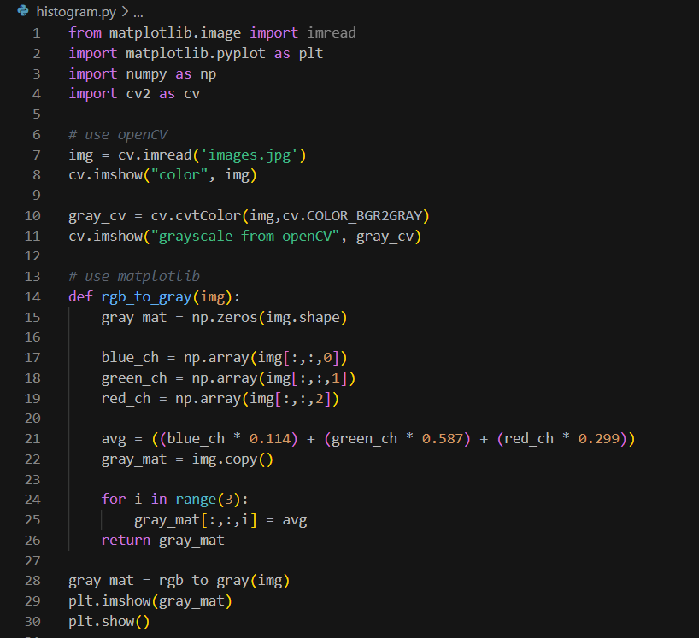

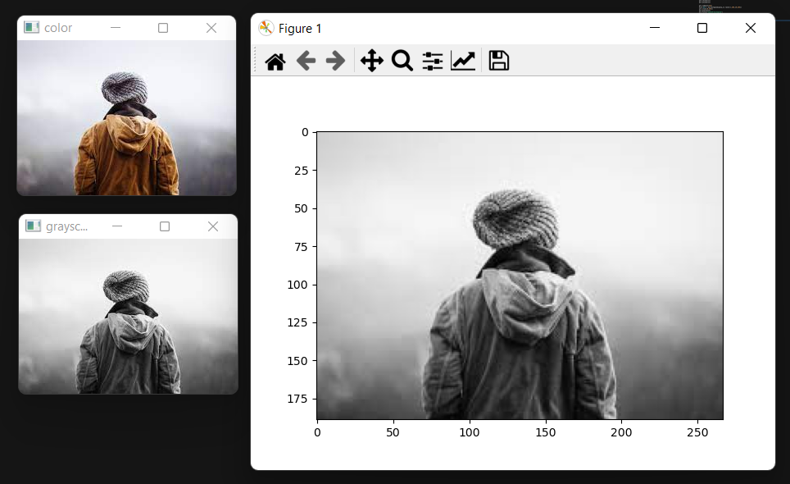

Plot the histogram of both grayscale images. Histogram was calculated using class in openCV and numpy.

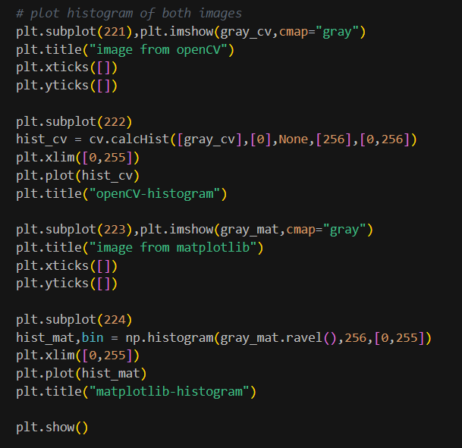

To clearly compare the results, plot in the same figure. However, they are on different scales.

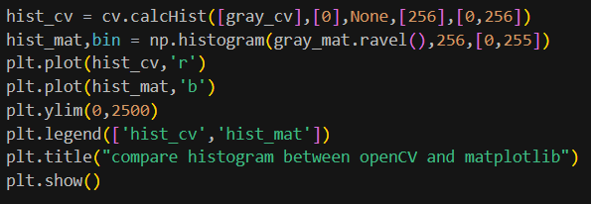

The results are shown below. From the histogram, the pattern of distribution is quite similar.

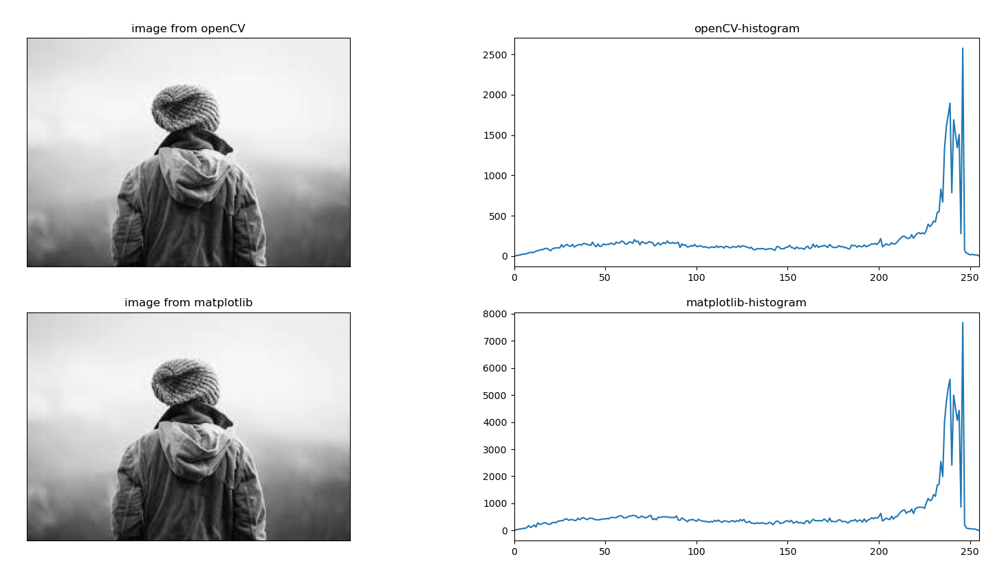

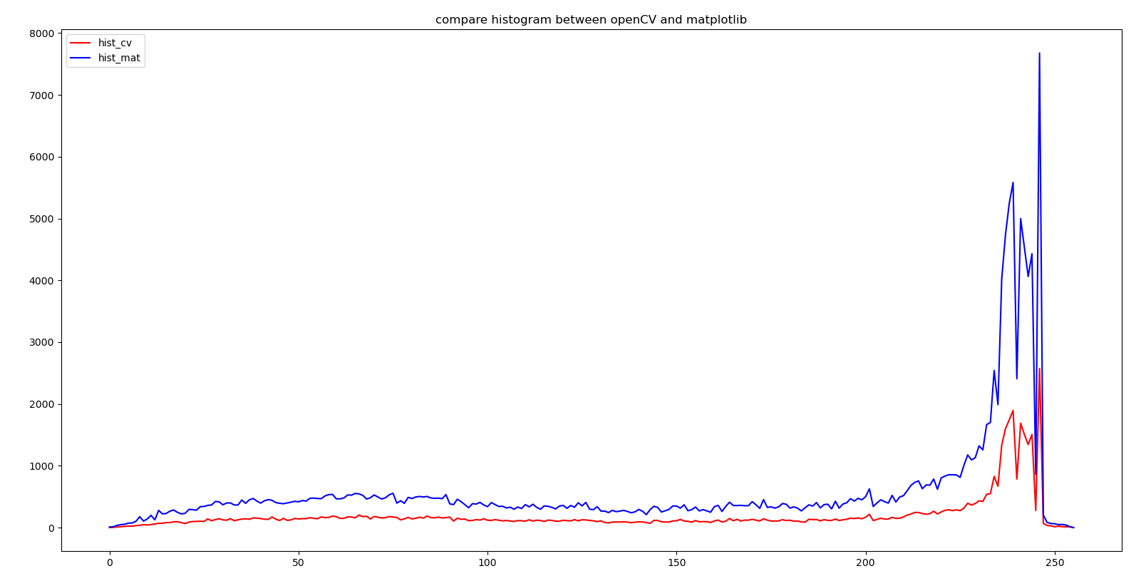

Plot histogram by using pixels in each image. The results are shown below. By using the pixels, both histograms are in the same scale which can be obviously seen that they are congruent.

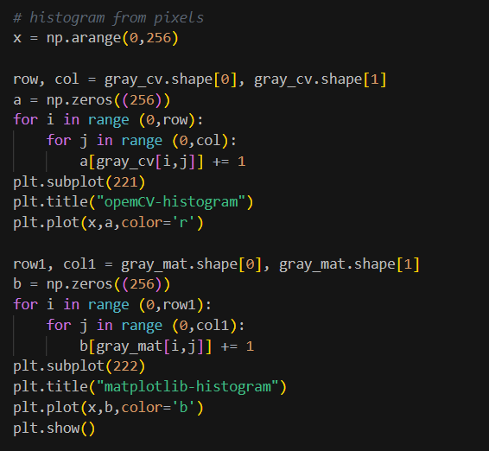

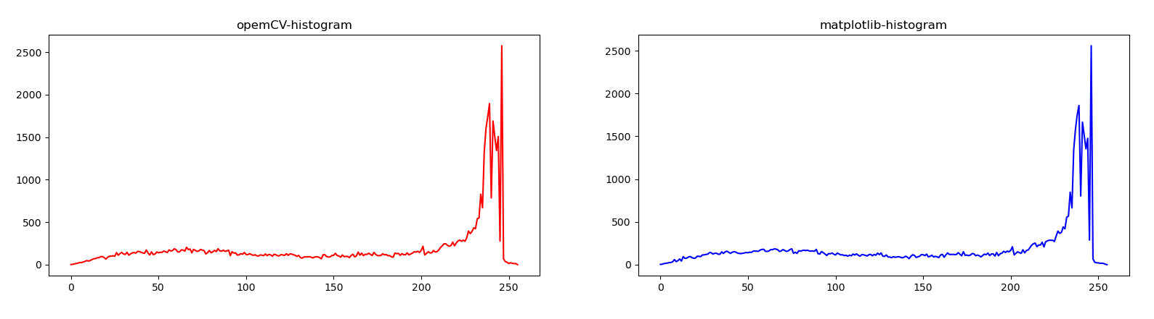

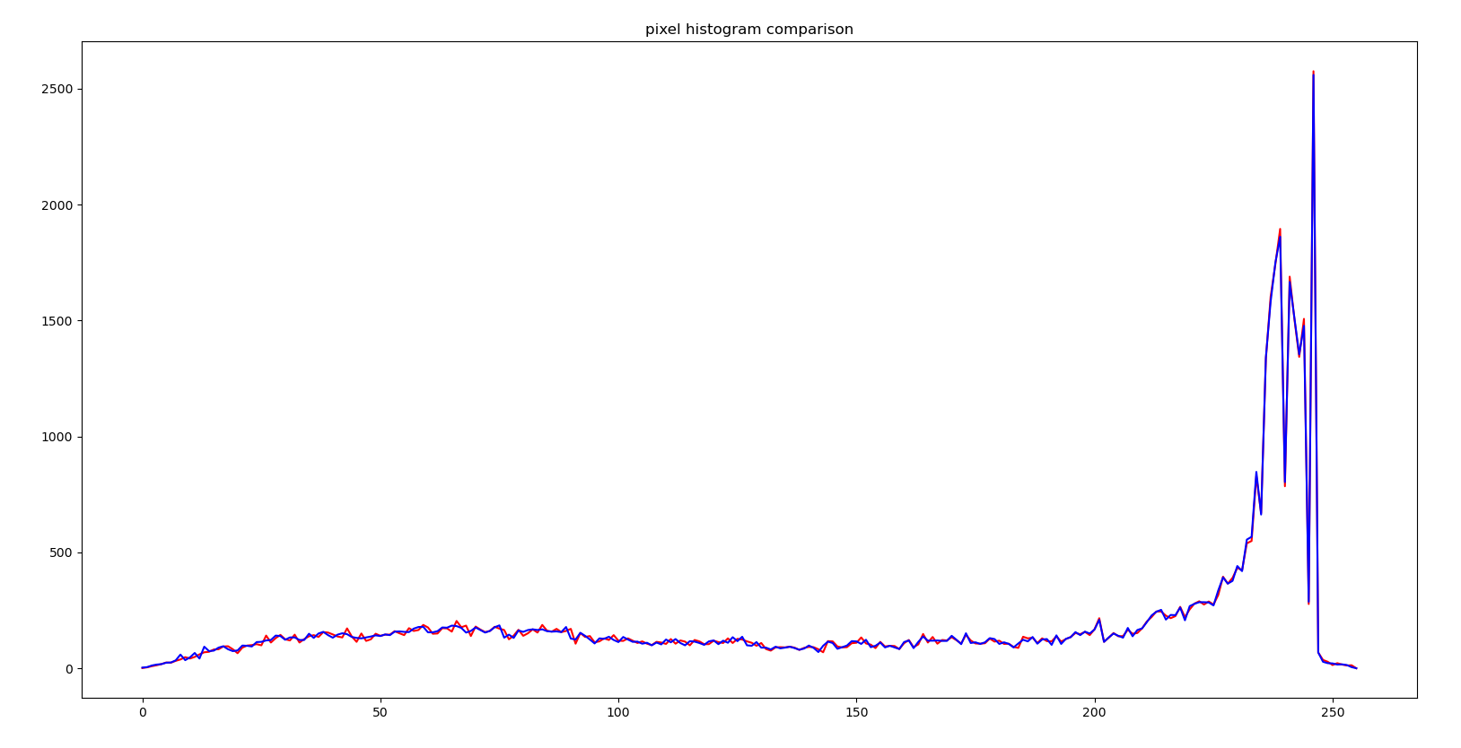

**Note**: I participated in the TESA competition which causes turning this homework out of your deadline.