**Assignment 3**

1. Find the formula for mapping among these color models
2. Write a program for converting an image to different color domains. Also, present image in each channel
3. What is LAB color domain and write the program for presenting each channel in LAB domain

**CMYK**

For converting BGR to CMYK format, I use the formula

Black (K) = 1 - ()

Cyan (C) =

Magenta (M) =

Yellow (Y) =

Where,

R’ = , G’ = , and B’ =

According to the formula, we can write Python as the coding below. The results in each channel are also shown below the coding by using imshow.

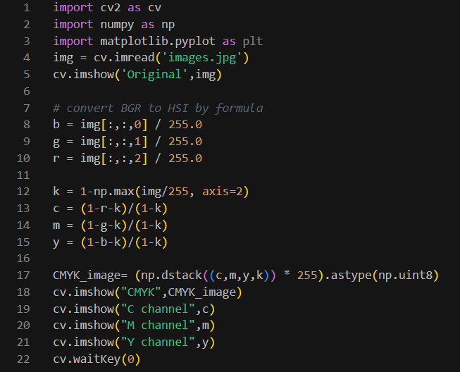

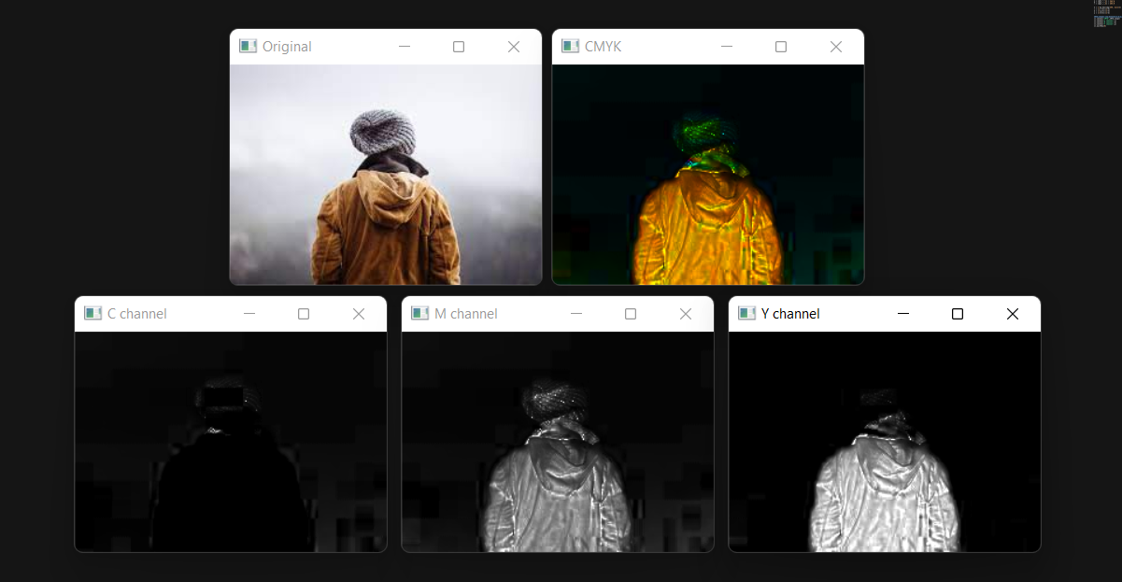

**HSV**

To convert the image to HSV domain, I follow the condition that

V = Max

When When Max = R and GB,

When Max = R and GB,

When Max = G,

When Max = B,

When Max = 0,

S = 0

Otherwise,

Then, write them in the format of Python. Finally, I compare the result which uses the formulas to the result using the openCV library as well.

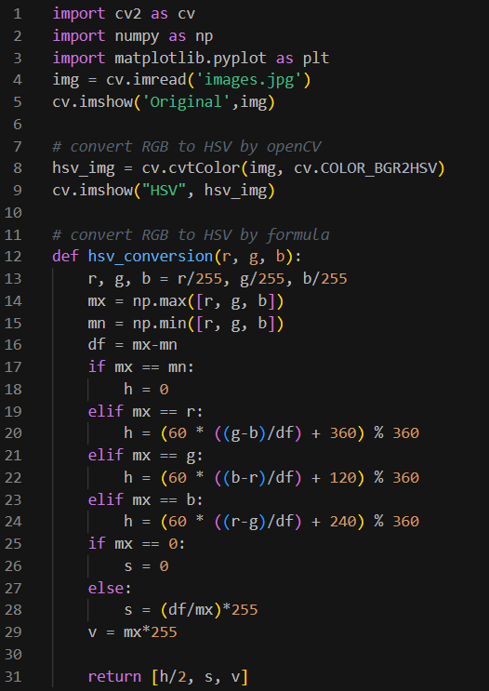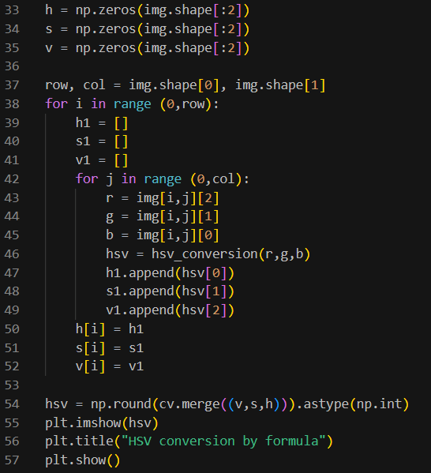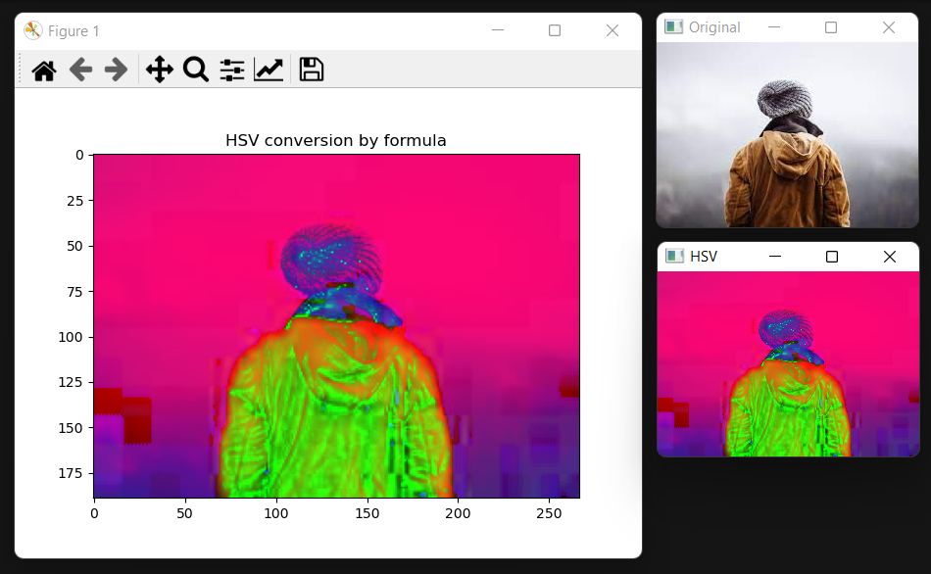

**LAB**

The LAB color space identifies 3 components of image which are lightness(L), color ranging from Green to Magenta (a), and color ranging from Blue to Yellow (b). Therefore, the L channel is independent and has duty on the brightness only while others are about the color responsibility.

To make the BGR image to LAB space, I use the formula that

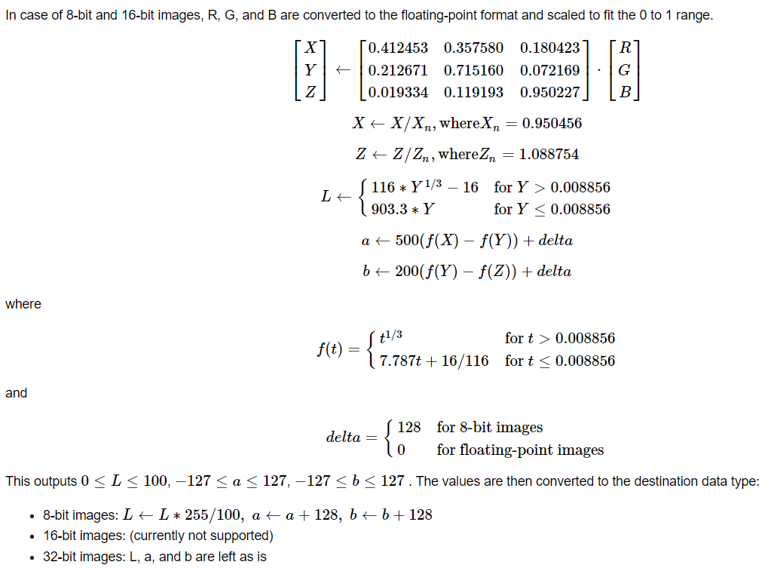

Figure from <https://docs.opencv.org/3.4/de/d25/imgproc_color_conversions.html>

Then, coding the above condition into Python and plotting the result and comparing it to the original image and LAB image which uses the library from openCV.

