**Assignment 4**

1. **Create python functions for contrast stretching and modified contrast stretching respectively**
2. **Apply your functions with an image and observe change of the image histogram**

The code below shows the contrast stretching and modified contrast stretching methods (lower at 1% and upper at 99%). Moreover, I provide you with histograms of both processings.

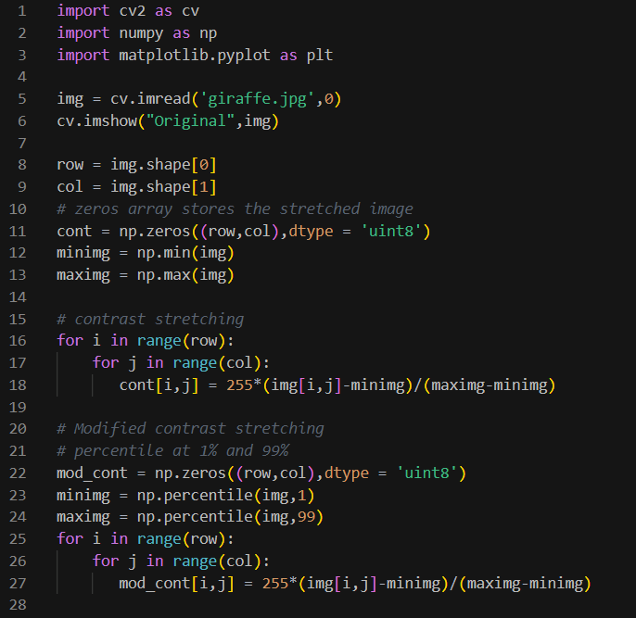

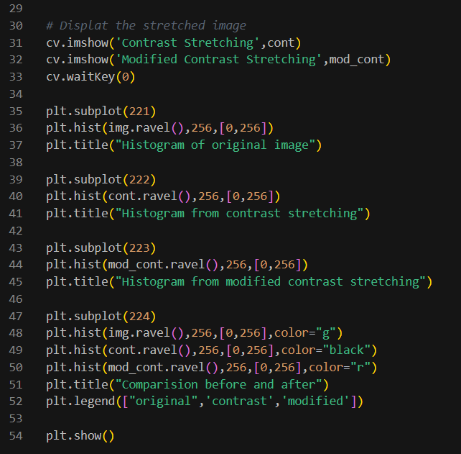

Image results:

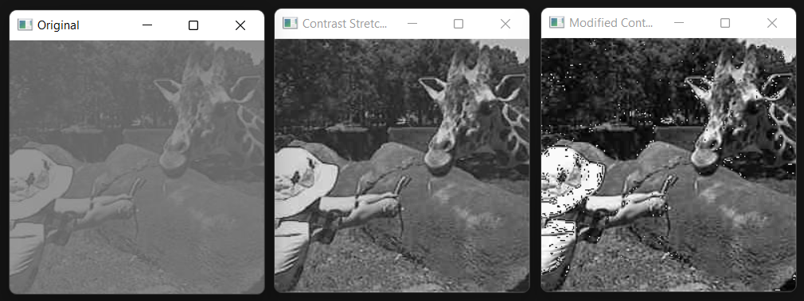

Histogram results:

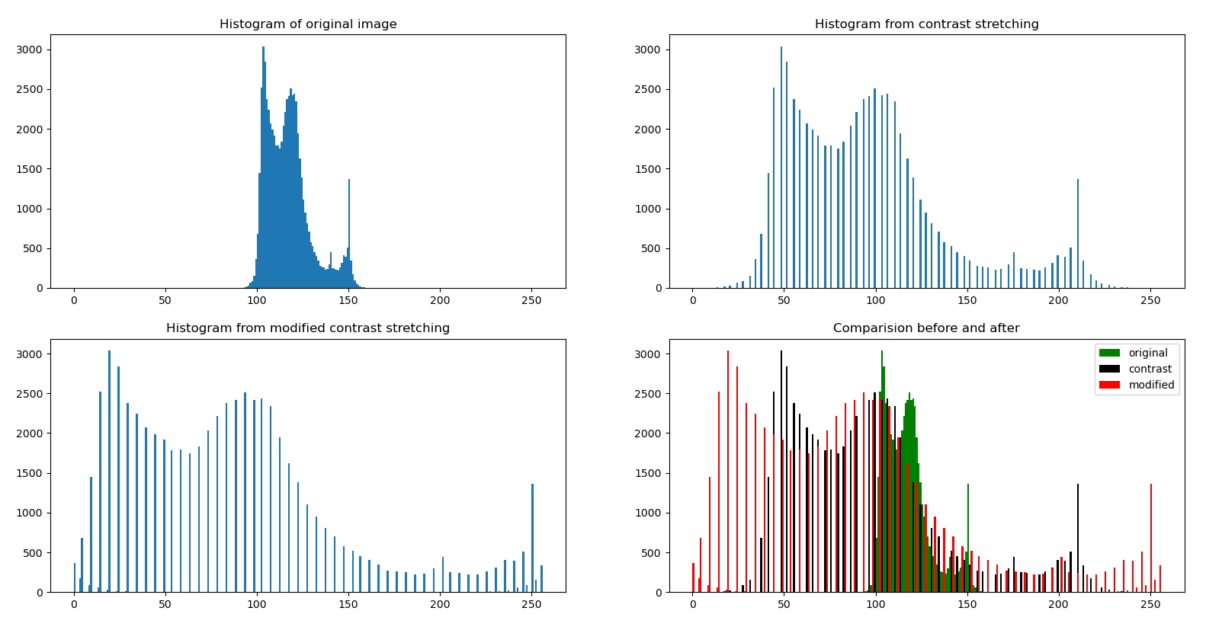

1. **Create python function for thresholding an image and apply to an image**

The code shows the way to define the threshold by coding as conditions and using a library from openCV.

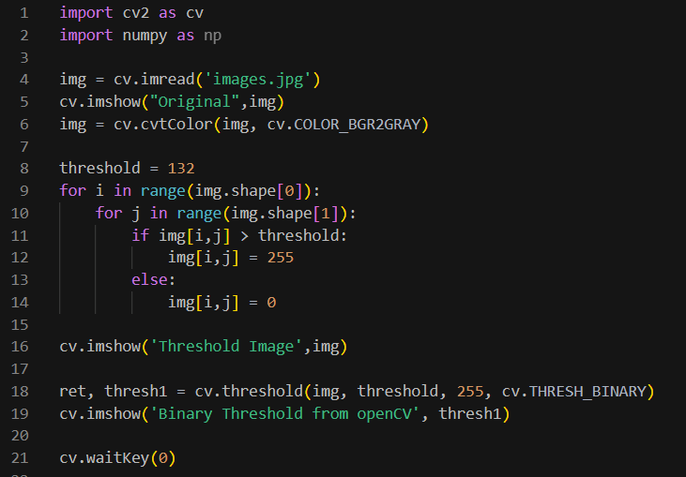

Image results:

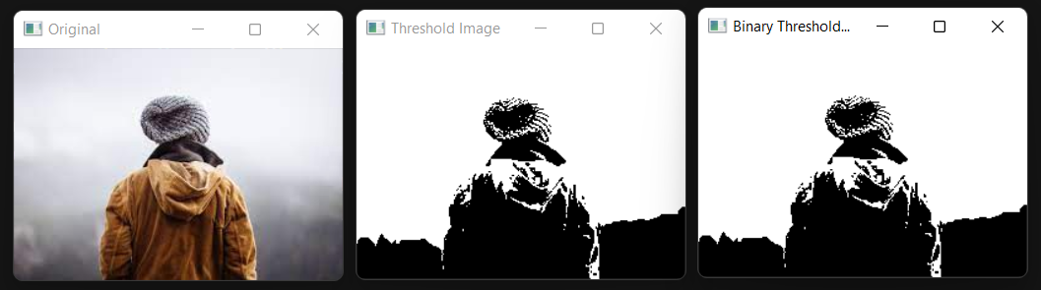

1. **Write python function for histogram equalization and apply to an image**

Coding the histogram equalization by using cumulative function and then, comparing the results. Moreover, there is a library from openCV which can be used as well.

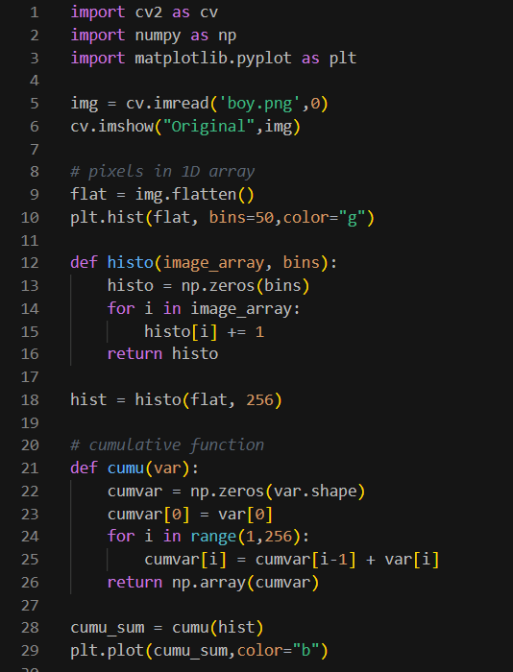

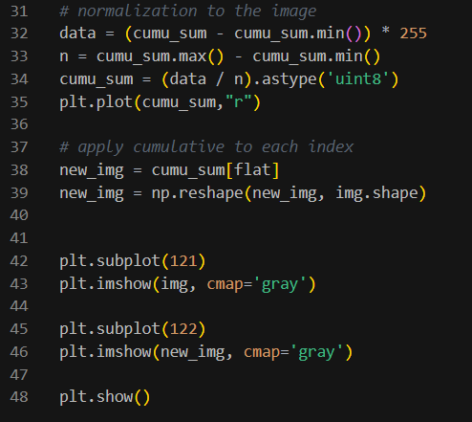

Image results: due to the matplotlib which cannot plot the exact grayscale, the left image in Figure1 is quite different from the real original image. The right image is new image after doing equalization

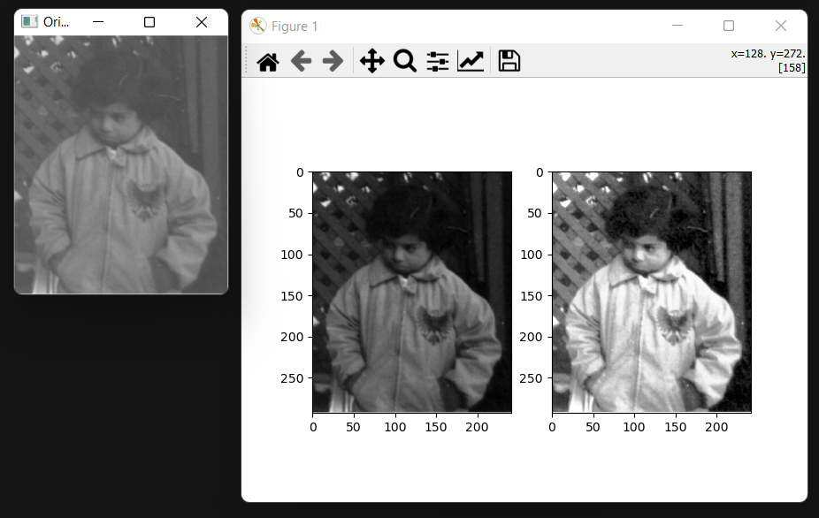

Histogram result: blue line is cumulative graph of image, green line is image’s histogram, and red line is normalization

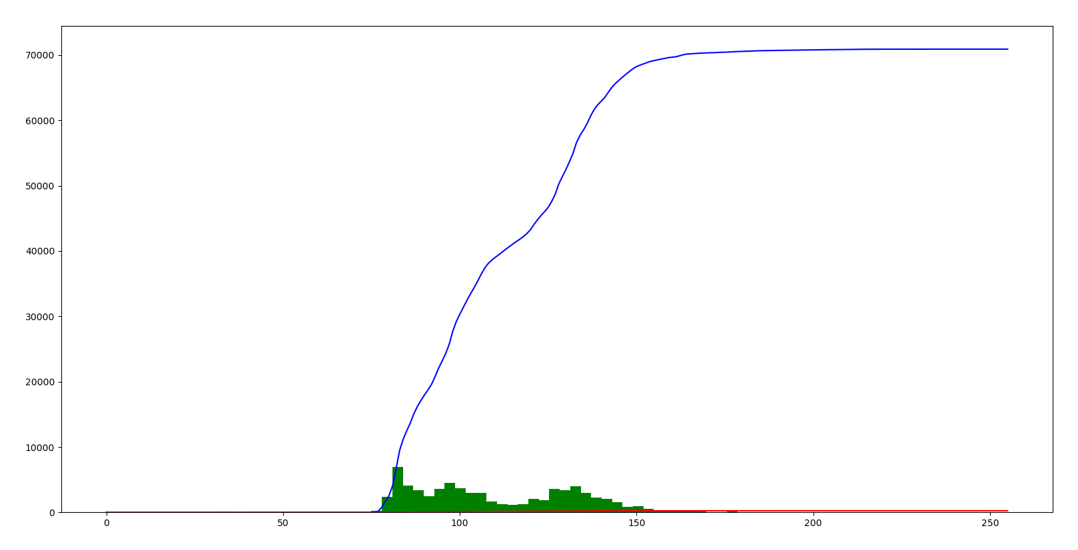

OpenCV coding:

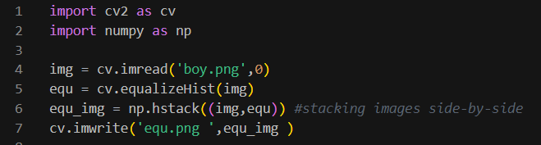

Image results: The right image is the result

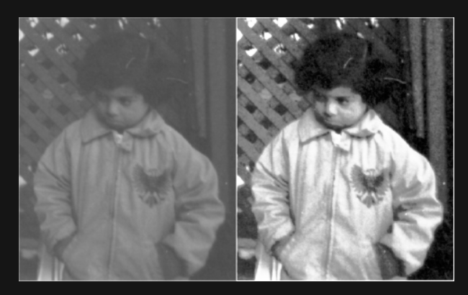

1. Study histogram specification and develop a function, test your function by applying an image and a targeted image

Developed coding of histogram specification as below, then plotting the histogram to compare the result of matching the image.

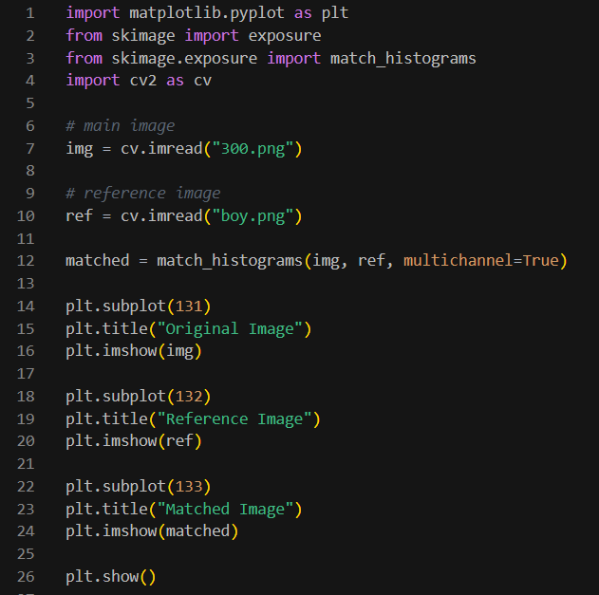

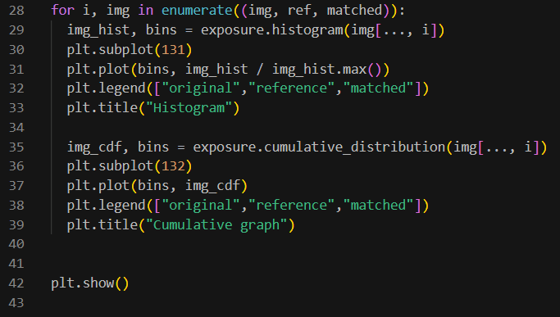

Image results:

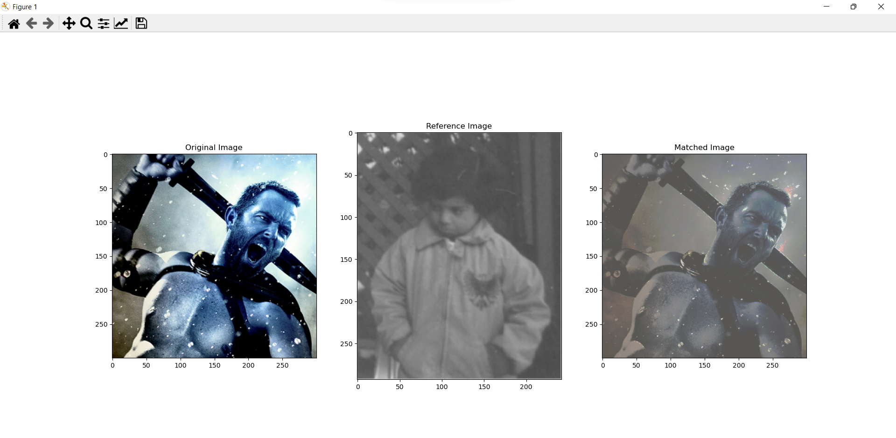

Histogram results:

