**Assignment7**

* Select two images and apply the Prewitt and Sobel operators for edge detection
* Select two images and apply Robert operator to the images
* Explain clearly about the horizontal derivative can well capture vertical edges and the vertical derivative can be used for detecting horizontal edges

**Prewitt Operator**

Prewitt operator is one of edge detection methods which detects both horizontal and vertical edges in the image. We need to use a smoothing filter before finding a derivative filter for edge detection because it can reduce noise which can cause the edge’s noise. For the smoothing filter, we use 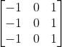 in the horizontal axis and 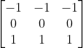 in the vertical axis. Then, we need to convolve the smoothing filter in both axes to the image. Next, we need to find edge detection by using magnitude in gradient.

Coding part:

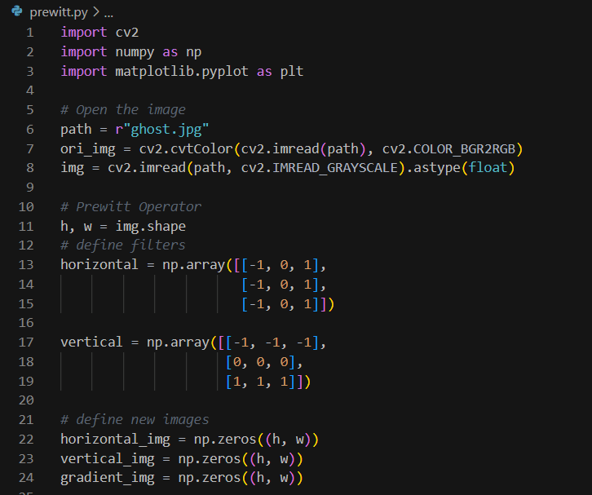

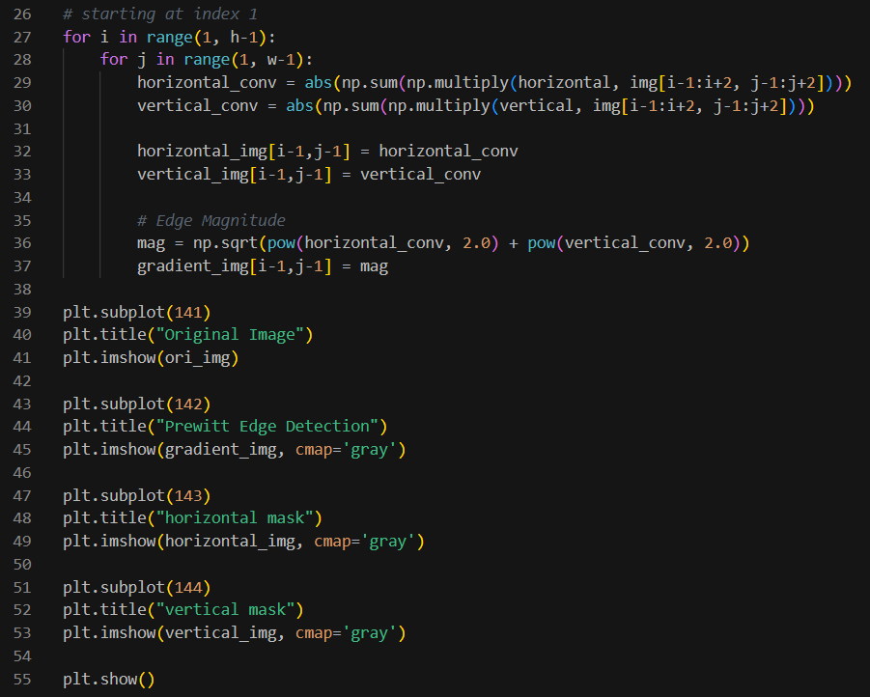

The results:

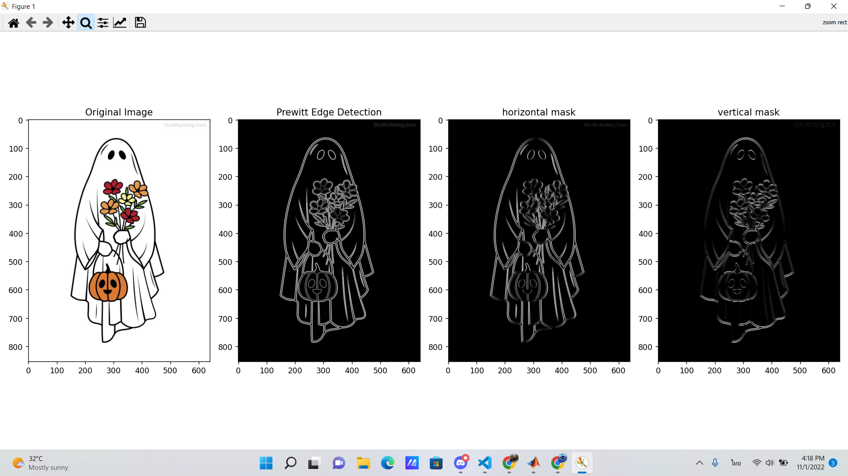

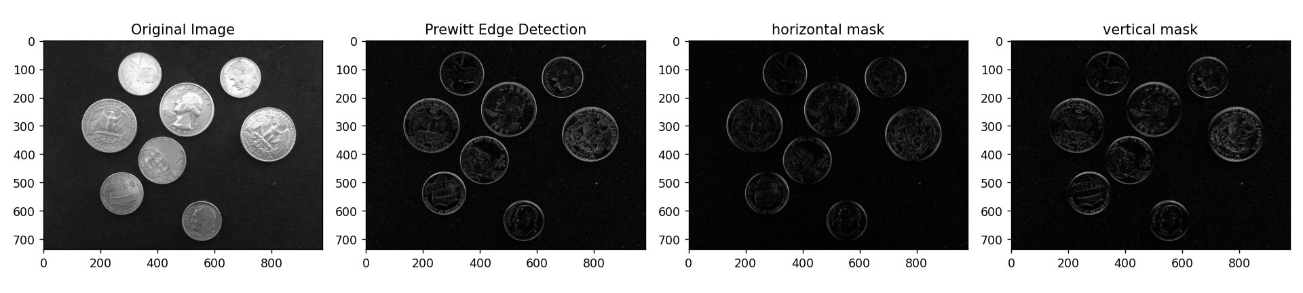

**Sobel Operator**

Sobel Operator is similar to the Prewitt operator but a little bit bigger for smoothing filters. The horizontal filter is 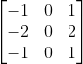 and the vertical filter is 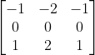.

The coding:

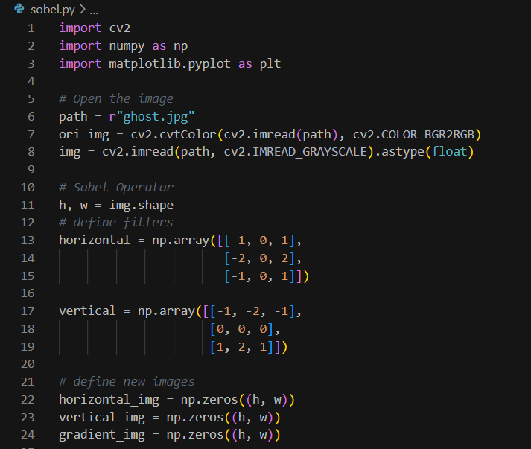



The results:

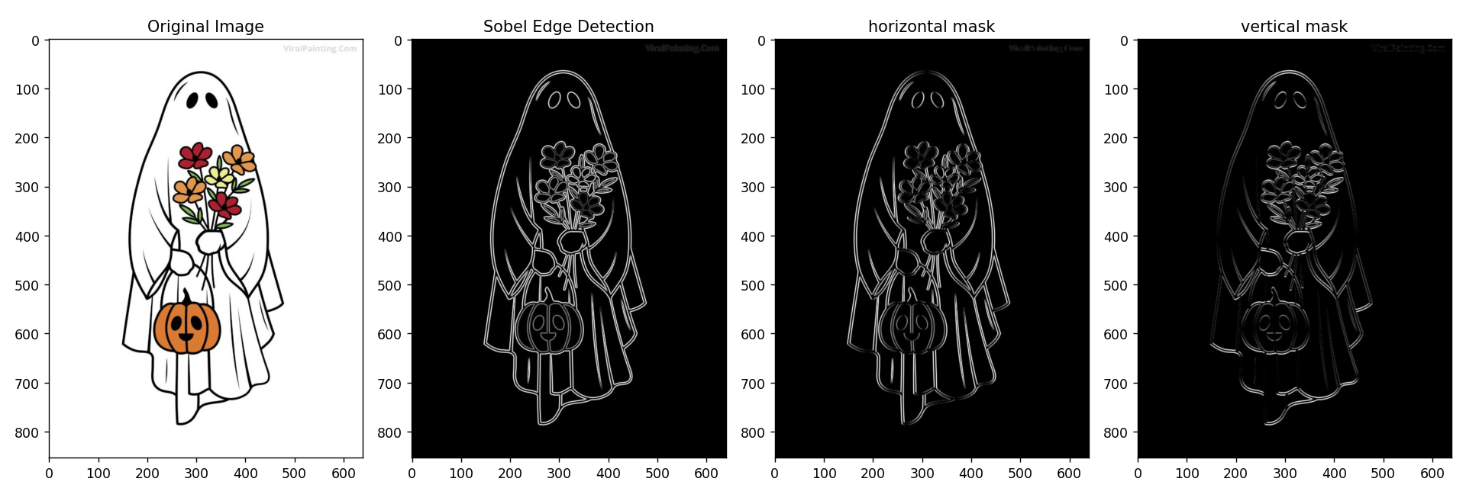

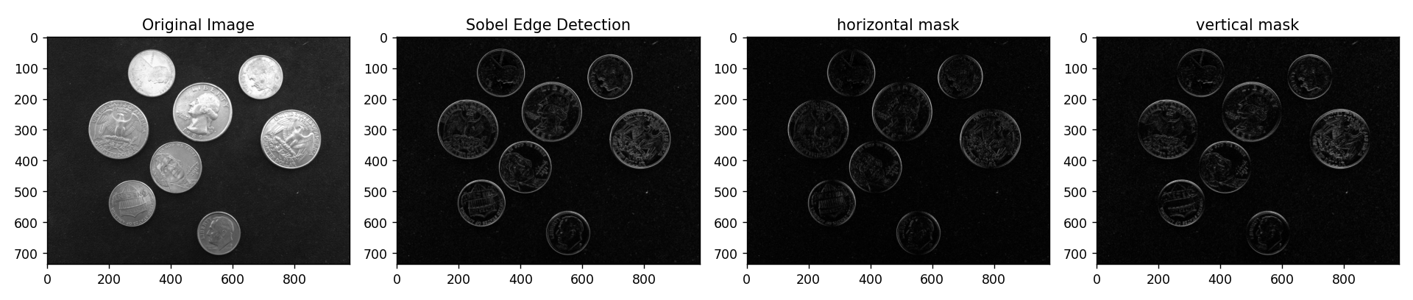

**Robert Operator**

Rober operator also uses gradients to the image for edge detection as well, but uses diagonal filter masks along 2 different sides. There are 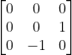 and 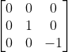 for matrix 3 x 3. After filtering, we need to find the magnitude of the image in each iteration which will lead us to detect the edge in the image.

The coding:

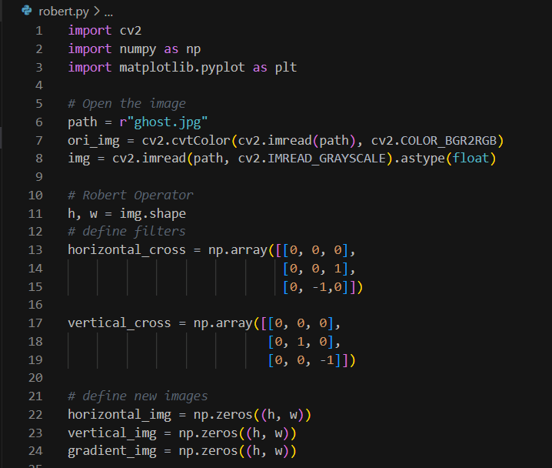

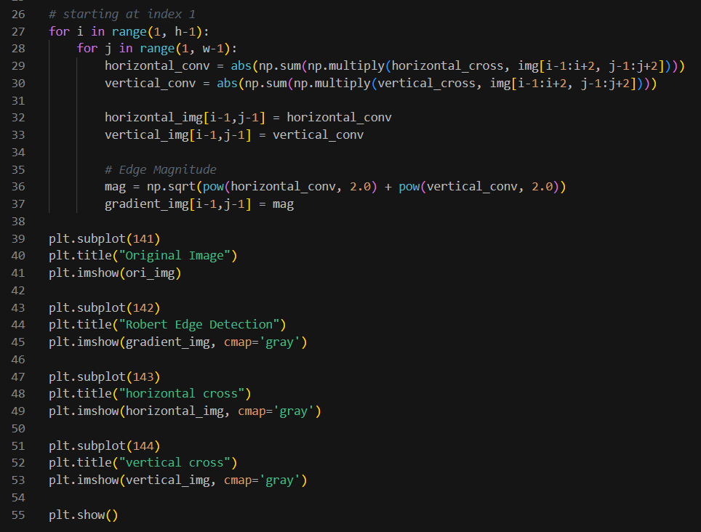

The results: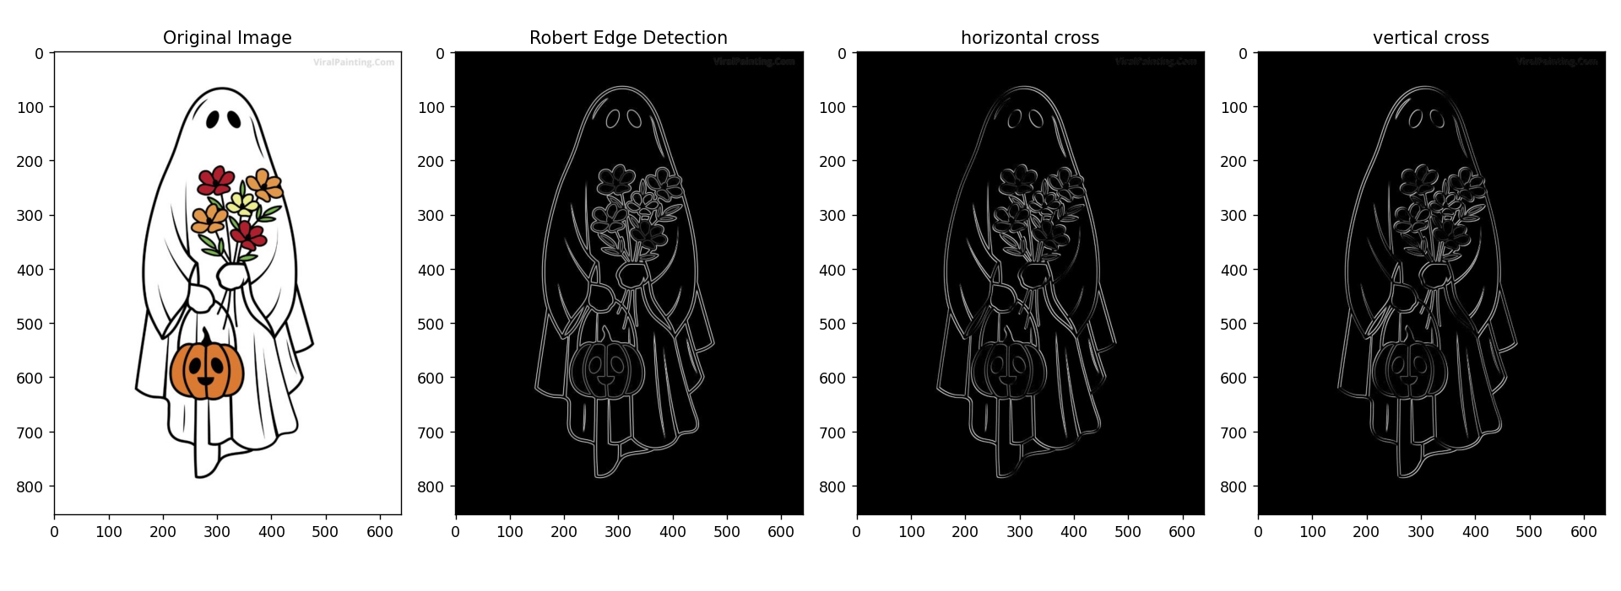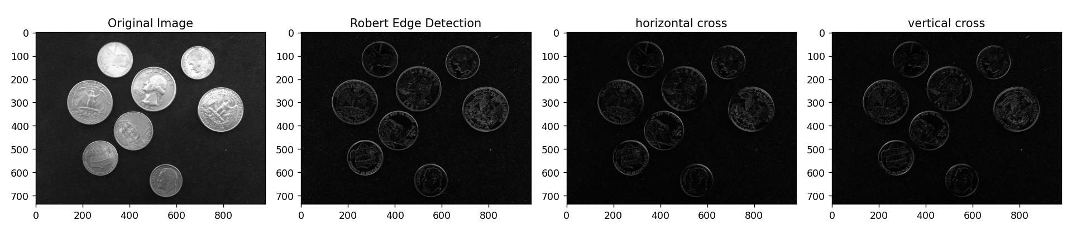

**Horizontal derivative and vertical derivative**

According to the results above, plotting the horizontal direction shows the vertical edges detection while plotting vertical direction shows the horizontal edges detection. It is because of the derivative intensity of the image by the interested axis. For example, we use a horizontal derivative to the image as figure below.

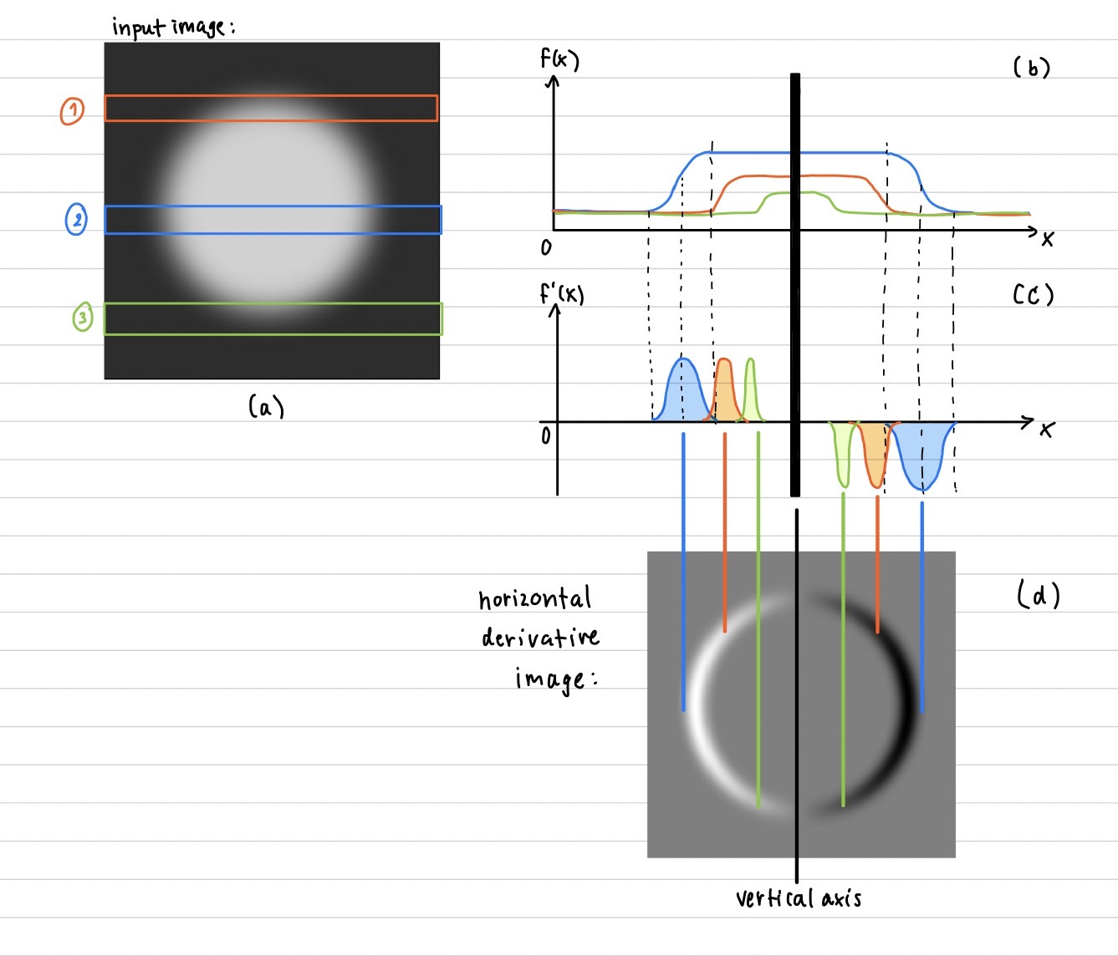

From (b), we plot the intensity from 3 horizontal masks in (a). Then, we plot the derivative of intensity from (b) to get the graph in (c). According to (c), we can see that there are zeros at the beginning, the middle and the ending. The between the middle and others are the values in distribution form which are considered as the edges. Therefore, we will get the result in (d). There is a vertical axis at the middle which makes left and right symmetry in different directions. To conclude, the horizontal derivative can capture the vertical edges and vice versa.