**One: Environment setup**

1. check whether python is installed in your environment (python 2.7,3.4,3.7 supported, mine is 3.7), if not, download and install python: <https://www.python.org/>

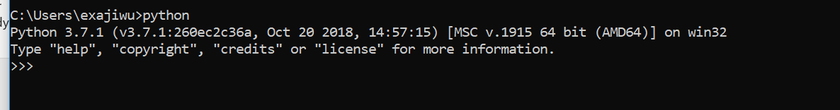

1. install beautifulsoup: pip install bs4



1. install xlwings: pip install xlwings

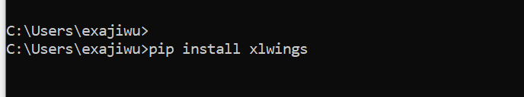

If install failed because of pip version too low, execute “python -m pip install --upgrade pip” first and re-execute “pip install xlwings”

**Two: Use Tool**

1. get diffLog file from ResultWeb(chrome browser): F12 then F5 to refresh the web, right click mouse at Response area, select ‘save as’ to save log_diffs file to my python script directory. Do not rename it.

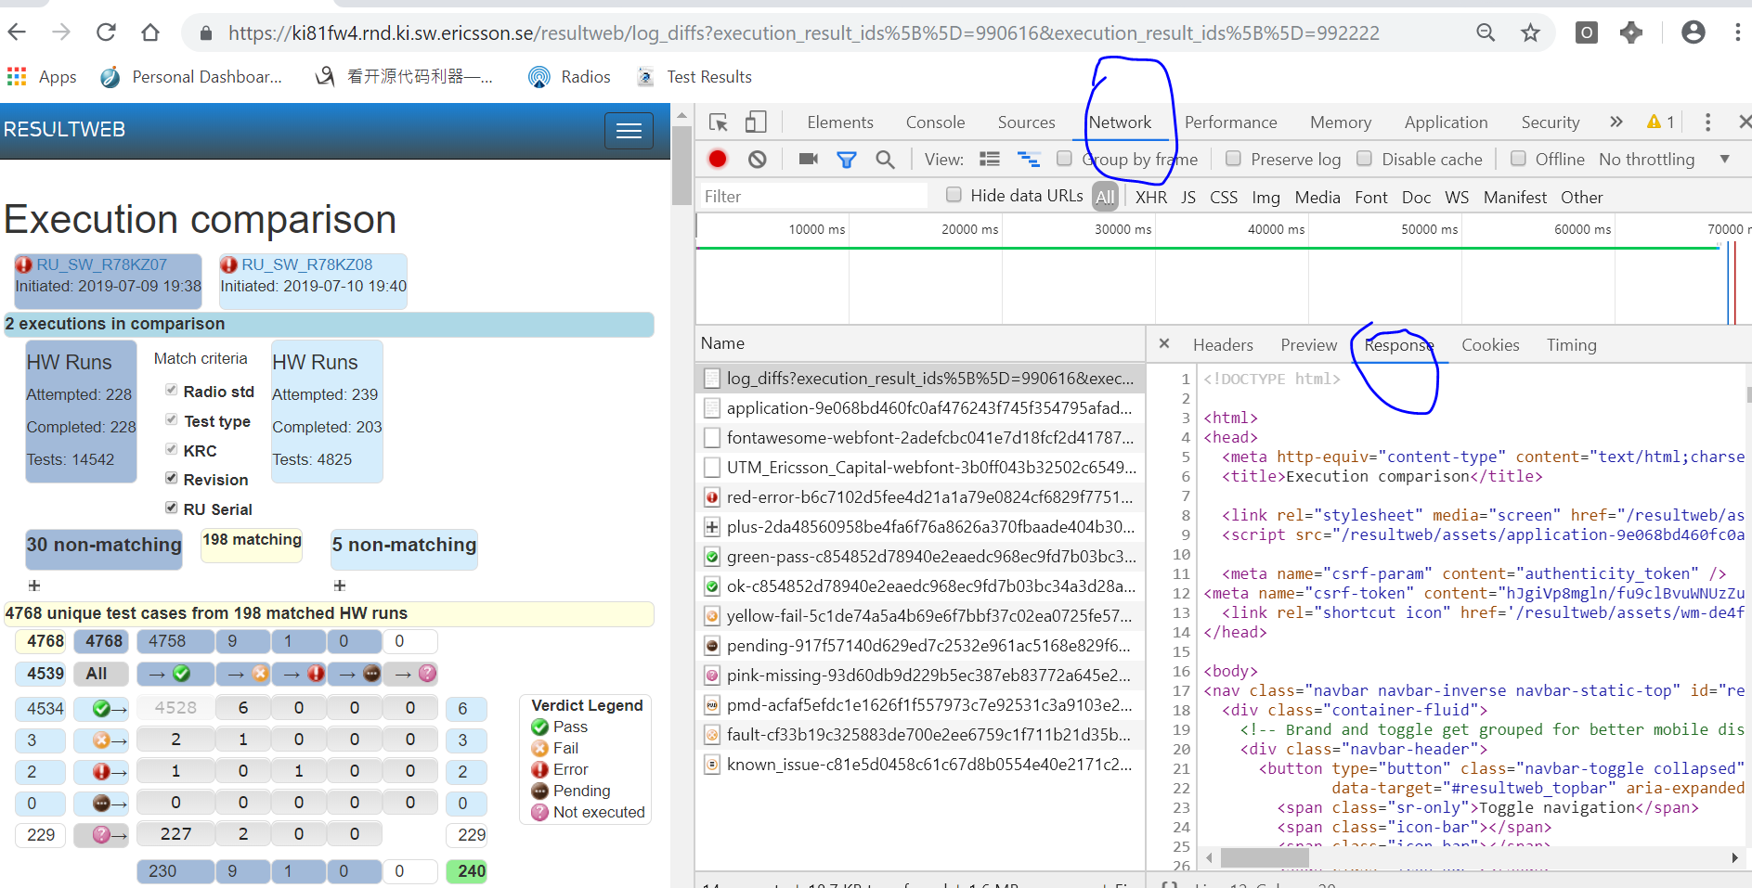

1. execute python script with a parameter which will be the name of output excel.

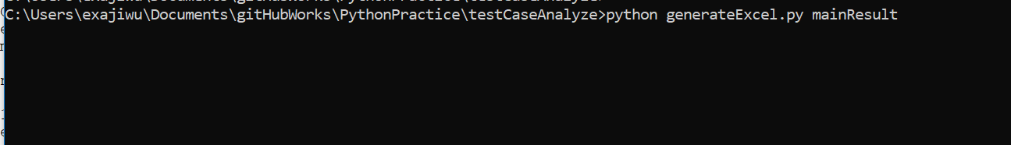

1. The result will be generated in the same directory, excel is the testcases result, returnCmd.txt is the command to generate rerun script.

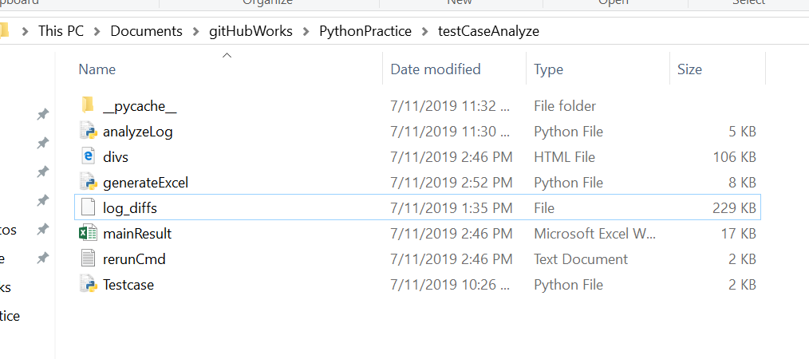

Any questions, please feel free to contact me(wendy.a.wu@ericsson.com).