justinbates@Justins-MacBook-Pro-3 LAP-final-proj % /usr/bin/python3 /Users/justinbates/LAP-final-proj/main.py
Categories: ['Sports', 'Fashion', 'Memes', 'Politics', 'Music']
True Pref: [0.1 0.3 0.4 0.05 0.15]
Initial Belief: [0.2 0.2 0.2 0.2 0.2]

--- One Step Test ---
Chosen Category: Music
Rating: 2
Updated Belief: [0.24968789 0.24968789 0.24968789 0.24968789 0.00124844]

--- Simulation Test (T=20) ---
First 20 categories: ['Fashion', 'Music', 'Politics', 'Sports', 'Memes', 'Memes', 'Memes', 'Memes', 'Memes', 'Memes', 'Memes', 'Memes', 'Memes', 'Memes', 'Memes', 'Memes', 'Memes', 'Memes', 'Memes', 'Memes']
First 20 ratings: [2, 2, 1, 1, 3, 3, 3, 2, 3, 3, 3, 2, 2, 2, 3, 3, 3, 3, 2, 3]
Final belief: [0.0118057 0.02933801 0.91770089 0.01765565 0.02349975]

--- Transition Matrix Test (T=5000) ---
Transition matrix P:
[[0.029 0.08 0.833 0.034 0.023]
[0.023 0.279 0.601 0.044 0.054]
[0.035 0.042 0.857 0.032 0.034]
[0.048 0.054 0.844 0.024 0.03 ]
[0.041 0.105 0.789 0.053 0.012]]
Row sums (should be ~1): [1. 1. 1. 1. 1.]

Stationary distribution pi: [0.035 0.06 0.838 0.033 0.034]
Sum of pi (should be ~1): 0.9999999999999994
Entropy of pi: 0.6614662994073134
Average rating: 2.4868

=== Alpha Sweep Experiment ===

Alpha | Entropy | Avg Rating | Stationary Distribution
0.0 | 1.6085 | 1.7952 | [0.186 0.205 0.205 0.209 0.195]
0.1 | 0.3867 | 2.5488 | [0.015 0.034 0.919 0.013 0.018]
0.3 | 0.6474 | 2.4828 | [0.035 0.056 0.843 0.032 0.034]
0.7 | 1.3481 | 2.1652 | [0.106 0.156 0.522 0.101 0.116]
1.0 | 1.5282 | 1.9828 | [0.15 0.173 0.373 0.152 0.152]
Matplotlib is building the font cache; this may take a moment.

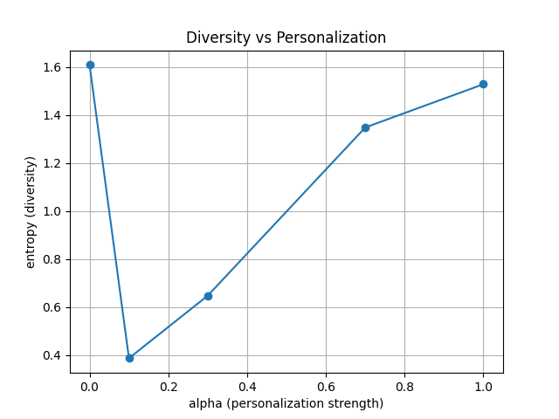

This plot shows how feed diversity changes as personalization strength increases. At α = 0, the system does not personalize, so the feed is maximally diverse (high entropy). At α = 0.1, entropy crashes, meaning the model strongly fixates on the user’s favorite category and the feed becomes extremely narrow. As α increases further, entropy begins to rise again—high personalization causes the model to react too strongly to noise and ratings fluctuate, which prevents the system from sticking to a single category for long. This results in more diversity at α = 0.7 and α = 1.0. The trend demonstrates a real phenomenon: moderate personalization creates the strongest filter bubble, while excessive personalization destabilizes the model.

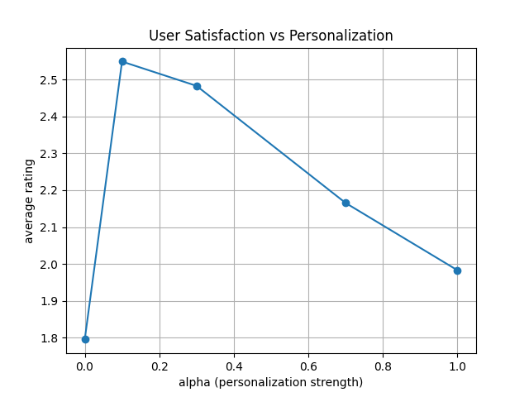

This plot shows the average user rating under each α value. When α = 0, the feed is random and ratings are low. At α = 0.1, ratings peak because the model quickly identifies and feeds the user’s favorite category. After that peak, satisfaction steadily declines as α becomes too large—belief updates overreact to random variation, swinging the feed away from the user’s favorite category too frequently. The shape of the curve demonstrates that some personalization improves satisfaction, but too much personalization destabilizes the system and reduces the user’s overall experience.

The Program
This is a simulation engine that models how a personalized content feed behaves when it updates its beliefs based on user ratings.
The system isn’t using real images. Each “image” is represented by a category (Sports, Fashion, Memes, Politics, Music). Everything happens in terms of categories and probabilities.

Inputs to the Program
- Category list
Five categories we defined: Sports, Fashion, Memes, Politics, Music.
- True user preferences
A fixed probability distribution that represents what the simulated user actually likes.
This never changes.
- Personalization strength (α)
A number that controls how aggressively the system responds to each rating.
We test multiple values: 0.0, 0.1, 0.3, 0.7, 1.0.
- Number of steps (T)
How long the feed runs. We used 5,000 steps for the experiments.

What the Program Does (in simple terms)
At each step:
- The model picks a category to show based on its current belief vector.
- The simulated user rates that category from 1 to 5.
- The model updates its belief vector depending on the rating and α.
- We record the category shown and the rating.
After 5,000 steps, we use the recorded sequence to compute:
- The transition matrix (how often the feed moves from one category to another)
- The stationary distribution (long-run distribution over categories)
- The entropy of that distribution (a diversity measure)
- The average rating during the run (user satisfaction)
We do this for each value of α to see how personalization strength affects diversity and satisfaction.

Outputs of the Program
Each run produces:
- Transition matrix
A 5×5 matrix of probabilities.
- Stationary distribution (π)
A probability vector showing the long-run share of each category in the feed.
- Entropy of π
A single number that measures how diverse the feed is.
  - High entropy → diverse
  - Low entropy → narrow feed / bubble
- Average rating
A number representing how satisfied the user was.
- Plots
  - Entropy vs α
  - Average rating vs α
These plots show the trade-off between diversity and personalization.

General Overview of the Methods
We simulated a recommendation system that learns by updating its belief about the user after each rating. The model chooses categories based on this belief vector, receives a rating, then adjusts its belief using a simple linear rule controlled by α. From the resulting sequence of categories we estimated the Markov chain transition matrix, computed its stationary distribution, and measured diversity using Shannon entropy. Running the simulation for different α values allowed us to study how personalization strength affects long-run behavior of the feed.
import numpy as np

# ============================================================
# SECTION 1 — DEFINING THE SIMULATED WORLD
# ============================================================

# These are our "content categories." Instead of real images,
# the program only tracks categories. This is all the simulation needs.
categories = ["Sports", "Fashion", "Memes", "Politics", "Music"]
k = len(categories)

# This vector represents what the simulated user ACTUALLY likes.
# These preferences never change and are hidden from the algorithm.
# The values form a probability distribution and influence ratings.
true_pref = np.array([0.1, 0.3, 0.4, 0.05, 0.15], dtype=float)
true_pref = true_pref / true_pref.sum() # ensure proper normalization

# This is the algorithm’s INITIAL belief about what the user likes.
# It starts uniform: all categories equally likely.
belief = np.ones(k) / k

print("Categories:", categories)
print("True Pref:", true_pref)
print("Initial Belief:", belief)

# ============================================================
# SECTION 2 — CORE HELPER FUNCTIONS
# These functions define one step of the recommendation process.
# ============================================================

def choose_category(belief):
"""
PURPOSE:
Select one category to show the user.
WHY:
The recommendation engine uses its belief vector as a probability
distribution. Categories with higher belief values are shown more often.
"""
return np.random.choice(len(belief), p=belief)

def generate_rating(cat_idx, true_pref):
"""
PURPOSE:
Produce a 1–5 rating from the simulated user.
METHOD:
The user has "true preferences." Categories they genuinely like
receive higher expected ratings. Noise is added to keep behavior realistic.
"""
base = true_pref[cat_idx] # How much the user likes this category
expected = 1 + 4 * base # Map preference → expected rating (1 to 5)
noisy = expected + np.random.normal(0, 0.3) # Add randomness
rating = int(np.clip(round(noisy), 1, 5)) # Clamp within 1–5
return rating

def update_belief(belief, cat_idx, rating, alpha):
"""
PURPOSE:
Update the system’s belief about the user after each rating.
IDEA:
Rating above 3 → increase belief in that category.
Rating below 3 → decrease it.
Rating = 3 → neutral.

The parameter alpha controls how aggressively the belief is updated.
"""
new_belief = belief.copy()

# Convert rating to positive/negative shift around 3.
delta = (rating - 3) * alpha

# Apply update to the selected category.
new_belief[cat_idx] += delta

# Prevent negative probabilities.
new_belief = np.clip(new_belief, 0.001, None)

# Re-normalize to ensure beliefs form a valid probability distribution.
new_belief = new_belief / new_belief.sum()

return new_belief

# ============================================================
# SECTION 3 — ONE-STEP DEMONSTRATION
# This is just a sanity check to show that one step works.
# ============================================================

alpha = 0.5 # example personalization strength

print("\n--- One Step Test ---")
cat = choose_category(belief)
rating = generate_rating(cat, true_pref)
new_belief = update_belief(belief, cat, rating, alpha)

print("Chosen Category:", categories[cat])
print("Rating:", rating)
print("Updated Belief:", new_belief)

# ============================================================
# SECTION 4 — FULL SIMULATION LOOP
# Repeats the one-step process many times.
# ============================================================

def simulate(alpha, T, true_pref):
"""
PURPOSE:
Run the recommendation process for T timesteps.

RETURNS:
categories_seen — a sequence of category indices shown
ratings — the ratings the user produced
final_belief — the belief vector after T steps
"""
k = len(true_pref)
belief = np.ones(k) / k # reset belief for each simulation

categories_seen = []
ratings = []

for _ in range(T):
cat = choose_category(belief)
rating = generate_rating(cat, true_pref)

categories_seen.append(cat)
ratings.append(rating)

# Update belief after observing rating.
belief = update_belief(belief, cat, rating, alpha)

return categories_seen, ratings, belief

# ============================================================
# SECTION 5 — TRANSITION MATRIX CONSTRUCTION
# ============================================================

def build_transition_matrix(categories_seen, k):
"""
PURPOSE:
Construct a Markov transition matrix from the simulated category sequence.

DEFINITION:
P[i, j] = probability that the next category is j given the current is i.

METHOD:
Count how many times the simulation moves from category i → j,
then normalize each row to make a valid probability distribution.
"""
counts = np.zeros((k, k), dtype=float)

# Count transitions from consecutive pairs.
for t in range(len(categories_seen) - 1):
i = categories_seen[t]
j = categories_seen[t + 1]
counts[i, j] += 1

# Normalize row-wise to convert counts → probabilities.
P = np.zeros_like(counts)
for i in range(k):
row_sum = counts[i].sum()
if row_sum > 0:
P[i] = counts[i] / row_sum
else:
P[i] = np.ones(k) / k

return P

# ============================================================
# SECTION 6 — STATIONARY DISTRIBUTION
# ============================================================

def stationary_distribution(P, num_iter=5000):
"""
PURPOSE:
Compute the stationary distribution of the Markov chain defined by P.

METHOD:
Start with uniform distribution v and repeatedly apply v @ P.
This converges to the stationary distribution π such that πP = π.
"""
k = P.shape[0]
v = np.ones(k) / k

for _ in range(num_iter):
v = v @ P

return v

# ============================================================
# SECTION 7 — ENTROPY MEASUREMENT
# ============================================================

def entropy(dist):
"""
PURPOSE:
Compute Shannon entropy of a probability distribution.
High entropy = diverse feed.
Low entropy = narrow feed dominated by one category.
"""
dist = np.array(dist, dtype=float)
dist = dist[dist > 0] # avoid log(0)
return -np.sum(dist * np.log(dist))

# ============================================================
# SECTION 8 — SHORT 20-STEP DEMO RUN
# ============================================================

print("\n--- Simulation Test (T=20) ---")
cats, rates, final_belief = simulate(alpha=0.3, T=20, true_pref=true_pref)

print("First 20 categories:", [categories[c] for c in cats])
print("First 20 ratings:", rates)
print("Final belief:", final_belief)

# ============================================================
# SECTION 9 — LONG RUN + TRANSITION MATRIX + ANALYSIS
# ============================================================

print("\n--- Transition Matrix Test (T=5000) ---")
cats_long, rates_long, final_belief_long = simulate(alpha=0.3, T=5000, true_pref=true_pref)

P = build_transition_matrix(cats_long, k)

np.set_printoptions(precision=3, suppress=True)
print("Transition matrix P:\n", P)
print("Row sums (should be ~1):", P.sum(axis=1))

# Compute stationary distribution and related metrics
pi = stationary_distribution(P)
H = entropy(pi)
avg_rating = np.mean(rates_long)

print("\nStationary distribution pi:", pi)
print("Sum of pi (should be ~1):", pi.sum())
print("Entropy of pi:", H)
print("Average rating:", avg_rating)

# ============================================================
# SECTION 10 — ALPHA SWEEP EXPERIMENT
# Tests how different personalization strengths behave.
# ============================================================

print("\n=== Alpha Sweep Experiment ===")

alphas = [0.0, 0.1, 0.3, 0.7, 1.0]
T = 5000

summary = []

for alpha in alphas:
cats, rates, final_belief = simulate(alpha, T, true_pref)
P = build_transition_matrix(cats, k)
pi = stationary_distribution(P)
H = entropy(pi)
avg_rating = np.mean(rates)

summary.append((alpha, H, avg_rating, pi))

# Print results in a clear table
print("\nAlpha | Entropy | Avg Rating | Stationary Distribution")
for alpha, H, avg_rating, pi in summary:
print(f"{alpha:>4} | {H:7.4f} | {avg_rating:11.4f} | {pi}")

# ============================================================
# SECTION 11 — PLOTTING RESULTS
# ============================================================

import matplotlib.pyplot as plt

# Plot Entropy vs Alpha
plt.figure()
plt.plot(alphas, [row[1] for row in summary], marker='o')
plt.xlabel("alpha (personalization strength)")
plt.ylabel("entropy (diversity)")
plt.title("Diversity vs Personalization")
plt.grid(True)
plt.savefig("entropy_vs_alpha.png")

# Plot Average Rating vs Alpha
plt.figure()
plt.plot(alphas, [row[2] for row in summary], marker='o')
plt.xlabel("alpha (personalization strength)")
plt.ylabel("average rating")
plt.title("User Satisfaction vs Personalization")
plt.grid(True)
plt.savefig("rating_vs_alpha.png")

