Facultatea de Matematică și Informatică

Universitatea din București

Temă laborator 1

Electronică digitală

Student, Marin Constantin – Cătălin

București, 2020

**Circuit 1**

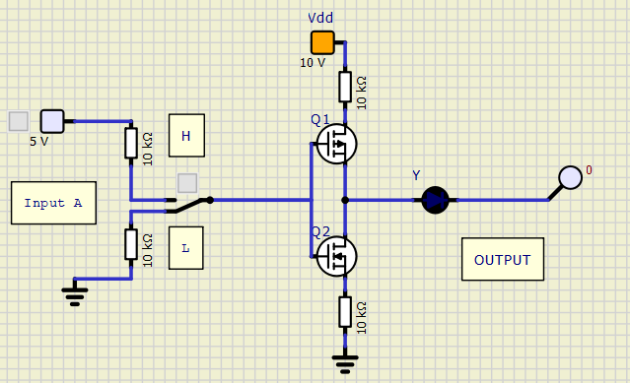

|  |  |  |  |
| --- | --- | --- | --- |
| **A** | **Q1** | **Q2** | **Y** |
| L | ON | OFF | H |
| H | OFF | ON | L |

**Circuit 2**

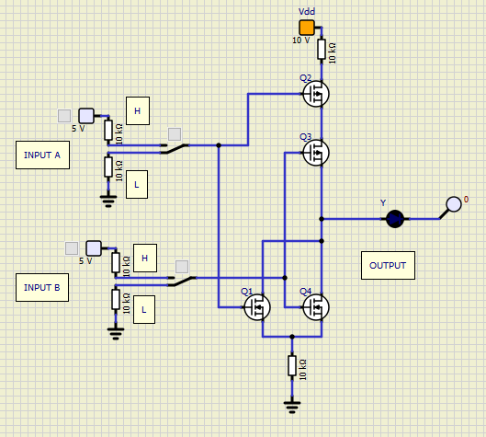

|  |  |  |  |  |  |  |
| --- | --- | --- | --- | --- | --- | --- |
| **A** | **B** | **Q1** | **Q2** | **Q3** | **Q4** | **Y** |
| L | L | OFF | ON | ON | OFF | H |
| L | H | OFF | ON | OFF | ON | L |
| H | L | ON | OFF | ON | OFF | L |
| H | H | ON | OFF | OFF | ON | L |

**Circuit 3**

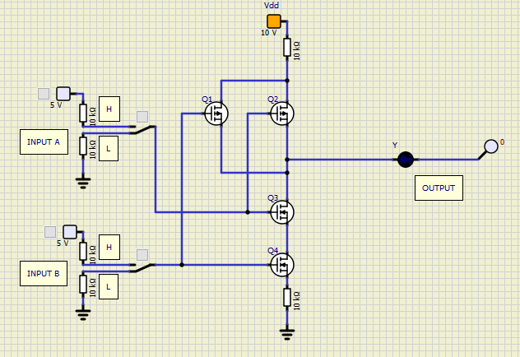

|  |  |  |  |  |  |  |
| --- | --- | --- | --- | --- | --- | --- |
| **A** | **B** | **Q1** | **Q2** | **Q3** | **Q4** | **Y** |
| L | L | ON | ON | OFF | OFF | H |
| L | H | OFF | ON | OFF | ON | H |
| H | L | ON | OFF | ON | OFF | H |
| H | H | OFF | OFF | ON | ON | L |

**Circuit 4**

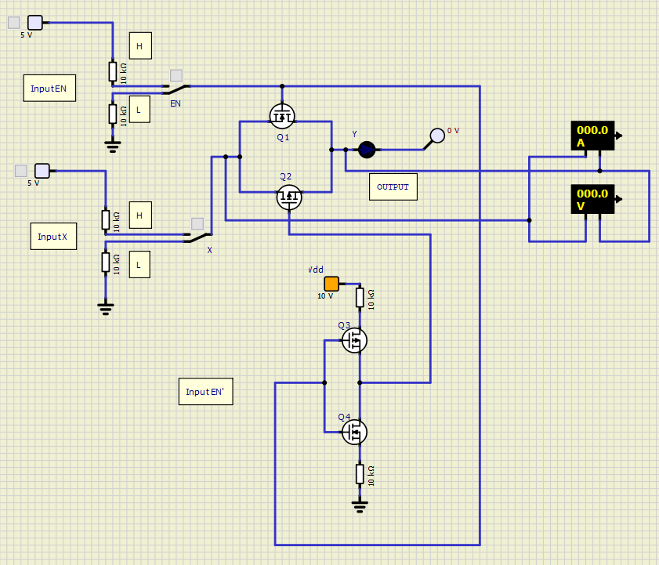

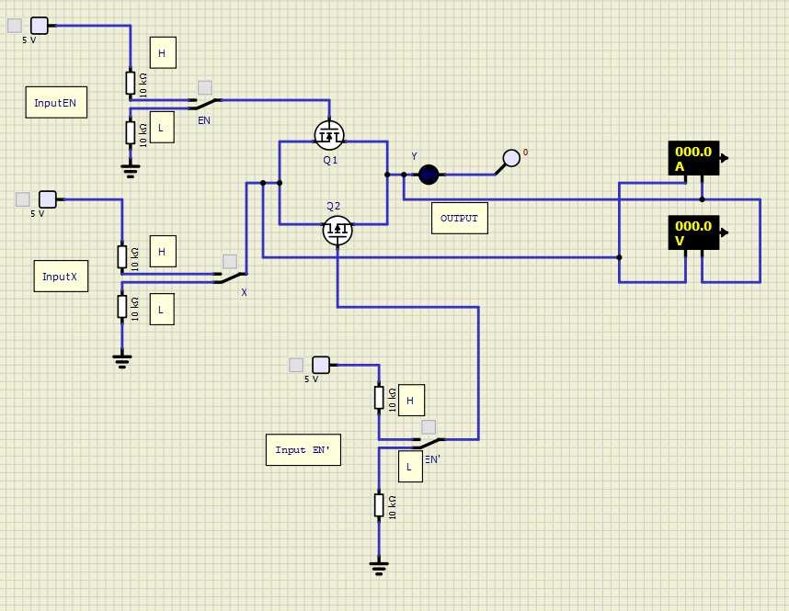

|  |  |  |
| --- | --- | --- |
| **Polaritate X/Y** | **EN** | **Z(Ω)** |
| +/- | L | 20*106 |
| +/- | H | 0.14 |
| -/+ | L | 24*106 |
| -/+ | H | 0.14 |

**Circuit 5**

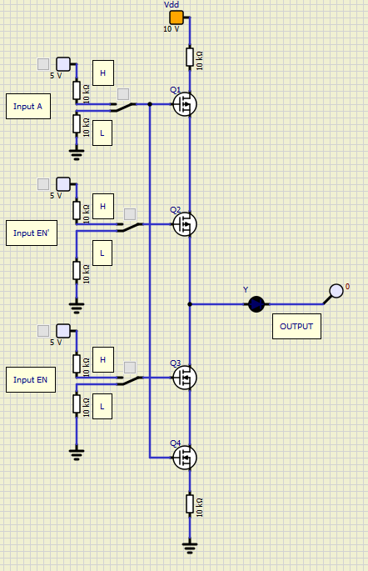 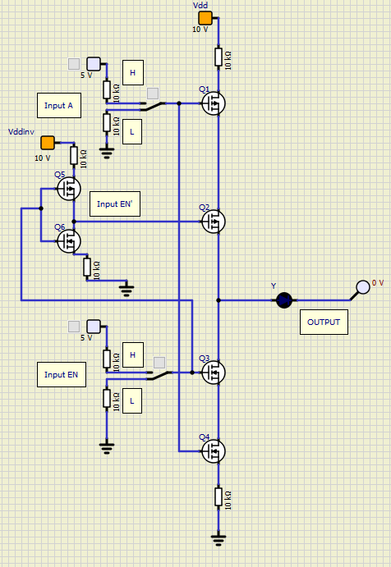

|  |  |  |  |  |  |  |  |
| --- | --- | --- | --- | --- | --- | --- | --- |
| **A** | **EN** | **EN’** | **Q1** | **Q2** | **Q3** | **Q4** | **Y** |
| L | L | L | ON | ON | OFF | OFF | H |
| L | L | H | ON | OFF | OFF | OFF | Z |
| L | H | L | ON | ON | ON | OFF | H |
| L | H | H | ON | OFF | ON | OFF | Z |
| H | L | L | OFF | ON | OFF | ON | Z |
| H | L | H | OFF | OFF | OFF | ON | Z |
| H | H | L | OFF | ON | ON | ON | L |
| H | H | H | OFF | OFF | ON | ON | L |