CSC - Exercise 2

How to get all those lines out?

$ grep "SCF Done:" dimer.log

What is the shortest string to $ grep that gives only these lines?

$ grep "E(RPBE-PBE) =" dimer.log

CSC - Exercise 5

Did the frequency calculation succeed? (freq.log) Are there errors or warnings? Was the preceding geometry optimization successful i.e. the structure is a minimum on a potential energy surface? (hint. were forces and displacements converged?)

$ grep "Normal termination" freq.log

  Normal termination of Gaussian 09 at Tue Feb  3 18:10:58 2015.

$ grep -E "Error|Warning|FAILED" freq.log

  Warning -- This program may not be used in any manner that

$ grep "frequencies" freq.log

  Low frequencies ---   -0.0010   -0.0006    0.0011  424.6424  557.5108  607.8266

  Low frequencies --- 1776.4309 3892.9592 4035.7842

  Harmonic frequencies (cm**-1), IR intensities (KM/Mole), Raman scattering

$ grep "Maximum Force" freq.log

  Maximum Force            0.020735     0.000450     NO

$ grep "RMS Force" freq.log

$ grep "Maximum Displacement" freq.log

  Maximum Displacement     0.052363     0.001800     NO

$ grep "RMS Displacement" freq.log

$ grep -E "imaginary frequencies|negative frequencies" freq.log

$ grep -E "RMS |Maximum " freq.log

  Requested convergence on RMS density matrix=1.00D-08 within 128 cycles.

  Cartesian Forces:  Max     0.020735179 RMS     0.011139561

  Internal  Forces:  Max     0.020735179 RMS     0.018378343

  Maximum Force            0.020735     0.000450     NO

  RMS     Force            0.011140     0.000300     NO

  Maximum Displacement     0.052363     0.001800     NO

  RMS     Displacement     0.028382     0.001200     NO

Exercise 6

What if your structure had also osmium atoms (Os). How would you change your commands?

$ grep -E " H | Os " cp2k.xyz | wc -l

0

Exercise 7

Is energy drift per atom speeding up? How to get access to those lines?

$ grep "ENERGY DRIFT PER ATOM" cp2k.out

  ENERGY DRIFT PER ATOM [K]    =         -0.810224161417E+02   0.000000000000E+00

  ENERGY DRIFT PER ATOM [K]    =         -0.815420472781E+02  -0.407710236391E+02

  ENERGY DRIFT PER ATOM [K]    =         -0.824299570660E+02  -0.546573347814E+02

  ENERGY DRIFT PER ATOM [K]    =         -0.833261399911E+02  -0.618245360838E+02

  ENERGY DRIFT PER ATOM [K]    =         -0.837312158207E+02  -0.662058720312E+02

  ENERGY DRIFT PER ATOM [K]    =         -0.833953761061E+02  -0.690707893770E+02

  ENERGY DRIFT PER ATOM [K]    =         -0.824858460216E+02  -0.709872260405E+02

  ENERGY DRIFT PER ATOM [K]    =         -0.814135930568E+02  -0.722905219175E+02

  ENERGY DRIFT PER ATOM [K]    =         -0.805659451301E+02  -0.732100133856E+02

  ENERGY DRIFT PER ATOM [K]    =         -0.801594119474E+02  -0.739049532418E+02

$ grep "ENERGY DRIFT PER ATOM" cp2k.out | awk '{print $6, $7}'

= -0.810224161417E+02

= -0.815420472781E+02

= -0.824299570660E+02

= -0.833261399911E+02

= -0.837312158207E+02

= -0.833953761061E+02

= -0.824858460216E+02

= -0.814135930568E+02

= -0.805659451301E+02

= -0.801594119474E+02

Exercise 8

How to plot the energy drift per atom?

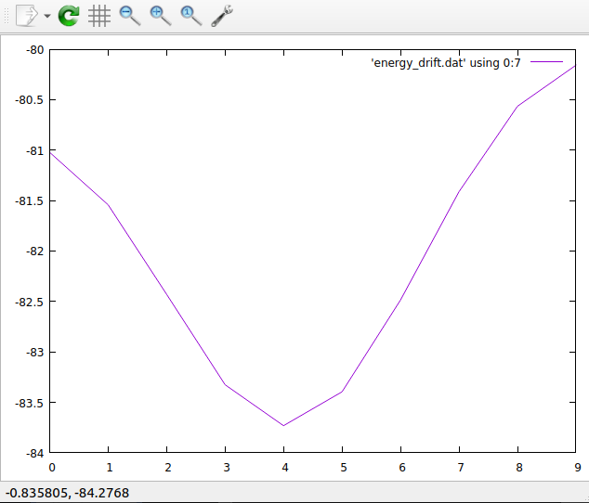

Exercise 9

How to plot both the instantaneous temperature and the cumulative average? (hint: in gnuplot if you use replot instead of plot, the previous plot is retained)

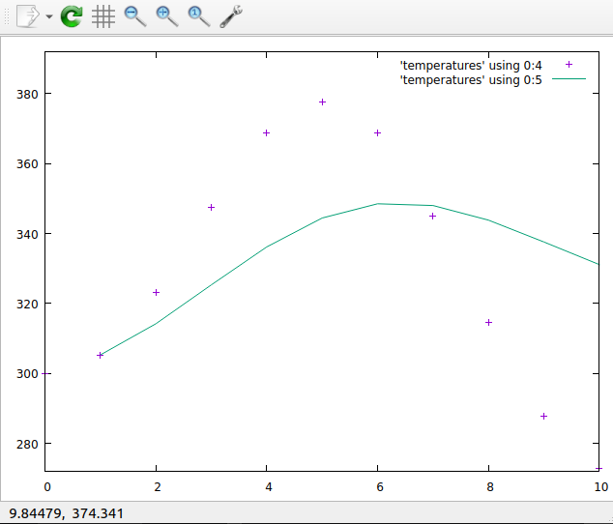

Exercise 10

What are the coordinates of the O atom that has the smallest z-coordinate? (in the 4th column)

grep " O " cp2k.xyz | sort -n -k 4 | head -1

O         0.1516300000       19.8187510000        0.0402800000

Exercise 11

Extra task. Make another file that only has entries from chromosome 2

grep "^2 " hsa.edited > chromosome_2_entries.txt