CSC - Exercise 2
How to get all those lines out?
$ grep "SCF Done:" dimer.log

What is the shortest string to $ grep that gives only these lines?
$ grep "E(RPBE-PBE) =" dimer.log

CSC - Exercise 5
Did the frequency calculation succeed? (freq.log) Are there errors or warnings? Was the preceding geometry optimization successful i.e. the structure is a minimum on a potential energy surface? (hint. were forces and displacements converged?)

$ grep "Normal termination" freq.log
Normal termination of Gaussian 09 at Tue Feb 3 18:10:58 2015.

$ grep -E "Error|Warning|FAILED" freq.log
Warning -- This program may not be used in any manner that

$ grep "frequencies" freq.log
Low frequencies --- -0.0010 -0.0006 0.0011 424.6424 557.5108 607.8266
Low frequencies --- 1776.4309 3892.9592 4035.7842
Harmonic frequencies (cm**-1), IR intensities (KM/Mole), Raman scattering

$ grep "Maximum Force" freq.log
Maximum Force 0.020735 0.000450 NO

$ grep "RMS Force" freq.log
$ grep "Maximum Displacement" freq.log
Maximum Displacement 0.052363 0.001800 NO

$ grep "RMS Displacement" freq.log
$ grep -E "imaginary frequencies|negative frequencies" freq.log

$ grep -E "RMS |Maximum " freq.log
Requested convergence on RMS density matrix=1.00D-08 within 128 cycles.
Cartesian Forces: Max 0.020735179 RMS 0.011139561
Internal Forces: Max 0.020735179 RMS 0.018378343
Maximum Force 0.020735 0.000450 NO
RMS Force 0.011140 0.000300 NO
Maximum Displacement 0.052363 0.001800 NO
RMS Displacement 0.028382 0.001200 NO

Exercise 6
What if your structure had also osmium atoms (Os). How would you change your commands?
$ grep -E " H | Os " cp2k.xyz | wc -l
0

Exercise 7
Is energy drift per atom speeding up? How to get access to those lines?
$ grep "ENERGY DRIFT PER ATOM" cp2k.out

ENERGY DRIFT PER ATOM [K] = -0.810224161417E+02 0.000000000000E+00
ENERGY DRIFT PER ATOM [K] = -0.815420472781E+02 -0.407710236391E+02
ENERGY DRIFT PER ATOM [K] = -0.824299570660E+02 -0.546573347814E+02
ENERGY DRIFT PER ATOM [K] = -0.833261399911E+02 -0.618245360838E+02
ENERGY DRIFT PER ATOM [K] = -0.837312158207E+02 -0.662058720312E+02
ENERGY DRIFT PER ATOM [K] = -0.833953761061E+02 -0.690707893770E+02
ENERGY DRIFT PER ATOM [K] = -0.824858460216E+02 -0.709872260405E+02
ENERGY DRIFT PER ATOM [K] = -0.814135930568E+02 -0.722905219175E+02
ENERGY DRIFT PER ATOM [K] = -0.805659451301E+02 -0.732100133856E+02
ENERGY DRIFT PER ATOM [K] = -0.801594119474E+02 -0.739049532418E+02

$ grep "ENERGY DRIFT PER ATOM" cp2k.out | awk '{print $6, $7}'

= -0.810224161417E+02
= -0.815420472781E+02
= -0.824299570660E+02
= -0.833261399911E+02
= -0.837312158207E+02
= -0.833953761061E+02
= -0.824858460216E+02
= -0.814135930568E+02
= -0.805659451301E+02
= -0.801594119474E+02

Exercise 8
How to plot the energy drift per atom?
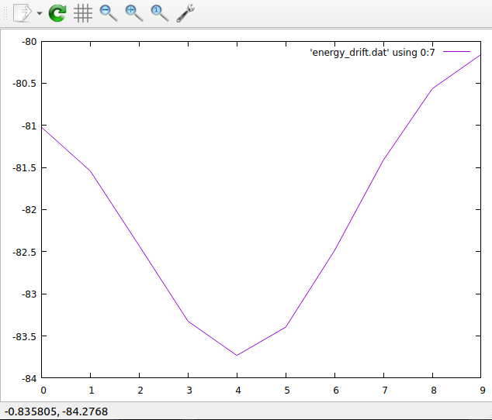

Exercise 9
How to plot both the instantaneous temperature and the cumulative average? (hint: in gnuplot if you use replot instead of plot, the previous plot is retained)
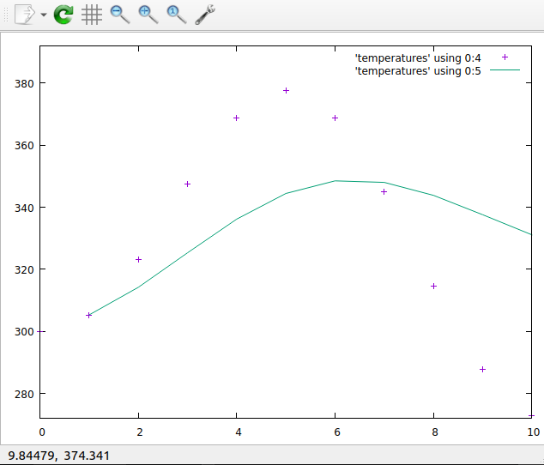

Exercise 10

What are the coordinates of the O atom that has the smallest z-coordinate? (in the 4th column)
grep " O " cp2k.xyz | sort -n -k 4 | head -1
O 0.1516300000 19.8187510000 0.0402800000

Exercise 11
Extra task. Make another file that only has entries from chromosome 2

grep "^2 " hsa.edited > chromosome_2_entries.txt

