Sound Guided Bluetooth Car System

Ionut Catalin Dondera, Ioan Filip Gut, Politehnica University of Timisoara June, 2018

# Repository

The project history, schematics, diagrams and codebase are contained under the following git repository:

**https://github.com/CatalinID/Sound-Guided-Bluetooth-Car**

# User requirements

*Imagine talking to a person without any technical background. User requirements should ex- press the intentions of a common user and not how you pan to engineer the system.*

* 1. The system must follow a sound provided in a certain area.
  2. The system should locate the sound source.
  3. The system should run each time you turn on the robot and a loud sound is played.
  4. Microphones should be placed somewhere on the robot or nearby and should record where the sound(noise) cames from .
  5. The robot has to go in the direction where the sound cames.

# System overview

*Illustrate how you engineered the system from a generic point of view. You should point out all the important subsystems, modules or entities.*

The overview of the system is depicted in Figure 1.

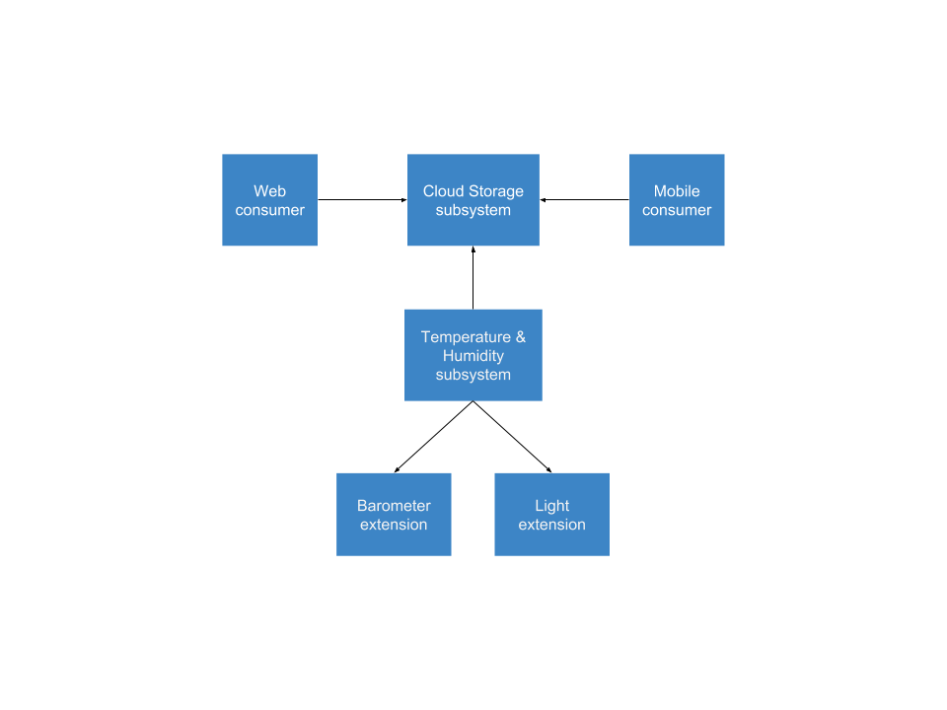

Figure 1: System overview diagram

Base (Temperature & Humidity) Subsystem encompasses the measurement functionality. It has the sole purpose to acquire information from it’s sensors and extensions.

Barometer extension provides an interface for pressure querying. It must conform to an in- terface defined by the Base Subsystem.

Light extension provides an interface for light related data. It must implement the interface defined by the Base Subsystem.

Cloud Storage Subsystem stores the data pushed by the Base Subsystem. Additionally, it offers a possibility to interpret stored information.

Web consumer provides a UI interpretation for the data stored in the Cloud Storage Subsys- tem. This view is accessed within a Web browser.

Mobile consumer also provides a UI interpretation for the stored data. The view will be accessed via a specialised application which runs on a mobile device.

# Circuit design

*Provide a detailed perspective of the hardware components you’ve used in your project. You can use Fritzing tool to draw circuit schematics.*

The hardware view of the system is depicted in Figure 2.

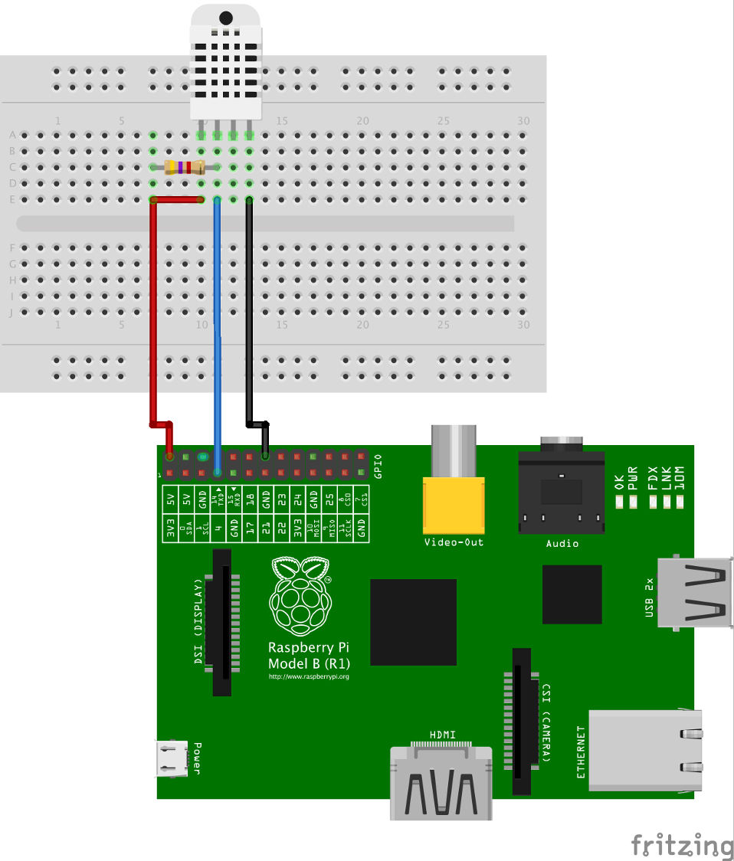

Figure 2: Circuit schematic

Raspberry Pi 2 provides support for quick prototyping. That makes it a perfect choice for quick prototyping but not adequate for real-time applications. We will use the one-wire interface it has, but also the implicit possibility of communicating with other devices over the Internet.

AM2302 (DHT-22) is an one-wire enabled sensor. It is a basic, digital-output relative tem- perature and humidity sensor.

The wiring of the components can be observed in Figure 2. An important aspect we need to mention is that the communication between the board and sensor is done via the one-wire interface.

# Software design

*Provide a walktrough of the most important component/modules/entities or concepts you imple- mented on the software.*

The software components and data flow directions are depicted in Figure 3. Each of these will be presented in the following subsections.

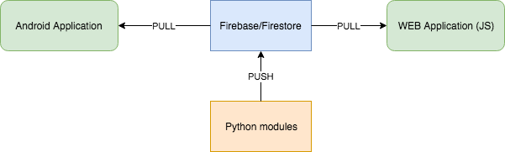

Figure 3: Software entities involved

## Python modules

*You should not concentrate on providing line level descriptions, but rather class/script/module level explanations. Short code comments are strongly advised. Third party libraries should also have a brief description and a reference link.*

write_firebase_sensor.py: it retrieves the temperature and humidity tuple from DHT-22 sen- sor over the one-wire interface and then pushes it to Firebase every 1 second.

Adafruit_DHT22 library: it provides a quick implementation of one-wire interface communi- cation with the sensor.

## 

## Android application

*Explain the responsibility of some key entities contained in your Android project.*

## Android application

*Give a brief description of the main parts contained by the JavaScript module.*

# 6 Results and further work

*Described what you accomplished so far, then what you plan to improve or extend.*

The current version of the project supports the following functionalities:

* reliable reading of the temperature and humidity
* storing data to Firebase Database
* client implementations for retrieving data stored in Firebase Database (Android and WEB)

The following list of extensions and improvements was identified to be supported in the future:

* remote access for configuring temperature and humidity interval reading
* extend Android app functionality to display retrieved information in real-time diagrams
* extend JavaScript application to support .csv exports
* improve the hierarchy design of Firebase Database

# 7 References

1. Draw IO [last seen: May 2018], <https://www.draw.io/>