Screenshots illustrating the functionality of the code:

1. Adding in a new user:

* First introducing the name of the new user in the text field
* Then press the “Add Row” Button and

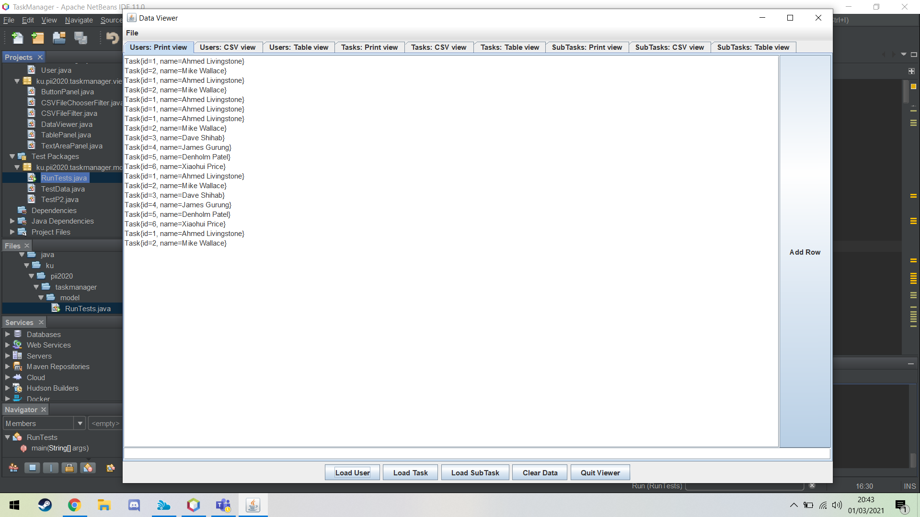

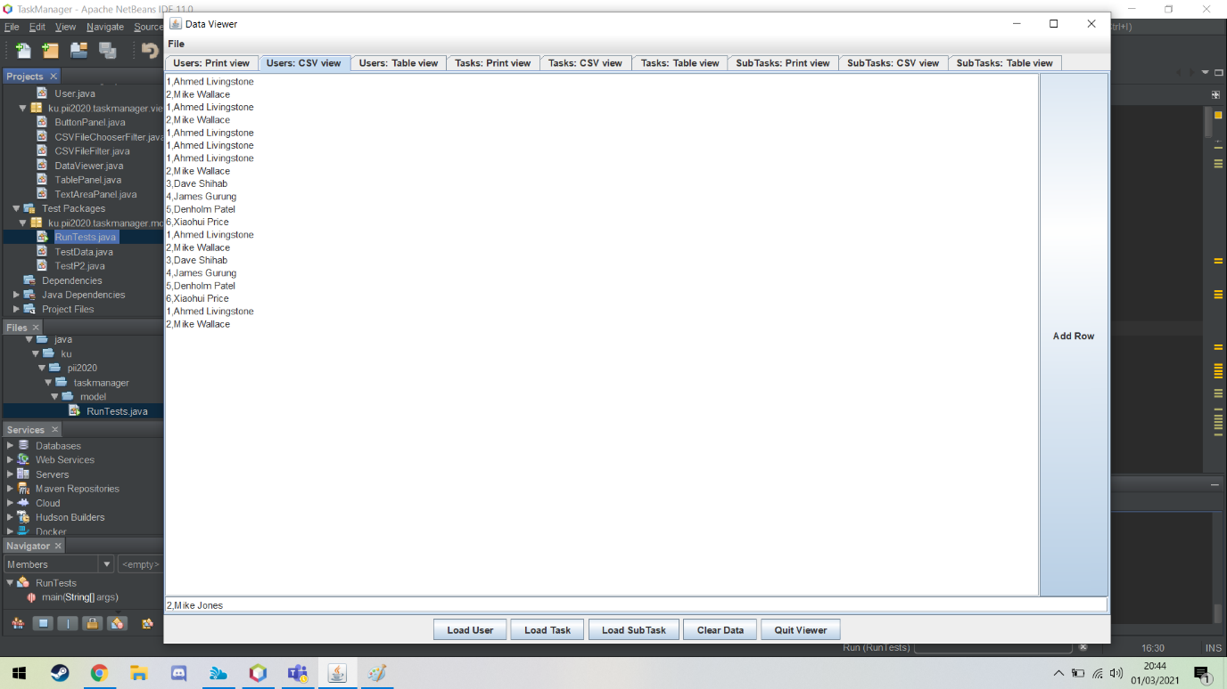

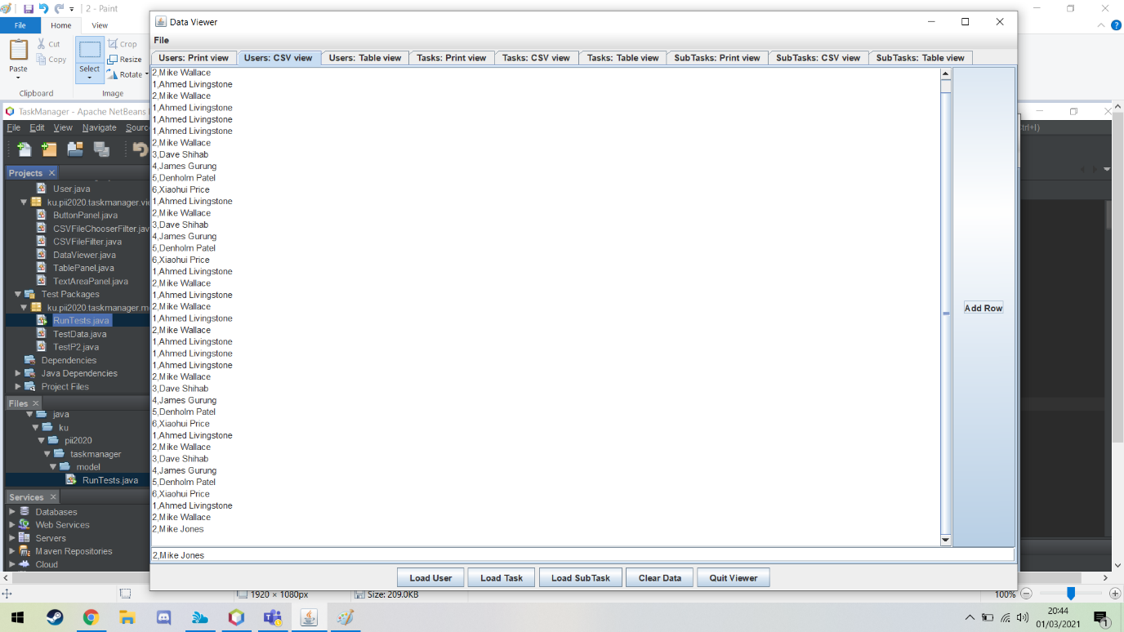

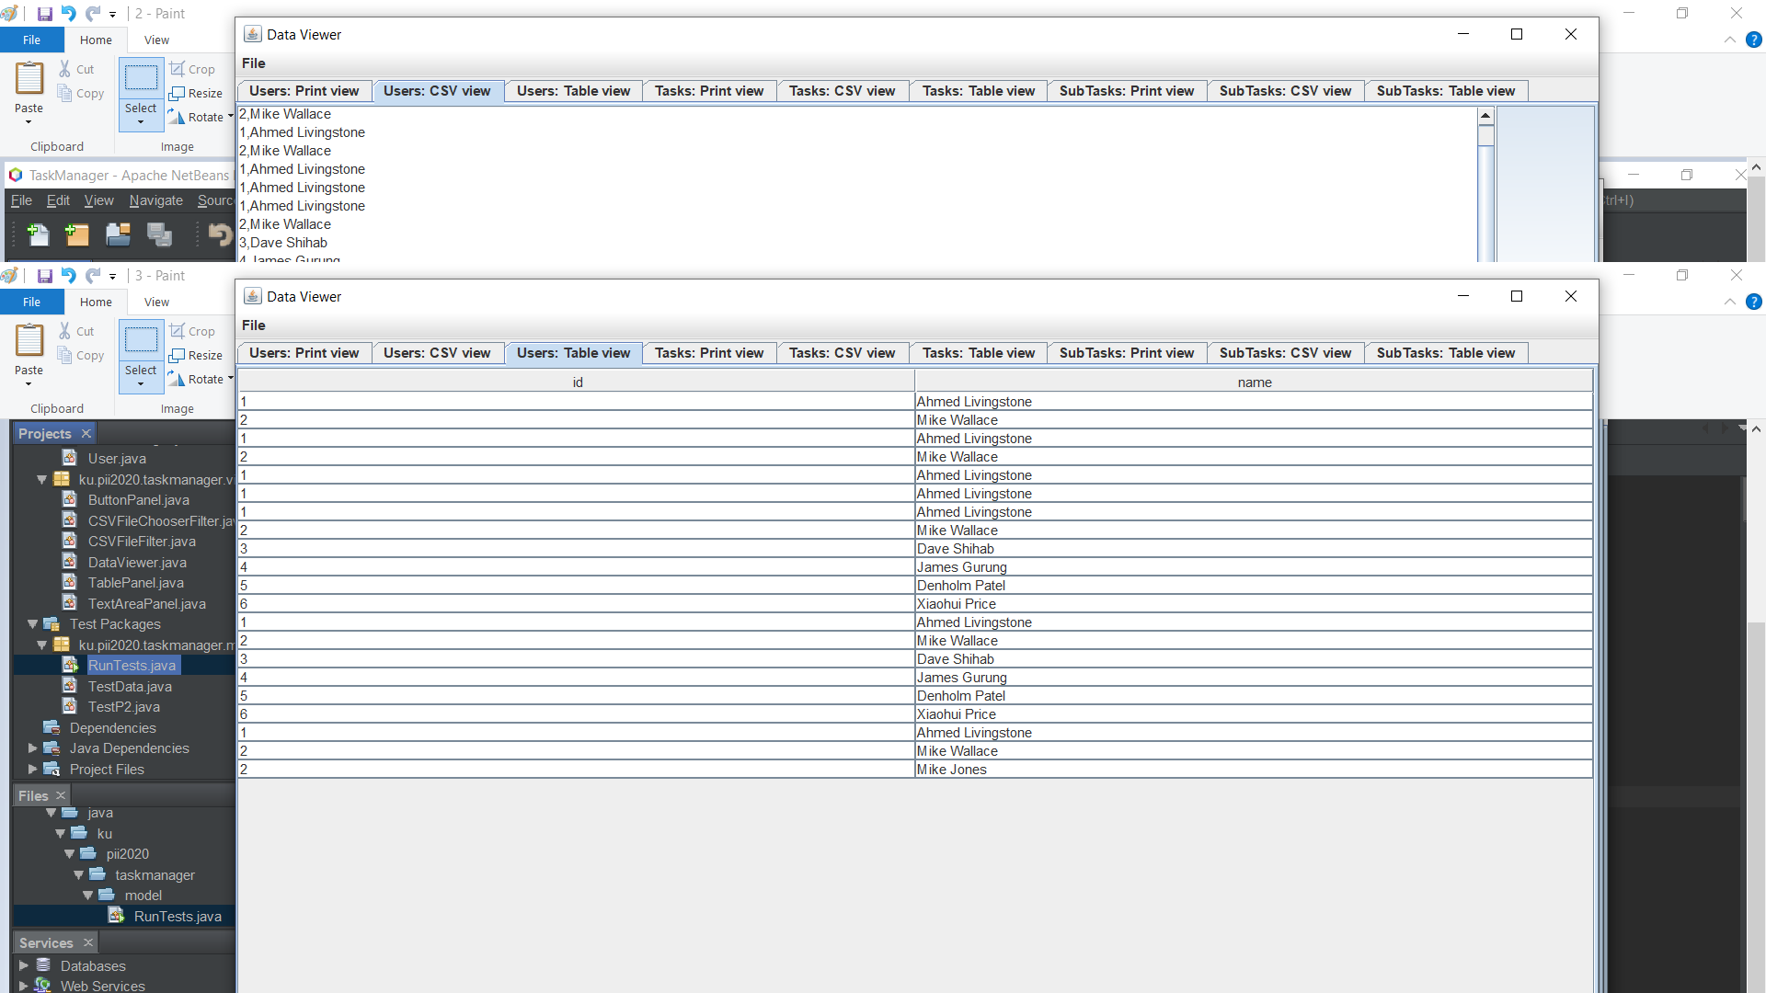

2. Save File:

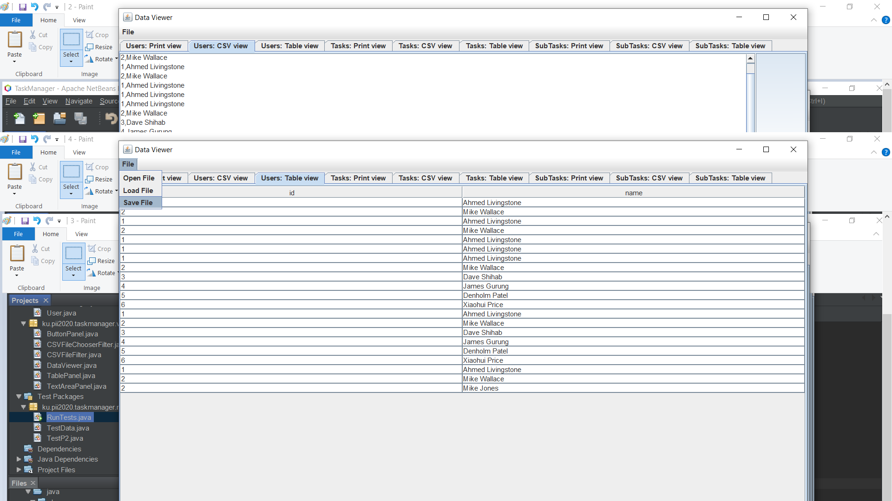- To save data to a file, first press “File” item on the JMenu then choose the directory where to save the file and then press save.

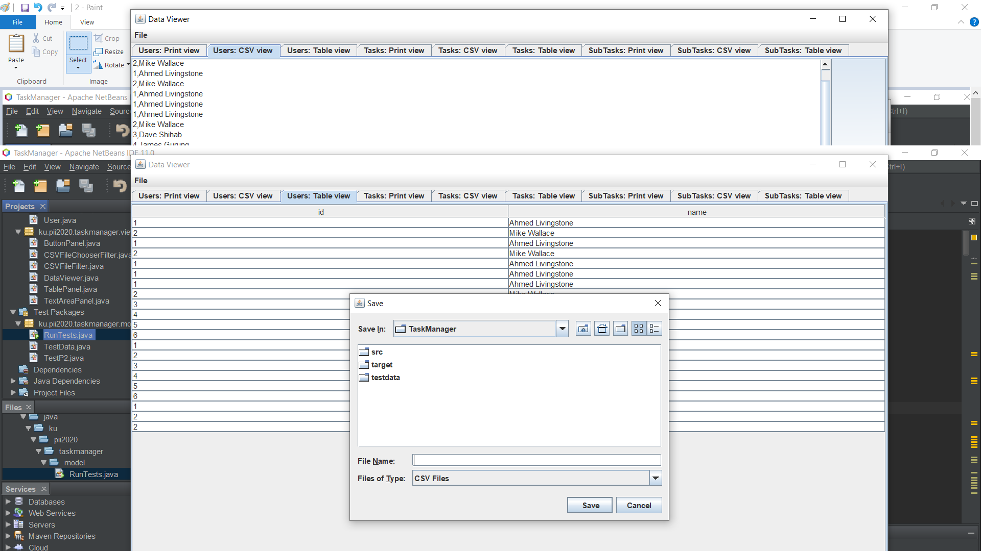

3.Load users, tasks, or subtasks:

- To load users, tasks, or subtasks press the buttons in order to load them:



4. Clear Data

- To clear the tables, there is an option to clear data by pressing the button “Clear Data”: