**ACADEMIA DE STUDII ECONOMICE DIN BUCUREŞTI**

**Facultatea de Relaţii Economice Internaţionale**

**Consumer behavior and manipulation tactics: increasing the desire to purchase**

**-Lucrare de licenta-**

**Coordonator stiintific:**

**Elena Nicolae**

**Absolvent:**

**Predoi Catalina Florentina**

**Bucuresti**

**2020**

Table of contents:

Introduction………………………………….

Chapter 1. Consumer behavior and factors influencing consumer buying behavior………….

* 1. Consumer behavior – background………….
  2. Consumer behavior- basic notions and concepts ………………….
  3. Factors influencing consumer behavior ……………………………….
  4. Buyer decision process………………
  5. Types of Buying Decision Behavior………………….

Chapter 2. Manipulation tactics- the case of advertising and social media……………. ???

2.1. Manipulation in marketing………………………..

2.2. Persuasion in marketing……………………………..

2.3. Advertising and manipulation………………………

Chapter 3. Case study ……………………………………

Conclusions ……………………………………………

References………………………………………..

Ipoteza: pornind de la intelegerea comportamentului si de la factorii care ii influenteaza trebuie sa ajungem la tehnicile de manipulare care ii determina sa cumpere mai mult.

**Chapter 1.** **Consumer behavior and factors influencing consumer buying behavior**

* 1. **Consumer behavior** – **background**

With the increase in the complexity of the economic life, it became necessary to study the way in which humans act and manifest from an economically point of view, both from his own perspective of producer of goods and services and also from his perspective of consumer. Those two positions being intrinsic components of human behavior.

Studying consumer’s buying behavior became one of the main preoccupation of marketing scientists, since they want to find out how consumers choose their goods and services necessary for the fulfilment of their needs and desires. Moreover, determining the stimuli and factors which influence consumers in the process of buying is an important aspect in analyzing and studying of the consumer’s buying behavior.

In this regard, since the 65s, the study of consumer behavior becomes an important field of marketing due to the need of understanding the complex mechanism of transforming consumer’s needs into demand for goods and services.

As studies in this particular field have progressed, it became clear that the behavioral investigation requires a multidisciplinary approach in which an essential role belongs to behavioral sciences – an important part being played by psychology and sociology from which fundamental ideas were borrowed. Being a new field of study, conceptual approaches concerning consumer behavior reach a large diversification which highlights both, its complexity and the attention received from the specialists. But before starting to analyze the consumer buying behavior, it is important firstly to take a look at what defines the behavior. This concept can be defined as a set of external reaction through which the individual responds to stimuli. From the psychological point of view, the behavior designates what is objectively observable in the overall reaction of the individual, regardless of what they say, what they think and regardless of their psychological attitudes. From a sociological point of view, the behavior is the activity of the subject in a gives social situation. (P. Mâlcomete coord. Dicţionar de marketing Ed. Junimea Iaşi 1979 p.72.) American psychologist, Harold Leavit identified three elements that define human behavior: the stimulus that represents the cause, the need that is the desire that can be fulfilled and the objective that is its purpose.

Moreover an equally important part in studying the consumer behavior is played by the consumer itself. Essentially the solution for any marketing problem starts from the consumer, but the real problem is that this concept defines the world with its needs and different interests.( Werk, 1988, p. 67) For e better efficiency of the marketing activity, specialists propose to group the consumers into specific segments with common needs and desires , because it is thought that it is way easier to adapt the offer to one segment that comprises all the consumers with an identical behavioral pattern than to address all the consumers on the market. Therefor marketing orientation towards consumer will tend to obtain a more clear representation of the typical clientele, considered to be the most suitable and will try to focus its activities on this segment. (Scherhorm, 2001, p. 278)

Consumer understanding and also orientation toward them are two important aspects for anyone who wants to succeed in a competitive environment. But those two steps are not enough, taking into account that there are some problems that can arise when toking about consumers that need to be taken into consideration. According to specialists some of the problem regarding the consumer that can be faced by the marketers are: ( Lefter, Bratucu, Balasescu, Chitu, Tecau, 2006, p. 309)

* Consumers are different from each other;
* Consumers act rather emotionally then rationally;
* Consumers act different in moments of time and space;
* Consumers respond differently to the same stimuli in different moments of time;
* Consumers can be convinced by a certain company or its competitors;

????????On the other hand, beside the problems related to the consumers that need to be taken into account, it is also necessary to brought into discussion the main types of consumers. According to specialist there are different types of buyers: dependent, easy to influence, conformist, hesitant, talkative, timid, exploiting, dishonest, aggressive, exigent, hurried, autonomous, and independent. But the most important types of consumers for studying how manipulation techniques can work

But knowing the consumer and also being aware of the problems that can arise when trying to study its behavior can ensure the foundation of the marketing strategy regarding product placement, market segmentation, launching new products and adapting the marketing-mix, all of those aspects ensuring the satisfaction of the consumer.

* 1. **Consumer behavior- basic notions and concepts**

After understanding the behavior and the consumer as two independent elements, it is important to start analyzing those two concept as a whole, more exactly as the concept of consumer behavior. As we can see in the first part, during the years the study of consumer behavior became an important field of study, conceptual approaches reaching a large diversification which allowed every marketing specialists to have his own perception and definition of what really means consumer behavior.

According to Werner Kroeber-Riel, “consumer behavior can be approached both narrowly and broadly. In a narrow way, consumer behavior contemplates the human conduct in the case of purchase and/or consumption of material goods and services. In a broadly way, consumer behavior, comprises the entire behavior of the final user of material and immaterial goods, like for example the behavior of the voters.” (KONSUMENTENVERHALTEN)

In Kotler and Armstrong‘s vision, consumer buying behavior refers to the “buying behavior of final consumers- individuals and households who buy goods and services for personal consumption.” (Kotler and Armstrong 2010, p. 158)

Extremely relevant for this study is the definition developed by Cătoiu and Teodorescu (1997, p.22), namely: "consumer behavior can be defined as a multidimensional concept par excellence, as a result of a system of dynamic relationships between the processes of perception, information, attitude, motivation and effective manifestation, which characterizes the individual's or group's integration into the space open to all consumer goods and services existing in the society at a time legislative decision making individual or group concerning them. "

Engle, Blackwell and Miniard consider consumer behavior as being “those actions of individuals directly involved in the process of obtaining and using goods and services, including the decision making process which precedes and determines those acts”.

Another perception on the definition of consumer buying behavior comes from the American Association of Marketing. According to them, consumer behavior can be defined as “the dynamic interaction of affect and cognition, behavior and the environment by which human beings conduct the exchange aspects of their lives”. (Bennett 1989)

On the other hand consumer behavior is much more than studying what consumers buy, it attempts to understand how the decision-making process works and how it affects consumer’s buying behavior. (Solomon 2004, pp. 6-8.)

Marketers study actual consumer buying patterns to discover what they buy, where they buy and how much they buy. However, finding out why consumers buy is not easy, because often the answers are locked deep within consumer’s minds. (Kardes et al. 2011, p. 8; Kotler&Armstrong 2010, p.160)

It can be observed that consumer buying behavior, as a marketing study field, refers to the behavior of the final consumers as well as the behavior of organizational consumers. Final consumer behavior is represented by individual persons who buy goods and services for the personal or family consumption in order to satisfy their current desires or to define and highlight their status in society. Organizational consumer behavior targets individuals or groups that purchase goods or services on the behalf of the organization for which they work, for consumption or use purposes in order to produce other goods and services.

Specialist believe that consumer behavior is considered as a complex system of manifestations, attitudes, motivations and decisions. Taken into account that consumer behavior determines interactions, it is important to know what consumers think, what they feel, what they do and which are the things and places that influence them. Consumer behavior implies successive or concomitant actions for the selection of one alternative or the other, being materialized in decisions.

In the paper “Sociologie des Konsum” sociologist Gerhard Scherhom analyzes the correlation between consumer behavior and his standard of living. He expresses this connection in the form of six main axioms that gives us the opportunity to understand better the complicated character of consumer behavior. (Scherhorm, 2001, p.112-114)

* The axiom of preference –highlights the fact that every consumer is obliged to rank their multiple needs, because their importance is not the same, and the resources they have are always lower. The hierarchy changes because any satisfied need leads to the appearance of others, and consumer behavior is permanently subjected to the process of learning and adaptation to the social economic system which is always changing;
* The axiom of obligation – shows that the standard of living imposes the consumer a certain behavior;
* The integration axiom – expresses the social side of consumer behavior, which does not concern the representation of the isolated individuals, but the consumption standards, as a result of the integration of individuals in belonging groups, especially the family, in which each individual has a specific role;
* The aspiration level axiom – explains the continuous change of the consumption level of a family due to its aspirations, aspirations that have a dynamic character and often irreversible;
* The plasticity of behavior axiom –reflects the flexibility of the needs system, but also of the means of satisfying those needs, because society does not “invent” only needs but also new concrete ways of satisfying the old needs;
* The norming axiom – specifies the important role of the system of values and norms of the belonging and reference group on the consumption standard, expressing the belonging of the individual to a culture or subculture that imposes certain norms on it;
  1. **Factors influencing consumer behavior**

Starting from the fact that it is hard to say why consumer buy it is essential to continue by trying to analyze what influences the consumers in their buying process. To better understand this it is needed to be taken into account how they respond to various stimuli and how various factors influence their daily buying decisions. . For this we will use the stimulus-response model of buyer behavior proposed by Ph. Kotler. This model presents how specific responses are produced by marketing and other stimuli that enter the “buyer’s black box”. Marketing stimuli are represented by the four P, fact that highlights what a great impact they have on buyer’s future responses and decisions. The main important aspect that marketers want to understand is how all those stimuli are changed and transformed into responses as soon as they enter the “black box”, which is divided into two parts: buyer’s characteristics and buyer’s decision process. The first ones who impact how consumers perceive and react to stimuli are buyer’s individualities, those particularities creating in return buying attitudes and preferences. It can be remained here that according to Kotler, buyer’s individualities include “a variety of cultural, social, personal, and psychological factors”. The second part of the buyer’s “black box”, namely the decision process can also affect the way in which consumers behave. This decision process mechanism is composed of five important stages that consumers actually pass when purchasing an item: need recognition, information search, alternative evaluation, purchase decision and post purchase behavior. This process triggers as a response the main important aspects of buying behavior: what, where, when and how much consumers buy – but also brand engagement. All these are shown in figure 1.

Figure 1. The Model of Buyer Behavior (Principles of Marketing)

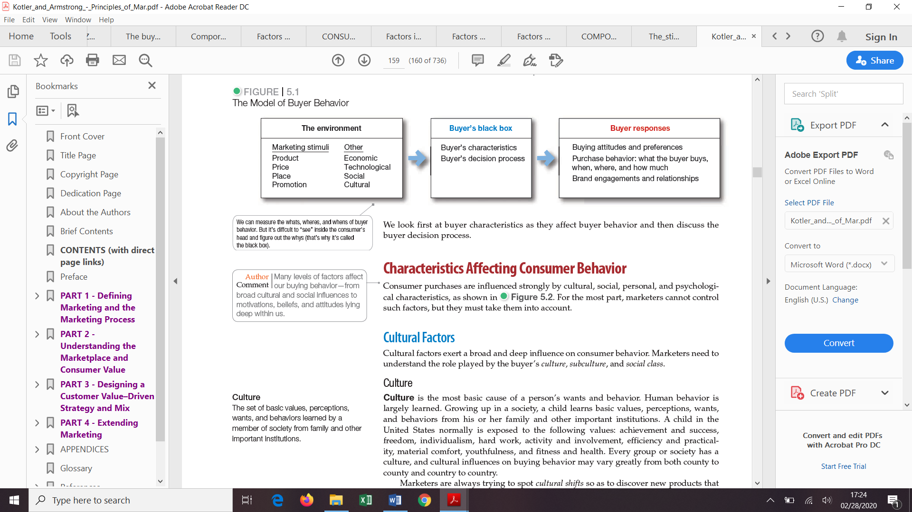

Moreover, trough time studies in the field of consumer behavior stated that the way in which consumers react to various stimuli can be structured, according to M.W. Pride, O.C. Ferell (Marketing concepts and Strategies ed.-a 7-a Houghton Miffin Company, Boston 1991) into four main types of behaviors:

1. The behavior of routine response which consumers frequently practice for the purchase of low cost and current consumption items, for which she/he doesn’t spend much time or effort to select a brand or product;
2. Taking the decision at the limit when purchasing a product occasionally, for which he/she needs moderate time to research for information and to deliberate;
3. Taking decisions extensively when buying a new, unknown and expensive product that implies a complex decision. Consumers more criteria for the evaluation of possible alternatives, situation that requires a longer time;
4. Impulsive buying behavior which determines a strong and consistent incentive to buy something immediately. For some individuals, this impulsive buying behavior represents the dominant of buying behavior;

On the other hand, even if the stimuli response model is a good way to understand how certain stimuli create specific responses, all specialists admit that, in fact consume behavior can only be explained through knowing the system of factors that influence it. However, the way in which they impact and especially the role they have in the system are perceived differently by specialist. This is why in the specialized literature can be found different classifications of those factors.

An important and extensive analysis on consumer behavior is made by Ph. Kotler (Kotler, 1999, pp334-338) which groups the factors that impact the behavior into:

1. Cultural factors that include culture, subculture and social class;
2. Social factors represented by groups and social networks, family and roles and status;
3. Personal factors which refer to age and life stage, occupation, economic situation lifestyle, personality and self-concept;
4. Psychological factors that include motivation, perception, learning, beliefs and attitudes;

As well, another approach on the subject is also presented by R. Boier (Boier, 202, pp. 30-51) which groups the factors into three groups:

1. Individual behavioral factors which include: needs and motivation, personality and self-concept, lifestyle, attitudes and preferences;
2. Social factors represented by family, reference groups, opinions leaders, role and social statue and social class;
3. Cultural factors;

In the analysis of consumer buying behavior, J. Lendrevie şi D. Lindron proposes the following types of explanatory variables: (J. Lendrevie şi D. Lindron – Mercator, Ed. Dalloz, 1990)

1. Individual explanatory variables (needs and motivations, attitudes, personality, self-image and lifestyle);
2. Sociological and psychological explanatory variables (the influence of the group on its members, social class, cultural variables and family);

Moreover, researcher J. H. Mayers considers as factors that influence the buyer’s decision the following ones: (J.H. Mayers – Marketing, Mc Graw Hill Book co., New York, 1986)

1. Demographic factors;
2. Psychological characteristics (lifestyle);
3. Individual factors (motivation and attitudes);
4. Socio-cultural factors;

Dubois and Jolibert grouped those factors into: (Dubois, P.L., Jolibert, A. (1994), Marketing. Teorie si practicã (traducere), Editura Universitatea de Stiinte Agricole din Cluj-Napoca)

1. Individual factors that include personality, cognitive style, lifestyle and perceived risk;
2. Environmental factors which refer to socio-demographic factors, reference groups, family and economic environment;

????However, extremely relevant is also the classification realized by I. Catoiu (Catoiu, 1997, pp. 25-45) which considers that consumer behavior is influenced by two types of variables: directly observable ones and deducted ones. Due to this aspect he classifies the factors as following:

1. Directly exercised influences:
2. Demo-economic factors;
3. Factors specific to the marketing mix;
4. Situational factors as following: time pressure, the importance of shopping and the occasion with which the purchase is made;
5. Deduced exercised influences:
6. Psychological factors (endogenous) represented by: perception, motivation, learning, personality and attitudes;
7. Sociological factors (exogenous) defined through: family, affiliation groups, reference groups, social class , subculture and culture;

Even if all those authors had a different approach over the classification of the factors that influence consumer behavior, it can be observed that there are still some factors that can be seen in all the classifications.

1. Cultural factors
2. Culture

There are a lot of ways in which the concept of culture is defined, but the most representative ones are Hofstede’s and Cateora’s. Hofstede defines culture as being “the collective programming of the mind which distinguishes the members of one group or category from those of another” and Cateora as “the sum of total knowledge, beliefs, arts, morals, laws, customs and any other capabilities and habits acquired by humans as members of society”. (3 Hofstede, G., 1999, Cultures and Organizations: Software of the Mind, McGraw Hill, 1991, p. 5. / 4 Cateora, Ph, et.al., 1999, Op.Cit, p. 86.)

It is well known that a broad and deep influence is exerted by those cultural factors on consumer behavior. The most important aspect regarding culture is represented by the fact that it is learned, transmitted from one generation to other. Because individuals are not born with it, as they evolve they learn “basic values, perceptions, wants, and behaviors from his or her family and other important institutions” (Kotler- Principles……..159)

Starting from the premise that, the desires and the behavior that characterizes a person are fundamentally caused by culture, marketing specialist will try to identify specific cultural shifts in order to find out a “new products that might be wanted”. Kotler……………..)

1. Subculture

At the base of each culture can be found a set of subcultures, which represent a “groups of people with shared value systems based on common life experiences and situations”. (KOTLER……) In general there can be distinguished four groups of subcultures which define and influence consumer buying behavior (Solomon, Bamossy et al, 2006, p.340):

* Nationality groups that live in large communities, with specific ethnical tastes and traditions;
* Religious groups with their own preferences and needs;
* Racial groups with distinct cultural styles and attitudes;
* Geographical groups with lifestyles characteristic to some territorial spaces;

In the market, many subcultures represent important segments that need to be studied. This is why marketers often came up with different products and marketing strategies designed especially based on their needs.

1. Social class

Each society is characterized through a social stratification. Social classes represent, according to Kotler, a “relatively permanent and ordered divisions whose members share similar values, interests, and behaviors”. (Kotler…………..)

It can be observed that social classes have four main characteristics:

1. People in the same social class have similar behaviors;
2. Based on their social class, people occupy different superior or inferior positions in society;
3. A person’s social class is determined by many variables such as: occupation, income, wealth, education, value system etc.;
4. Individuals can move from one social class to another over their lifetime;

Marketers usually tend to focus on social classes, because people in specific social classes can be characterized through similar preferences, fact that will offer the specialist a better view and understanding of the brands and product preferred by the people in those social classes.

1. Social factors
2. Groups and social network

According to Kotler, reference groups are “all those groups which have a direct or indirect influence on a person’s attitudes and behavior”. (Managementul marketingului) As an individual, every consumer belongs in a group, a membership group, which exercises a direct influence on him/her. However, some groups can be classified as being primary groups, as family, friends, neighbors with which the individual is in permanent contact, and as secondary groups with which the contact is not so frequent. Also, groups to which they don’t belong can have an influence on how individuals behave. Aspirational groups, are those groups “to which a person wishes to belong”. (Kotler principiile…..p 162)

According to Philip Kotler, reference groups can influence a person’s behavior in at least three ways:

1. The individual is exposed to new behaviors and lifestyles;
2. Influence of attitudes and self-perception through the fact that the individual searches to adapt in that specific group;
3. Reference groups create pressure on the individual in order for them to adapt to the groups status, fact that lead to a substantial influence of the choices she/he makes regarding the products and brands purchased; (Kotler Philip, Gary Armstrong, 1991, Principles of Marketing (fifth edition), Prentice-Hall International; pp. 122-123.)

Another important aspect when talking about reference groups refers to the role played by the opinion leaders on the individual’s buying behavior. Philip Kotler defines opinion leaders as being “a person within a reference group who, because of special skills, knowledge, personality, or other characteristics, exerts social influence on others”. ( Principiile Marketingului, p 163)

It is important for marketers to identify the specificities of the reference group to which their targeted segment belong and also their opinion leader in order to elaborate specific marketing programs and strategies for different types of products and services.

1. Family

Without any doubt, family members are the ones who have a very strong influence on a buyer’s behavior. It can be observed that a consumer’s behavior can be influenced by two types of family. The family from which she/he comes represents the first type of family. From them, the person acquires a certain orientation towards religion, politics, economy problems, as well as the feeling of personal ambition, self-appreciation and love. ( Carte managementul marketingului , punctul 4) The second type of family, the one that the person forms, being made up of the two spouses and their children, has a more direct influence on consumer’s daily buying behavior. Overall, family represents the most important consumption organization within a society, being the subject of some in-depth studies. (Carte – reference 5)Marketing specialists are mainly interest in the role played by each family member and the influence it has on the acquisitions of different goods and services. Those influences and roles played by the members of the family varies from one country to another and also in some cases from a social class to another. For example, it was well known that in some countries the wife was the main purchasing agent for food, clothes and various household items. But nowadays that trend changed and a shift in the roles played can be observed, with more men doing the primary grocery shopping in their households and women spending more on technology items and “influencing more than 80 percent of all new car purchases”.17(principles ok marketing) Moreover, beside the influence of the wife and husband, an important influence in the purchasing process belongs to the children. They have a major impact on decisions regarding: ways of spending money and free time, places in which to go on vacation, how often they eat out and the most important one, where to live. In the end, after studying all those influences and shifts in the roles of family members, marketers need to focus on their targeted segment in order to change their strategy and adapt to the new marketing reality.

1. Roles and Status

During their life, individuals take part in different groups. Their position in these is well-defined by their role and status. Each of those roles consist of specific activities that “people are expected to perform according to the people around them”. (Kotler and Armstrong, 166) All those roles “carry a status reflecting the general esteem given to it by society”. (Kotler and Armstrong, 166) Marketers need to understand that all those positions that individuals have in different groups have a certain influence on their buying behavior, because “product and brand selection often reflects the social role and status”. (Wright 200, p. 360.)

1. Personal factors
2. Age and life stage

Over their lifetime consumers change the goods and services they buy, change that mainly depends on their age and stage of life. Their preferences in food, clothes, furniture, and recreation are mainly age related but there are also some buying behaviors that are formed through the stage of their family life-cycle. Specialists have found out some psychological stages in the life-cycle of individuals. According to their studies, during their lifetime, adults experience “a series of evolutions and transformations”. (carte reference 8) Because of those changes marketers need to pay attention to those shifts that take place in individual’s life (marriage, divorce, remarriage) and also to effects those changes can have over the consumer’s buying behavior.

1. Occupation

An individual’s occupation and also his/hers purchasing power will have an important influence over their future buying behaviors. Depending on their job, every person will search to purchase those goods and services which better adapt their needs and wishes and are also related to the activities they carry out. For example a marketing manager of an organization will try to purchase business suits, whereas a low level worker in the same organization will purchase rugged work clothes. Also another important aspect that needs to be taken into consideration when talking about occupation is the income level which has an impact on what consumers can afford and their perception toward money. ((Solomon 2004, p. 12.)

1. Economic Situation

Choosing a product or service depends largely on the individual’s economic situation. This situation is given by the “income that can be spent (size, stability, duration), savings and the assets held (including liquidity), liabilities, lending power and the inclination towards spending or saving”. (carte managementul marketingului 245) Marketing specialists need to permanently follow the changes that may concern the size of the income, savings and interest rates in order to adapt new strategies concerning product redesign and price in the case of a recession period.

1. Lifestyle

When analyzing an individual’s lifestyle it can be observed that even if they come from the same subculture or social class their lifestyles are quite different. According to Philip Kotler, lifestyle can be perceived as “a person’s pattern of living as expressed in his or her activities, interests, and opinions”. (Principles of Marketing 168) A person’s lifestyle can be also defined through their AIO dimensions.

* Activities which describe haw consumers spend their time: work, hobbies, social events, shopping, sports, vacations;
* Interests which are a consumer’s preferences and priorities: food, family, home, fashion, recreation;
* Opinions which tell how a consumer feels about different issues: about themselves, social problems, politics, ( all from

This concept of lifestyle can help marketing specialist understand different changes that may occur in consumer values and how those shifts can affect consumer’s buying behavior.

1. Personality and Self-Concept

Due to the fact that each person is unique, each one of them has a distinct personality, which influences his or hers buying behavior. According to Kotler, personality “refers to the unique psychological characteristics that distinguish a person or group”. (Principles of marketing 168). Personality is usually analyze depending on different features like: self-confidence, dominance, autonomy, sociability, respect, adaptability, and aggressiveness. An individual’s personality can change throughout his or hers lifetime because she or he grows up, changes the environment in which she/he lives and also the people with which she/he interacts. Moreover, personality governs the way in which we perceive ourselves, the world that surrounds us, and most important the way in which other individuals see us.

When talking about personality it is also important to analyze the self-concept notion that is much related to personality. Being a multi-dimensional and complex concept, it is defined by Kardes et al. (2011) as following “the totality of an individual’s thoughts and feelings regarding him/herself as an object.” In some other words, it can be described as the impression humans hold about their selves formed through attitudes and beliefs. Because brands have already established a reputation and an identity that resembles with consumers’ principles and characteristics, it offers buyers the possibility to express themselves through their product selections. **(Kardes et al. 2011,p. 230.)** Over time, scientists have identified five brand image dimensions: sincerity, excitement, competence, sophistication and ruggedness. Every aspect includes specific factors that can be associated with consumer’s personality as shown in figure 2.

 Figure 2. A brand personality framework (Arpan 2011)

Marketers use all those concepts that are related to consumer’s personality in order to understand better the consumers, the way in which they see themselves and also the way in which they choose a product or brand that matches their values.

1. Psychological factors
2. Motivation

A consumer, as any other individual, has many needs at a given moment in time during their life. Those needs can be mainly classified into biological needs like hunger, thirst or discomfort, or psychological ones like the need for recognition, esteem or belonging. Along time, those needs transform into motives when a sufficient level of intensity is produce to them. According to Kotler, a motive (drive) can be defines as a being a “need that is sufficiently pressing to direct the person to seek satisfaction of the need”.(principiile marketingului,169) Over time, psychologists have developed numerous theories, which can be used as the basis of human motivation. Out of those theories, two of them are the most important. The theories of Sigmund Freud and Abraham Maslow address distinct significations for marketing and consumer study.

The first one, the Freudian model, claims that the decisions made by a person when purchasing a product or service are influenced by involuntary motives caused by the subconscious, motives that are hard even for the buyer to fully understand. Because in many cases consumers don’t really know or can’t exactly explain why they behave in a certain way, some marketing companies hire specialized teams formed of psychologists, anthropologists, and other social scientists in order to conduct motivation research. Those researches are mainly used to analyses the motives caused by the subconscious and the primary buyer’s emotions towards different products, services or even brands in order to develop better marketing strategies.

The second one is Abraham Maslow’s motivation theory. He “sought to explain why people are driven by particular needs at particular times”. (Kotler&Armstrong p.171) For a better understanding he arranged human needs in a hierarchy as shown infigure 3. He started ranking them by putting the most urgent ones at the bottom and the least pressing ones at the top. As it can be seen the hierarchy includes physiological needs, safety needs, social needs, esteem needs and self-actualization needs. Moreover, it can be observed that the hierarchy of needs looks exactly like a pyramid, fact that highlights the basic rule of this theory. An individual attempts to satisfy first the most essential need in order to proceed up on the hierarchy and satisfy the next important one. This happens due to the fact that when the first need is fulfilled, it will stop being a motivator and it will give the person the opportunity to satisfy the other need and so on.

Maslow’s theory helps marketers understand how well their different product correspond to potential consumer’s plans, aspirations and lifestyle. ( carte managementul marketingului , 250)

Figure3. Maslow’s Hierarchy of Needs ( Principiile marketingului)

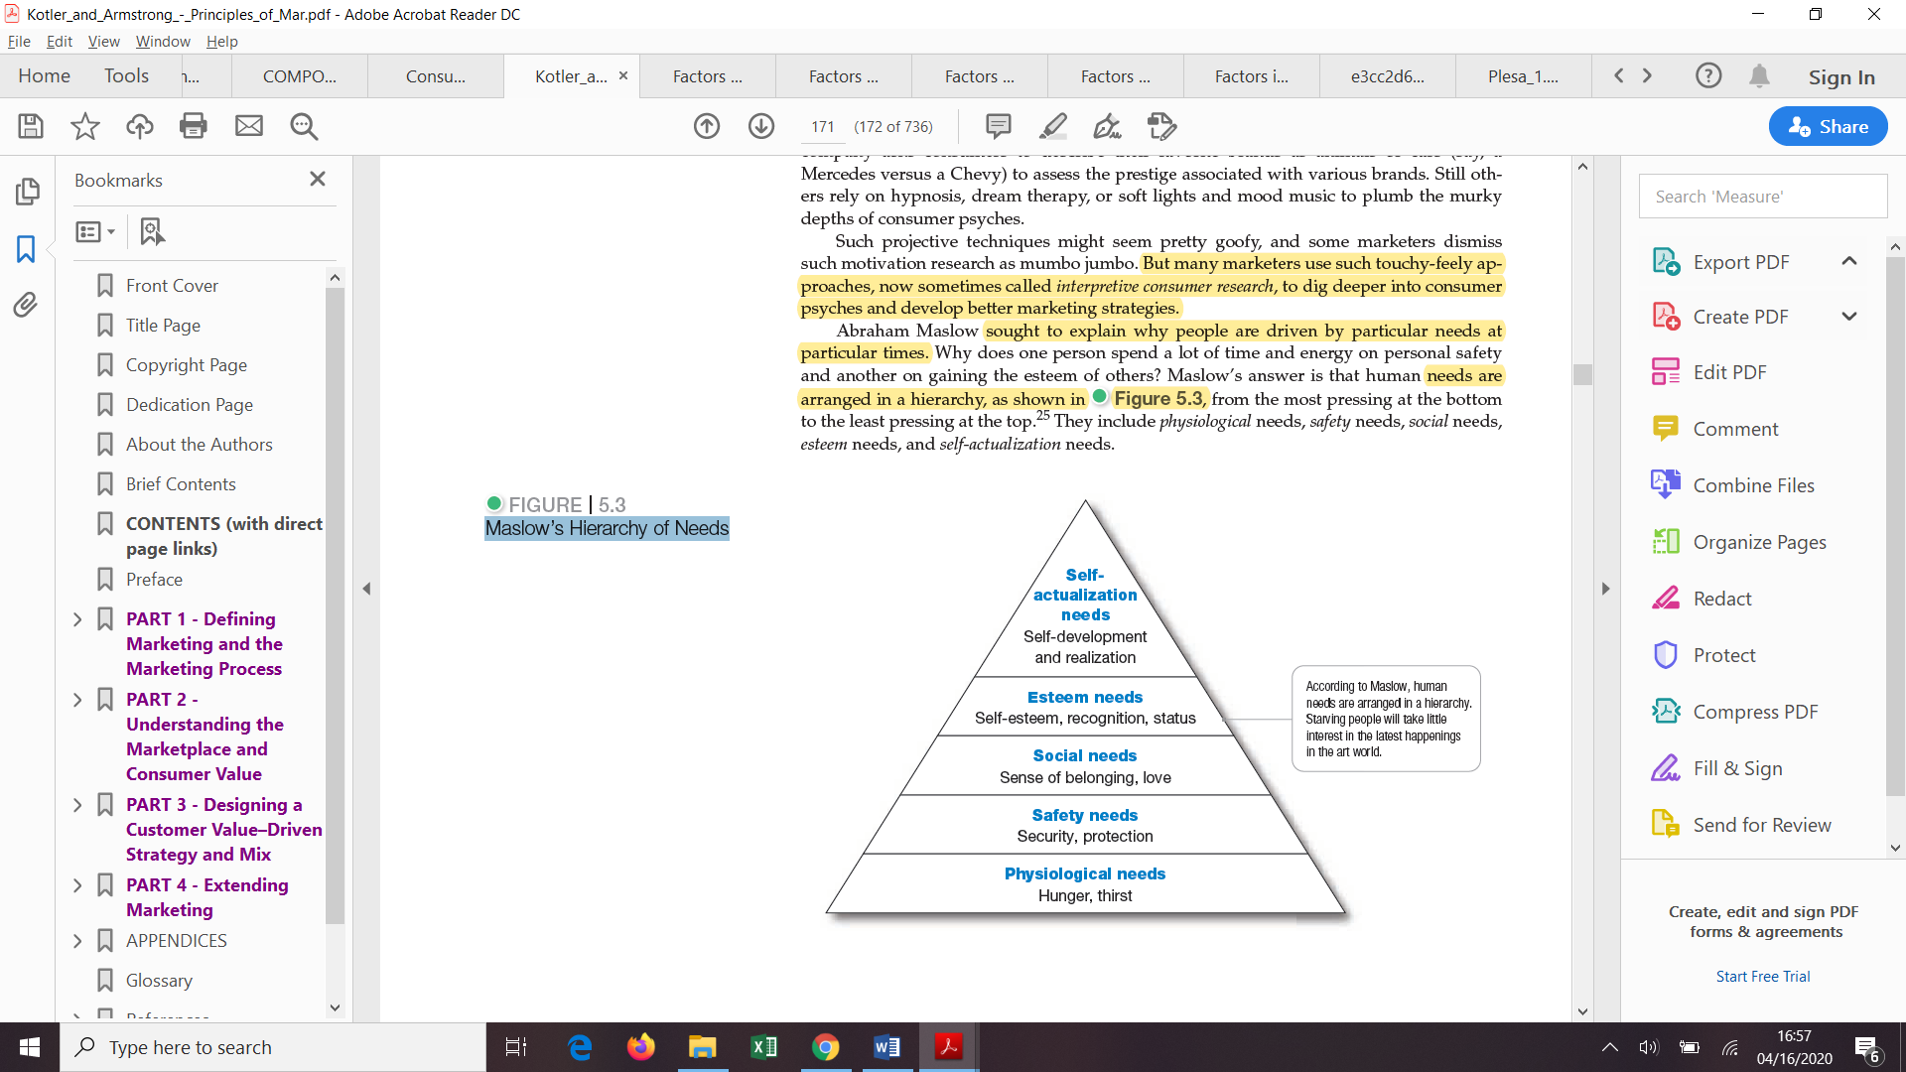

1. Perception

When an individual feels motivated he/she starts to act according to his or hers perception of the given situation. Because every individual is different, their perception on the same situation will also be different due to the fact that they will recognize objects based on the sensations that are transmitted to them through the five senses: sight, hearing, smell, touch, and taste. According to Kotler, perception is the “process by which people select, organize, and interpret information to form a meaningful picture of the world”. Moreover, people have the possibility to create distinct perceptions of the same stimuli as a result of the influence of the three perceptual processes: selective attention, selective distortion, and selective retention.

* Selective attention: because people are exposed to a great amount of stimuli every day it is impossible for them to pay attention to all those stimuli, and due to this they will ignore some and focus only on few of them. The main stimuli consumers will react to are: stimuli related to their current need, stimuli to whose action is anticipated and stimuli whose deviations are greater than the normal size of the respective stimuli.
* Selective distortion: refers to the way in which people will interpret the information received in such a way that will maintain their already existing beliefs. It also represents the people’s tendency to force the information to mold on their own opinions.
* Selective retention: because people are exposed to a great volume of information and to many stimuli at the same time, it is almost impossible for them to retain all of it. Due to this they will only remember those information which support their attitudes and beliefs. For example this can be seen when consumers tend to remember good points about specific brands they favor and forget everything good about rival brand. (principiile marketingului 172)

1. Learning

Learning appears in the moment when a person is motivated ad ready to act. Kotler describes learning as the process through which “changes in an individual’s behavior arise from experience”. (principiile marketingului 173) According to specialists a big part of the human behavior is learned through the interaction of drives, stimuli, cues, responses, and reinforcement. Also learning can be unconscious. For example consumers can remember many advertisement songs and associate the brands with those jingles even if they don’t use those specific brands. Moreover, learning changes an individual’s behavior as he or she gains more information and experiences. For example, if a consumer uses a product and he has a negative experience after that, he automatically will associates that state of discomfort with the specific product and learn that he shouldn’t use it and buy it anymore. On the other hand, if he has a good experience with the product used, he will have much more desire to purchase it again next time.

Moreover to explain the learning process, specialist have already discovered some techniques which are also relevant for the marketing activity: (Datculescu, 2006, p.48)

* Learning through the classical conditioning technique of pavlovian-type;
* Instrumental learning technique;
* Cognitive learning technique;

1. Beliefs and attitudes

The attitudes and beliefs that people acquire through learning and experiencing have a big importance in knowing the mechanism of consumer behavior. According to Kotler, a belief is a “descriptive thought that a person holds about something”. (principiile marketingului 173) People can form belief based on some aspects like knowledge, others opinions and trust and at the same time can have an impactful emotional charge. Those beliefs form in the eyes of the consumers images about product and brand. Because consumers act based on those images they form, specialist need to pay attention and to take into consideration and to correct those wrong beliefs that might affect the purchase of their products.

On the other hand, beside beliefs, people also have attitudes. Because people are different so are their attitudes regarding religion, politics, clothes, music, food, and almost everything else. According to Kotler, attitudes are defined as being a “person’s relatively consistent evaluations, feelings, and tendencies toward an object or idea”. ( Principiile mareketingului 173) Those attitudes lead to consumers forming a new way of thinking based on liking or disliking things, moving toward or away from them. Also, attitudes make people have a relatively constant behavior towards similar objects. They don’t need to form a different opinion and to react every time in a new way to each object.

Another important aspect that needs to be taken into consideration when talking about attitudes and belies is that they are both hard to change, being anchored deep in consumers mind and can be part of a person’s personality. (Kotler&Armstrong 2010, p. 175.)

* 1. **Buyer decision process**

Deciding what product to buy or what brand to choose is not an action that can be taken instantly in any circumstance, because behind the act of purchasing stays the buying decision process. All the analyzed factors that impact consumers buying behavior, also play a significant role in explaining the decision process which is composed of five stages that are illustrated by Kotler in figure 4 below.

Figure 4. Buyer Decision Process (Principiile marketingului 175)

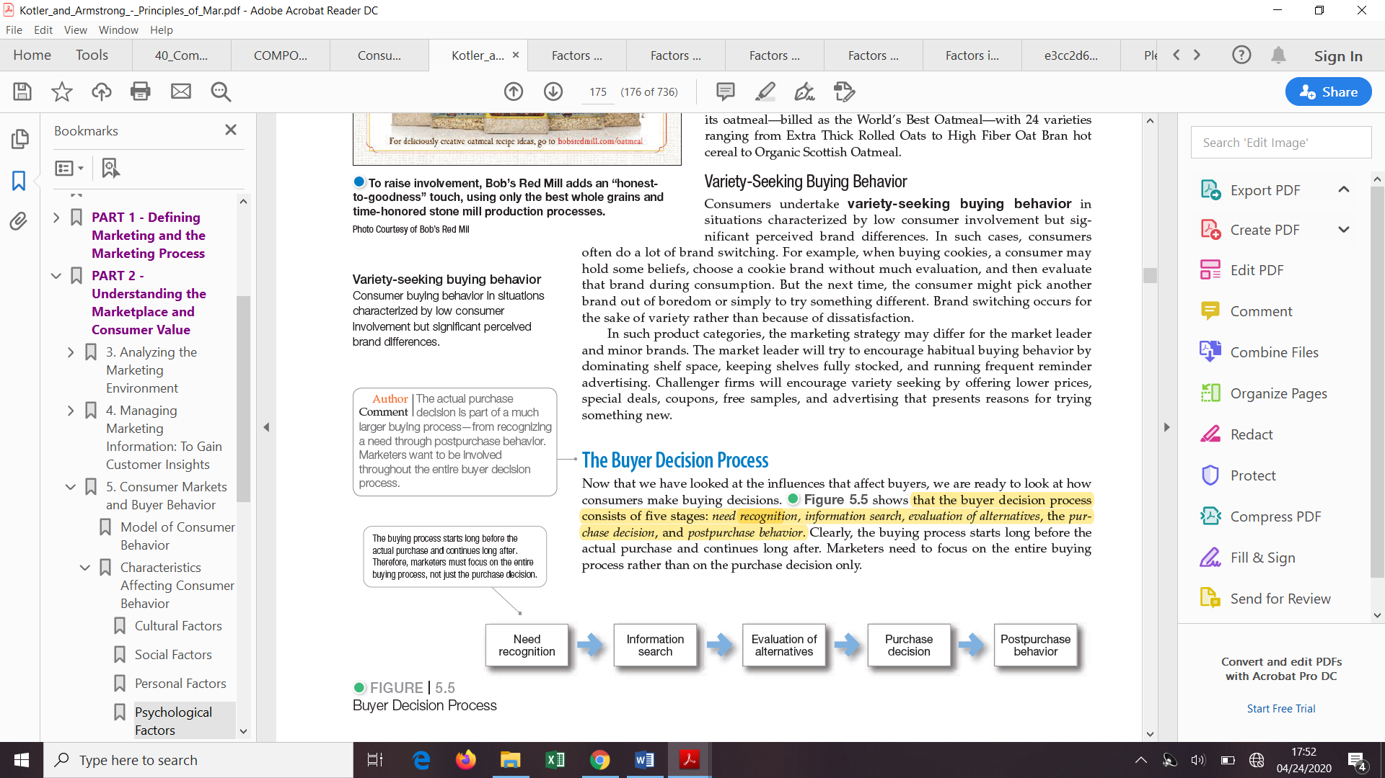

Figure 4 starts from the hypothesis that consumers pass through all five stages of the decision process when purchasing a product. But this hypothesis is not always valid because for example, in the case of acquisitions that require minimal involvement or for routine purchases, consumers can skip or reverse some stages. However, when a customer encounters a new and complex buying situation, all five steps must be used to complete the buying process.

Moreover, because the buying process starts long before the actual purchase and because it also has some effect long after, marketing specialist need to focus on all of the five stages in order to achieve a comprehensive understanding of the buying decision process as a whole.

1. Need recognition

Is the first stage of the buying decision process and it is the step in which the consumer recognizes the need or problem he faces. This stage can be classified in two main ways. First, according to Kotler, needs can be triggered by internal stimuli represented through basic needs – that are usually situated at the foundation of Maslow’s pyramid of needs like for example, hunger or thirst or external stimuli represented by advertisement or discussions with friends. Secondly, taking into account Perreau’s classification, need recognition can be: (Perreau, 2014.)

1. Functional need when it is related to a functional problem. For example the consumer buys a dish washing machine in order to avoid washing dishes by hand.
2. Social need when the buyer wants to achieve social recognition or wants belongingness.
3. Need for change when the consumers feels the need to change something

It is important for marketers to identify the elements that trigger a certain need because by gathering information from a large number of consumers they can identify those stimuli that have the highest frequency in arousing interest for a certain category of products and they can elaborate suitable strategies that can arouse consumer’s interest.

1. Information search

The second stage of the decision making process is the one in which the consumer searches information about the product. There are cases in which the consumer chooses the product without any previous information research, because the drive is to strong, and there are also cases in which information needs to be searched carefully for identifying all alternatives. (Solomon 2004, p. 299.) Also there can be distinguished two different levels of this stage: increased attention and active information. In the first case, the consumer will become more receptive to information regarding the product and he will pay more attention to the advertisements, similar products purchased by friends and to conversations about the product. In the second case consumers will seek to search information online, to call friends and they will try to get involved in activities in order to gather information in other way.

Another important aspect that needs to be taken into consideration refers to the sources from which consumers obtain information. There are two types of research than can be done by the consumer and four types of source:

1. Internal research: when the consumer is searching the information stored in the memory, actively or passively;
2. External research: when consumer acquires information from different sources;

* Personal sources like family, friends, neighbors and acquaintance;
* Commercial sources like advertising, salespeople, dealer and manufacturer sites and packaging;
* Public sources like mass media, consumer organizations and social media;
* Experiential sources like examining and using the product;

But from all four types of sources consumer receive the most information from commercial sources that are controlled by the marketers. However, the most effective ones are considered to be personal sources, because normally commercial sources inform the buyer and personal ones legitimize or evaluate products for the buyer. (principiile marketingului 176) When talking about information sources, specialists need to identify them and evaluate their importance. In order to this, they need to ask consumers what they’ve heard first time about the brand, what information have they obtained later and what is the importance they give to different information sources. Those answers will help the company develop efficient communication means for the targeted market.

1. Evaluation of Alternatives

Starting from the second stage that presents how consumers collect information in order to get to the chosen brand or product, it is important to get to the third step, alternative evaluation, which shows the process through which consumers choose among alternative products after processing the information researched. This evaluation of alternatives may be different among buyers and among the type of purchase. (Wright 2006, p. 28.) There are cases in which consumers do little or no evaluation and take their buying decision based on impulse or intuition and there are also cases in which consumers may wisely evaluate among several alternatives in order to take the best decision. The first scenario mainly refers to those situation in which the purchased is based on a habitual decision process. Moreover when the customer tries to identify it alternatives that will be considered during the selection process, he or she is actually structuring his/hers evoked set. This set contains products and brands that are already etched in consumer’s mind, but also brand and products that have an important name in the retail environment. Also the number of alternatives included is relatively small and all alternatives share similar features. (Solomon 2004, p. 305.)

1. Purchase Decision

After evaluating the alternatives and structuring the evoked set, buyers need to form their purchase intentions. Usually consumer’s purchase decision is to buy the most preferred brand. There are also some factors that can intervene between the purchase intention and purchase decision. First factor is represented by the attitudes of others and the second one is unexpected situation factors. In the second case, the consumer may base his purchase intentions on factors such as estimated income, price and expected product benefits.

Moreover, a consumer’s decision to postpone, change or avoid making a purchase decision is determined by the perceived risk. The size of the perceived risk depends on the amount of money invested in that product, the degree of buyer’s insecurity regarding the product’s characteristics and on his self-confidence. In this case it is important for marketers to understand what factors provoke this risk sensation in order to support consumers to diminish the perceived risk.

1. Post-purchase Behavior

Because the decision making process continues even after the purchase is made, the last stage of the process is represented by the post-purchase behavior. This stage is mainly represented by the satisfaction or dissatisfaction felt by the consumer after purchasing a product. The degree of satisfaction felt by the consumer is determined by the relationship between his/hers expectations and the product’s perceived performance. There are three stages of consumer’s satisfaction. When the product doesn’t fulfil the expectations, the consumer will feel disappointed. (Khan 2006, p. 168.) On the other hand, consumers will be satisfied when the product bought meets the expectation, fact that will determine the buyer to spend more in the future on that specific product. Furthermore, the third level appears when consumers feel a high level of satisfaction and also when their expectations regarding the product are exceeded. This step leads the consumer to future brand loyalty. (Kardes et al. 2011, p. 91.)

* 1. **Types of Buying Decision Behavior**

Because knowing the factors that affect the consumer’s buying behavior and the decision making process are not sufficient for a better understanding of the whole mechanism of consumer behavior, the last step of this first part will focus on the types of buying behaviors. It is well known that buying decisions are not the same for every consumer and also that the implication and the amount of effort put into this decision differs from one product to the other. In his book, Kotler presents four types of consumer buying behavior identified by H. Assael. Those types are represented in figure 5 below and they are assigned based on the degree of consumer involvement and on the degree of differences between brands.

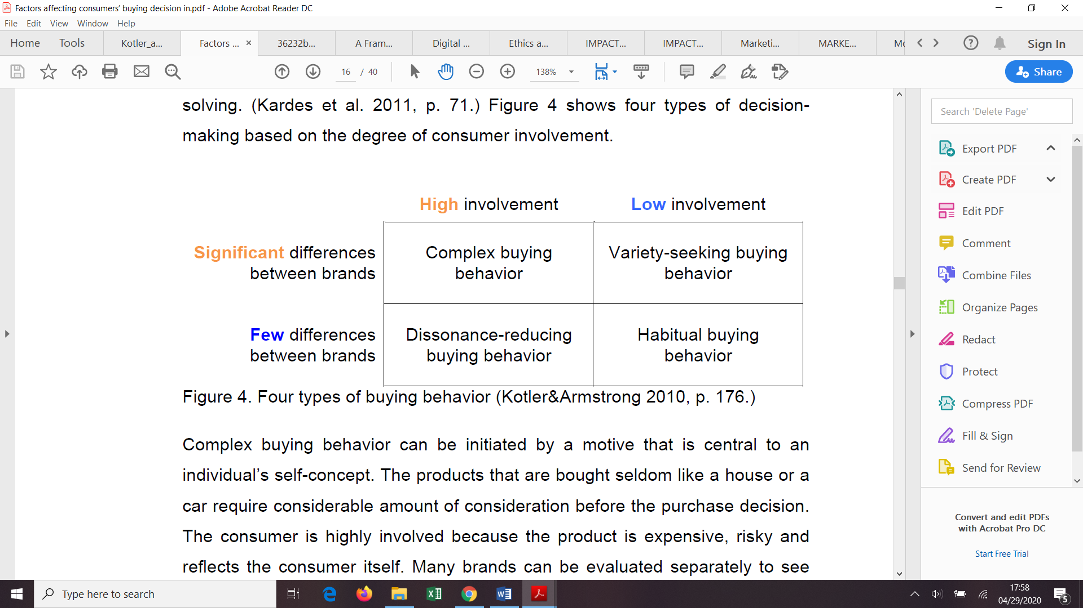

Figure 5. Four Types of Buying Behavior

1. Complex buying behavior

When a consumer has a complex buying behavior he or she is a “situations characterized by high consumer involvement in a purchase and significant perceived differences among brands”. (Kotler and Armstrong principiile marketingului 174) Those types of situations occur when the consumer purchase an expensive item, a risky one or one that reflects his or her identity. Also, in view of the fact that consumers observe differences among brands, they need to take and evaluate each brand separately in order to find out which better responds to the desired characteristics. (Kotler&Armstrong 2010, p. 176; Solomon 2004, p. 295.) Because typically the consumers don’t know that much about the product category they want to purchase, they first need to go through a process of learning in order to form beliefs and attitudes about the product that will help them in the final purchase decision. Moreover, due to this, marketers of this specific types of products must understand the stages of gathering information and evaluating alternatives of the consumer’s behavior in order to provide efficient strategies that will help consumers know better the attributes of the product.

1. Dissonance-Reducing Buying Behavior

The second type of buying behavior refers to a situation in which “consumers are highly involved with an expensive, infrequent, or risky purchase but see little difference among brands”. (Kotler and Armstrong principiile marketingului 174) In this case, buyers will shop around in order to see what products are available but the decision to choose between alternatives is a straightforward and simple activity. (Kotler&Armstrong 2010, p. 176; Solomon 2004, p. 295.) However, after purchasing the product it is possible for consumers to experience post purchase dissonance, also known as after-sale discomfort. This happens mainly in the moment consumers discover certain disadvantages about the purchased brand or certain favorable things about the other alternative brands.

1. Habitual Buying Behavior

This type of buying behavior is characterized by “low-consumer involvement and little significant brand difference” (Kotler and Armstrong principiile marketingului 174) In this case, consumers purchase the same brand mainly out of routinely, without much effort and also without a strong brand loyalty. It is known that this happens usually with low-priced product that are bought frequently, like for example sugar, salt or coffee. For this kind of products consumers don’t need to go through the stages of forming beliefs and attitudes, searching information and evaluating brand alternatives, they simply buy it. Moreover, because consumers receive certain information from television or advertising, repeating those ads contributes mainly to consumer familiarization with the brand rather than them forming a belief about it.

On the other hand, even if for the consumers this type of buying behavior allows them to diminish the time and energy used when selecting products, for marketers this habitual buying becomes problematic when they want to introduce new products in order to modify consumer’s old habits. (Solomon 2004, p. 295.) Also because consumers are not loyal to a certain brand, marketers of this kind of product may benefit from this by using price and sales promotions in order to stimulate purchasing.

1. Variety-Seeking Buying Behavior

This behavior mainly occurs in circumstances “characterized by low consumer involvement but significant perceived brand differences”. (Kotler and Armstrong principiile marketingului 175) In this case consumers seek to change the brands purchased out of boredom or because they want to try something different and not because they are not satisfied with it. In this situations consumer can take the buying decision without any preliminary evaluation and actually evaluate the brand during its consumption. Also when dealing with this kind of products, it can be observed that there are two categories of brands, market leaders and minor brands, which have different strategies. The first one will support habitual buying behavior and the second one will promote variety seeking through low prices and exclusive deals.

**Chapter 2. Manipulation tactics- the case of advertising and social media**

**2.1. Manipulation in marketing**

The second part of the study focuses on the understanding of the way in which marketers use the knowledge gathered about the consumer’s needs and wants through the study of the consumer behavior, in order to develop marketing approaches that use sensory marketing senses and also persuasion, strategies that will influence the buyer’s perception. By doing this they will have the capability to control and also manipulate the consumer. They will do so through methods that are unknown to the consumers, and that will “undermine their capacity of making conscious, rational choices in their interest”. Even though specialist emphasize the danger of using manipulative marketing and also, the fact that it is an unethical method, many marketing departments still practice this technique. (Kimmel, 2005; Schiffman et. al, 2012).

A very important aspect refers to the question of ethics and morality when talking about the relationship between the salespersons and the buyers. Because the marketer’s job is to give information to consumers about the products and also to persuade them into buying, it is hard to establish if a specific technique is manipulative or unethical. (Sher, 2011; Crane & Matten, 2010). Trying to determine if, indeed those techniques are unethical and manipulative, it is important first, to take a look at the meaning of those two concepts.

Giving a proper definition to ethics can be hard because its meaning can be quite ambiguous considering the context in which it is applied. When talking about marketing, ethics can be seen as an action that would advantage or protect consumers and members of the marketing network (Ferrell *et al.*, 2013). On the other hand, because culture also pays an important role in establishing marketing communication strategies, it is also important to know how ethics in culture is perceived. According to Jackson, the “national differences in ethical attitudes may be attributed to differences in underlying cultural values” (Jackson, 2001:1268).

When talking about manipulation, in its marketing context, it is important to look at what means manipulative marketing tactics. In Shlomo Sher’s point of view, a marketing strategy can be perceived as manipulative if “it intends to motivate by undermining what the marketer believes is the audience's normal decision-making process, either by deception or by playing on a vulnerability the marketer believes exists in his/her audience's normal decision-making process”( A Framework for Assessing Immorally Manipulative Marketing). Also the concept of manipulation stands between rational persuasion and coercion and comprises at the same time, “both verbal and nonverbal tactics that communicate through emotional cues” (Greenspan, 2003).

Because the strategies used by marketers are based on sensory marketing, it is important to analyze those stimuli and the way they manipulate the consumer. First, it is known that consumers are exposed to two types of stimuli: physical ones that come from the environment and individual ones which depend on the individual’s experiences, needs and wants. In Krishna’s (2012) review of the five senses used in sensory marketing, it is showed how marketers use physical stimuli as triggers on individual stimuli, in order to involve consumers in buying their products. The first sense used by marketers is touch. Its use is important for products displayed in stores and events because consumers are more likely to buy the product if they can touch it first. Another sense used is smell. It is frequently used in restaurants because it gives consumers a strong emotion to keep in memory and associate it with that specific product, increasing also the buying mood. (Krishna, 2012; Oort, 2012; Sher, 2011). Also, Martin Lindstrøm states in his book, “Brandwashed” that specific fragrances are also used in shopping centers and in stores, in order to create a more pleasing shopping experience (Tartakovsky, 2011). For example, Starbucks is using in every of its stores the smell of fresh coffee. This also happens with audition, due to the fact that “ambient sound, such as music heard in hotels, restaurants, retail stores, and supermarkets, can influence consumer mood, actual time spent in a location, perception of time spent, and actual spending”(Krishan, 2012:341). The last senses marketers use with the purpose of influencing buyers are taste and vision. Taste is used as a mean of influence, for example, by the big companies who produce soda. In order to make their beverage sweeter and to make the consumer addicted to it, they started to substitute sugar with corn syrup. Because of this addiction to the sweet taste, buyers will begin to purchase more in order to satisfy their need (Oort, 2012; Sher, 2011). When talking about vision, marketers use large portions or packages in order to make the consumers feel like they get value deserved for the amount of money paid. They are also targeting buyers’ perception through advertising, by placing babies and beautiful models in order to create an emotional impact or cognition (Krishna, 2012; Wansink, 2004; Oort, 2012).

Those tactics used by companies can be declared successful in their way of manipulating consumers, if the buyers comprehend the message in a serious way. But this is not possible, because consumers’ perception depends in a great extent on past experiences, culture and mood, and it is impossible to expose consumers to identical incentives and on the end to have the same responses from them.

**2.2. Persuasion in marketing**

Because manipulation is not the only way through which companies can influence consumers into buying more, and because it stands between rational persuasion and coercion, it is important to also analyze what the concept of persuasion means.

In marketing, persuasion is defined as “a simple human communication designed to influence the beliefs and attitudes of others” (Kimmel, 2005:31). It aims to make the customer believe that buying a specific product or service is the right thing to do in that moment. There are two ways through which marketers will try to persuade consumers into buying. The first one is the persuasion through rational remarks, case in which the marketer gives consumers information, rational point of views and also evidence that can be used by customers in their final decision. On the other hand, the second way of persuasion is through multiple means of coercion. By doing so, marketers will make a proposal hard to be deny by consumers, a choice of “either accepting her/his offer or suffering a consequence she/he believes will be so highly unacceptable to him/her as to virtually guarantee that her/his offer will be accepted” ”( A Framework for Assessing Immorally Manipulative Marketing).

To better understand this concept it is essential to take a look at Cialdini’s (2001) principle of persuasion. The first one is the principle of reciprocity through which any person will feel obliged to give something back if he they received something. For example a purchase if a taster or a present was received. Another principle is the one of scarcity. Companies use this principle in order to trick consumers into believing that products are more valuable if they are less available or limited. When consumers see limited products they automatically think that they will lose the chance of buying it, if they don’t act immediately. The third principle is the one of authority. Customers will always follow an expert’s advice because they believe he/she has the right information needed in their decision making process. The next principle that needs to be considered is the principle of consistency. Consumers feel like they are committed to something they have been told to do. Even if it is a persuasion tactic, consistency can’t be viewed as manipulative because it can’t be applied without the consumer being unaware of it. The fifth one is the principle of consensus or social proof. People decide what they should do in different situations by looking at others or by seeking signals from the seller. This principle can have a very powerful impact if the salesperson is friend with the consumer. This leads to the last principle which is the liking principle. If the seller has similarities with the consumer or compliments him, automatically the buyer will develop appreciation for the salesperson.

* 1. **Advertising in between manipulation and persuasion**

After seeing what manipulation and persuasion mean and what are their ethical and moral involvements it is necessary to take a look at what advertising is, what it involves and also at how marketers can use it in order to manipulate and persuade consumers.

In Thorson’s and Duffy’s (2011) perception the core of marketing advertising is represented by the concept of consumer sovereignty. They claimed that most definitions of advertising are based on the consumer sovereignty model, but at the same time all of them emphasize the need of consumer orientation, consumer focus and consumer driven strategies. But, despite the fact that marketers are consumer oriented they are also aiming to persuade and manipulate the consumer into buying, through advertising. According to Ph. Kotler (2003), “The marketing concept and one of its components – advertising are created to meet the needs and wants of the target market. Satisfying these needs is how organizational goals are achieved, to surpass the desired satisfactions more effectively and efficiently than competitors”. It is known that some marketing practices may be aggressive and used in order to try to control the mind of the buyer because the main goal of advertising, as an element of the promotion mix is first to promote the product and second to persuade the targeted customer into buying it. In order to make the consumer buy, persuaders use special techniques that capture their attention, gain their trust and stimulate the desire. All those techniques are known as “the language of persuasion” and it is important to understand them in order to see how advertising messages influence consumers into taking their own decisions.

Is it know, that especially in advertising, language plays a very important role because certain words and phrases used by markets can stimulate certain emotional reactions. This is why im