**Documentation**

**1. styles.css (/public/styles.css):**

- Used css to add more styles to my html elements to enhance the form/contract. This **styles.css** is linked in my **index.html** file as:

 **2. index.html**

- I linked a cloudflare script that I used for downloading the file and converting it to pdf. The script I used is linked as:

****- At the top of my form I have put my **‘Download’** button for the user to be able to download the file and save it as a pdf. This button uses the **downloadDoc()** function to generate a html2pdf feature which I added the script in the html file under the form element.

**  
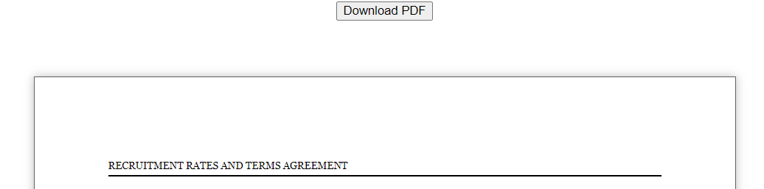**

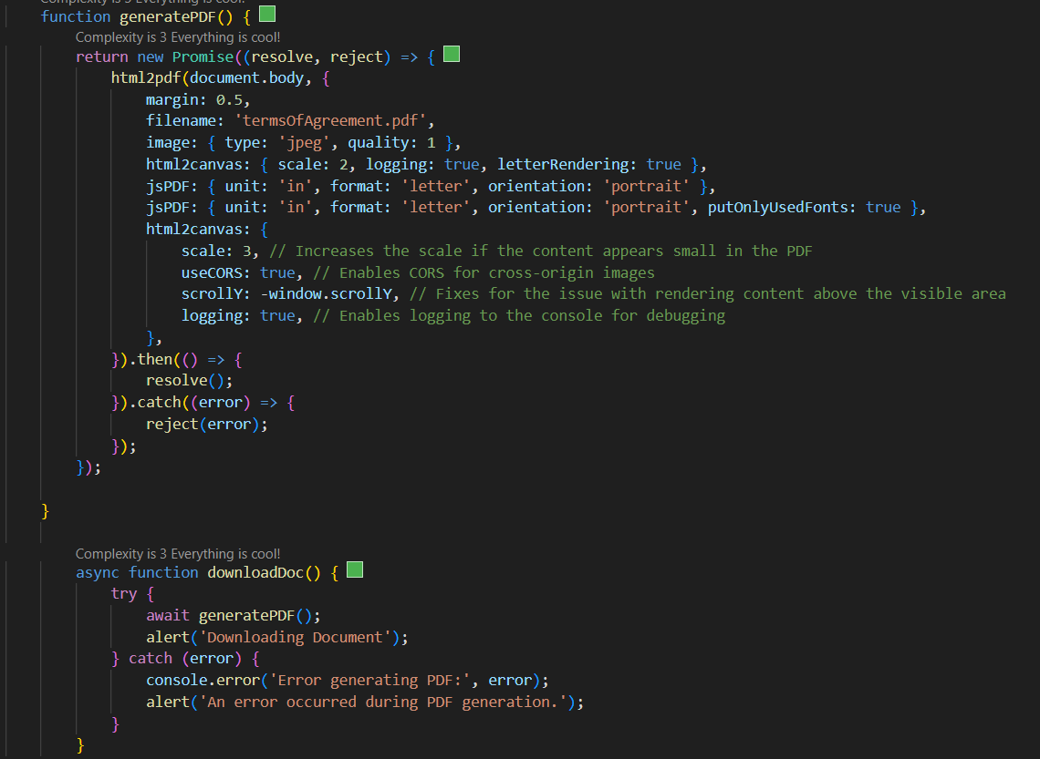

- Inside my html body, I added a form element that’s named with an id of **“contractForm”.** This form is the one I used to take input from the users and then save the input on my **mongoDB**. All the fields the user should enter are set to as “required”.

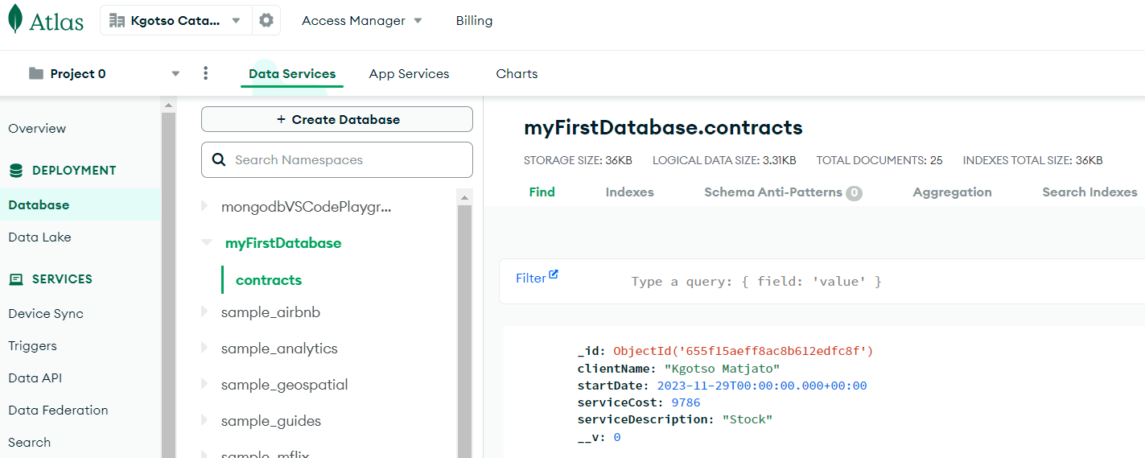

**3. index.js**

- This is my first main script in the entire project. This script is responsible for submitting the document input to my **mongoDB** using **node.js**, **mongoose**, **express** and **bodyParser**.

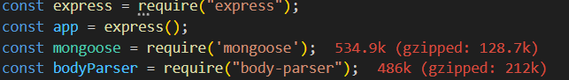 - An **app.get** API is user to send my **index.htlm** to the webpage. An **app.post** API is used to send the input/**Contracts** object to my **mongoDB**.   
I use **localhost:3000** as my port to run the node index.js script on the terminal for the web form to appear on my browser.

**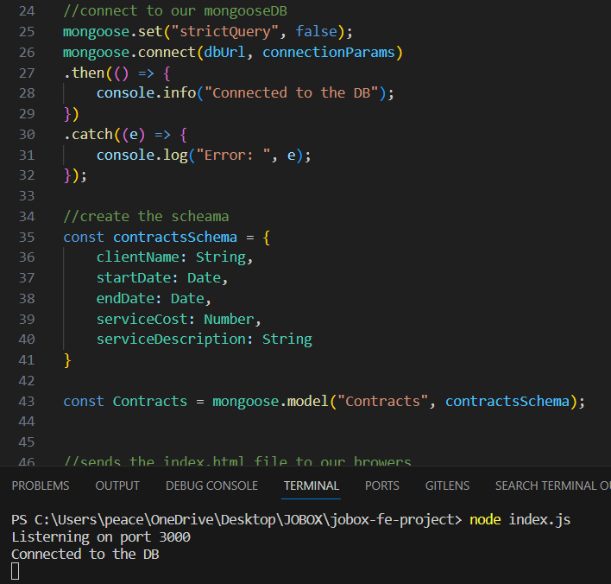  
  
4. server.js**

- This is the second most important script in my project. It’s responsible for the retrieval of the **Contracts** object that comes from my **database** and sets the values to an html table using **ejs**, **mongoose**, **express** and **bodyParser**.

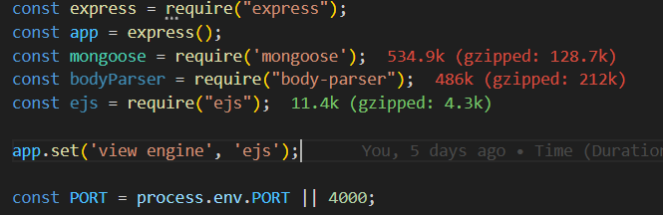

- I am using **localhost:4000** for the data retrieval. This data is then sent into an html table with the help of bootstrap.



**5. index.ejs**- This is an html file that retrieves all the data from the Contracts database and puts it in a table using ejs, bootstrap and htlm.  
