Software Requirements Specification
for
Score
Sonar COde Rewards Engine
A Sonar Plugin

Phase 1 - Alpha
Prepared by
Team Build Meister
James Dunn, Margi Womack, Lakshmi Sajeev

April 8th, 2013
Table of Contents
Table of Contents ii
1. Introduction 1
1.1 Purpose 1
1.2 Intended Audience 1
1.4 Project Scope 1
2. Overall Description 3
2.2 Product Features 3
2.3 User Classes and Characteristics 3
2.4 Operating Environment 3
2.5 Design and Implementation Constraints 3
2.6 User Documentation 4
2.7 Assumptions and Dependencies 4
3. System Features 4
3.1 Adding the SCORE plugin to Sonar – Phase 1 4
3.2 Viewing the SCORE widget - Phase 1 5
3.3 Uploading a team or project logo - Phase 1 5
4. Software Requirements 6
4.1 User Interface 6
4.2 SCORE API 7

Introduction

Purpose
The purpose of this document is to describe the functionality of the SCORE project: Phase 1 - Alpha release.

Intended Audience
The intended audience for this SRS includes the business owner for SCORE, Bradley Johnson. The document will be used by the following people:
- Team Build Meister, as the specification from which to implement the working code.
- The Team SDET(s), to outline functionality to test.
- Bradley Johnson, to identify what functionality will be delivered during the project.

Project Scope
SCORE is a plugin for Sonar, which is an open source software platform that manages code quality. The SCORE plugin is intended to be used by organizations and institutions that develop software. It integrates Sonar’s user interface with gamification principles and dynamics, with the goal of instilling in software developers an enthusiasm for code quality.

Overall Description

Product Features
Team Build Meister has divided the development of the SCORE plugin into three or more cumulative releases. Each release will introduce a new and complete set of major features.
- The Alpha Release will consist of a “Points” metric and project profile picture functionality in a new widget.
- The Beta Release will introduce trophies that are earned by projects for achievements in good metrics, and additional widgets for comparing projects.
- The Gamma Release is intended to introduce teams, and badges earned by users. The feasibility of developing some of these features in a plugin is yet to be determined.

The SCORE plugin, at the end of Phase 1, will allow the Sonar administrator to configure the SCORE Points Widget for all projects on their Sonar. Once the SCORE plugin is added to Sonar, a user may select and upload a project or team logo/image directly from the SCORE Points Widget for a given project.

User Classes and Characteristics
In order to add the SCORE plugin to Sonar, the user will need administrator credentials. Once the administrator adds the SCORE Points Widget, anyone using Sonar may view their project’s points and browse and select their project or team’s logo. The SCORE plugin will automatically re-calculate a project’s points when a successful build is completed for that project.

Operating Environment
Users of the SCORE plugin will need to install Sonar and read Sonar’s documentation regarding how to configure and add projects to Sonar in addition to how to run analysis on those projects. Once Sonar is installed, and projects are added to Sonar, the SCORE plugin jar file must be copied to the sonar/extension/plugins folder wherever the user installed Sonar.

Design and Implementation Constraints
- The SCORE plugin should work “out-of-the-box”, meaning that all that is needed for it to work is to install it, restart Sonar and then build projects to Sonar. No other installations of supporting plugins or files should be necessary.
- Sonar’s Schema should be treated as immutable. Although it might technically be possible to create another table in Sonar’s database, Sonar does not recommend this. This has implications for how rewards like trophies and badges will be stored. The best way may be to write data to text files.
- Sonar’s page structure seems to be fixed in terms of plugins. Sonar allows plugins to add features to the user interface in terms of widgets, which can be placed in one of two dashboards: the global dashboard, and the project dashboard. All new features in the user interface will have to be implemented as widgets on existing dashboards unless a way is found to create new dashboards. This may affect the feasibility of developing desired features in Gamma.

User Documentation
The Score Plugin will be extensively documented in the following ways:
- Javadocs for all public API
- Comments where necessary
- README text files
- A document explaining how to use and get the most out of the SCORE plugin.

Sonar’s documentation explains how to download and install plugins. Installing and using the SCORE plugin will be the same for the other Sonar plugins.

Assumptions and Dependencies
It is assumed that the users of the SCORE plugin will be utilizing Sonar to run code metrics on their software development projects.

It is assumed that the Sonar system will interface with a relational database.

It is assumed that SCORE’s plugin jar file will be added to the user’s copy of sonar in the sonar/extension/plugins folder.

Software Requirements

User Interface
The user interface for the Alpha and Beta releases of the plugin will consist of ruby widgets addable to existing dashboards. The features on these widgets will be limited to the types of controls that can be generated using HTML, Javascript, Cascading Style Sheets and Ruby.

Once the SCORE plugin is installed in Sonar, the widgets provided by the plugin can be added to a dashboard by configuring the dashboard’s widgets. The Points widget will be under the “Points” category (Figure 2).

SCORE API
Sonar’s API is written in Java and designed for plugins written in Java, so SCORE will be written in Java, extending Sonar’s extension points (which Sonar provides specifically for plugin use). Where necessary, SCORE will also create alternate forms of data storage (such as writing to and reading from text files).

Alpha Release System Features

Currently, Sonar has plugins for software development projects that measure certain code metrics such as code violations, rules compliance, unit test coverage, and package tangle, to name a few. From Sonar’s home page dashboard, users may select a project which directs them to Sonar’s project dashboard that displays various code metrics for a given project (see Figure 1 – Sonar’s Project Dashboard). The SCORE plugin project will create a new metric called “Points”, calculated from other metrics, and provide a widget that will display the project’s name and the points the project has earned. The widget will also allow users to upload a project logo/image (see Figure 2 – Project Dashboard with SCORE’s Points Widget).

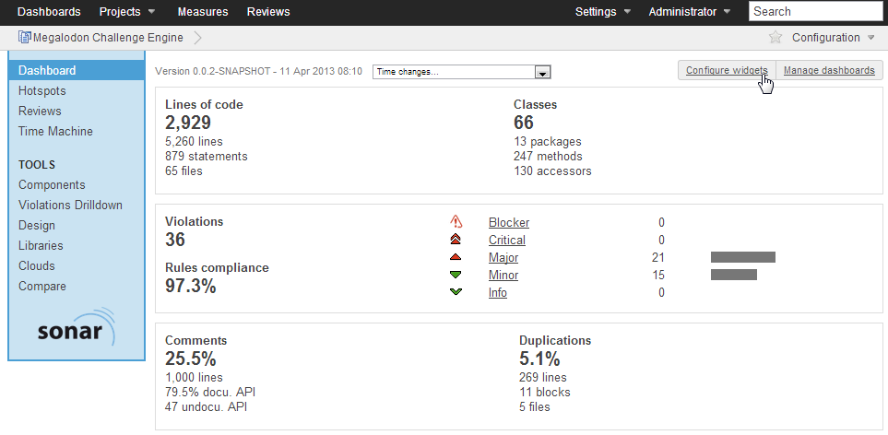
Figure 1

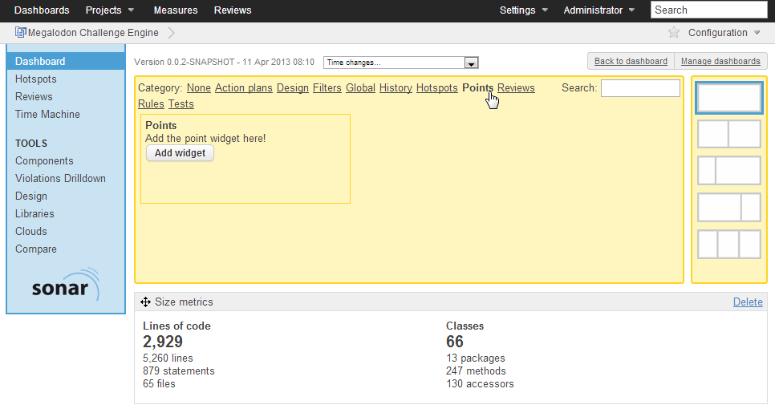
Figure 2

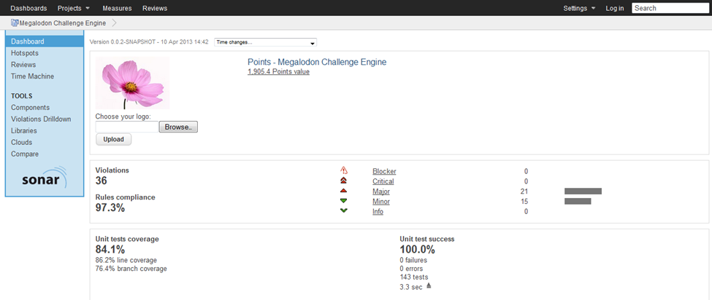
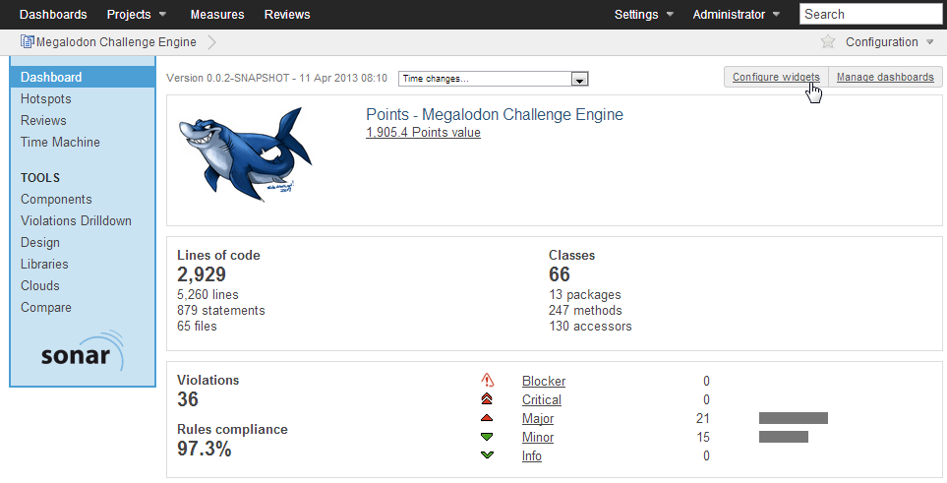
Figure 3

Figure 4

Adding the SCORE plugin to Sonar

Description
This feature pertains to adding the SCORE plugin to Sonar.

Stimulus/Response Sequences
- The administrator, once logged in, is able to configure Sonar widgets by selecting a project from the project page and clicking the “Configure widgets” button at the top of the dashboard.
- From the widget configuration menu, with all widgets organized by category, the administrator may choose which widgets to add.
- The Points widget will be located under the “Points” category. From the “Points” category, the administrator then clicks on the “Add widget” button within the Points widget section with the option to add SCORE to their Sonar.

Functional Requirements
REQ-1: The system will provide a “Points” category for selecting the SCORE’s Points Widget on the category menu when configuring widgets
REQ-2: The system will provide a brief description of the Points Widget in the point’s widget section
REQ-3: The system will provide a button that allows the user to add SCORE’s Points Widget on the widget configuration page under the “Points” category.

Viewing the SCORE widget

Description

This feature allows the user to view a project’s name and points earned on SCORE’s Points Widget.

Stimulus/Response Sequences

- Once the administrator has added the SCORE widget to the project dashboard, a user may select a project from the global dashboard to view the Points Widget on the dashboard for that project.
- The project name and points earned will be displayed on the given project’s personal project page.

Functional Requirements

REQ-1: The widget will display a selected project’s name and points earned based on various code metrics.
REQ-2: The widget will calculate a project’s points with every successful build for a given project.

Uploading a team or project logo

Description and Priority

This feature includes the functionality for a user to browse and select a team or project logo that will appear on the SCORE widget.

Stimulus/Response Sequences

- Once a user selects a project from the main or project dashboard and is directed to that project’s personal project page, the user has the option to add a project logo to the SCORE Points Widget by clicking a browse button to browse the system to update or change a project’s logo.
- The user may select an image and click the Upload button to save their changes.

Functional Requirements
REQ-1: The system will supply a default image on the SCORE widget if no project logo has been selected.
REQ-2: The system will allow a user to click on a browse button to browse for images.
REQ-3: The system will allow a user to click a submit button to save the changes they have made to the project logo.

Beta Release System Features
Beta continues the gamification theme set by Alpha in the features it provides. While Alpha facilitates basic user interaction by providing the Points widget on the project dashboard, Beta will add additional widgets to Sonar, including a project group comparison widget and an enhanced filters widget. In addition, Beta will introduce the trophies feature. Trophies will be earned by projects for various achievements in code quality, including such factors as consistency and improvement. Trophies earned by a project will be displayed in a Trophies widget.

Gamma (and later) Release System Features

Gamma (and later) releases will introduce teams, a user profile dashboard, and badges earnable by users.

