Software Requirements Specification
for
Score
Sonar COde Rewards Engine
A Sonar Plugin

Phase 1 - Alpha
Prepared by
Team Build Meister
James Dunn, Margi Womack, Lakshmi Sajeev

April 8th, 2013
Table of Contents
Table of Contents ii
1. Introduction 1
1.1 Purpose 1
1.2 Intended Audience 1
1.4 Project Scope 1
2. Overall Description 3
2.2 Product Features 3
2.3 User Classes and Characteristics 3
2.4 Operating Environment 3
2.5 Design and Implementation Constraints 3
2.6 User Documentation 4
2.7 Assumptions and Dependencies 4
3. System Features 4
3.1 Adding the SCORE plugin to Sonar – Phase 1 4
3.2 Viewing the SCORE widget - Phase 1 5
3.3 Uploading a team or project logo - Phase 1 5
4. Software Requirements 6
4.1 User Interface 6
4.2 SCORE API 7

Introduction

Purpose
The purpose of this document is to describe the functionality of the SCORE project: Phase 1 - Alpha release.

Intended Audience
The intended audience for this SRS includes the business owner for SCORE, Bradley Johnson. The document will be used by Team Build Meister as the specification from which to implement the working code. The document will be used by Bradley Johnson to identify what functionality will be delivered during the project.

Project Scope
SCORE is a plugin for Sonar, which is an open source software platform that manages code quality. The SCORE plugin is intended to be used by organizations and institutions that develop software. It integrates Sonar’s user interface with gamification principles and dynamics, with the goal of instilling in software developers an enthusiasm for code quality.

Team Build Meister has divided the work to be completed for the SCORE plugin project into three or more phases. Phase 1- Alpha consists of developing specific features on SCORE’s Points Widget. Phase 2 – Beta involves creating SCORE’s trophies earned feature as well as a project comparison widget.

Phase 3 - Gamma

Phase 1

Currently, Sonar has plugins for software development projects that measure certain code metrics such as code violations, rules compliance, unit test coverage, and package tangle, to name a few. From Sonar’s home page dashboard, a user may select a project which directs them to Sonar’s project page that displays various code metrics for a given project (see Figure 1 – Sonar’s Project Dashboard). Phase 1 of the SCORE plugin project will create a widget that will allow a user to also view their project’s name and project points they have earned based on various code quality metrics as well as the ability to select and upload a project or team logo/image (see Figure 2 – Project Dashboard with SCORE’s Points Widget).

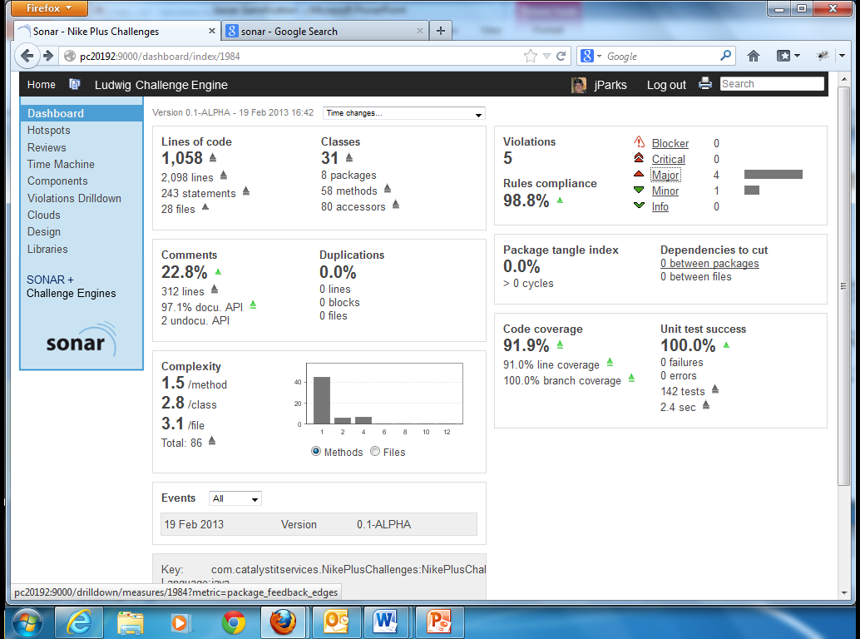

Figure 1 - Sonar’s Project Dashboard

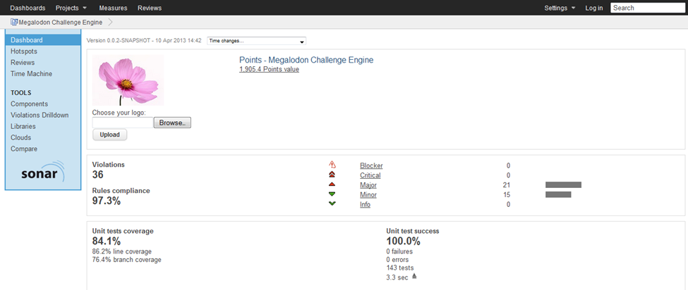

Figure 2 – Project Dashboard with SCORE’s Points Widget
Phase 2

Phase 2 – Beta builds on the work from Phase 1. While Phase 1 seeks to develop the user’s main or first interaction with the SCORE plugin by creating a widget on Sonar’s project dashboard, the goal of Phase 2 is to add the trophies earned feature that will be displayed on SCORE’s Points Widget along with the project’s logo, points and name. Phase 2 will also involve creating a project comparison widget that compares various code metrics for different teams on the same project.

Phase 3

Phase 3 – Gamma …..James to fill in

Overall Description

Product Features
Phase 1

The SCORE plugin, at the end of Phase 1, will allow the Sonar administrator to configure the SCORE Points Widget for all projects on their Sonar. Once the SCORE plugin is added to Sonar, a user may select and upload a project or team logo/image directly from the SCORE Points Widget for a given project.

User Classes and Characteristics
In order to add the SCORE plugin to Sonar, the user will need administrator credentials. Once the administrator adds the SCORE Points Widget, anyone using Sonar may view their project’s points and browse and select their project or team’s logo. The SCORE plugin will automatically re-calculate a project’s points when a successful build is completed for that project.

Operating Environment
Users of the SCORE plugin will need to install Sonar and read Sonar’s documentation regarding how to configure and add projects to Sonar in addition to how to run analysis on those projects. Once Sonar is installed, and projects are added to Sonar, the SCORE plugin jar file must be copied to the sonar/extension/plugins folder wherever the user installed Sonar.

Design and Implementation Constraints
Do we want to add anything here?

User Documentation
**Will we be supplying any documentation for SCORE?
Sonar documentation explains how to download and install plugins. Installing and using the SCORE plugin will be the same for the other Sonar plugins.

Assumptions and Dependencies
It is assumed that the users of the SCORE plugin will be utilizing Sonar to run code metrics on their software development projects.

It is assumed that the Sonar system will interface with a relational database.

It is assumed that SCORE’s plugin jar file will be added to the user’s copy of sonar in the sonar/extension/plugins folder.

System Features

Adding the SCORE plugin to Sonar – Phase 1

Description
This feature pertains to adding the SCORE plugin to Sonar.
    - Stimulus/Response Sequences
- The administrator, once logged in, is able to configure Sonar widgets by selecting a project from the project page and clicking the “Configure widgets” button from the dashboard menu.
- From the widget configuration menu, with all widgets organized by category, the administrator may choose which widgets they would like to add.
- The SCORE widget will be located under the “Points” category. From the “Points” category, the administrator then clicks on the “Add widget” button within the Points widget section with the option to add SCORE to their Sonar.
3.1.3 Functional Requirements
REQ-1: The system will provide a “Points” category for selecting the SCORE’s Points Widget on the category menu when configuring widgets
REQ-2: The system will provide a brief description of the Points Widget in the point’s widget section
REQ-3: The system will provide a button that allows the user to add SCORE’s Points Widget on the widget configuration page under the “Points” category.

Viewing the SCORE widget – Phase 1

Description

This feature allows the user to view a project’s name and points earned on SCORE’s Points Widget.
3.2.2 Stimulus/Response Sequences
1. Once the administrator has added the SCORE plugin to Sonar, a user may select a project from the main or project dashboard to view the Points Widget.
2. The project name and points earned will be displayed on the given project’s personal project page.

3.2.3 Functional Requirements
REQ-1: The system will display a selected project’s name and points earned based on various code metrics.
REQ-2: The system will calculate a project’s points with every successful build for a given project.

Uploading a team or project logo – Phase 1

Description and Priority

This feature includes the functionality for a user to browse and select a team or project logo that will appear on the SCORE widget.
3.3.2 Stimulus/Response Sequences
1. Once a user selects a project from the main or project dashboard and is directed to that project’s personal project page, the user has the option to add a project logo to the SCORE Points Widget by clicking a browse button to browse the system to update or change a project’s logo.
2. The user may select an image and click the Upload button to save their changes.

3.3.3 Functional Requirements
REQ-1: The system will supply a default image on the SCORE widget if no project logo has been selected.
REQ-2: The system will allow a user to click on a browse button to browse for images.
REQ-3: The system will allow a user to click a submit button to save the changes they have made to the project logo.

Software Requirements

User Interface – Phase 1
The user interface for the system will be part of Sonar’s current user interface. Once the SCORE plugin is added to Sonar, a link to configure the SCORE widget will appear on Sonar’s widget configuration page under the “Points” category (Figure 3 – SCORE’s Points Widget configuration page).
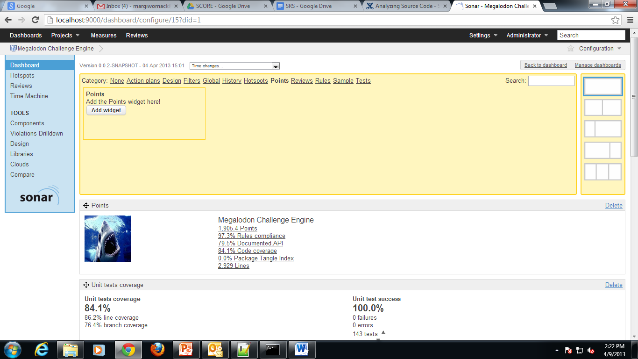

Figure 3 – SCORE’s Points Widget configuration page

Currently, Sonar’s user interface is written using Ruby, therefore SCORE’s user interface will be written in Ruby. The user interface will be limited to the types of controls that can be generated using HTML, Javascript, Cascading Style Sheets and Ruby.

SCORE API – Phase 1
Sonar’s API is written in Java and SCORE will also use Java to create the SCORE plugin and to calculate points.

