Click on Assessments, which will display applications with site assessments pending or site assessments complete status

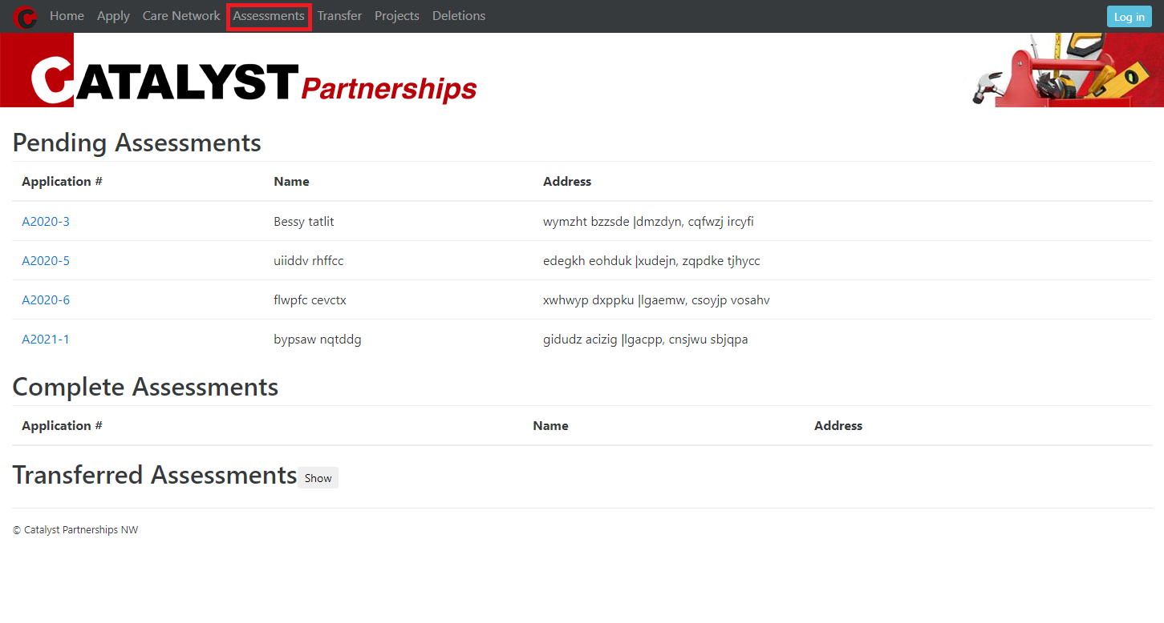

Clicking on one of the site assessment links under Application #. This will enter the site assessment page:

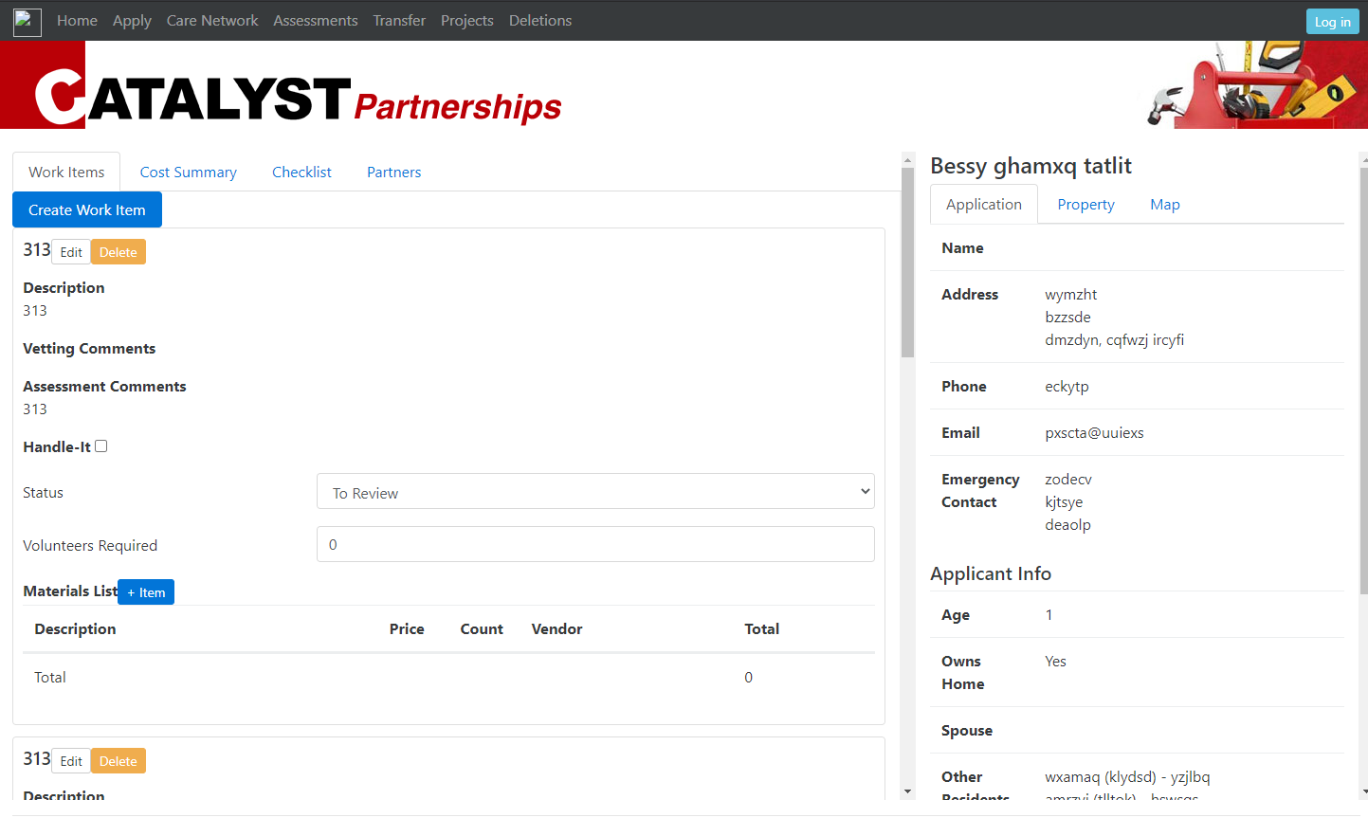

Create work items with materials under the materials list and edit any information. For now, the approval of the work items is in this page. Change the status of the non-handle-it work items to “Accepted”:

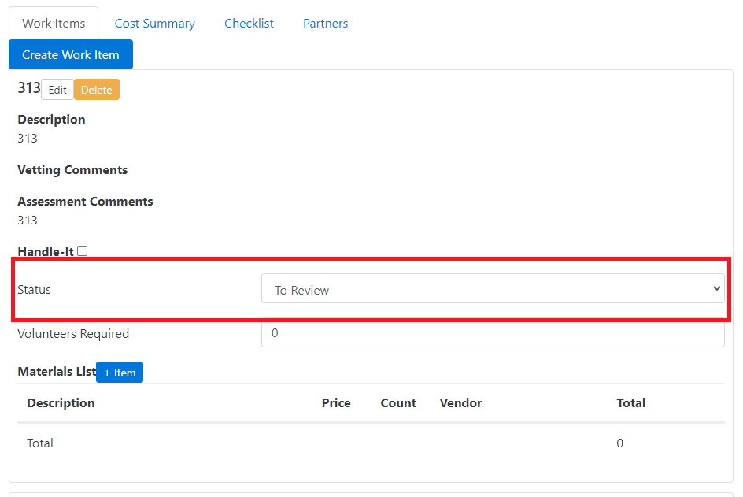

Note: there is a handle-it status and a handle-it checkbox. I believe that the handle-it relies on the checkbox, but I wanted to see which would be the better option and have the better work flow.

Finally, when the site assessment is complete, go to the Checklist navigation tab:

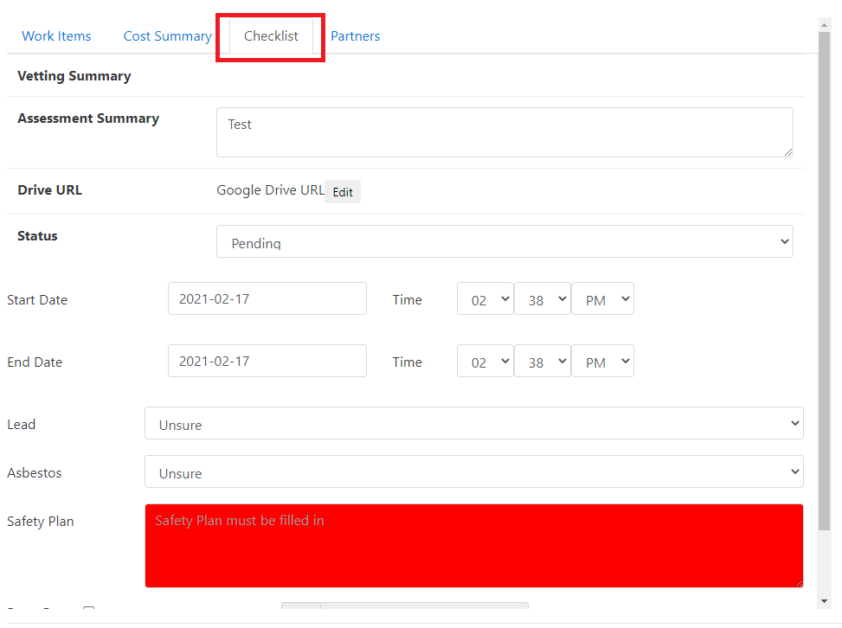

Mark the status as complete:

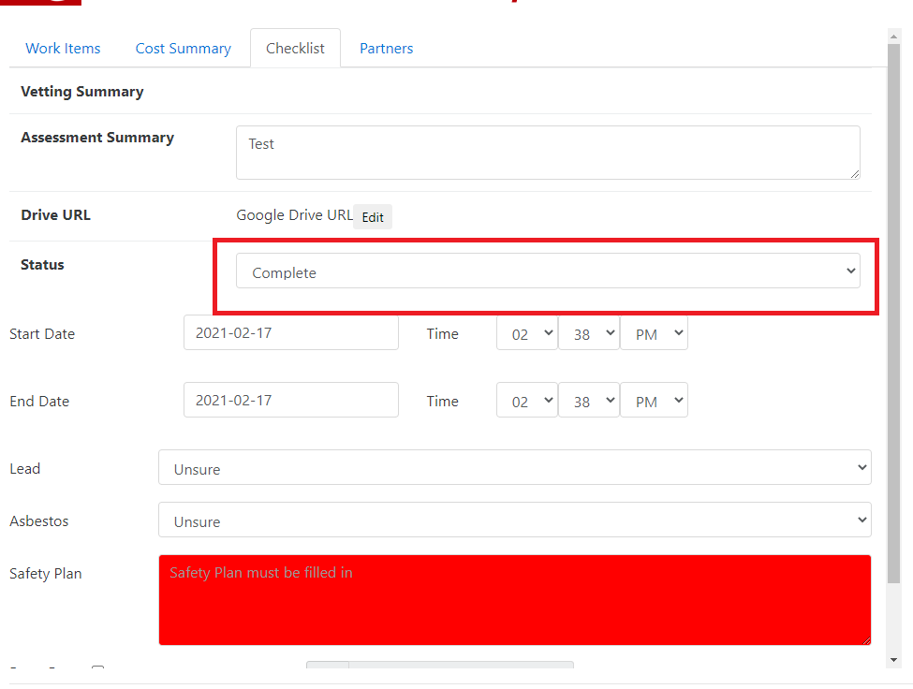

Go back to the Assessments Page, and the site assessment will now show under “Complete Assessments”:

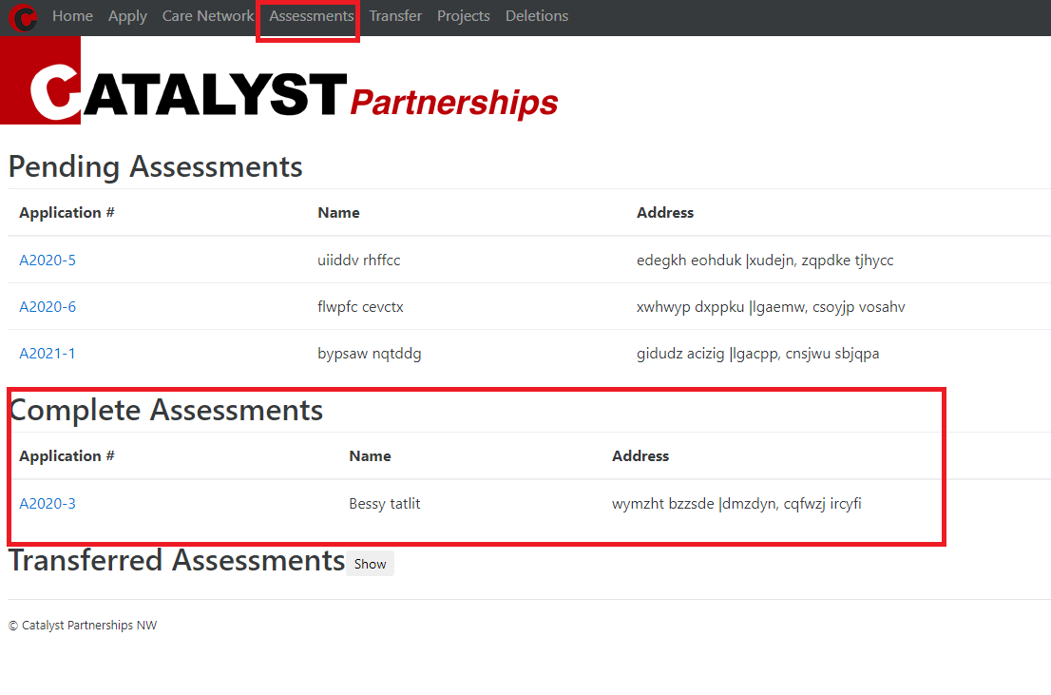

This site assessment will now show under the “Transfer” page:

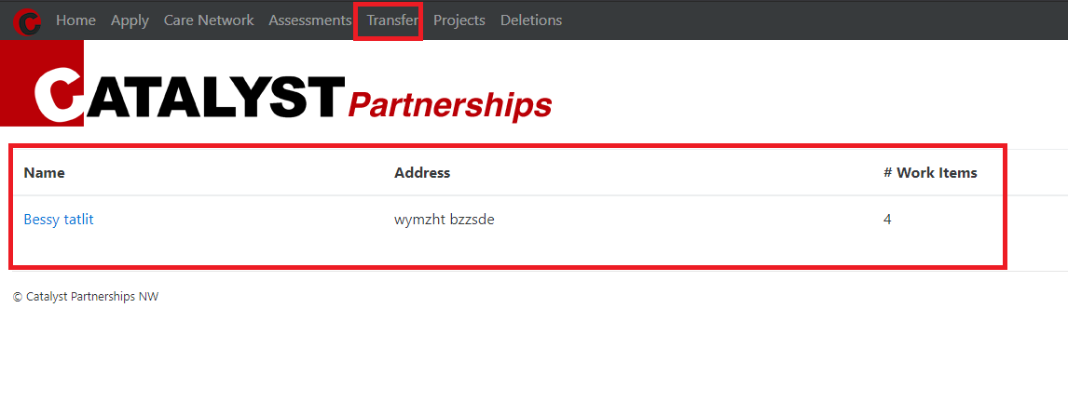

Click on the link and here you will see all work items that were accepted. Right now, the work items for handle-it also have to have an accepted status, but I can change that so handle-it work items do not have a status and will be accepted automatically.

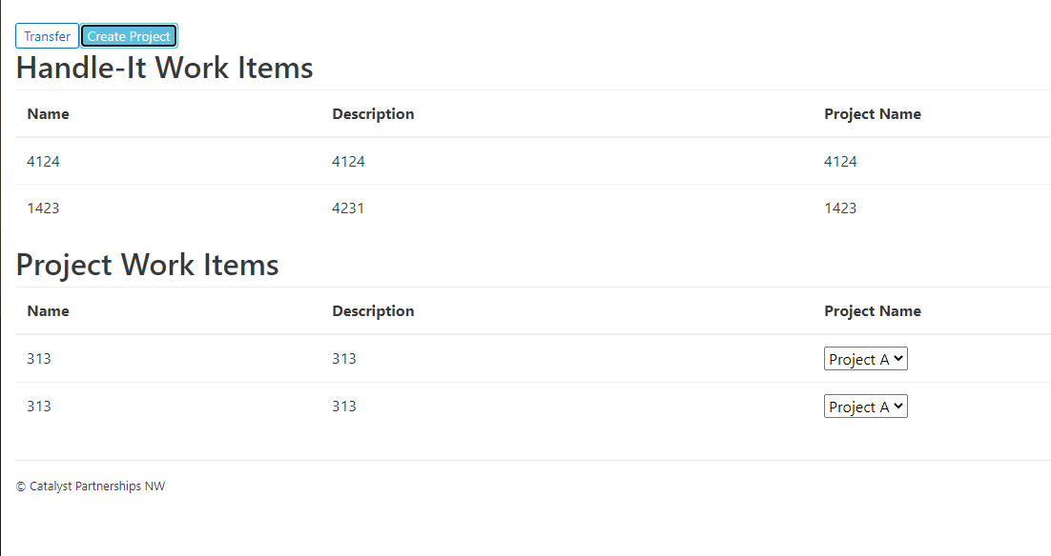

Click on the “Create Project” button to “create” a project. What this does really is create project names that will be shown under “Project Name”:

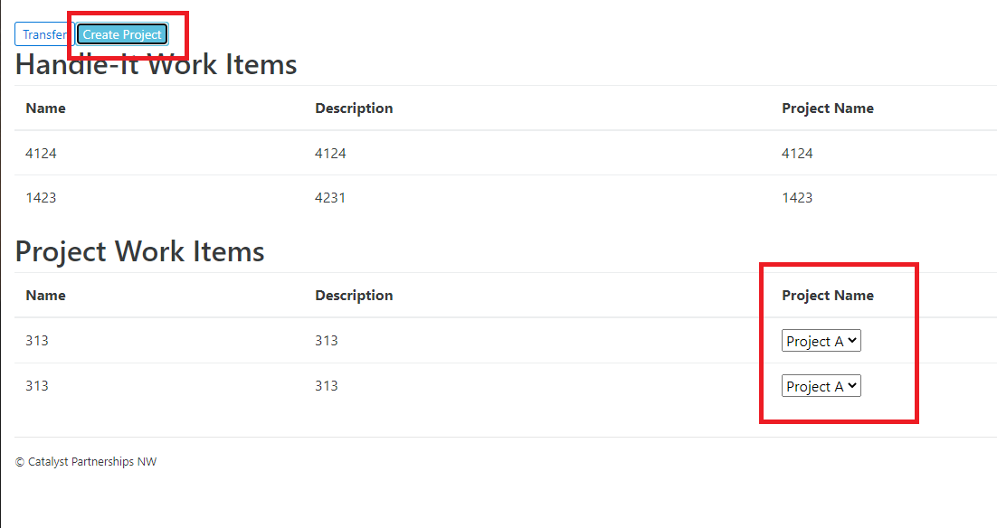

It doesn’t create projects yet until you hit the “Transfer” button when all project work items have the correct project name. Here you can create different projects for different work items or they can all be under the same project.

The handle-it work items will have their own separate project for each work item. The name of the projects will be the same name as the work item.

After transferring the site assessment, the site assessment will now show up under “Transferred Assessments”:

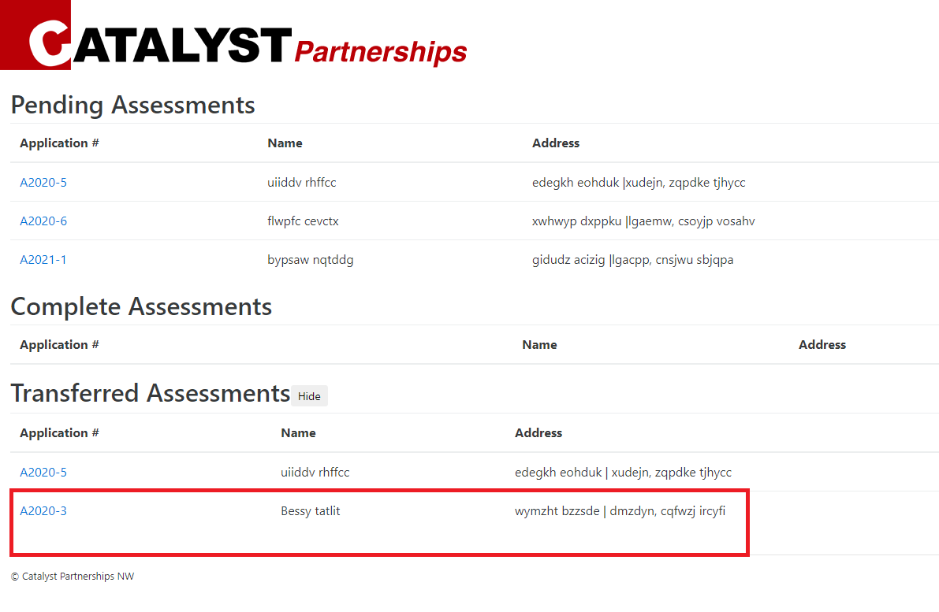

This site assessment cannot be changed, which also includes all of its work items and materials lists, and partners. This is for record keeping.

Go to the projects page and you will now see the projects that were created or transferred over from site assessments:

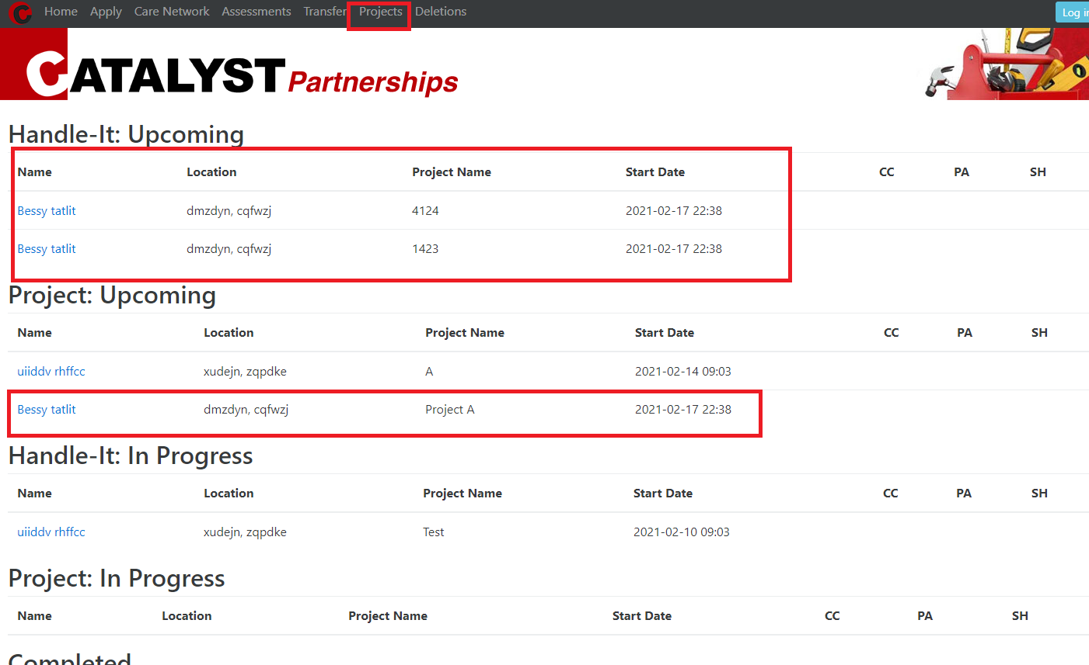

After clicking on the link to go to the project, you will now enter the project page:

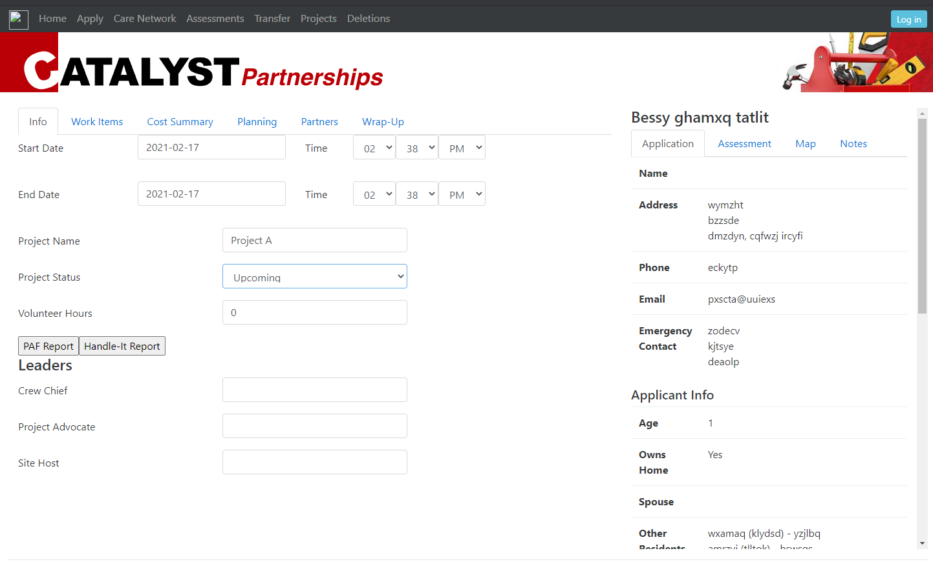

There you can edit information. The PAF Report and Handle-It Report will create a new page for the reports where you can print out.

The Work Items here still have “Assessment Comments” when you edit/create it but that will be fixed in the future.

I can also “lock” the projects once they are under the “complete” or “withdrawn” status as well if necessary.

Finally, you can create multiple site assessments and projects for each applicant.

The transferred applicant will be under “Transferred” for the vetting page:

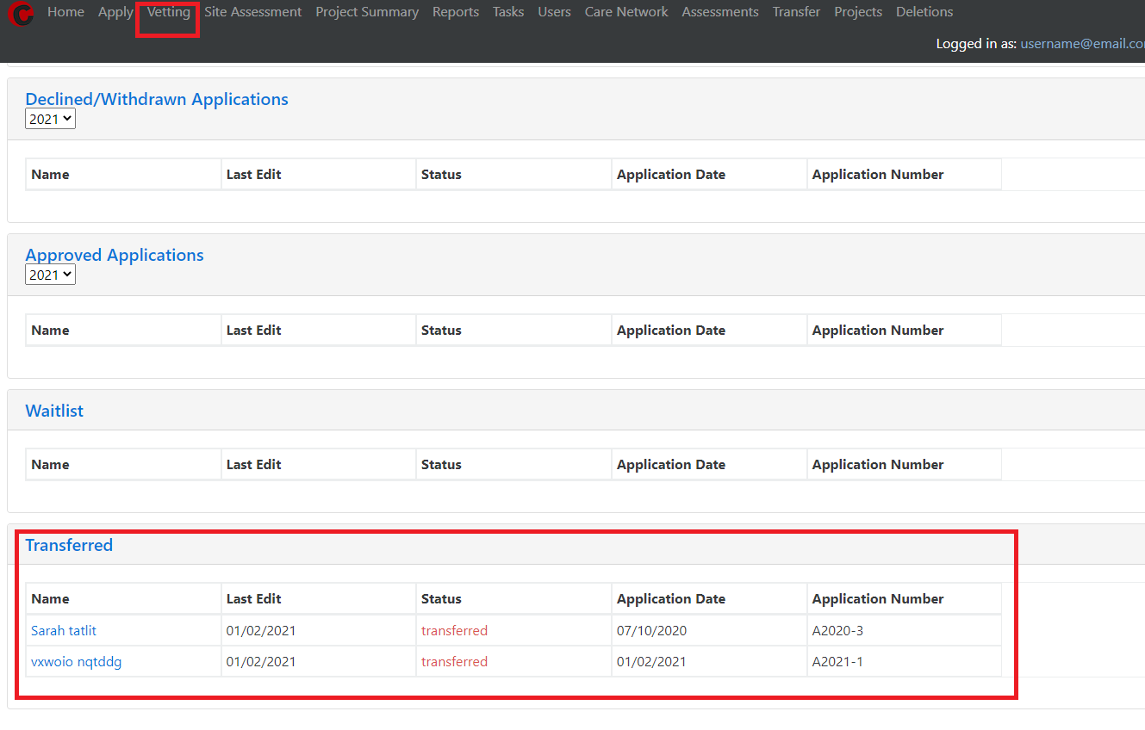

The applicant is “Sarah tatlit”. She was shown as Bessy before because that was her first name, while the vetting page shows her preferred name.

If Bessy needs another construction project, then her status will need to be changed in the vetting edit page back to site assessment - pending:

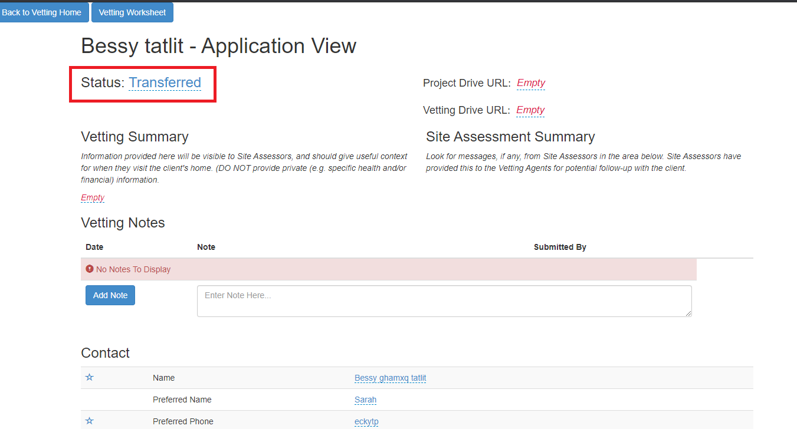

Then the application will be site assessment again with a completely new site assessment. Her previous site assessment is still under “Transferred Assessments” and it is different from the new one: