Trees in Agriculture Policy Analysis

Lisa Meixner McCullough

2022-08-15

Table of Contents

# Document Purpose

1. Import tia1_policy_long
2. Make a custom histogram

# Import Data

#read csv  
policy_long<-read_delim("tia1_policy_long.csv",delim=",",col_names=T)  
policy_long<-policy_long%>%  
 mutate_at(vars(reasonImportance),factor,levels=c("Not Meaningful","Last","Eighth","Seventh","Sixth","Fifth","Fourth","Third","Second","Top"))%>%  
 mutate_at(vars(policyPriority),factor,levels=c("Not Meaningful","Last","Fifth","Fourth","Third","Second","Top"))

# Visualize Data

* Defaults
  + It will include responses for all continents and all biomes

1. Create Histogram Function

crop_histogram<-function(crop,data,what2plot,continent,biome){  
 if(crop!="All"){  
 if(crop=="corn"){  
 data<-data%>%filter(crop=="corn")  
 }  
 if(crop=="wheat"){  
 data<-data%>%filter(crop=="wheat")  
 }  
 if(crop=="soy"){  
 data<-data%>%filter(crop=="soy")  
 }  
 }  
 dimDistinct<-transmute(data,name=name,repTree=repTree)%>%distinct()%>%dim()  
 numResp<-dimDistinct[1]  
  
 data%>%  
 filter(policy!="Other"&policy!="None"&!is.na(policy))%>%  
 ggplot(mapping=aes(x=policy)) +  
 geom_bar(position="fill",aes(fill=policyPriority))+  
 coord_flip()+  
 labs(y="Proportion of Reponses",x=what2plot,title="Expert Responses",subtitle=paste("Continent:",continent," Biome:",biome," Crop:",crop),caption=paste("Number of Unique Responses:",as.character(numResp)))+  
 theme_minimal()+  
 scale_fill_brewer(type="div",palette="RdYlBu",direction=-1,aesthetics=c("fill"))  
}

1. Display plot for All Crops

#initialize defaults  
what2plot<-"Policy"  
continent<-"All"  
biome<-"All"  
var<-"policy"  
fill<-"policyPriority"  
  
crop_histogram(crop="All",data=policy_long,what2plot=what2plot,continent=continent,biome=biome)

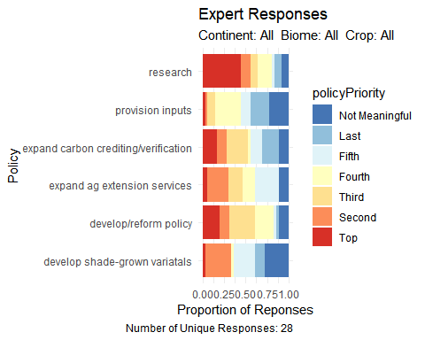 2. Display plot for corn

#initialize defaults  
what2plot<-"Policy"  
continent<-"All"  
biome<-"All"  
var<-"policy"  
fill<-"policyPriority"  
  
crop_histogram(crop="corn",data=policy_long,what2plot=what2plot,continent=continent,biome=biome)

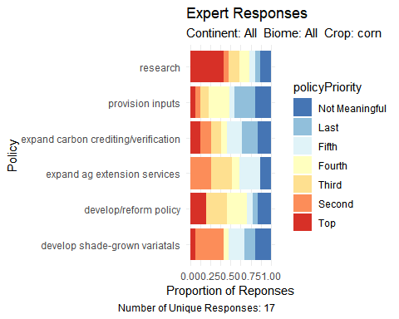

1. Display plot for wheat

#initialize defaults  
what2plot<-"Policy"  
continent<-"All"  
biome<-"All"  
var<-"policy"  
fill<-"policyPriority"  
  
crop_histogram(crop="wheat",data=policy_long,what2plot=what2plot,continent=continent,biome=biome)

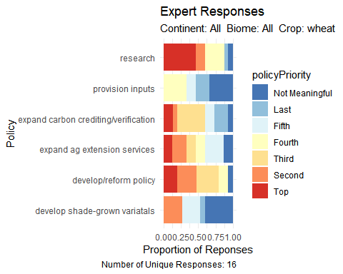

1. Display plot for soy

#initialize defaults  
what2plot<-"Policy"  
continent<-"All"  
biome<-"All"  
var<-"policy"  
fill<-"policyPriority"  
  
crop_histogram(crop="soy",data=policy_long,what2plot=what2plot,continent=continent,biome=biome)

