Documentation for ***ProtModel***

*Selection of the best-fitting substitution model of protein evolution accounting for structural constrains for protein sequences alignments by approximate Bayesian computation*

Current version is 1.0

© 2022. David Ferreiro

[david.ferreiro.garcia@uvigo.es](mailto:david.ferreiro.garcia@uvigo.es) – [ferreirogarciadavid@gmail.com](mailto:ferreirogarciadavid@gmail.com)

08/06/2022

**

**Contents**

Disclaimer 3

Credits 3

1. Purpose 3

1.1. Models 4

2. Versions and Graphical User Interface 4

3. Executables and compilation 5

4. ProtModel execution 6

5. ProtModel usage 6

5.1. The Settings input file 7

5.1.1. Available prior distributions 7

5.1.2. Simulation phase 8

5.1.3. Estimation phase 12

5.2. Screen information with an example 12

5.2.1. ProtModel compilation: 12

5.2.2. ProtModel execution: 16

5.3. Output files 20

5.3.1. ABCOutputs 20

5.3.2. SimulationsOutputs 21

5.4. Re-analysing data 21

5.5. Examples 22

5.6. Message errors and recommendations 22

6. Models and Methods 23

6.1. Evolutionary Models and Computer Simulations 23

6.2. Summary Statistics 23

6.3. ABC Methods 24

6.4. *ProtModel* Performance 24

6.5. Assumptions and Limitations 24

7. Acknowledgments 24

8. References 24

# Disclaimer

This program is free software; you can redistribute it and/or modify it under the terms of the GNU General Public License as published by the Free Software Foundation; either version (at your option) of the License. This program is distributed in the hope that it will be useful, but WITHOUT ANY WARRANTY; without even the implied warranty of MERCHANTABILITY or FITNESS FOR A PARTICULAR PURPOSE. See the GNU General Public License for more details. You should have received a copy of the GNU General Public License along with this program; if not, write to the Free Software Foundation, Inc., 59 Temple Place – Suite 330, Boston, MA 02111-1307, USA.

# Credits

This program was developed at,

* *Department of Biochemistry, Genetics and Immunology, University of Vigo, 36310 Vigo, Spain.*
* *Biomedical Research Centre (CINBIO), University of Vigo, 36310 Vigo, Spain.*

# Purpose

*ProtModel* is an evolutionary framework to estimate the best-fitting substitution model with approximate Bayesian computation (ABC) from protein sequence alignments. *ProtModel* is designed to run either on Linux OS or Mac OSX and it is freely available from <https://github.com/DavidFerreiro/ProtModel>.

The user can specify a prior distribution of substitution rate as well as other evolutionary parameters that will be treated as nuisance parameters, like amino acid frequencies, proportion of invariable sites (+I) or heterogeneity change across sites according to a gamma distribution (+G). Also, there is a graphical user interface (GUI) *ProtModel_GUI* available, which allows for a user-friendly procedure to run *ProtModel* and a version to run it on clusters (*ProtModel_Cluster*) to save computer time and resources.

The computer simulations are performed via the coalescent program *ProteinEvolverProtABC*, a version of the simulator *ProteinEvolver* (<https://github.com/MiguelArenas/proteinevolver>) (Arenas et al., 2013) adapted to ABC. *ProtModel* implements a total of 7 summary statistics (SS). In general, they either explore the stability of the individual sequences of the alignment or the physicochemical properties of the amino acids’ replacements. Conveniently, *ProtModel* can run the simulations on parallel, according to user specifications, to save computer time. This is highly recommended because the simulations under substitution models that consider the stability of the protein and its calculation require a long time.

Three ABC methods are implemented in *ProtModel*, (*i*) the “*rejection*” algorithm which uses the proportion of accepted simulations to estimate the posterior probabilities of the model(s) (Csilléry et al., 2012), (*ii*) the "*mnlogistic*", in which the posterior model probabilities are estimated using a multinomial logistic regression and, (*iii*) using "*neuralnet*", which uses neural networks to predict the probabilities of models based on the observed SS (Beaumont, 2010; Csilléry et al., 2012). For all algorithms, the user must specify the number of simulations to use, the proportion of simulations to retain (tolerance of the algorithm), the number of iterations and which SS to use. *ProtModel* provides also several diagnostic plots to assess qualitatively how well the model fit the data, namely: boxplots of the SS calculated for each investigated model; bar plot of the median distance between the simulations retained SS values and the observed for each model; histograms of the SS of the retained simulations for each model; scatterplots of the SS and the prior distribution for each model; and a plot of the two principal components from the SS calculated from simulations. In all the plots, the values for the target protein alignment data are superimposed in blue except for PCA plot, where the target protein alignment data value is represented by a black cross.

## Models

*ProtModel* is able to work with both empirical or site independent and with site-dependent substitution models that consider the stability of the protein, called structural constrain substitution (SCS) models (Arenas et al., 2015). In case of empirical substitution models, the user can select among Blosum62 (Henikoff & Henikoff, 1992), CpRev (Adachi et al., 2000), Dayhoff (Dayhoff et al., 1978), DayhoffDCMUT (Kosiol & Goldman, 2005), HIVb (Nickle et al., 2007), HIVw (Nickle et al., 2007), JTT (Jones et al., 1992), JonesDCMUT (Kosiol & Goldman, 2005), LG (Le & Gascuel, 2008), Mtart (Abascal et al., 2006), Mtmam (Yang et al., 1998), Mtrev24 (Adachi & Hasegawa, s. f.), RtRev (Dimmic et al., 2002), VT (Müller & Vingron, 2000), WAG (Whelan & Goldman, 2001) and UserEAAM models (Arenas, 2015) (the latter is a user-defined model that must be provided as an additional input file with name UserEAAM, the format of this file is explained with details in the documentation of the simulator *ProteinEvolver* (Arenas et al., 2013)). Within SCS models, there are two available, mean-field Neutral (which does not consider population size) and mean-field Fitness (which needs user specified population size) (Arenas et al., 2015).

# Versions and Graphical User Interface

The folder available from GitHub includes two versions of the *ProtModel* framework, one to run on the local computer (“*ProtModel*” folder) and another to run in a cluster (“*ProtModel_Cluster*”).

## *ProtModel*

***GUI***

The user can run the framework in their computer using the command lines or using a Python graphical user interface (GUI), which allow the user to work with the program without using the command line. The GUI will display two consecutive windows. The first one allows the user to choose between the mandatory parameters and to fill the optional if intended (see section 4.1). Settings must be specified carefully, incorrect specification may be detected by the framework automatically (e.g., it does not allow negative substitution rates), yet user-specified settings without biological meaning may produce errors in *ProtModel* analysis, even though when the analysis runs completely (see section 4.2). The second window will launch the simulations, SS calculation and the consecutive ABC analyses. While the program is running, it will inform about the progress and it will be show up a message when it ends (see section 4.3.2).

***Command line***

GUI and command line version works in the same way. However, in this version the user has to change manually the Settings input file, including both the value of the parameters as well as maintaining the format (see section 4.2). Remove or add any characters may cause *ProtModel* to fail and such changes may be difficult to detect. We recommend to use one of the Settings.txt files of the “*Examples*” folder and change the values carefully. Once the framework was executed it will check Settings inputs and launch simulations, SS calculation and the consecutive ABC analyses. Some information about the progress will be printed on the command line (see section 4.3.2).

## *ProtModel_Cluster*

This version of *ProtModel* can be run on clusters if they are based on Linux OS environments. It enables the user to work with many more processors and in parallel without sharing memory taking advance of MPI interface. Like the command line version, the user must manually fill the Settings input file considering the biological meaning of the input values and the format of the file (see section 4.2). *ProtModel_Cluster* execution will check the Settings inputs and compute the SS of the multiple sequence alignment (MSA), but won’t launch the simulations and their corresponding SS calculation. While the execution, some batch script will be created and to run simulations and their corresponding SS calculation we have to submit a master batch script called “*launch_Simu.sh*” to Slurm (a task and cluster management system). Once the analysis finished, we will find the same output files and folders as in a local computer execution (see section 4.4). However, the user has to perform the ABC estimation in their computer because the cluster don’t have an updated R version whit the ABC library (see section 4.3.2). Everything needed to carry out the ABC estimation will be placed in the “*ABCOutputs*” folder, the user only needs to change the directory rout of the “*ABCAnalysis.r*” file.

# Executables and compilation

*ProtModel* requires that Python3 (<https://www.python.org/downloads/>) and R (https://www.r-project.org), as well some libraries, are installed by the user (Table 1) Note that some python libraries may be already installed by default. Python libraries can be installed by the command: pip install ("*library_name*") in the terminal or, in the case of R, by the command install.packages("*library_name*") in the R environment. See further details in <https://docs.python.org/3/installing/index.html>, [http://cran.r-project.org/doc/manuals/R-admin.html#Installing-packages](http://cran.r-project.org/doc/manuals/R-admin.html" \l "Installing-packages). For example,

*pip install numpy*

*install.packages("abc")*

Our program works using the *ProteinEvolverProtABC* simulator (Arenas et al., 2013) and the *DeltaGREM* software (Arenas et al., 2017), which are used to perform the protein sequences simulations and to calculate the protein free energy, respectively. They are placed in the “*source*” folder with a csv file called “*Grantham*”, and all of them should not be modified by the user. The folder “*GUI*” contains the GUI executable and two images needed to run it. *ProtModel* pipeline consists on 6 executable files needed to execute the framework but the user should only execute the main file called “*ProtModelGeneral.py*”. All these folders and files must not be modified to a properly execution of *ProtModel*.

*ProtModel* must be compiled for the OS through a Makefile file which is placed on the main directory. It will compile *ProteinEvolverProtABC* and *DeltaGREM* programs and will create the executables and place them in the folder “*bin*”.

Table 1. Libraries needed to run *ProtModel*

|  |  |  |
| --- | --- | --- |
| *Name* | *Language* | *Version* |
| abc | R | Command line and GUI |
| os | Python | All |
| sys | Python | All |
| Biopython | Python | All |
| random | Python | All |
| numpy | Python | All |
| warnings | Python | All |
| pandas | Python | All |
| csv | Python | All |
| multiprocessing | Python | Command line and GUI |
| re | Python | All |
| platform | Python | All |
| mpi4py | Python | Cluster |
| threading | Python | GUI |
| tkinter | Python | GUI |
| tkmacosx | Python | GUI |
| time | Python | GUI |

# *ProtModel* usage

*ProtModel* have four mandatory input files:

* **Settings file:** This file, named Settings.txt, must contain all the desired specifications for simulations and ABC estimation. It has to be carefully specified, incorrect parameters values will be detected (e.g., it does not allow negative substitution rates) but user-specified settings without biological meaning may produce errors in *ProtModel* analysis.
* **Multiple alignment of protein sequences:** The protein sequence alignment that will be analyzed must be provided by the user in sequential *phylip* format (.phy). It requires that each sequence identifier is exactly 10 characters long, padded with spaces when necessary. In addition, work with template structures demands that the MSA has to have the same length as template chain. So, sequences have to be aligned with the one template chain sequence and remove the positions that in the template sequence has a gap in every sequence. For all this process, we strongly recommend to use “*Align.py*” script placed in the folder “*Scripts*” (see section 4.1.). Another option could be use other programs as *MUSCLE* (Edgar, 2004) for sequences alignment or “*Phylogeny.fr*” (Dereeper et al., 2008) to convert into *phylip* format (<http://phylogeny.lirmm.fr/phylo_cgi/data_converter.cgi>), but the user must check all the process and the number of characters of the sequences identifier carefully to avoid errors.
* **Template structure:** This is a protein structure (.pdb file) which has the highest homology with the multiple alignment of protein sequences. We advised to use *SWISS-MODEL* (Waterhouse et al., 2018) to find the best template (<https://swissmodel.expasy.org>). *SWISS-MODEL* works with a maximum of 10 sequences, so we include the “*Find-WT.py*” python script in the “*Scripts*” folder, which return wild-type (WT; a sequence composed by the most common amino acid per site) to find the template in *SWISS-MODEL* that better represents the alignment (see section 4.1.).
* **Structures.in:** This file contains structural information needed for stability calculation (needed to calculate two of the SS, namely the DGREM_Mean and the DGREM_sd) and for MSA simulations under SCS models. It cannot be modified.

## Before starting

Before starting a *ProtModel* analysis the user must do some extra work. First, although the framework uses *phylip* format, the user needs the protein alignment in *fasta* format. Then, we recommend to use *SWISS-MODEL* (Waterhouse et al., 2018) to find the best template (<https://swissmodel.expasy.org>). If the MSA includes more than 10 sequences, *SWISS-MODEL* will fail, in which case we recommend to use the “*Find-WT.py*” python script in the “*Scripts*” folder, which return the WT sequence.

*python FindWT.py --input MSA.fasta*

Next, the WT sequence will be used to find the template in *SWISS-MODEL* that better represents the alignment. Usually, the user must download the first template of the results screen, but it is recommended to check the X-ray when possible, to avoid high values. Work with template structures requires the MSA to have the same length as the template chain. So, sequences have to be aligned with the template chain sequence and positions that have a gap in the template sequence have to be removed in every sequence. The “*Align.py*” script placed in the folder “*Scripts*” will make the alignment, remove the gaps positions and change the file into *phylip* format. Another option could be using other programs as *MUSCLE* (Edgar, 2004) for sequences alignment or “*Phylogeny.fr*” (Dereeper et al., 2008) to convert into *phylip* format. “*Align.py*” works with an input *fasta* MSA (--input), a template structure (--temp), the chain of the template (--chain) and the desired name of the output file, which must have the .*phy* extension (--output).

*python Align.py --input MSA.fasta --temp structure.pdb --chain A to Z --output MSA.phy*

*ProtModel* aim is to include SCS models in an evolutionary framework to estimate the best-fitting substitution model. Thus, it is not the best option to estimate the best-fitting substitution model between empirical models. The recommended use of *ProtModel* is to **compare the two SCS models with an empirical substitution model previously selected for the alignment** using other programs, such as *ProtTest* (Darriba et al., 2011). To perform the simulations the user must design a prior distribution for the substitution rate per site. This can be an unfamiliar measure, so we also include a script which for a desired theta (*θ*) value will return the sequences identity of the MSA and substitution rate per site, asking if the organism is haploid or diploid and the population size. Sequence identity will give us an idea about the *θ* value, if it is very high, we should not use a high *θ* (>500).

*Theta.py --input NS1.phy*

The recommend structure of a *ProtModel* analysis consists on a folder located at a user-defined path, including the Settings.txt file, the MSA, the template .*pdb*, the *structures.in* file and all *ProtModel* material (including executable files and folders). Examples well prepared for a standard *ProtModel* run are provided in the folder “*Examples*”. After completing a run of *ProtModel,* two folders are created in the working directory, the “*ABCOutputs*” and the “*SimulationsOuputs*” folders (see details in section 4.4). Since the estimation phase is quite fast in comparison with the simulation phase, the user is advised to explore different settings for the ABC method (see section 4.5 in “*Re-analyzing data*”) if desired, without having to run again the simulation phases.

## The Settings input file

The Settings input file must contain all the information required to perform the analysis. It is highly recommended to be carefully handled by the user since mistakes may alter results (error messages will be displayed on the screen and may suggest stop the execution by typing CTRL+C) or use the GUI.

The file consists of two main blocks, the simulation phase and the estimation phase.

**Important notes when handling with the Settings file**

- Parameter values must be introduced in the line after the parameter description, otherwise such parameter will be considered as “*not specified*” (see examples below).

- Do not modify the parameter description (it is used by the program to identify the parameter).

- Some parameters are mandatory and must be specified, these parameters contain an “*\**” (see below).

- Some parameters require a prior distribution (see section 4.1.1), this is a distribution of the parameters values used to perform the simulations which should include the presumed value (for example, if the user believes that the substitution rate per site can be 0.1 then the prior distribution of the substitution rate per site should include 0.1).

### Available prior distributions

Several distributions are included in *ProtModel* to simulate protein data under different evolutionary scenarios (Table 2). In addition, most of them can be truncated at lowest and highest values. However, note that some parameters must be specified by an integer number (e.g., generation time) while others by a float number (e.g., amino acid frequencies). Therefore, not all distributions can be applied to any parameter. Details for each particular parameter are described in the following subsections.

Table 2. Available distributions in ProtModel.

|  |  |  |  |
| --- | --- | --- | --- |
| *Distribution* | *Description* | *Truncated* | *Examples* |
| fix | Fixed value (integer or non-integer) | n.a. | fix 4; fix 0.7 |
| Uniform (*uniform*) | Random between two values (integer or non-integer): lowest highest | n.a. | uniform 1.0e-8 1.0e-5; uniform 2e-9 5e-6; uniform 0 3 |
| Normal (*norm*) | Normal distribution (mean, sd) | t # # | norm 1.0e-8 1.0e-5; norm 1.0e-8 1.0e-5 t 1.0e-9 1.0e-6 |
| Exponential (*exp*) | Exponential distribution (rate) | t # # | exp 1.0e-7; exp 1.0e-7 t 1.0e-8 1.0e-6 |
| Gamma (*gamma*) | Gamma distribution (shape, rate “1/scale”) | t # # | gamma 1.0e-7 5.0e-7; gamma 1.0e-7 5.0e-7 t 2.0e-7 1.0e-6 |
| beta | Beta distribution (shape1, shape 2) | t # # | beta 1.0e-7 5.0e-7; beta 1.0e-7 5.0e-7 t 2.5e-7 1.0e-6 |
| Dirichlet | Dirichlet distribution (alpha “vector”) | n.a. | dirichlet 1 1 1 1; dirichlet 1 1 1 1 1 1 |

### 

### Simulation phase

***General settings for the simulation***

* **Name of the file with the target protein sequences alignment.** This specification is mandatory. Only specify the filename (i.e., no pathway) since the target alignment file needs to be placed in the same pathway as the Settings.txt file.

*### Target alignment file ### # phylip format*

*\*NameOfPhylipFile=* *ProtSeq1.phy*

* **Number of simulations.** This parameter is mandatory. We recommend at least 1 000 computer simulations but with 10 000 simulations results should be accurate. However, the number of simulations required to obtain accurate estimates depends on many factors, especially the target MSA. More complex sequences (large molecular diversity) may require more simulations due to the irregularity of the parametric landscape that requires more sampling.

*### Total number of simulations ###*

*\*NumberOfSimulations=10000*

* **Consideration of indels.** This parameter is mandatory. The user specifies if indels (gaps) should be “*Ignored*” (by default and recommended) or considered as a “*NewState*”. This decision can affect the SS if there are indels in the multiple sequence alignment.

*# Consideration of indels. "Ignored" (indels are ignored), "NewState" (indels are considered as a new state). See documentation for details*

*\*Indels=Ignored*

* **Number of processors to run the simulations in parallel on a machine.** This parameter is mandatory (by default using the GUI simulations run on all user computer processors). This parallelization works on machines using Linux OS with shared memory. Ideally, one should specify at the most the number of available processors of the machine.

*# Number of available processors to run the simulations in parallel. All recommended*

*\*NumberOfProcessors=12*

* **Save simulated data.** This parameter is mandatory. It is recommended to not save the simulated data because it requires a lot of space in the hard disk of the user’s computer. If the user wants to save the data it will be placed in a compressed folder called “*Simulations.tar.gz*”. Note that even if choosing not to save simulated data, simulated data is created and saved temporally since this data is required for calculating the SS in the following step.

*#* *Save simulated data. “No”, “Yes” (but it requires space in the disk)*

*\*SaveSimulations=No*

* **Show running information.** This parameter is mandatory. If the user chooses “*No*” the amount of information printed on the screen during *ProtModel* execution will be reduced. This option is recommended to save computing time (printing information on the screen requires more resources). Regardless of the option selected, the results will not change, it only affects to the amount of information shown on the screen during the execution.

*# Show running information (simulations and summary statistics) on the screen. “No”, “Yes” (but it slows down the running time)*

*\*ShowInformationScreen=No*

***Demographic settings***

* **Haploid/diploid simulated data.** This parameter is mandatory. Haploid is defined with a value of 1 and diploid with a value of 2.

*# Haploid or Diploid data (haploid=1, diploid=2)*

*\*Haploid/Diploid=2*

* **Effective population size (*N*).** This parameter is mandatory. The parameter value must be an integer.

*# Population size (i.e., 1000).*

*\*PopulationSize=1000*

***Longitudinal sampling***

* **Sampling at different times.** This parameter is optional. The user can specify the time at which the tip nodes of the tree were sampled **in years**. In the example, 4 sampling times are specified: sampled in 1995 - sequences 1 to 10; sampled in 2003 - sequences 11 to 16; sampled in 1997 - sequences 17 to 26; sampled in 2001: sequences 7 and 8. Note that this option does not work if a deme converges, backwards in time, before the last sampling time.

*# Logitudinal sampling. Requires GenerationTime. See documentation for details*

*DatedTips=4 1995 1 10 2003 11 16 1997 17 26 2001 27 29*

* **Generation time.** This parameter is optional. The user can specify the time for each generation. The parameter value can be fixed (fix) or sampled from a uniform distribution.

*# Generation time. fix, uniform; i.e., uniform 500 1000. See documentation for details*

*GenerationTime=fix 1200*

* **Growth rate.** This parameter is optional. The first number specifies the model, exponential growth rate (0) or demographic periods (1). These parameters are looking back in time, so it is not recommended to specify a negative growth rate for the last period, as the coalescent time could become infinite in the past. For an exponential growth per individual per generation, after “*0*” the growth rate must be specified. In the example the user chose an exponential growth model with a rate of 1e-5 (= 0 0.00001).

*# Exponential growth rate or Demographic periods. See documentation for details*

*Growthrate=0 1e-5*

For demographic periods, after “*1*” the user has to specify the number of periods (from the present to the past). For each period should be three consecutive numbers indicating the size at the beginning and at the end of the period, and the duration of the period in generations. In the example the user chose a growth model based on demographic periods with 3 periods. In the first one, the population size increases from 1000 to 1250 during 1000 generations, the second starts with a population size of 1300 from 1550 from generations 1000-2000 and finally during the last period (2000-3000) the population size decrease from 1560 to 1000.

*# Exponential growth rate or Demographic periods. See documentation for details*

*Growthrate=1 3 1000 1250 1000 1300 1550 2000 1560 1000 3000*

* **Migration model.** This parameter is optional. The first number specifies the migration model (island model=1, stepping-stone model=2, continent-island model=3). The second number specifies the total number of demes or subpopulations sampled. The next *n* numbers specify the number of individuals (or sequences) per deme (note that the specified sample size must be equal to the sum of these). For the island-continent model, deme #1 will be the continent while the other demes will be islands. In this example the user chose a stepping-stone model, two demes with three samples each.

*# Migration model and population structure. See documentation for details*

*MigrationModel=2 2 3 3*

* **Migration rate.** This parameter is optional. This parameter introduces the migration rate, which can be constant or vary through time according to temporal periods. The first number specifies the number of temporal periods: for only 1 period, the second number is the migration rate (constant). In this example the user chose only 1 period with migration rate = 0.001.

*# Migration rate (constant or variable with time according to temporal periods). See documentation for details*

*MigrationRate=1 0.001*

For more than one period, the second number is the time for the beginning of a new migration rate and the third numbers are the migration rate corresponding to each period. In the following example, the user set a migration rate that varied among two period, the first period occurs from generation 0 to 100 with a migration rate of 0.001, and the second period occurs from generation 100 to the end of the simulation with a migration rate of 0.005).

*# Migration rate (constant or variable with time according to temporal periods). See documentation for details*

*MigrationRate=2 100 0.001 0.005*

In this next example the migration rate varied among three periods: the first period occurs from generation 0 generation 100 with a migration rate of 0.002, the second period occurs from generation 100 to the generation 800 with a migration rate of 0.001, and the last period goes from the generation 800 to the end of the simulation with a migration rate of 0.003.

*# Migration rate (constant or variable with time according to temporal periods). See documentation for details*

*MigrationRate=3 100 800 0.002 0.001 0.003*

* **Convergence demes.** This parameter is optional. The first number specifies the total number of convergent events. For each convergence event should be three consecutive numbers. The first number and the second number are the numbers of the demes to converge. The third number is the time to that convergence. With this option the user can build the demes evolutionary tree but it is only available when the migration model is activated (despite the migration rate could be zero). In the following example there is one convergence event between demes 1 and 2 at time 2000 to create a new deme.

*# Events of convergence of demes. See documentation for details*

*ConvergenceDemes= 1 1 2 2000*

In this next example there are 3 convergence events, between deme 1 with deme 2 at time 400 to create a new deme 5, convergence of deme 3 with deme 4 to create a new deme 6 at time 1900, convergence of deme 5 with deme 6 at time 2000 to create a final new deme 7).

*# Events of convergence of demes. See documentation for details*

*ConvergenceDemes= 3 1 2 400 3 4 1900 5 6 2000*

***Protein evolution and substitution model***

* **Amino acid substitution rate per site.** This parameter is mandatory. Distributions allowed: *fix*, *uniform*, *norm*(t), *exp*(t), *gamma*(t), *beta*(t) (see Table 2).

*# Amino acid substitution rate. i.e., fix 7.0e-6. See documentation for details*

*\*SubstitutionRate=uniform 0 1.67e-4*

* **Empirical substitution model of amino acid evolution.** This parameter is mandatory. The user has to specify the desire empirical substitution model of protein evolution separated by a space among the following: Blosum62, CpRev, Dayhoff, DayhoffDCMUT, HIVb, HIVw, JTT, JonesDCMUT, LG, Mtart, Mtmam, Mtrev24, RtRev, VT, WAG, UserEAAM (the latter is a user-defined model that must be provided as an additional input file with name UserEAAM, the format of this file is explained with details in the documentation of the simulator *ProteinEvolver* (Arenas et al., 2013)). We **highly recommend to use only the best-fitting empirical substitution model for the alignment** which can be obtained using some programs as *ProtTest* (Darriba et al., 2011).

*# Model of amino acid substitution (i.e., Blosum62, CpRev, Dayhoff, DayhoffDCMUT, HIVb, HIVw, JTT, JonesDCMUT, LG, Mtart, Mtmam, Mtrev24, RtRev, VT, WAG, UserEAAM)*

*\*SubstitutionModel=JTT*

* **SCS models of amino acid evolution.** This parameter is mandatory. The user has to specify the desire SCS models of protein evolution (Fitness and/or Neutral) separated by a space.

*# Model of structural amino acid substitution (Fitness, Neutral)*

*\*StructuralSubstitutionModel=Fitness Neutral*

* **Amino acid frequencies.** This parameter is mandatory. Frequencies for each amino acid site along sequences. Distributions allowed: fix or dirichlet. If it is not specified the program will assume equally distributed frequencies (all fix with value 0.05).

*# Amino acid frequencies. fix or dirichlet. By default, equally distributed frequencies. i.e., dirichlet 1 1 1 1 1 1 1 1 1 1 1 1 1 1 1 1 1 1 1 1*

*\*AminoacidFrequencies=fix 0.05 0.05 0.05 0.05 0.05 0.05 0.05 0.05 0.05 0.05 0.05 0.05 0.05 0.05 0.05 0.05 0.05 0.05 0.05 0.05*

* **Rate of heterogeneity across sites (+G).** This parameter is optional. Distributions allowed: *fix*, *uniform*, *norm*(t), *exp*(t), *gamma*(t), *beta*(t).

*# Rate of heteregeneity across sites, +G. fix, uniform, gamma, beta, normal, exponential; i.e., fix 0.6*

*RateHetSites=uniform 0.76 0.90*

* **Proportion of invariable sites (+I).** This parameter is optional. Distributions allowed: *fix*, *uniform*, *norm*(t), *exp*(t), *gamma*(t), *beta*(t). For example,

*# Proportion of invariable sites, +I. fix, uniform, gamma, beta, normal, exponential; i.e., exponential 0.002 t 0 1.0*

*PropInvSites=uniform 0.3 0.5*

* **Template.** This parameter is mandatory. PDB protein structure used to structural substitution models and to calculate proteins free energy.

*# PDB protein structure used to structural substitution models. See documentation for details*

*\*Template=3IXO.pdb*

* **Chain.** This parameter is mandatory. PDB protein chain used to structural substitution models and to calculate proteins free energy. For example,

*# Chain of the PDB protein structure used to structural substitution models. See documentation for details*

*\*Chain=A*

* **GMRCA.** This parameter is optional. By default, the grand most recent common ancestor or the partial most recent common ancestor (GMRCA/MRCA) sequence is simulated according to the amino acid frequencies. However, the user can optionally specify its own root sequence by a text file which must be located in the main directory. The file just contains in a single sequence. In case the user does not select any GMRCA/MRCA template sequence will be used, which is highly recommended.

*# GMRCA input file. See documentation for details*

*GMRCA=GMRCA.txt*

***Graphical settings***

* **Multiple pages.** This parameter is mandatory. PDF documents with multiple plots per page (No, Yes). For example,

*#* *Multiple pages. PDF documents with multiple plots per page (No, Yes)*

*\*MultiPage=Yes*

### Estimation phase

***ABC estimation***

* **ABC iterations.** This parameter is mandatory. Number of cross-validation events for each model. We recommend the user to not select a high value which might take too much time. Note that the number of simulations must be equal or less than the number of iterations.

*#ABC iterations. Number of cross-validation events for each model (Iterations <= NumberOfSimulations). See documentation for details*

*\*ABCIterations=100*

* **ABC tolerance.** This parameter is mandatory. An user-defined proportion of simulations that generated SS close to the real SS and are retained to perform the ABC procedure. A tolerance of 0.01 can be enough but the value of tolerance that gives the best results may vary among MSAs. We recommend the user to explore different values.

*#ABC tolerance. % of simulations closest to real data to retain in the ABC procedure. See documentation for details*

*\*ABCTolerance=0.01*

* **ABC method.** This parameter is mandatory. The ABC algorithm has to be specified. The user can choose between *rejection*, *mnlogistic* or *neuralnet*.

*#ABC method (rejection, mnlogistic, neuralnet). See documentation for details*

*\*ABCMethod=rejection*

* **Summary statistics.** This parameter is mandatory. The user needs to choose the SS to use for the ABC estimation by specifying their numeric ID (see Table 4 and section 5 “*Models and Methods*” for further details).For initial exploratory analyses, we recommend to specify the 7 SS implemented in the program. Later, analysing the output plots the user can inspect which suit better for the data. For example, in some cases where the folding stability standard deviation (SS 2) is far from the real data value we recommend to disregard it.

*#Summary statistics to use. See documentation for details*

*\*SummaryStatistics= 1 2 3 4 5 6 7*

## Screen information with an example

The data shown below corresponds with the normal output information of a ProtModel run. To the first phase of the program, the user has to use computer terminal. The example corresponds with a rapid project, in which we tried to distinguish between the empirical HIVw and the SCS Neutral models. Before try this example, you have to have installed Python 3 and R.

### ProtModel compilation:

* First, the user needs to be in the main directory of *ProtModel*. The bold name files bellow corresponds to the mandatory input files, while the rest are the files and folders inside the *ProtModel* directory available to download.

*Test_ProtModel %* ***ls***

**3on9.pdb** LeerSettings.py Variables.py

ChangeVariablesPE.py Makefile source

Errores.py ProtModelGeneral.py **structures.in**

Functions.py **Settings.txt**

GUI **TNF.phy**

* Then, the “*make all*” command compiles all the programs (*ProteinEvolutionProtABC* and *DeltaGREM*).

*Test_ProtModel %* ***make all***

*Creating bin folder ...*

*Done!*

*Copying Grantham.csv file ...*

*Done!*

*Compiling DeltaGREM ...*

*/Library/Developer/CommandLineTools/usr/bin/make -C source/DeltaGREM_src clean*

*rm -fr main_DeltaGREM.o REM.o random3.o Get_pars_DeltaGREM.o alignments.o mutations.o Codes.o Input.o gen_code.o allocate.o output.o read_pdb.o read.o Sec_str_all.o NeedlemanWunsch.o Profit_aux.o DeltaGREM*

*/Library/Developer/CommandLineTools/usr/bin/make -C source/DeltaGREM_src all*

*gcc -O2 -Wall -std=c99 -pedantic -g -pg -D_FILE_OFFSET_BITS=64 -D_LARGE_FILE_SOURCE -c -o main_DeltaGREM.o main_DeltaGREM.c*

*gcc -O2 -Wall -std=c99 -pedantic -g -pg -D_FILE_OFFSET_BITS=64 -D_LARGE_FILE_SOURCE -c -o REM.o REM.c*

*gcc -O2 -Wall -std=c99 -pedantic -g -pg -D_FILE_OFFSET_BITS=64 -D_LARGE_FILE_SOURCE -c -o random3.o random3.c*

*gcc -O2 -Wall -std=c99 -pedantic -g -pg -D_FILE_OFFSET_BITS=64 -D_LARGE_FILE_SOURCE -c -o Get_pars_DeltaGREM.o Get_pars_DeltaGREM.c*

*gcc -O2 -Wall -std=c99 -pedantic -g -pg -D_FILE_OFFSET_BITS=64 -D_LARGE_FILE_SOURCE -c -o alignments.o alignments.c*

*gcc -O2 -Wall -std=c99 -pedantic -g -pg -D_FILE_OFFSET_BITS=64 -D_LARGE_FILE_SOURCE -c -o mutations.o mutations.c*

*gcc -O2 -Wall -std=c99 -pedantic -g -pg -D_FILE_OFFSET_BITS=64 -D_LARGE_FILE_SOURCE -c -o Codes.o Codes.c*

*gcc -O2 -Wall -std=c99 -pedantic -g -pg -D_FILE_OFFSET_BITS=64 -D_LARGE_FILE_SOURCE -c -o Input.o Input.c*

*gcc -O2 -Wall -std=c99 -pedantic -g -pg -D_FILE_OFFSET_BITS=64 -D_LARGE_FILE_SOURCE -c -o gen_code.o gen_code.c*

*gcc -O2 -Wall -std=c99 -pedantic -g -pg -D_FILE_OFFSET_BITS=64 -D_LARGE_FILE_SOURCE -c -o allocate.o allocate.c*

*gcc -O2 -Wall -std=c99 -pedantic -g -pg -D_FILE_OFFSET_BITS=64 -D_LARGE_FILE_SOURCE -c -o output.o output.c*

*gcc -O2 -Wall -std=c99 -pedantic -g -pg -D_FILE_OFFSET_BITS=64 -D_LARGE_FILE_SOURCE -c -o read_pdb.o read_pdb.c*

*gcc -O2 -Wall -std=c99 -pedantic -g -pg -D_FILE_OFFSET_BITS=64 -D_LARGE_FILE_SOURCE -c -o read.o read.c*

*read.c:251:1: warning: control may reach end of non-void function*

*[-Wreturn-type]*

*}*

*^*

*1 warning generated.*

*gcc -O2 -Wall -std=c99 -pedantic -g -pg -D_FILE_OFFSET_BITS=64 -D_LARGE_FILE_SOURCE -c -o Sec_str_all.o Sec_str_all.c*

*gcc -O2 -Wall -std=c99 -pedantic -g -pg -D_FILE_OFFSET_BITS=64 -D_LARGE_FILE_SOURCE -c -o NeedlemanWunsch.o NeedlemanWunsch.c*

*gcc -O2 -Wall -std=c99 -pedantic -g -pg -D_FILE_OFFSET_BITS=64 -D_LARGE_FILE_SOURCE -c -o Profit_aux.o Profit_aux.c*

*gcc main_DeltaGREM.o REM.o random3.o Get_pars_DeltaGREM.o alignments.o mutations.o Codes.o Input.o gen_code.o allocate.o output.o read_pdb.o read.o Sec_str_all.o NeedlemanWunsch.o Profit_aux.o -o DeltaGREM -lm -L/usr/lib64/libg2c.so.0.0.0*

*ld: warning: directory not found for option '-L/usr/lib64/libg2c.so.0.0.0'*

*Done!*

*Compiling ProteinEvolverProtABC ...*

*/Library/Developer/CommandLineTools/usr/bin/make -C source/ProteinEvolverProtABC clean*

*Removing object and executable files to save space*

*Finished cleanup.*

*/Library/Developer/CommandLineTools/usr/bin/make -C source/ProteinEvolverProtABC all*

*Building ProteinEvolverProtABC version 1.2.0*

*gcc -c -O3 -Wall ProteinEvolverProtABC1.2.0.c*

*ProteinEvolverProtABC1.2.0.c:2035:16: warning: taking the absolute value of*

*unsigned type 'unsigned short' has no effect [-Wabsolute-value]*

*seed = seed + fabs(tmb.millitm);*

*^*

*ProteinEvolverProtABC1.2.0.c:2035:16: note: remove the call to 'fabs' since*

*unsigned values cannot be negative*

*seed = seed + fabs(tmb.millitm);*

*^~~~*

*ProteinEvolverProtABC1.2.0.c:16910:33: warning: using floating point absolute*

*value function 'fabs' when argument is of integer type [-Wabsolute-value]*

*arrayIndBreakpointsOrd_C[i] = fabs(arrayIndBreakpointsOrd[i]/3);*

*^*

*ProteinEvolverProtABC1.2.0.c:16910:33: note: use function 'abs' instead*

*arrayIndBreakpointsOrd_C[i] = fabs(arrayIndBreakpointsOrd[i]/3);*

*^~~~*

*abs*

*ProteinEvolverProtABC1.2.0.c:25094:33: warning: using floating point absolute*

*value function 'fabs' when argument is of integer type [-Wabsolute-value]*

*arrayIndBreakpointsOrd_C[i] = fabs(arrayIndBreakpointsOrd[i]/3);*

*^*

*ProteinEvolverProtABC1.2.0.c:25094:33: note: use function 'abs' instead*

*arrayIndBreakpointsOrd_C[i] = fabs(arrayIndBreakpointsOrd[i]/3);*

*^~~~*

*abs*

*ProteinEvolverProtABC1.2.0.c:25285:33: warning: using floating point absolute*

*value function 'fabs' when argument is of integer type [-Wabsolute-value]*

*arrayIndBreakpointsOrd_C[i] = fabs(arrayIndBreakpointsOrd[i]/3);*

*^*

*ProteinEvolverProtABC1.2.0.c:25285:33: note: use function 'abs' instead*

*arrayIndBreakpointsOrd_C[i] = fabs(arrayIndBreakpointsOrd[i]/3);*

*^~~~*

*abs*

*ProteinEvolverProtABC1.2.0.c:27134:22: warning: format string is not a string*

*literal (potentially insecure) [-Wformat-security]*

*sprintf(FILE_CODE, FILE_CODE_DEF);*

*^~~~~~~~~~~~~*

*/Library/Developer/CommandLineTools/SDKs/MacOSX.sdk/usr/include/secure/_stdio.h:47:56: note:*

*expanded from macro 'sprintf'*

*__builtin___sprintf_chk (str, 0, __darwin_obsz(str), __VA_ARGS__)*

*^~~~~~~~~~~*

*ProteinEvolverProtABC1.2.0.c:27134:22: note: treat the string as an argument to*

*avoid this*

*sprintf(FILE_CODE, FILE_CODE_DEF);*

*^*

*"%s",*

*/Library/Developer/CommandLineTools/SDKs/MacOSX.sdk/usr/include/secure/_stdio.h:47:56: note:*

*expanded from macro 'sprintf'*

*__builtin___sprintf_chk (str, 0, __darwin_obsz(str), __VA_ARGS__)*

*^*

*ProteinEvolverProtABC1.2.0.c:27709:22: warning: format string is not a string*

*literal (potentially insecure) [-Wformat-security]*

*sprintf(FILE_CODE, FILE_CODE_DEF);*

*^~~~~~~~~~~~~*

*/Library/Developer/CommandLineTools/SDKs/MacOSX.sdk/usr/include/secure/_stdio.h:47:56: note:*

*expanded from macro 'sprintf'*

*__builtin___sprintf_chk (str, 0, __darwin_obsz(str), __VA_ARGS__)*

*^~~~~~~~~~~*

*ProteinEvolverProtABC1.2.0.c:27709:22: note: treat the string as an argument to*

*avoid this*

*sprintf(FILE_CODE, FILE_CODE_DEF);*

*^*

*"%s",*

*/Library/Developer/CommandLineTools/SDKs/MacOSX.sdk/usr/include/secure/_stdio.h:47:56: note:*

*expanded from macro 'sprintf'*

*__builtin___sprintf_chk (str, 0, __darwin_obsz(str), __VA_ARGS__)*

*^*

*ProteinEvolverProtABC1.2.0.c:33636:38: warning: for loop has empty body*

*[-Wempty-body]*

*{ int i; for (i=0; i<n; x[i]*=a,i++) ; return(0); }*

*^*

*ProteinEvolverProtABC1.2.0.c:33636:38: note: put the semicolon on a separate*

*line to silence this warning*

*ProteinEvolverProtABC1.2.0.c:33638:40: warning: for loop has empty body*

*[-Wempty-body]*

*{ int i; for (i=0; i<n; y[i]=x[i],i++) ; return(0); }*

*^*

*ProteinEvolverProtABC1.2.0.c:33638:40: note: put the semicolon on a separate*

*line to silence this warning*

*ProteinEvolverProtABC1.2.0.c:52540:13: warning: unused function 'PrintTitle'*

*[-Wunused-function]*

*static void PrintTitle(FILE *filep)*

*^*

*ProteinEvolverProtABC1.2.0.c:52709:13: warning: unused function 'PrintDate'*

*[-Wunused-function]*

*static void PrintDate (FILE *filep)*

*^*

*10 warnings generated.*

*gcc -lm -O3 -Wall -o ProteinEvolverProtABC1.2.0 ProteinEvolverProtABC1.2.0.o*

*Finished compiling.*

*Done!*

*Note that R will require the following libraries: abc*

*These libraries can be installed from R by typing:*

*install.packages(abc)*

*And python will require the following libraries: os, sys, Biopython, rnamdom, numpy, warnings, pandas, csv, re, plataform and multiprocessing*

*These libraries can be installed from command line by typing:*

*pip install library_name*

*See the documentation for additional details about ProtModel and for cluster version information*

*Compilation completed!*

*Test_ProtModel %* ***make clean***

*Removing executables ...*

*/Library/Developer/CommandLineTools/usr/bin/make -C source/DeltaGREM_src clean*

*rm -fr main_DeltaGREM.o REM.o random3.o Get_pars_DeltaGREM.o alignments.o mutations.o Codes.o Input.o gen_code.o allocate.o output.o read_pdb.o read.o Sec_str_all.o NeedlemanWunsch.o Profit_aux.o DeltaGREM*

*/Library/Developer/CommandLineTools/usr/bin/make -C source/ProteinEvolverProtABC clean*

*Removing object and executable files to save space*

*Finished cleanup.*

*Done!*

* *DeltaGREM* and *ProteinEvolverProtABC* executables and the “*Grantham.csv*” file will be placed in a new folder named “*bin*”, which cannot be removed or edited. On the other hand, the executable *ProtModel_GUI* should stay in the folder “*GUI*” but it can be moved as long as the images are kept in the same location.

*Test_ProtModel %* ***ls***

*3on9.pdb* ***GUI******source***

***bin***  *LeerSettings.py structures.in*

*ChangeVariablesPE.py Makefile TNF.phy*

*Errores.py ProtModelGeneral.py Variables.py*

*Functions.py Settings.txt*

### *ProtModel* execution:

A full execution may take a lot of time. In particular, simulations under SCS models and to calculate SS related with the protein stability may take a considerable amount of time, especially when performing a large number of simulations or when the protein dataset includes a large number and long sequences. To reduce the execution time, simulations and SS calculation can be run in parallel on a Linux environment if the user specifies this in the settings file and works in a machine with many processors or if the user uses a cluster selecting many processors. Note that if simulation settings are unexpected the analysis may fail (see section 4.7).

To execute *ProtModel* all the python scripts (.py) must be placed jointly with the mandatory input files (Settings.txt, the multiple alignment of protein sequence, template structure and *structures.in*). *ProtModel* was developed using python3.9 version and tested under most of python3 versions so is recommended to use python3.9 version but every version python3 is expected to work. Then, depending on the version the user must:

* **Execution with GUI:**

1. To open ProtModel GUI we have two options. The user has to go to the “*GUI”* directory and type “*python3.9 ProtModel_GUI.py*” in the command line, or go to the “*Executable”* directory and click the executable “*ProtModel_GUI*”. Remember that GUI “*.py*” or executable do not have to be in the GUI folder, they can be moved but always with the corresponding images in the case of the “*.py*” file.

*python3.9 ProtMoldel_GUI.py*

1. 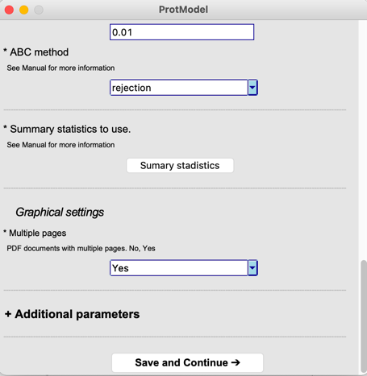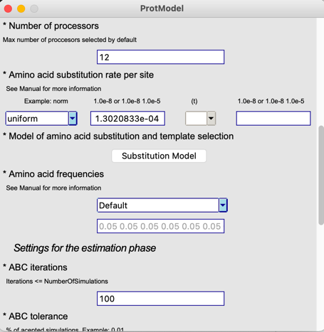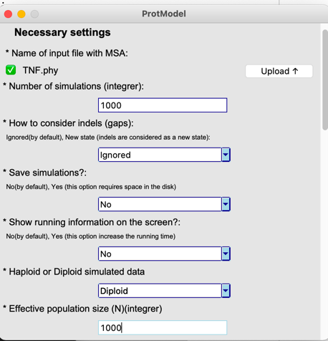Now, the user must click or fill in all the necessary settings. Once everything is filled, the user must click on the “*Save and* *Continue*” button to start the simulation and estimation phases. *ProtModel* will show up warnings if the user forgets to fill an entry or does it wrong, but user-specified settings without biological meaning won’t be detected, which may produce incorrect estimations. See section 4.2 for more information.
2. A new window will appear and to launch the simulation and the estimation phase the user only have to click in the “*Start*” button. Inside this window there are a box which will display all the *ProtModel* execution information.

**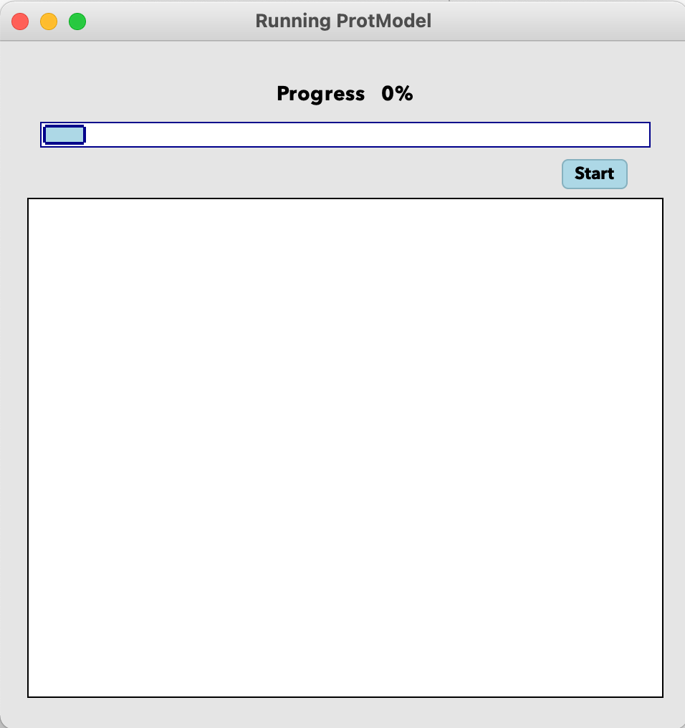***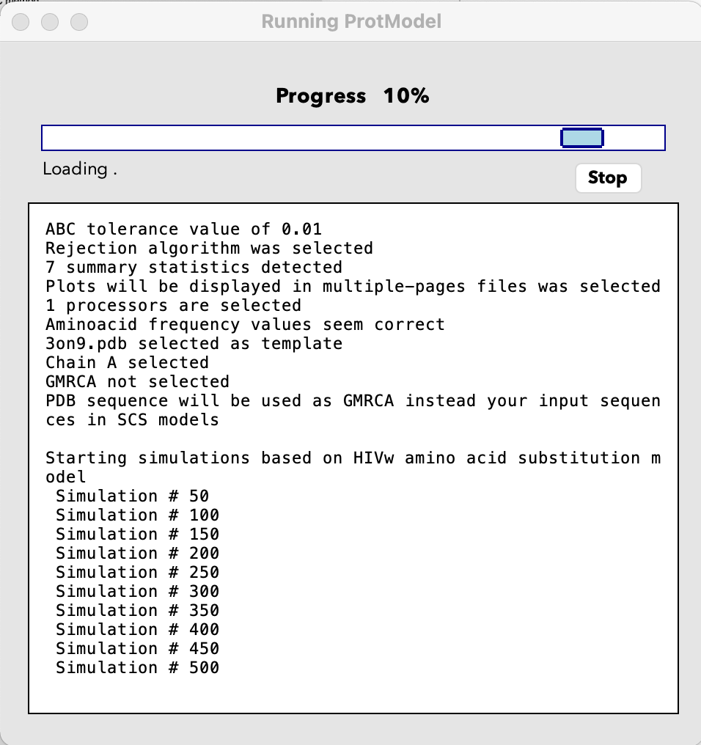*

1. Once *ProtModel* is done, a new message will show up.

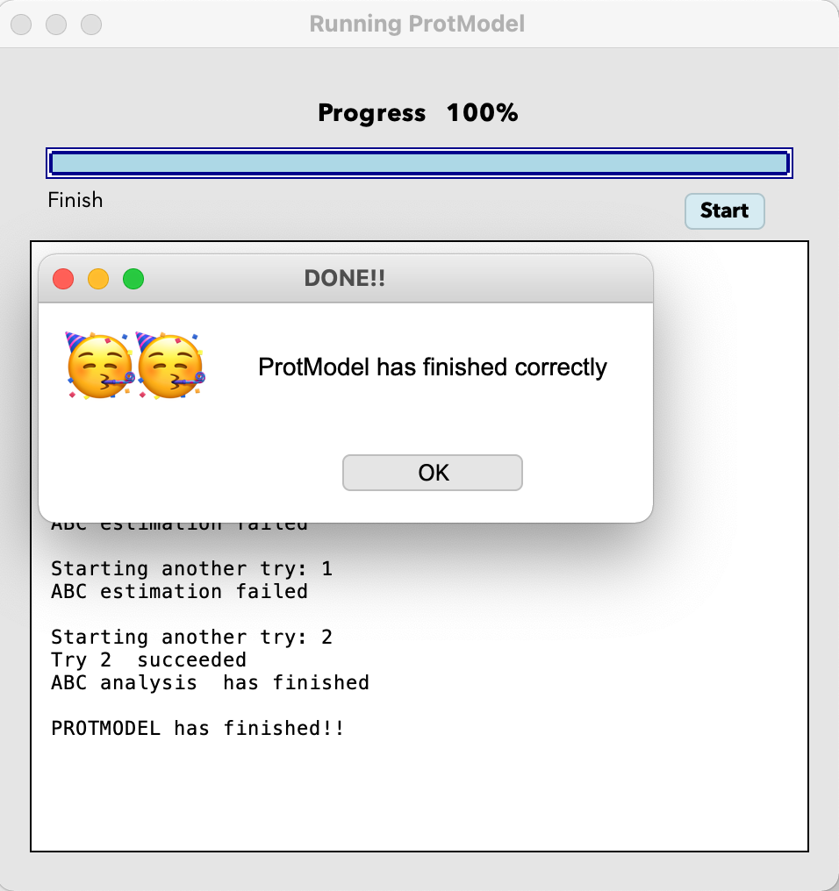

* **Execution with terminal:**

1. First, the user has to modify the Settings.txt file. Again, we recommend to not change anything other than the parameters values in the file.
2. Once the input files are ready, the user goes to the *ProtModel* main directory and type “*python3.9 ProtModelGeneral-M.py*”.

*Test_ProtModel %* ***ls***

*3on9.pdb* ***GUI******source***

***bin***  *LeerSettings.py structures.in*

*ChangeVariablesPE.py Makefile TNF.phy*

*Errores.py ProtModelGeneral.py Variables.py*

*Functions.py Settings.txt*

*Test_ProtModel %* **python3.9 ProtModelGeneral.py**

1. Then, the Settings.txt file is read and the main inputs are printed:

Alignment file exists

Alignment file exists

Correct number of simulations

Indels are ignored

Simulated data is saved

Running information will not be displayed on the screen

Diploid data are selected

PopulationSize selected

Parameter values sampled from a uniform distribution of 0 - 1.3020833e-04

Parameter values sampled from a uniform distribution of 0 - 1.3020833e-04 seem correct

HIVw substitution model selected

Fitness substitution model selected

Neutral substitution model selected

ABC iterations value of 100

ABC tolerance value of 0.01

Rejection algorithm was selected

7 summary statistics detected

Plots will be displayed in multiple-pages files was selected

12 processors are selected

Aminoacid frequency values seem correct

3on9.pdb selected as template

Chain A selected

GMRCA not selected

PDB sequence will be used as GMRCA instead your input sequences in SCS models

1. If any parameter is incorrect, *ProtModel* will stop the execution and print a message error (see section 4.6), such as:

Number of processors introduced is higher than your computer number of processors

Please check your computer number of processors

ERROR!! Please check NumberOfProcessors value

1. Next, if the user selected an empirical substitution model, simulations will be launched:

Starting simulations based on HIVw amino acid substitution model

Simulation # 50

Simulation # 100

Simulation # 150

Simulation # 200

Simulation # 250

Simulation # 300

Simulation # 350

Simulation # 400

Simulation # 450

Simulation # 500

Simulation # 550

Simulation # 600

Simulation # 650

Simulation # 700

Simulation # 750

Simulation # 800

Simulation # 850

Simulation # 900

Simulation # 950

Simulation # 1000

Simulations based on HIVw amino acid substitution models ended

1. Later, if the user also selected structural substitution models, simulations will be launched:

Starting simulations based on Fitness amino acid substitution model

Simulation # 1050

Simulation # 1100

Simulation # 1150

Simulation # 1200

Simulation # 1250

Simulation # 1300

Simulation # 1350

Simulation # 1400

Simulation # 1450

Simulation # 1500

Simulation # 1550

Simulation # 1600

Simulation # 1650

Simulation # 1700

Simulation # 1750

Simulation # 1800

Simulation # 1850

Simulation # 1900

Simulation # 1950

Simulation # 2000

Simulations based on Fitness amino acid substitution models ended

Starting simulations based on Neutral amino acid substitution model

Simulation # 2050

Simulation # 2100

Simulation # 2150

Simulation # 2200

Simulation # 2250

Simulation # 2300

Simulation # 2350

Simulation # 2400

Simulation # 2450

Simulation # 2500

Simulation # 2550

Simulation # 2600

Simulation # 2650

Simulation # 2700

Simulation # 2750

Simulation # 2800

Simulation # 2850

Simulation # 2900

Simulation # 2950

Simulation # 3000

Simulations based on Neutral amino acid substitution models ended

1. Then, *ProtModel* will calculate the SS of the observed and of the simulated data:

Summary statistics calculation

Calculating TNF summary statistics

Calculating simulation # 50 summary statistics

Calculating simulation # 100 summary statistics

Calculating simulation # 150 summary statistics

Calculating simulation # 200 summary statistics

Calculating simulation # 250 summary statistics

Calculating simulation # 300 summary statistics

Calculating simulation # 350 summary statistics

Calculating simulation # 400 summary statistics

Calculating simulation # 450 summary statistics

Calculating simulation # 500 summary statistics

Calculating simulation # 550 summary statistics

Calculating simulation # 600 summary statistics

Calculating simulation # 650 summary statistics

Calculating simulation # 700 summary statistics

Calculating simulation # 750 summary statistics

Calculating simulation # 800 summary statistics

Calculating simulation # 850 summary statistics

Calculating simulation # 900 summary statistics

Calculating simulation # 950 summary statistics

Calculating simulation # 1000 summary statistics

Calculating simulation # 1050 summary statistics

Calculating simulation # 1100 summary statistics

Calculating simulation # 1150 summary statistics

Calculating simulation # 1200 summary statistics

Calculating simulation # 1250 summary statistics

Calculating simulation # 1300 summary statistics

Calculating simulation # 1350 summary statistics

Calculating simulation # 1400 summary statistics

Calculating simulation # 1450 summary statistics

Calculating simulation # 1500 summary statistics

Calculating simulation # 1550 summary statistics

Calculating simulation # 1600 summary statistics

Calculating simulation # 1650 summary statistics

Calculating simulation # 1700 summary statistics

Calculating simulation # 1750 summary statistics

Calculating simulation # 1800 summary statistics

Calculating simulation # 1850 summary statistics

Calculating simulation # 1900 summary statistics

Calculating simulation # 1950 summary statistics

Calculating simulation # 2000 summary statistics

Calculating simulation # 2050 summary statistics

Calculating simulation # 2100 summary statistics

Calculating simulation # 2150 summary statistics

Calculating simulation # 2200 summary statistics

Calculating simulation # 2250 summary statistics

Calculating simulation # 2300 summary statistics

Calculating simulation # 2350 summary statistics

Calculating simulation # 2400 summary statistics

Calculating simulation # 2450 summary statistics

Calculating simulation # 2500 summary statistics

Calculating simulation # 2550 summary statistics

Calculating simulation # 2600 summary statistics

Calculating simulation # 2650 summary statistics

Calculating simulation # 2700 summary statistics

Calculating simulation # 2750 summary statistics

Calculating simulation # 2800 summary statistics

Calculating simulation # 2850 summary statistics

Calculating simulation # 2900 summary statistics

Calculating simulation # 2950 summary statistics

Calculating simulation # 3000 summary statistics

1. Next, the ABC estimation will be launched. Sometimes, the confusion matrix creation could fail due to a low ABC tolerance value, a low number of simulations and/or a high ABC iterations value. However, it is common that repeating the analysis produce successful analysis. So, ABC estimation will be performed until 10 times and in case it doesn’t success, we recommend repeat the analysis considering more simulations. If the user doesn’t select enough simulations the estimation will fail continuously even increasing the tolerance (i.e. 0.1) or decreasing the iterations value (i.e. 10) to reasonable values.

Executing ABC analysis

ABC estimation failed

Starting another try: 1

ABC estimation failed

Starting another try: 2

Try 2 succeeded

ABC analysis has finished

1. Finally, a message will be printed to confirm that *ProtModel* has finished:

PROTMODEL has finished!!

* **Execution on Cluster:**

1. First, the user has to modify the Settings.txt file. Again, we recommend to not change anything more than the parameters values in the file. Note that, although *ProtModel* is designed to work with no matter the number of processors, is highly recommended to use a number of simulations divisible by the number of processors.
2. Once we have our input files ready, we have to go to the ProtModel main directory and type “*python3 ProtModel_Clusterl.py*”.

python3 ProtModel_Clusterl.py

1. Now, instead of launching the simulations and the SS calculations as the other versions, some executables files are created. The user only has to focus on “*launch_Simu.sh*” file. It will be created following the CESGA cluster format so maybe it has to be adapted to the features of the user’s cluster, possibly changing any of the first lines (those which start with “*#*”) or the next line, which load CESGA modules needed for the execution (e.g., python, mpi4py). However, change the other lines, which launch the simulations and the SS calculations, is not recommended. *ProtModel* running information will be the same as in the others versions and will be written in a *“slurm.out”* file.

sbatch launch_simu.sh

1. In this version, the **ABC estimation will not be performed.** Our cluster didn´t have the R version needed to work with the “*abc library*” so the user must to download the folder and perform the estimation running the “*ABCAnalysis.r*” file. **The user must change the path to corresponding of the directory once downloaded.** See section 4.4. Note that sometimes ABC may fail so, in this case, its highly recommended to re-execute R-script several times.

## Output files

Several output files are generated by *ProtModel* during the different stages of the estimation. These files are saved in the output folders “*ABCOutputs*” and “*SimulationsOutputs*” that will be placed in the working directory. The script “*ABCAnalysis.r*” within the folder “*ABCOutputs*” contains all the instructions to perform the ABC estimation phase and to create all the plots.

### ABCOutputs

This folder contains the information regarding the ABC estimations and all the necessary files to repeat the ABC estimation. A normal *ProtModel* run will produce:

* The file “*Histogram_Priors.pdf*”, which shows an illustrative histogram of the prior distributions used for the simulations of substitution rates. In addition, a *θ* histogram is also provided.
* In case the user selects all SS, the files “*Results_SS_Energy.pdf*” and “*Results_SS_AAReplacements.pdf*” are created. The file “*Results_SS_Energy.pdf*” shows two boxplot graphs: one representing the mean stability of the simulated proteins under the studied substitution model(s) (ΔG kcal/mol) and the second one their corresponding standard deviation. The file “*Results_SS_AAReplacements.pdf*” shows five boxplot graphs: one with the number of segregating sites, and the remaining with the corresponding mean, standard deviation, skeaness and the kurtosis of the Grantham distances of the simulated proteins. If the user does not select all the SS, only one file is created (named “*Results_SS.pdf*”) with the boxplots corresponding to the selected SS. For more information about the SS see section 5.2.
* The file “*Histograms_SStats.pdf*” shows a histogram of the SS values from the retained simulations under the evaluated substitution model(s). Vertical blue lines correspond to the value of the SS of the target sequences alignment. Ideally the histograms should have a gaussian-like shape with the blue line in the centre of the distribution. These plots are used to assess if the model assumed for the simulations fits well the data.
* The file “*Histogram_GoodnessOfFit.pdf*” shows a histogram of for each evaluated substitution model representing the median of the distance between accepted simulations SS (bars) and observed ones (blue line). The p-value is also computed to test the fit to every substitution model (and showed in the file “*Results_text”*).
* The file “*PCA.pdf*” shows a plot of the two first principal components of a principal component analysis (PCA) of the SS values of the considered substitution model(s). The black cross corresponds to the target sequences alignment and the area inside the coloured lines represent the retained simulations. Ideally, the black cross falls inside of only one model. This plot is also used to assess if the model assumed for the simulations fits well the data.
* The file “*Results_ConfusionMatrix_100sampSSSimulations.pdf*” shows a plot of the confusion matrix, a specific table layout that allows visualization of the performance of the distinction between models. Note that the name will change depending on the number of ABC iterations selected (i.e., “*Results_ConfusionMatrix_10sampSSSimulations.pdf” or “Results_ConfusionMatrix_1000sampSSSimulations.pdf”).*
* The file “*Scaterplots_SStatsVSParams.pdf*” shows a scatter plot of the values of the SS and the corresponding values of *θ* prior distribution. Again, the blue line corresponds to the value of the SS of the target sequences alignment. Ideally, the blue line and points should be as close as possible, and the latter evenly distributed across substitution rate per site.
* The file “*Results_text.txt*” shows the results of the all the analysis performed. Firstly, the confusion matrix followed by an ABC method matrix, then the best-fitting substitution model estimation followed by a bayes factors matrix, and finally the p-value of the goodness of fit analyses followed by simulations distances.
* The file “*SSSimulations.csv*” file contains the SS values computed from each simulated data.
* The file “*SSRealData.csv*” presents the SS values computed from the target MSA.
* The file “*PSimulations.txt*” shows the values sampled from the prior distribution of the substitution rate and its corresponding *θ* value.

### SimulationsOutputs

* A copy of the “*SSSimulations.csv*” file.
* A copy of the “*SSRealData.csv*” file.
* A copy of the “*PSimulations.txt*” file.
* The simulated alignments are compressed into the file “*Simulations.tar.gz*” if the user specified in the settings file the option of save the simulations.

*ProtModel* executables files created during the framework execution will be placed in this directory to allow user to modify code to adapt it to their corresponding clusters.

## Re-analysing data

*ProtModel* allows to choose a few different settings for the ABC estimation without having to repeat the time-consuming simulation and SS calculation phases. These settings can be changed for a better tuning of the estimations. Among these, the most important to consider are the following:

- ABC iterations, which defines the number of cross-validation events for each model to create the confusion matrix.

- ABC tolerance, which defines the number of simulations closest to the target sequences alignment that are retained. Choosing the tolerance is not trivial: it has to be large enough to provide a good characterization of the posterior distribution, but on the other hand, it has to be small enough to retain the simulations that are closer to the target sequences alignment.

- Summary statistics to use for the ABC estimations. As the number of simulations and the tolerance interval, the choice on the SS is not trivial in ABC. For the estimation of the best-fitting substitution model, we showed that the use of all the SS provided in *ProtModel* works fairly well yet, sometimes the folding stability standard deviation of the real data is high and far from the simulations value. In that case, we recommend not to consider it. The user may either repeat the analysis without considering it or editing the script “*ABCAnalysis.r*” and remove the stability standard deviation values of real target and simulations. See section 5.2

To re-analyse the data, no matter the version used, the user must go to the ABCOutputs folder. Then, the user must open the “*ABCAnalysis.r*” file and change the desired ABC parameters values in the first lines.

*#####################################################*

*################### ABC VARIABLES ###################*

*#####################################################*

*ABC_Method <- "rejection"*

*ABC_Tolerance <- 0.01*

*ABC_N_Iterations <- 100*

*#####################################################*

*#####################################################*

*#####################################################*

If the user needs to change the path only one line has to be edited.

*#Path*

*address<-paste("/****User route to the new directory****", sep="")*

*setwd(address)*

*############################*

## Examples

The package includes the following examples in the folder “*Examples*” including all input and output files. Every example can be run in every *ProtModel* version, but we divided the eight examples into two folders, one folder containing rapid examples to run on the command line or using the GUI, and another folder with seven examples to run on cluster:

1. **Example1-TNF_Monkeypox:** Analysis of a simulated real target alignment [10 sequences, 160 amino acids] of the tumour necrosis factor receptor (TNF) of monkeypox virus using only 1,000 simulations (a few simulations with the aim of only performing a rapid exploration of the framework but producing accurate results) comparing the HIVw (best-fitting empirical substitution model according *ProtTest* (Darriba et al., 2011)) and the two SCS models (Fitness and Neutral) (Table 3). We performed two analyses using this multiple protein sequence alignment (Table 3).

The initial ABC results (within the folder *example-1-TNF_Monkeypox-rapid*) show that the best-fitting substitution model is the Fitness with a probability of 0.4333, while the Neutral and HIVw models have a probability of 0.4 and 0.1667, respectively. Looking closer at the SS plots, some values of the SS calculated from the simulations related with the amino acid replacements are far from the real data values (Results_SS_AAReplacements.pdf, Histograms_SStats.pdf and Scaterplots_SStatsVSParams.pdf). Despite we applied a realistic substitution rate, we repeated the analysis reducing it (**Example1-TNF-Monkeypox-2**) (Table 3). This time, SS from target and simulated data are closer and the Neutral model was selected as the best-fitting substitution model with a probability of 0.6667, while Fitness and HIVw model had a probability of 0.2333 and 0.1 respectively. This in only an example of the importance of choosing suitable evolutionary parameters values for the simulations. We also use this MSA to test the regression ABC methods *mnlogistic* and *neuralnet*. Despite both are likely to fail, we didin’t have any problems during the estimation. We obtain that, considering *mnlogistic,* the best-fitting substitution model is Neutral with a probability of 1. On the other hand, considering *neuralnet*, the best-fitting substitution model was Neutral with a probability of 0.9616, while Fitness and HIVw model had a probability of 0.0333 and 0.0051 respectively. These results enhance our previous believe that the SCS Neutral model is the best-fitting substitution model.

1. **Example2-Protease_HIV:** Analysis of a simulated real target alignment [50 sequences, 99 amino acids] of the protease of HIV-1 virus using 10,000 simulations comparing the JTT (best-fitting empirical substitution model according *ProtTest* (Darriba et al., 2011)) and the two SCS models (Fitness and Neutral) (Table 3).
2. **Example3-GAG_HIV:** Analysis of a simulated real target alignment [27 sequences, 288 amino acids] of the protease of HIV-1 virus using 10,000 simulations comparing the JTT (best-fitting empirical substitution model according *ProtTest* (Darriba et al., 2011)) and the two SCS models (Fitness and Neutral) (Table 3).
3. **Example4-NS1_Flu:** Analysis of a simulated real target alignment [25 sequences, 202 amino acids] of the NS1 of influenza virus using 10,000 simulations comparing the JTT (best-fitting empirical substitution model according *ProtTest* (Darriba et al., 2011)) and the two SCS models (Fitness and Neutral) (Table 3).
4. **Example5-C30_COVID:** Analysis of a simulated real target alignment [30 sequences, 299 amino acids] of the C30 endopeptidase of SARS-CoV virus using 10,000 simulations comparing the LG (best-fitting empirical substitution model according *ProtTest* (Darriba et al., 2011)) and the two SCS models (Fitness and Neutral) (Table 3). In this case we performed two analyses differing on the SS calculated and used to do the ABC estimation.

The initial ABC results show that the best-fitting substitution model is the LG with a probability of 1. Looking closer the summary statistics plots, the SS DGREM_sd is so far from the real data that it does not appear in the plots (Results_SS_Energy.pdf, Histograms_SStats.pdf and Scaterplots_SStatsVSParams.pdf). So, we repeated the analysis without considering DGREM_sd as a SS (**Example5-C30_COVID-2**) (Table 3). This time, the Fitness model is selected as the best-fitting substitution model with a probability of 0.88, while Neutral and LG model had a probability of 0.1067 and 0.0133, respectively. This is only an example where the standard deviation of the folding stability of the simulations is not representing the real target.

1. **Example6-** **Methyltr-2 _COVID:** Analysis of a simulated real target alignment [28 sequences, 298 amino acids] of the SARS-CoV 2'-O-methyltransferase protein using 10,000 simulations comparing the LG (best-fitting empirical substitution model according *ProtTest* (Darriba et al., 2011)) and the two SCS models (Fitness and Neutral) (Table 3).
2. **Example7-EFC_Ca:** Analysis of a simulated real target alignment [18 sequences, 263 amino acids] of the Calcium-binding EGF domain using 10,000 simulations comparing the Blosum62 (best-fitting empirical substitution model according *ProtTest* (Darriba et al., 2011)) and the two SCS models (Fitness and Neutral) (Table 3).
3. **Example8-TIR:** Analysis of a simulated real target alignment [23 sequences, 171 amino acids] of the Toll-Interleukin receptor using 10,000 simulations comparing the WAG (best-fitting empirical substitution model according *ProtTest* (Darriba et al., 2011)) and the two SCS models (Fitness and Neutral) (Table 3). It was run on the cluster using all the summary statistics except the DGREM_sd.

Table 3. Best-fitting substitution model probabilities estimated with *ProtModel* for the studied protein families. The table shows the results and some important parameters for the best-fitting substitution model estimation.

|  |  |  |  |  |  |  |  |  |  |
| --- | --- | --- | --- | --- | --- | --- | --- | --- | --- |
| *Protein family description* | *Number and length of sequences* | *Template* | *Substitution Rate prior* | *Theta prior* | *Summary Statistics* | *Nº Simu x model* | *Emp Subs Model* | *ABC Method* | *ABC estimation* |
| Monkeypox tumour necrosis receptor | 10 sequences  160 amino acid | 3on9 | Uniform  0 7.8125e-04 | Uniform  0 500 | 1 2 3 4 5 6 7 | 1 000 | HIVw | rejection | **Fitness** HIVw Neutral  **0.4333** 0.1667 0.4 |
| Monkeypox tumour necrosis receptor | 10 sequences  160 amino acid | 3on9 | Uniform  0 1.8750e-04 | Uniform  0 120 | 1 2 3 4 5 6 7 | 1 000 | HIVw | rejection | Fitness HIVw **Neutral**  0.2333 0.1 **0.6667** |
| Monkeypox tumour necrosis receptor | 10 sequences  160 amino acid | 3on9 | Uniform  0 1.8750e-04 | Uniform  0 120 | 1 2 3 4 5 6 7 | 1 000 | HIVw | mnlogistic | Fitness HIVw **Neutral**  0 0 **1** |
| Monkeypox tumour necrosis receptor | 10 sequences  160 amino acid | 3on9 | Uniform  0 1.8750e-04 | Uniform  0 120 | 1 2 3 4 5 6 7 | 1 000 | HIVw | neuralnet | Fitness HIVw **Neutral**  0.0333 0.0051 **0.9616** |
| HIV protease | 50 sequences,  99 amino acid | 1tcx | Uniform 0 2.5253e-04 | Uniform  0 100 | 1 2 3 4 5 6 7 | 10 000 | JTT | rejection | **Fitness** JTT Neutral  **0.8533** 0.0667 0.08 |
| HIV Gag polyprotein | 27 sequences 288 amino acid | 1l6n | Uniform 0 1.041667e-04 | Uniform 0 120 | 1 2 3 4 5 6 7 | 10 000 | JTT | rejection | Fitness HIVb **Neutral**  0.4333 0.1067 **0.4600** |
| Influenza NS1 | 25 sequences  202 amino acid | 4OPH | Uniform 0 2.4752e-04 | Uniform  0 200 | 1 2 3 4 5 6 7 | 10 000 | JTT | rejection | Fitness JTT **Neutral**  0.0067 0.22 **0.7733** |
| Coronavirus endopeptidase C30 | 30 sequences  299 amino acid | 1LVO | Uniform 0 4.180602e-04 | Uniform 0 500 | 1 2 3 4 5 6 7 | 10 000 | LG | rejection | Fitness **LG** Neutral  0 **1** 0 |
| Coronavirus endopeptidase C30 | 30 sequences  299 amino acid | 1LVO | Uniform 0 4.180602e-04 | Uniform 0 500 | 1 3 4 5 6 7 | 10 000 | LG | rejection | **Fitness** LG Neutral  **0.88** 0.0133 0.1067 |
| Coronavirus 2'-O-methyltransferase | 28 sequences  298 amino acid | 7c2i | Uniform 0 4.194631e-04 | Uniform 0 500 | 1 2 3 4 5 6 7 | 10 000 | LG | rejection | **Fitness** LG Neutral  **0.6733** 0.1267 0.2 |
| Calcium-binding EGF domain | 18 sequences  263 amino acid | 6pog | Uniform 0 2.118644e-04 | Uniform 0 100 | 1 2 3 4 5 6 7 | 10 000 | Blosum62 | rejection | **Blosum62** Fitness Neutral  **0.9933** 0 0.0067 |
| Toll-Interleukin receptor domain | 23 sequences  171 amino acid | 5ku7 | Uniform 0 7.309942e-04 | Uniform 0 500 | 1 3 4 5 6 7 | 10 000 | WAG | rejection | **Fitness** Neutral WAG  **0.9933** 0.0067 0 |

## Message errors and recommendations

Errors generated from incorrect settings are usually shown on the screen and the program will suggest abort the execution by typing CTRL+C in the command line. However, if the user uses the GUI, incorrect values will be automatically detected. If the user doesn’t want to work with GUI, we recommend copying a provided input file “Settings.txt” from the “examples” folder and edit it with the desired settings.

The input multiple sequence alignment must be presented in *standard phylip sequential* format. Importantly, the amino acid sequences of the input multiple sequence alignment should only include any of the 20 amino acids (one-letter code) or indels (as “-”). Other letters or symbols (e.g., X or $) will produce an error displayed on the screen. Next, *ProtModel* check Settings.txt inputs. If any of them is incorrect (i.e., number when string is expected, parameters out of limits) *ProtModel* will stop the execution printing the parameter which is incorrect.

In general, note that the simulation phase can be computational expensive with long running times. This is particularly found when performing a large number of simulations, or when the simulated data includes a large number and long sequences. Therefore, reducing the number of simulations and the size of the input alignment of protein sequences can dramatically reduce the computer time. However, sometimes it is not possible to reduce the input dataset, in which case one can try to reduce the number of simulations. Alternatively, one can run the simulations in parallel (if the machine has more than one processor) which will reduce considerably the computer times. Some of the simulations may fail due to intrinsic problems of substitution models, particularly for the Fitness SCS. However, after the last simulation is finished, *ProtModel* will check if some of them failed and will automatically rerun each failed simulation.

During the ABC procedure the estimation may fail due to a low value of the tolerance, a high number of iterations or when *mnlogistic* or *neuralnet* methods are selected (see section 5.4). If the ABC estimate cannot be carried out completely, no matter the reason, *ProtModel* will launch a big size error. In this situation, the ABC estimation can be executed again (section 5.4) varying the ABC tolerance, iterations or method in the “*.r*” file. Concerning the ABC method, the rejection approach can be more robust (it rarely fails) than the others to analyze real data. In addition to varying these values, one can increase the number of simulations. This could be enough to run successfully the ABC estimation but implies repeat the whole *ProtModel* execution with the new number of simulations.

If you find any unexpected error, or there is any doubt, do not hesitate to contact [ferreirogarciadavid@gmail.com](mailto:ferreirogarciadavid@gmail.com). Thanks for your contribution!

# Models and Methods

*ProtModel* is a framework to the estimate the best-fitting substitution model of multiple protein sequence alignments using an ABC procedure. The simulator includes a variety of evolutionary models that may help to better mimic real scenarios. Informative SS are calculated from the simulated data and compared with the same SS calculated from the real protein sequence alignment. Finally, the computation of the posterior distributions is performed using ABC methods.

## Evolutionary Models and Computer Simulations

The first step of *ProtModel* is based on the simulator *ProteinEvolverProtABC*, which is an adapted version of the program *ProteinEvolver* (<https://github.com/MiguelArenas/proteinevolver>) (Arenas et al., 2013) to perform ABC. *ProteinEvolverProtABC* implements a variety of evolutionary models and generates protein sequence alignments (see below) collected at same or different times (temporal longitudinal sampling or tip dates [see, Navascués et al., 2010]), from a population evolved using the coalescent approach (Hudson, 2002; Kingman, 1982). Protein sequences evolved under a variety of empirical substitution models of protein evolution Blosum62 (Henikoff & Henikoff, 1992), CpRev (Adachi et al., 2000), Dayhoff (Dayhoff et al., 1978), DayhoffDCMUT (Kosiol & Goldman, 2005), HIVb (Nickle et al., 2007), HIVw (Nickle et al., 2007), JTT (Jones et al., 1992), JonesDCMUT (Kosiol & Goldman, 2005), LG (Le & Gascuel, 2008), Mtart (Abascal et al., 2006), Mtmam (Yang et al., 1998), Mtrev24 (Adachi & Hasegawa, s. f.), RtRev (Dimmic et al., 2002), VT (Müller & Vingron, 2000), WAG (Whelan & Goldman, 2001) and UserEAAM models (Arenas, 2015). Of course, protein sequences can be evolved under SCS models of protein evolution too, suing mean-field Neutral (which does not consider population size) and mean-field Fitness (which needs user specified population size) (Arenas et al., 2015). Both haploid and diploid data can be simulated. Indeed, the program also implements heterogeneity across sites according to a gamma distribution (+G) and proportion of invariable sites (+I) (Yang, 1996).

## Summary Statistics

*ProtModel* includes a total of 7 summary statistics (Table 4). The first two SS are related with the proteins folding stability. Folding stability was measured with another framework called *DeltaGREM* (Arenas et al., 2017) using Gibbs free energy difference between folded and unfolded states (ΔG kcal/mol). In addition, *ProtModel* uses the number of amino acids segregating sites and the mean, standard deviation, skeaness and kurtosis of Grantham distance between amino acids replacements per protein site. It assesses the difference between replaced amino acids (Grantham, 1974).

Table 4. Summary statistics implemented in *ProtModel* and their identifiers (ID).

|  |  |  |
| --- | --- | --- |
| *ID* | *Name* | *Description* |
| 1 | DGREM_Mean | Mean of alignment folding stability |
| 2 | DGREM_sd | Standard deviation of alignment folding stability |
| 3 | SegSites | Number of segregation sites |
| 4 | Grantham_mean_Position | Mean of the Grantham distance between aa replacements per protein site |
| 5 | Grantham_sd_Position | Standard deviation of the Grantham distance between aa replacements per protein site |
| 6 | Grantham_sk_Position | Skeaness of the Grantham distance between aa replacements per protein site |
| 7 | Grantham_ku_Position | Kurtosis of the Grantham distance between aa replacements per protein site |

## ABC Methods

Different ABC estimation methods are implemented in *ProtModel*. For the rejection method (“*rejection*”) the posterior probability of a given model is approximated by the proportion of accepted simulations given this model. On the other hand, “*mnlogistic*”, estimate the posterior probabilities using a multinomial logistic regression using neural networks. The third method implemented is neural networks based (“*neuralnet*”), and applies neural networks to predict the probabilities of models based on the observed statistics. This method can be particularly useful if many SS are used.

## *ProtModel* Performance

Substitution models of amino acids replacement are employed routinely to study evolutionary processes of protein evolution (Arenas 2015, Thorne 2000). However, there is a lack of evolutionary frameworks to select the best-fitting substitution model including SCS models, which successfully yielded accurate inferences of protein evolution overcoming empirical substitution models (e.g. Arenas et al., 2013, 2015, 2017; Arenas & Bastolla, 2019; Challis & Schmidler, 2012; García-Portugués et al., 2018; Golden et al., 2017; Herman et al., 2014; Norn et al., 2021; Perron et al., 2019).

We performed an evaluation of *ProtModel* considering three substitution models Dayhoff (empirical model) (Dayhoff et al., 1978), Fitness and Neutral (Arenas et al., 2015) (both SCS models), and with a dataset of 27 sequences and the 1TDE structure (Waksman et al., 1994) of the thioredoxin reductase protein family. We used *ProteinEvolverProtABC* to perform a different number of protein simulations (10,000, 50,000 and 100,000) under a uniform prior distribution for *θ* (0, 500) which encompass values that are commonly observed in real data (Lopes et al., 2014). We applied the three ABC methods (*rejection*, *mnlogistic* and *neuralnet*) and, as in previous studies (Arenas et al., 2020), we made a cross-validation of the ABC methods based on 100 pseudo-observed simulations with a tolerance of 0.005, 0.01 and 0.05 (Csilléry et al., 2012). Additionally, we simulated 100 multiple sequence alignments under each substitution model considered (Dayhoff, Fitness and Neutral) and for every combination of parameters (3 models × 3 sets of simulations × 3 methods), which were used as test datasets. Then, we tested if *ProtModel* can correctly estimate the best-fitting substitution model in the test datasets using ABC.

Generally, the rejection method yielded precise estimations regardless the number of simulations (Figure 1). However, increase the tolerance value produced a little decrease in the framework accuracy (Figure 1). Regarding the *mnlogistic* and the *neuralnet* ABC methods, both failed in at least one estimation of the test dataset (100 per model) regardless the number of simulations or the tolerance value. The higher values of these parameters produced less failed estimations than the lower values, but we still obtain errors using 100,000 simulations and a tolerance value of 0.05. However, we think that *mnlogistic* and *neuralnet* methods are still useful. Note that here we are performing 100 estimations to validate the method obtaining some errors, but probably a common user is only interested in estimate the best-fitting substitution model for one MSA and it could work (see example 1). If the user proves more than one method the result can be different. Obtain as the best-fitting model with one method a structural model and with the other method the other structural model could be normal due to these models are very similar. Contrary, obtaining as the best-fitting one structural and one empirical with different methods could be more problematic. Here, in case of discrepancy between methods, we recommend to consider the rejection output as the true because it is the unique method validated. Even if an error occurs, *ProtModel* will perform the estimation with the rejection method. Note that increase the tolerance value to use these methods is not recommended. Remember that the framework accuracy decreases as the tolerance values increase. Then, we applied the rejection algorithm to estimate the best-fitting substitution model of the test datasets. Overall, the results from the rejection method show that the best-fitting substitution model estimation is generally accurate (Figure 1) and can distinguish between the empirical and the SCS models, as well as between SCS models.



Figure 1. Evaluation of the estimation of the best-fitting substitution model. The estimation was performed under the rejection method and shows the probability of selecting the true substitution model for the 100 simulations under the three models (Dayhoff, Fitness and Neutral), for every ABC tolerance (0.005, 0.01 and 0.05) and number of simulations (10,000, 50,000 and 100,000). Error bars indicate 95% confidence intervals from the mean.

We also evaluate the computer time with different number of processors. We used 1,000 simulations for command executions and 10,000 for cluster executions. For both, we used the HIV-1 protease data (see section 4.6) to perform independent runs with 1, 2, 4, 8 and 12 processors in our computer, and with 50, 100, 200, 250 and 500 processors in the cluster (Figure 2). Note that, for cluster analysis it is highly recommended to use a number of simulations divisible by the number of processors. In both cases the number of processors and the computer time do not follow a linear function (Figure 2). For the computer analysis this was expected because the processors do not work independently. Instead, they shared memory and even the computer time can be affected by the simultaneous computer use. On the other hand, we expected the computer time and the number of processors during a cluster analysis to follow a nearly linear function, but we obtained that they follow the same function as the computer analysis. In this case, the processors do not share memory and they are not affected by any other cluster usage. We think this occurs because the software only starts a new process (e.g., SS calculation) when the previous process finishes for all the processors. So, if one processor is working slower, all the process will be affected.

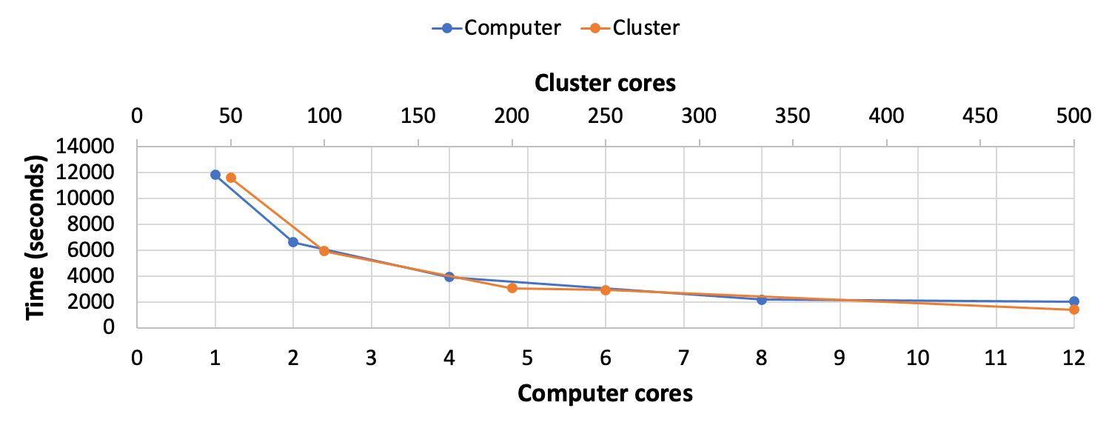

Figure 2. *ProtModel* computing times of different versions. *ProtModel* computing times for the analysis of HIV-1 PR real data (example 2) using cluster (orange) and computer (blue) versions with different number of cores. The analyses were run on a 2.6 GHz Intel Core i7 computer with 12 processors and CESGA partition thin, with 306 nodes everyone with 2 processors Haswell 2680v3, 24 cores.

## Assumptions and Limitations

ABC assumes that simulated data can mimic the real data. Simulations are based on models and are never fully representative of the real process. This is actually a limitation present in any estimation approach based on a model of evolution. The idea is to perform simulations as realistic as possible. The data-generating process assumed by *ProteinEvolverABC* consists of drawing a sample genealogy from the standard coalescent (Kingman, 1982), and then, given the genealogy, generating the sequences evolved under a substitution model of protein evolution (Arenas et al., 2013). This is a well-established methodology to simulate protein sequences upon evolutionary histories (Yang, 2006).

# Acknowledgments

This work was supported by the Xunta de Galicia through the Grants [ED481A-2020/192].

# References

Abascal, F., Posada, D., & Zardoya, R. (2006). MtArt: A New Model of Amino Acid Replacement for Arthropoda. *Molecular Biology and Evolution*, *24*(1), 1-5. https://doi.org/10.1093/molbev/msl136

Adachi, J., & Hasegawa, M. (1996). *Programs for Molecular Phylogenetics Based on Maximum Likelihood*. *28*, 1-150.

Adachi, J., Waddell, P. J., Martin, W., & Hasegawa, M. (2000). Plastid Genome Phylogeny and a Model of Amino Acid Substitution for Proteins Encoded by Chloroplast DNA. *Journal of Molecular Evolution*, *50*(4), 348-358. https://doi.org/10.1007/s002399910038

Arenas, M. (2015). Trends in substitution models of molecular evolution. *Frontiers in Genetics*, *6*. https://doi.org/10.3389/fgene.2015.00319

Arenas, M., & Bastolla, U. (2019). ProtASR2: Ancestral reconstruction of protein sequences accounting for folding stability. *Methods in Ecology and Evolution*, *11*, 248-257. https://doi.org/10.1111/2041-210X.13341

Arenas, M., Dos Santos, H. G., Posada, D., & Bastolla, U. (2013). Protein evolution along phylogenetic histories under structurally constrained substitution models. *Bioinformatics*, *29*(23), 3020-3028. https://doi.org/10.1093/bioinformatics/btt530

Arenas, M., Gorostiza, A., Baquero, J. M., Campoy, E., Branco, C., Rangel-Villalobos, H., & González-Martín, A. (2020). The Early Peopling of the Philippines based on mtDNA. *Scientific Reports*, *10*(1), 4901. https://doi.org/10.1038/s41598-020-61793-7

Arenas, M., Sánchez-Cobos, A., & Bastolla, U. (2015). Maximum-Likelihood Phylogenetic Inference with Selection on Protein Folding Stability. *Molecular Biology and Evolution*, *32*(8), 2195-2207. https://doi.org/10.1093/molbev/msv085

Arenas, M., Weber, C. C., Liberles, D. A., & Bastolla, U. (2017). ProtASR: An Evolutionary Framework for Ancestral Protein Reconstruction with Selection on Folding Stability. *Systematic Biology*, *66*(6), 1054-1064. https://doi.org/10.1093/sysbio/syw121

Beaumont, M. A. (2010). Approximate Bayesian Computation in Evolution and Ecology. *Annual Review of Ecology, Evolution, and Systematics*, *41*(1), 379-406. https://doi.org/10.1146/annurev-ecolsys-102209-144621

Challis, C. J., & Schmidler, S. C. (2012). A Stochastic Evolutionary Model for Protein Structure Alignment and Phylogeny. *Molecular Biology and Evolution*, *29*(11), 3575-3587. https://doi.org/10.1093/molbev/mss167

Csilléry, K., François, O., & Blum, M. G. B. (2012). abc: An R package for approximate Bayesian computation (ABC): *R package: abc*. *Methods in Ecology and Evolution*, *3*(3), 475-479. https://doi.org/10.1111/j.2041-210X.2011.00179.x

Darriba, D., Taboada, G. L., Doallo, R., & Posada, D. (2011). ProtTest 3: Fast selection of best-fit models of protein evolution. *Bioinformatics*, *27*(8), 1164-1165. https://doi.org/10.1093/bioinformatics/btr088

Dayhoff, M. O., Schwartz, R. M., & Orcutt, B. C. (1978). A model of evolutionary change in proteins. En *Atlas of Protein Sequence and Structure* (Dayhoff, M.O. Edition, Vol. 5, pp. 345-352). National Biomedical Research Foundation.

Dereeper, A., Guignon, V., Blanc, G., Audic, S., Buffet, S., Chevenet, F., Dufayard, J.-F., Guindon, S., Lefort, V., Lescot, M., Claverie, J.-M., & Gascuel, O. (2008). Phylogeny.fr: Robust phylogenetic analysis for the non-specialist. *Nucleic Acids Research*, *36*(Web Server), W465-W469. https://doi.org/10.1093/nar/gkn180

Dimmic, M. W., Rest, J. S., Mindell, D. P., & Goldstein, R. A. (2002). rtREV: An Amino Acid Substitution Matrix for Inference of Retrovirus and Reverse Transcriptase Phylogeny. *Journal of Molecular Evolution*, *55*(1), 65-73. https://doi.org/10.1007/s00239-001-2304-y

Edgar, R. C. (2004). MUSCLE: Multiple sequence alignment with high accuracy and high throughput. *Nucleic Acids Research*, *32*(5), 1792-1797. https://doi.org/10.1093/nar/gkh340

García-Portugués, E., Golden, M., Sørensen, M., Mardia, K. V., Hamelryck, T., & Hein, J. (2018). *Toroidal diffusions and protein structure evolution*. https://doi.org/10.1201/9781315228570

Golden, M., García-Portugués, E., Sørensen, M., Mardia, K. V., Hamelryck, T., & Hein, J. (2017). A Generative Angular Model of Protein Structure Evolution. *Molecular Biology and Evolution*, *34*(8), 2085-2100. https://doi.org/10.1093/molbev/msx137

Grantham, R. (1974). Amino Acid Difference Formula to Help Explain Protein Evolution. *Science*, *185*(4154), 862-864. https://doi.org/10.1126/science.185.4154.862

Henikoff, S., & Henikoff, J. G. (1992). Amino acid substitution matrices from protein blocks. *Proceedings of the National Academy of Sciences*, *89*(22), 10915-10919. https://doi.org/10.1073/pnas.89.22.10915

Herman, J. L., Challis, C. J., Novák, Á., Hein, J., & Schmidler, S. C. (2014). Simultaneous Bayesian Estimation of Alignment and Phylogeny under a Joint Model of Protein Sequence and Structure. *Molecular Biology and Evolution*, *31*(9), 2251-2266. https://doi.org/10.1093/molbev/msu184

Hudson, R. R. (2002). Generating samples under a Wright-Fisher neutral model of genetic variation. *Bioinformatics*, *18*(2), 337-338. https://doi.org/10.1093/bioinformatics/18.2.337

Jones, D. T., Taylor, W. R., & Thornton, J. M. (1992). The rapid generation of mutation data matrices from protein sequences. *Bioinformatics*, *8*(3), 275-282. https://doi.org/10.1093/bioinformatics/8.3.275

Kingman, J. F. C. (1982). The coalescent. *Stochastic Processes and Their Applications*, *13*(3), 235-248. https://doi.org/10.1016/0304-4149(82)90011-4

Kosiol, C., & Goldman, N. (2005). Different Versions of the Dayhoff Rate Matrix. *Molecular Biology and Evolution*, *22*(2), 193-199. https://doi.org/10.1093/molbev/msi005

Le, S. Q., & Gascuel, O. (2008). An Improved General Amino Acid Replacement Matrix. *Molecular Biology and Evolution*, *25*(7), 1307-1320. https://doi.org/10.1093/molbev/msn067

Lopes, J. S., Arenas, M., Posada, D., & Beaumont, M. A. (2014). Coestimation of recombination, substitution and molecular adaptation rates by approximate Bayesian computation. *Heredity*, *112*(3), 255-264. https://doi.org/10.1038/hdy.2013.101

Müller, T., & Vingron, M. (2000). Modeling Amino Acid Replacement. *Journal of Computational Biology*, *7*(6), 761-776. https://doi.org/10.1089/10665270050514918

Navascués, M., Depaulis, F., & Emerson, B. C. (2010). Combining contemporary and ancient DNA in population genetic and phylogeographical studies: MOLECULAR POLYMORPHISM ANALYSIS OF ANCIENT DNA. *Molecular Ecology Resources*, *10*(5), 760-772. https://doi.org/10.1111/j.1755-0998.2010.02895.x

Nickle, D. C., Heath, L., Jensen, M. A., Gilbert, P. B., Mullins, J. I., & Kosakovsky Pond, S. L. (2007). HIV-Specific Probabilistic Models of Protein Evolution. *PLoS ONE*, *2*(6), e503. https://doi.org/10.1371/journal.pone.0000503

Norn, C., André, I., & Theobald, D. L. (2021). A thermodynamic model of protein structure evolution explains empirical amino acid substitution matrices. *Protein Science*, *30*(10), 2057-2068. https://doi.org/10.1002/pro.4155

Perron, U., Kozlov, A. M., Stamatakis, A., Goldman, N., & Moal, I. H. (2019). Modeling Structural Constraints on Protein Evolution via Side-Chain Conformational States. *Molecular Biology and Evolution*, *36*(9), 2086-2103. https://doi.org/10.1093/molbev/msz122

Waksman, G., Krishna, T. S., Williams, C. H., & Kuriyan, J. (1994). Crystal structure of Escherichia coli thioredoxin reductase refined at 2 A resolution. Implications for a large conformational change during catalysis. *Journal of Molecular Biology*, *236*(3), 800-816.

Waterhouse, A., Bertoni, M., Bienert, S., Studer, G., Tauriello, G., Gumienny, R., Heer, F. T., de Beer, T. A. P., Rempfer, C., Bordoli, L., Lepore, R., & Schwede, T. (2018). SWISS-MODEL: Homology modelling of protein structures and complexes. *Nucleic Acids Research*, *46*(W1), W296-W303. https://doi.org/10.1093/nar/gky427

Whelan, S., & Goldman, N. (2001). A General Empirical Model of Protein Evolution Derived from Multiple Protein Families Using a Maximum-Likelihood Approach. *Molecular Biology and Evolution*, *18*(5), 691-699. https://doi.org/10.1093/oxfordjournals.molbev.a003851

Yang, Z. (1996). Among-site rate variation and its impact on phylogenetic analyses. *Trends in Ecology & Evolution*, *11*(9), 367-372. https://doi.org/10.1016/0169-5347(96)10041-0

Yang, Z. (2006). *Computational Molecular Evolution*. Oxford University Press. https://doi.org/10.1093/acprof:oso/9780198567028.001.0001

Yang, Z., Nielsen, R., & Hasegawa, M. (1998). Models of amino acid substitution and applications to mitochondrial protein evolution. *Molecular Biology and Evolution*, *15*(12), 1600-1611. https://doi.org/10.1093/oxfordjournals.molbev.a025888