
Table of Contents
1. Introduction 3
2. Exploratory Analysis 4
3. Data Preprocessing 6
3.1. Language detection (Extra technique) 6
3.2. Data Cleaning 6
3.3. Exploration of the Resulting Data 7
4. Feature Engineering 8
4.1. BoW 8
4.2. TF-IDF 8
4.3. Word2Vec 9
4.4. BERT (Extra Method) 9
4.5. LabSE (Extra Method) 9
4.6. Summary of the Results 10
5. Classification Models – Model Testing 10
5.1. Method used for training the models 10
5.2. Scoring metric – training results 11
5.3. Logistic regression (scikit-learn) 11
5.4. MLP (scikit-learn) 11
5.5. K-Nearest Neighbors (scikit-learn) 12
5.6. XGBoost (Extra Model) 12
5.7. DistilBERT (Extra model) 12
5.8. Model testing results 12
6. Model Evaluation 13
6.1. Logistic Regression 13
6.2. K-Nearest Neighbors (KNN) Classifier 13
6.3. Multi-Layer Perceptron (MLP) Classifier 14
6.4. XGBoost 14
6.5. DistilBERT 14
6.6. Comparing model’s results 15
6.7. Best Performing Model And Test Data Predictions 16
7. Conclusion 16
7.1. Limitations and Future Work 16
References 18

Introduction
The rise of social media platforms and user-generated content (UGC) has enabled people to rate and share their (dis)satisfactory accommodation experiences and influence consumer behavior worldwide. Consequently, organizations and individuals in the hospitality business that offer accommodations use these data to get valuable insights over time, ranging from brand reputation management to property listing retention (Baka, 2016; Cavique et al., 2022). The latter situation, the focus of this project, is essential for both hosts who manage their properties and platforms (e.g., Airbnb) that connect hosts and customers.
The latest advancements in the artificial intelligence (AI) field allowed practitioners and researchers to employ natural language processing (NLP) to uncover (un)expected relationships embedded in large bodies of text data (Grégoire et al., 2024). Therefore, we apply NLP models and text-mining techniques in the wild to Airbnb datasets to predict unlisting events for properties in the next quarter. The comprehensive datasets comprise textual data about property descriptions, host profiles, and guest reviews in multiple non- and European languages.
NLP models have already demonstrated their effectiveness in the hospitality industry. They have been crucial in understanding guest satisfaction with properties listed on a platform (Cavique et al., 2022) and in deciphering the interdependence of host profiles, purchase behavior, and guests' trust perceptions in the Airbnb platform (Zhang et al., 2020). Given the successful cases in the hospitality industry and its promising applications in other fields, such as in cultural studies in organizational identity (Hannigan et al., 2019), we expect to: first, manage the challenge of handling multilingual data and varied text formats to ensure our model's flexibility and reliability; second, uncover hidden patterns and insights within this large textual data and construct a robust predictive model; third, empower hosts and platform managers to make informed decisions regarding property management.
In the upcoming sections, we will detail data exploration, preprocessing, feature engineering strategies, as well as portray the rationale and metrics employed in training, validating, and selecting our best model.

Exploratory Analysis
We initiated our analysis by importing the four datasets into the notebook and examining the first five rows of each table to gain an initial understanding of their inherent characteristics. It is worth highlighting that the datasets consist, first, of training and test sets with 6,248 and 695 observations about property descriptions, host profiles, and a binary target variable indicating when a property is in the Airbnb platform (i.e., 0) or removed from the quarterly list (i.e., 1) in the former. Second, it has separate train and test sets for the guest reviews, with 361,281 and 41,866 observations, respectively.
We noticed languages other than English and special characters in all sets in the beginning of our assessment. Furthermore, we verified the number of missing and duplicate values in all sets and word count (Figure 1 and Figure 2) in the reviews. The missing and duplicate values are not a concern in the dataset because: first, we identified only two missing values in the train guest review; second, duplicate values represent different cases with the same content in the comments. In other words, the reviews reflect the level of (dis)satisfaction with the accommodation from different guests. Regarding the word count in the figures below, we notice that most reviews in both sets have less than 100 words. Based on the count, we also plotted word clouds (Figure 3 and Figure 4) for each set to visualize the most common words, highlighting several special characters as the most relevant "words" in each.
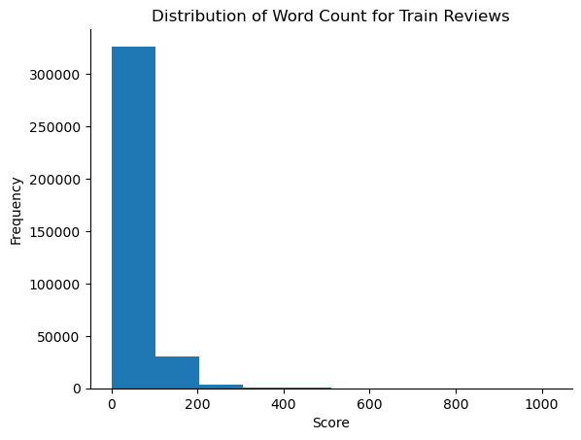
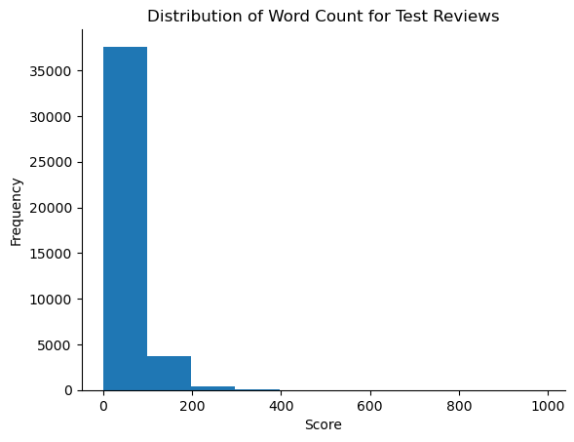

Figure 1: Distribution of Word Count (train reviews)

Figure 2: Distribution of Word Count (test reviews)
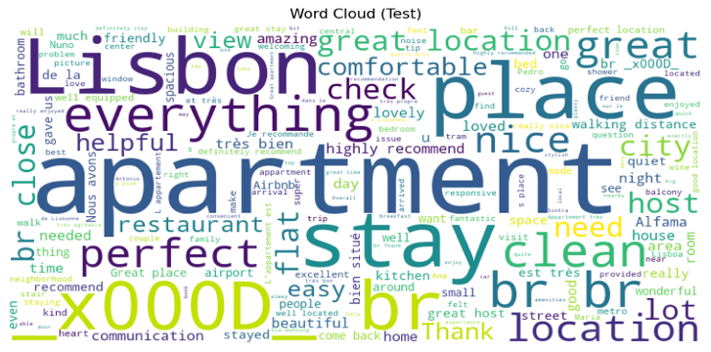
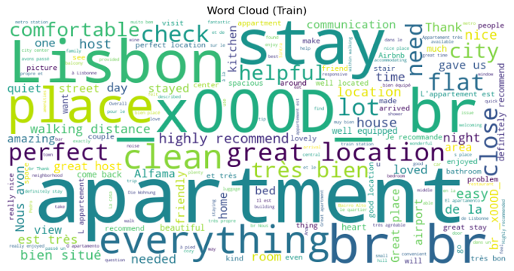
Figure 3: Initial WordCloud for comments (train)
Figure 4: Initial WordCloud for comments (test)

All in all, data exploration enabled us to define points we should consider during data preprocessing. First, we must lower or uppercase the words to avoid different tokens representing the same word. Second, it is crucial to identify and count the occurrences of each language in our datasets to set the stop words to remove and lemmatize. Third, we must remove special characters and white spaces, as well as handle potential missing values stemming from any of these procedures.

Data Preprocessing
The first step in our preprocessing pipeline involved lowercasing all text data and removing irrelevant characters and tags. We utilized regular expressions to achieve this, effectively stripping HTML tags and non-alphabetic characters from the text. Additionally, we removed specific characters like 'x' and 'd' when they appeared alone, ensuring cleaner text for subsequent processing.

Language detection (Extra technique)
Language detection was essential to apply language-specific preprocessing techniques accurately. We employed language detection libraries such as langdetect and langid to identify the primary and secondary languages present in the text. A confidence threshold of 0.85 was set to determine the dominant language, meaning that the technique keeps the primary language detection (langdetect) results if the confidence level is below 85% and for when is greater than 85% it returns the results for the secondary language detection (langid). Texts with unidentified languages were labeled as 'unknown' for further handling.
We encountered instances where language detection resulted in 'unknown' languages, particularly in the reviews dataset. Since the lowercase function removed non-textual content, rows with 'unknown' languages were essentially empty. Consequently, we chose to drop these rows from the reviews dataset to maintain data integrity.

Data Cleaning
In the property description and host about datasets, each property had only one corresponding row. Therefore, removing rows with missing data would lead to a loss of target rows for certain properties. To address this issue, we filled missing data with the placeholder "empty," ensuring that all properties retained their target labels.
With missing data handled, we proceeded to the data cleaning phase. This involved further processing steps such as removing stop words, lemmatization, and any additional text-specific cleaning tailored to each language identified in the dataset.
Firstly, we defined a set of stop words for the most common languages present in our dataset, including English, French, Portuguese, Spanish, German, Italian, Dutch, and Russian. These stop words were then removed from the text data to eliminate noise and improve the quality of our analysis. Additionally, we employed lemmatization techniques to transform words into their base or dictionary form, aiding in standardization and reducing the dimensionality of the dataset.
For cleaning the text columns, we implemented a function that cleaned each text column individually for both the training and testing datasets. This function tokenized the text, removed stop words, and applied lemmatization according to the language of the text. By cleaning each column separately, we ensured that language-specific preprocessing techniques were applied accurately.
Even after handling missing data when preprocessing, we still had missing values due to the cleaning process. This occurred because, for instance, if an entry comprises solely stop words, applying cleaning techniques could render the entry empty. Similarly, if language detection inaccurately identifies non-textual content as part of the text, it may be removed during cleaning, resulting in the disappearance of the entire entry. Therefore, to ensure consistency in the dataset, we filled in the missing values with "empty" to avoid any issues in further analysis.
With the text data cleaned and missing values handled, we proceeded to drop unnecessary columns. For the property details dataset, we discarded the original columns containing the unprocessed property descriptions and host information, retaining only the cleaned versions. Similarly, for the reviews dataset, both in the training and testing sets, we retained only the cleaned reviews column and dropped the original. Additionally, we removed columns containing language information for each row in the text columns, as they were no longer needed after preprocessing.

Exploration of the Resulting Data
After preprocessing and cleaning the text data, it was ideal to analyze its insights and compare it to the original data provided. To do this, each cleaned column was checked once at a time, being this step essential to detect if there are any unnoticed omissions or errors.
Beginning with the observation of the cleaned comments (Figure 5), the following visualizations enhance words that appear more frequently as being displayed larger. From them, it is noticeable that HTML tags and other non-alphabetical characters no longer appear compared to the original data (Figure 3), having the noise initially present being removed. Also, another visible example is that all words are now presented in lowercase as well. Considering this, the same was identified for the other cleaned columns, which signifies a successful execution of the preceding steps.
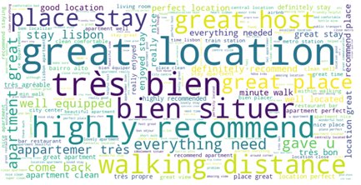
Figure 5: WordCloud for cleaned_comments (train)

While comparing the frequency of individual words between the training (Figure 6) and test (Figure 7) datasets for this column, we found an interesting pattern. Being the top three most frequent words (“apartment”, “great” and” place”) the same in both cases, while the other words tend to slightly oscillate its frequency rankings on the bar plots.
This variability is quite normal and was similarly noticed across other cleaned columns. One contributing factor could be the smaller size of the test dataset compared to the training dataset. Since the test dataset serves a different purpose, namely evaluating the performance of trained models, it may exhibit slightly different word frequency distributions. Considering this, to maintain consistency and leverage a larger portion of available data, the analysis of the other cleaned columns will be focused on the training dataset.

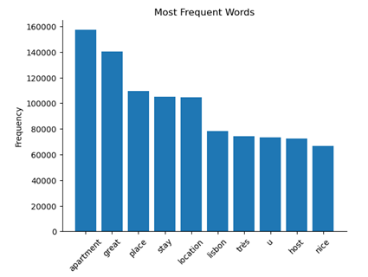
Figure 6: Most Frequent Words in cleaned_comments (train)
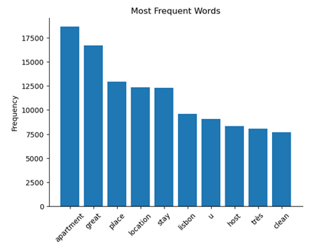
Figure 7: Most Frequent Words cleaned_comments (test)
In the cleaned text associated with the host, it was observed that sentences such as “love travel” and “new people”, along with the individual word “lisbon”, appeared with high frequency, providing a view into the characteristics and preferences of the hosts (Figure 8).
Phrases like “love travel” and “new people” suggests a passion for exploration and a welcoming attitude toward their guests, while the high occurrence of “lisbon” indicates a strong association with the city usually because the hosts' accommodations are located there (Figure 9).

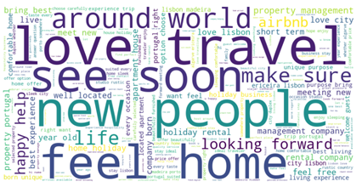
Figure 8: WordCloud for cleaned_host (train)
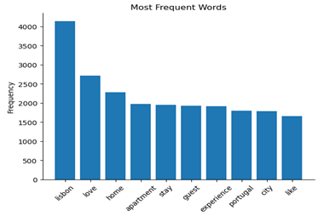
Figure 9: Most Frequent Words in cleaned_host (train)
Lastly, in the cleaned property description feature, it was observed that the phrases “living room” and “license number” were the most frequently occurred (Figure 10). Additionally, the individual word “apartment” also appeared with high frequency (Figure 11). The prominence of “living room” and “license number” suggests their significance in property listings, while the repeated occurrence of “apartment” highlights that this is the most usual property type to be found
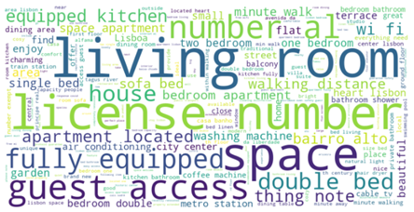
Figure 10: WordCloud for cleaned_description (train)
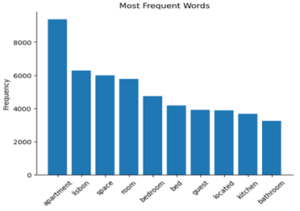
Figure 11: Most Frequent Words in cleaned_description (train)

Data splitting technique
For our project, we chose cross-validation, specifically k-fold cross-validation, as our preferred method for splitting our data. This decision aimed to enhance the robustness of our model evaluations by dividing the data into multiple subsets for both training and testing, thus reducing the risk of bias and overfitting associated with a single split. Subjecting our models to diverse data configurations allowed us to obtain more reliable performance estimates, which are crucial for the success of our project. This strategy will be used consistently across all phases of the project, including evaluating feature engineering methods and model testing, ensuring comprehensive and unbiased assessments.

Feature Engineering
Proceeding with Feature Engineering, to prepare our data for future steps we began by merging the two existent pre-processed and cleaned datasets into one based on their shared index column. Afterwards, missing values detected for “cleaned_comments” were filled with the string “empty”, and the target of the dataset was defined to be the feature “unlisted”, where could be noticed that from all the properties present within the Airbnb data 3405 of them were listed and 1281 were not.
Moreover, after dropping the target variable, the dataset was split into a training and validation set. However, the validation set will not be used for feature extraction or model training but solely for evaluating the performance of our models. Being this approach considered with the objective that the models could only assess unseen data and make more realistic predictions.
To maintain consistency, we confirmed that the number of columns in the training dataset matches the number of rows. Additionally, to proceed with the feature extraction methods, each feature of this dataset was attributed to a new feature name in order to simplify things.
It is important to note that for each method, a common approach was considered, each column transformed individually and then all of them being concatenated into a single column so that the models could be trained based on the specific methods considered.
For the feature extraction, so that raw text data could be converted into numerical features that the models could understand and process effectively the following methods were utilized:

BoW
Regarding Bag-of-Words (BoW), we used a text representation method that focuses on the presence and frequency of words, disregarding the order or structure within a document.
For each training column the text data was transformed into a numerical vector where each element represents the count of a corresponding token. Afterwards, the different column matrices were concatenate horizontally into a single matrix, being it applied multiple train-test splits alongside the target variable while considering cross-validation to evaluate the performance across different subsets of data. A loop was created for each of the 5 folds, being the BoW representation trained, with a maximum of 1000 iterations, on the training data, and subsequently tested on its corresponding test data.

TF-IDF
Concerning Term Frequency-Inverse Document Frequency (TF-IDF), it is responsible to assign weights to words based on their frequency on the document and how rare they are across dataset. However, even though this is a method than the previous one we followed the same structure.
The text data starts by being converted into numerical TF-IDF weighted numerical matrices for each of the columns of the dataset, being those features afterwards concatenate together into a single column. A loop is used to iterate through 5-fold cross-validation splits. Within each iteration, a train-test split is performed on the combined TF-IDF feature matrices, utilizing the train and test indices obtained from the cross-validation split. Lastly, a model is trained and evaluated with a maximum of 1000 iterations to check the performance of the method.

Word2Vec
In our Word2Vec implementation, we generate embeddings for our textual data, aiming to capture domain-specific semantic relationships between words. The model is trained on the combined text data from three separate columns: Each word will be represented by a vector of 100 dimensions, 5 words to the left and 5 words to the right of the target word will be considered when training. The minimum frequency threshold for words to be included in the training is 1, and the training will be parallelized over 4 CPU cores.

Followingly, we define a function to train Word2Vec models for each column individually, converting the text data into fixed-size numerical vectors by averaging the Word2Vec embeddings of words present in each document. The resulting vectors from each column are concatenated along the feature dimension to form a unified feature set (X_word2vec).

BERT (Extra Method)
For our first additional method, we used a pre-trained Bidirectional Encoder Representations (BERT) from Transformers model to generate embeddings for textual data. We create the function “embedding” that takes a list of texts and processes them in batches to generate their embeddings, with a default of 8. For each batch, the texts are tokenized using the BERT tokenizer, with the ‘bert-base-multilingual-cased' variant (the most suitable for our multilingual text processing needs), which converts the text into input tensors suitable for this model, with the defined appropriate padding and truncation. Additionally, gradient calculations were disabled to reduce memory usage and speeding up the process.

The output from the model includes hidden states for each token and mean pooling is applied to these hidden states along the sequence length dimension, resulting in a single vector representation for each text in the batch.

LabSE (Extra Method)
Our second extra method from sentence-transformers was Language-agnostic BERT Sentence Embedding (LaBSE), which is specifically optimized for creating high-quality sentence embeddings across multiple languages, and where all necessary preprocessing steps, like padding and tokenization, are intrinsic to its structure.

Similarly to the previous model, we use a pre-trained model capable of generating multilingual sentence embeddings, and within the “embedding” function we store the embeddings and process the text in in batches (default is 8). For each batch, the texts are encoded using the LaBSE model’s encode method, which generates embeddings for the entire batch.

For both embedding approaches the progress bar is updated to reflect the number of texts processed, and the resulting embeddings for the three datasets (property reviews, host information, and property description) are concatenated to form combined embeddings arrays: combined_embeddings (BERT) and combined_embeddings_labse (LaBSE), and subsequently transforming text data into numerical vectors suitable for machine learning tasks.

Summary of the Results
It is important to note that we decided to repeatedly split our data through Cross-Validation into multiple training and testing sets to ensure that the models are being evaluated across different subsets of the data, getting a more robust estimate of their performance and mitigating the variability in performance that can arise from a single split.

For each one of the five models used for feature extraction we evaluated their performance through Logistic Regression models on the generated features. Our decision to use logistic regression for evaluating feature engineering results was due to its simplicity, interpretability, and efficiency. It provides a clear baseline performance, allowing us to understand the impact of different features on predictions without the risk of overfitting associated with more complex algorithms. Additionally, logistic regression's computational efficiency facilitates quicker iterations, making it easier to test multiple feature engineering methods. This approach ensures that improvements in model performance are genuinely due to better features rather than the intricacies of a complex model, providing a solid foundation for subsequent, more sophisticated modeling. Ater evaluating the feature extraction methods we stored their resulting metrics (accuracy, precision, recall, f1-score). The results can be seen in the following table:

 | BoW | TF-IDF | Word2Vec | BERT | LaBSE
Mean Accuracy | 0.858 | 0.886 | 0.874 | 0.859 | 0.878
Mean Precision | 0.732 | 0.769 | 0.739 | 0.742 | 0.755
Mean Recall | 0.760 | 0.835 | 0.837 | 0.745 | 0.820
Mean F1 Score | 0.745 | 0.800 | 0.785 | 0.743 | 0.786
Table 1: Summary of feature extraction methods’ metrics
TF-IDF features are the ones with the best performance in all the metrics, followed closely by LaBSE features. We will therefore focus on developing classification models using these two approaches from feature extraction.

Classification Models – Model Testing
To identify the most effective model and feature extraction method for our NLP project, we performed a comprehensive evaluation using different techniques. Our testing involved two primary methods of feature extraction: TF-IDF and LaBSE. The first provided us with the best preliminary results; however, we found it beneficial to also include the latter, the second-best performing method, for further detailed testing. This allowed us to assess the models' performance and determine which approach performs best overall.

Method used for training the models
To achieve our main goal, we explored various classification models and their hyperparameters through randomized search, ensuring a robust comparison. We employed k-fold cross-validation to evaluate model performance, as this method helps in reducing overfitting and provides a reliable estimate of model performance.
For all models, the randomized search was used for hyperparameter tuning. This approach allowed us to explore a wide range of hyperparameters by evaluating only a subset of possible combinations, making it more efficient than exhaustive grid search. By doing so, we were able to identify effective hyperparameter values while balancing the time constraints of the project.
It is still important to mention that all models (in this phase) were trained and assessed solely on the training dataset to prevent data leakage and bias. This ensured that each model's performance was optimized based on the training data's characteristics. The validation dataset was reserved exclusively for the evaluation phase, where the models' performance will be rigorously assessed using various metrics. This clear separation of training and validation data ensured the integrity of our model evaluation process, enabling us to make well-informed decisions about model selection and deployment.

Scoring metric – training results
We chose the F1 score as the primary metric for evaluating our models during the randomized search because of our imbalanced dataset, with significantly more instances of properties that are still listed compared to unlisted ones. The F1 score is a suitable metric for imbalanced datasets as it considers both precision and recall, providing a balanced measure of a model's performance. By optimizing for the F1 score, we aim to achieve a good balance between correctly identifying unlisted properties (recall) while minimizing false positives (precision). Once we identify the best models based on the F1 score, we will proceed to model evaluation, where we will assess the performance of these models across all relevant metrics, including accuracy, precision, recall, and F1 score. This evaluation will provide a thorough understanding of each model's strengths and weaknesses enabling us to select the most suitable model for our prediction task.

Logistic regression (scikit-learn)
We evaluated Logistic Regression models with various hyperparameters using features extracted from the best methods discussed in the previous section. The approach involved hyperparameter tuning through randomized search with cross-validation for three different logistic regression models, each with unique settings for the solver parameter. The models were defined with varying solvers and hyperparameters: Model 1 utilized solver 'saga' and penalty 'l2' with different values for regularization strength (C); Model 2 employed solver 'liblinear' with penalties 'l1' and 'l2', alongside a range of C values; Model 3 utilized solver 'saga' with penalties 'l1' and 'elasticnet', with varied C values and l1_ratios.

MLP (scikit-learn)
For our Multilayer Perceptron (MLP) implementation, we integrated it with RandomizedSearchCV for hyperparameter tuning. We explored a wide range of configurations, including hidden_layer_sizes, activation functions, solvers, learning rates, alpha (regularization parameter), learning_rate_init, max_iter, and batch_size. The best-performing MLP configurations were recorded and compared against other models, ensuring a comprehensive evaluation of all tested approaches.

K-Nearest Neighbors (scikit-learn)
We also explored the KNN algorithm, leveraging the transformed text data. Hyperparameter tuning was conducted through randomized search with cross-validation, examining parameters such as the number of neighbors, weights (uniform or distance-based), algorithm for computing neighbors, and the distance metric parameter (Manhattan or Euclidean). This exploration aimed to assess KNN's performance under various configurations and its suitability for our prediction task.

XGBoost (Extra Model)
In addition to Logistic Regression, MLP, and KNN, we decided to include eXtreme Gradient Boosting (XGBoost) as an extra in our model evaluation due to its well-known advantages in handling structured and unstructured data, especially for classification tasks. XGBoost leverages gradient boosting techniques and is capable of handling large datasets with high dimensionality. We defined the model with various hyperparameters, including the number of estimators, maximum depth, subsample ratio, minimum child weight, and learning rate. The randomized search with stratified k-fold cross-validation was then used to identify the best hyperparameters, focusing on optimizing the F1 score.

DistilBERT (Extra model)
As another extra model, the transformer DistilBERT was used as a strategic decision, primarily due to its lighter weight compared to the popular model BERT. Being this lighter version 60% faster, keeping around 95% of BERT’s performance and needing significantly less memory available to run (Sanh & Kraj, n.d.), which in our case was something important to take into consideration, since the computational space available was limited. Also, DistilBERT is considered a language model and can process natural language by capturing the contextual meaning of words in sentences.
To prepare the data to be trained, the cleaned columns done before the feature engineering step were used and concatenated into a single column. We started by creating a binary classification task that was defined using a custom dataset class, which tokenizes the text data at a given index and processes the text with a maximum length of 512 tokens, returning a dictionary that contains the tokenized input IDs, attention masks and the target variable as a tensor. Afterwards, a pre-trained DistilBERT is configured for this type of classification, allowing it to process input text sequences and predict one of two possible classes. Lastly, training parameters were defined allowing fine-tuning and optimization of the model.

Model testing results
When comparing the outcomes during the hyperparameter tuning through random searches of LaBSE and TF-IDF features when training the models (Logistic Regression, MLP, KNN, and XGBoost), we observed that TF-IDF consistently provided superior results, although there was an instance where LaBSE outperformed TF-IDF likely due to parameter settings.

 | LogReg | KNN | MLP | XGBoost | Average Score
TF-IDF | 0.80387527 | 0.79169549 | 0.79502845 | 0.79182062 | 0.79560496
LaBSE | 0.78419933 | 0.79654942 | 0.78701209 | 0.80134262 | 0.79227587
Table 2: Summary of models' weighted F1 performances
Given the steadily high performance of TF-IDF features, we believe that with more exhaustive parameter optimization, the results from both methods might be comparable. Nevertheless, based on our findings from the random searches, we decided to proceed with TF-IDF features as they delivered more reliable and robust results. As for the DistilBERT implementation, it will be evaluated comparatively with the final choices.

Model Evaluation
In this section we will assess and evaluate the performance of the different Machine Learning models applied to predict our target. Our goal was to identify the model that best predicts our target variable on unseen data. To achieve this, we used the hyperparameters for each model that performed best on our data based on the randomized search results, and then trained these models on our training dataset and evaluated on the unseen data we separated in the beginning of feature engineering in order to understand how well the models generalize to new data.
To prepare our data, we vectorized the text data using TF-IDF: the method that provided us with the best model results in a general way. Specifically, we applied TF-IDF vectorization to three distinct text fields: cleaned_comments, cleaned_host, and cleaned_description. The vectorizers were fitted on the training data, and the resulting features were transformed accordingly. We combined the TF-IDF features for these fields to create a unified feature set for both the training and validation datasets. This feature set was then used for model training and evaluation.

Logistic Regression
For the Logistic Regression model, we used the hyperparameters C=8.68511373751352, penalty='l2', and solver='saga', which were selected based on the results of our randomized search. Upon training the model, we observed a very high training F1 score of 0.9891, indicating that the model performed exceptionally well on the training data. However, the testing F1 score on the validation set was 0.8079, reflecting a notable decrease in performance when applied to unseen data. This suggests that while the model fits the training data very well, it may be overfitting, as evidenced by the lower validation score.
The classification report for the training data showed nearly perfect precision, recall, and F1 scores for both classes, with a confusion matrix indicating very few misclassifications. For the validation data, the model maintained high precision and recall for class 0 (listed) but performed slightly worse for class 1 (unlisted), indicating a potential bias towards the majority class.

KNN Classifier
The KNN model was trained with the parameters weights='distance', p=2, n_neighbors=25, and algorithm='auto'. The model achieved an almost perfect training F1 score of 0.9988, suggesting that it fits the training data exceptionally well. However, the testing F1 score dropped to 0.7899, indicating significant overfitting. This drop in performance suggests that while KNN can capture the patterns in the training data, it struggles to generalize to new, unseen data.
The classification report for the training data confirmed the overfitting, showing perfect precision and recall across both classes. However, the validation data report indicated a higher rate of misclassification, especially for class 1, demonstrating that the model's performance on unseen data was less reliable.

MLP Classifier
For the MLP classifier, we used the hyperparameters max_iter=250, learning_rate_init=0.01, solver='sgd', learning_rate='adaptive', hidden_layer_sizes=(30), batch_size=143, alpha=0.3593813663804629, and activation='tanh'. The MLP model yielded a training F1 score of 0.9466 and a testing F1 score of 0.8133. These results suggest that the MLP model, while still fitting the training data well, generalizes better to the validation data compared to KNN and Logistic Regression.
The training classification report showed high precision, recall, and F1 scores, indicating robust performance. On the validation data, the MLP model maintained good precision and recall for class 0 and showed slightly improved performance for class 1 compared to Logistic Regression. This balance suggests that the MLP model is better at generalizing and managing the trade-off between precision and recall for both classes.

XGBoost
The XGBoost model was configured with random_state=19, objective='binary:logistic', eval_metric='logloss', subsample=1.0, n_estimators=350, min_child_weight=5, max_depth=15, and learning_rate=0.01. The model achieved a training F1 score of 0.8744 and a testing F1 score of 0.7809. These scores indicate a more balanced performance between training and validation data, suggesting that XGBoost is less prone to overfitting compared to the other models evaluated.
The training classification report showed high precision and recall, though slightly lower than the other models, which may imply a better balance in capturing the data's underlying structure without overfitting. The validation report showed decent precision and recall for both classes, with more misclassifications compared to the MLP model but a robust overall performance.

DistilBERT
For the DistilBERT model, we fine-tuned it with a maximum sequence length of 512 and trained it for 8 epochs using a batch size of 16. The evaluation metrics on the validation set included an evaluation loss of 0.3306, an evaluation accuracy of 0.8796, an evaluation F1 score of 0.7849, an evaluation precision of 0.7673, and an evaluation recall of 0.8033.
The classification report for the validation set revealed high precision and recall for class 0 (listed) with a precision of 0.92, a recall of 0.91, and an F1 score of 0.92. For class 1 (unlisted), the model achieved a precision of 0.77, a recall of 0.80, and an F1 score of 0.78. The overall accuracy of the model was 0.88, with a macro average F1 score of 0.85 and a weighted average F1 score of 0.88. These results suggest that while the DistilBERT model performed well, it exhibited a slight bias towards the majority class, similar to the other models evaluated.
The performance of the DistilBERT model, although good, was slightly lower compared to other models evaluated. This discrepancy may be attributed to various factors, such as the complexity of the dataset and the inherent limitations of the model architecture. With more time, further fine-tuning of hyperparameters, experimenting with different architectures, or exploring techniques to address class imbalance could potentially enhance the performance of the DistilBERT model and mitigate its bias towards the majority class.

Comparing model’s results
Our evaluation of models for predicting property listing status on Airbnb provided valuable insights into their strengths and weaknesses. While Logistic Regression and KNN achieved high training scores, they showed signs of overfitting, as evidenced by their lower performance on the validation set. This discrepancy suggests that these models may have learned the training data too well, leading to reduced performance on unseen data.
In contrast, the MLP model demonstrated a more balanced approach, maintaining high performance on both the training and validation datasets. This indicates better generalization to new data and less susceptibility to overfitting. Although XGBoost did not achieve the highest individual scores, it showcased robustness and a good balance between training and validation performance, suggesting it may be a more reliable model for generalization to unseen data.
The DistilBERT model, when fine-tuned, showed strong performance with an evaluation F1 score of 0.7849, an evaluation accuracy of 0.8796, however still didn´t outperform MLP Classifier.
We also assessed the models' performance using ROC curves (Figure 12). The area under the ROC curve (ROC-AUC) provides a measure of the model's ability to distinguish between classes. All models achieved high ROC-AUC scores, with values around 0.9, except for KNN, which scored slightly lower at 0.89.
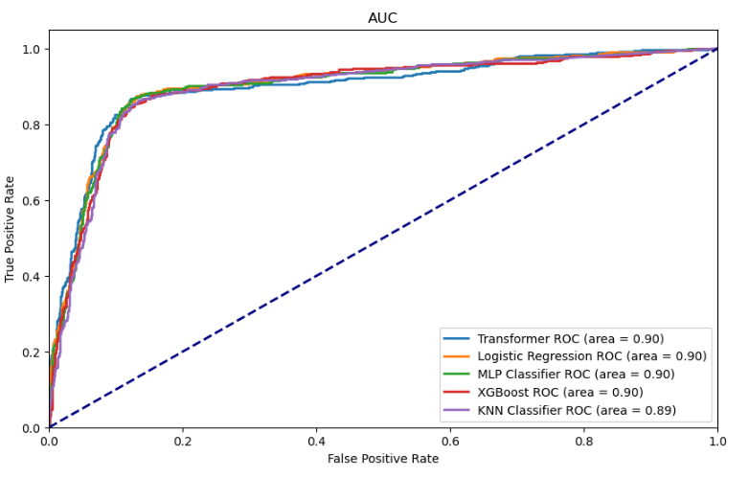
Figure 12: ROC curves for each model
Ultimately, the optimal model selection depended on the specific requirements and constraints of our use case. In our project, it is crucial to accurately identify the properties that will be unlisted (class 1). Therefore, models like MLP or XGBoost, with their balanced approach to precision and recall across classes, might be preferred. Based on these observations, both MLP and XGBoost emerge as strong contenders for our task due to their balanced performance and potential for generalization.
Comparing the performance of the best models, the MLP classifier demonstrated strong performance in both training and testing phases. It achieved a high training F1 score of 0.9466 and a testing F1 score of 0.8133, indicating excellent generalization to unseen data. Moreover, the MLP model exhibited balanced precision and recall for both classes, as observed in the validation results. This balance suggests that the MLP model effectively manages the trade-off between precision and recall, crucial for our task of predicting property listing status on Airbnb.
While XGBoost also showed competitive performance, with a training F1 score of 0.8744 and a testing F1 score of 0.7809, the MLP model outperformed it in terms of generalization and managing the trade-off between precision and recall for both classes. The MLP model's slightly higher testing F1 score and balanced performance across classes make it the preferred choice for our task.
Furthermore, the assessment of ROC curves revealed that all models achieved high ROC-AUC scores, indicating their ability to distinguish between classes effectively. However, the MLP model's superior performance in terms of F1 scores and balanced precision and recall on the validation data solidifies its position as the preferred model for predicting property listing status on Airbnb.

Best Performing Model and Test Data Predictions
Based on our evaluation, we chose the MLP model as our best-performing model. The following hyperparameters were the ones that helped us achieve the best results: max_iter=250, learning_rate_init=0.01, solver='sgd', learning_rate='adaptive', hidden_layer_sizes=(30), batch_size=143, alpha=0.3593813663804629, activation='tanh', and random_state=42.

Finally, we applied the top-performing model to forecast the test set, where labels were unavailable. The resulting distribution indicated 489 instances classified as class 0 (listed) and 206 instances classified as class 1 (unlisted). Subsequently, these predictions were stored and archived in a file formatted as a pandas Series.

Conclusion
After exploring and preprocessing the text data, our comparative analysis revealed that TF-IDF was the best-performing feature extraction method, which included BoW, Word2Vec, BERT, and LaBSE. The TF-IDF method was able to provide superior results across various models, likely due to its ability to effectively capture the importance of terms in the context of the entire corpus while maintaining simplicity and computational efficiency, unlike dense embedding techniques such as BERT and LaBSE, that require considerable computational resources.
The MLP proved to be the best performer among the models tested. Its superior performance can be attributed to the capability to learn complex, non-linear patterns in the data through its multiple layers and neurons. Alternatively, Logistic Regression and KNN are generally simpler and may struggle with capturing intricate relationships in the data, and XGBoost, despite being powerful for structured data, may not fully leverage the nuances of textual features. The surprise was DistilBERT which, although powerful, is computationally intensive and did not outperform MLP in our specific experiments. Hence, the combination of TF-IDF features and the MLP model provided a powerful, efficient, and effective approach to the task at hand.

Limitations and Future Work
While testing with various Machine Learning models, we encountered several challenges related to time and device constraints, particularly when working with computationally expensive algorithms and techniques, like sequential models and transformers. The use of such advanced methods requires significant resources due to their complex architecture and large number of parameters, therefore training and fine-tuning these models proved to be particularly demanding. Their innate complexity means they require more time to converge compared to simpler models like Logistic Regression or even XGBoost.
Despite the constraints we faced, the results were promising. The trained models successfully captured complex patterns and nuances in the data that simpler models might miss. However, the high computational cost of advanced models necessitated careful planning and resource management, limiting the number of iterations and cross-validation folds to ensure feasible model testing. For further exploration, we could use broader ranges of hyperparameters and employ grid search for fine-tuning, potentially achieving better performance through a more exhaustive search to identify optimal hyperparameter settings.
For future projects, balancing the trade-off between model performance and computational efficiency will be crucial. Although transformer models offer state-of-the-art performance, their resource demands require strategic approaches to ensure practicability within time and equipment constraints. Leveraging advancements in model optimization and resource-efficient computing can help lessen the burden of these challenges and pave the way for more effective and scalable implementations.

References
Baka, V. (2016). The becoming of user-generated reviews: Looking at the past to understand the future of managing reputation in the travel sector. Tourism Management, 53, 148–162. https://doi.org/10.1016/j.tourman.2015.09.004
Cavique, M., Ribeiro, R., Batista, F., & Correia, A. (2022). Examining Airbnb guest satisfaction tendencies: a text mining approach. Current Issues in Tourism, 25(22), 3607–3622. https://doi.org/10.1080/13683500.2022.2115877
Grégoire, D. A., Ter Wal, A. L. J., Little, L. M., Bermiss, S., Kotha, R., & Gruber, M. (2024). From the Editors - Mobilizing New Sources of Data: Opportunities and Recommendations. Academy of Management Journal, 67(2), 289–298. http://journals.aom.org/doi/full/10.5465/amj.2024.4002
Hannigan, T., Haans, R. F. J., Vakili, K., Tchalian, H., Glaser, V. L., Wang, M., Kaplan, S., & Jennings, P. D. (2019). Topic modeling in management research: rendering new theory from textual data. Academy of Management Annals, 13(2), 586–632. https://doi.org/10.5465/annals.2017.0099
Sanh, V., & Kraj, K. (n.d.). DistilBERT. https://huggingface.co/docs/transformers/model_doc/distilbert
Zhang, L., Yan, Q., & Zhang, L. (2020). A text analytics framework for understanding the relationships among host self-description, trust perception and purchase behavior on Airbnb. Decision Support Systems, 133(September 2019), 113288. https://doi.org/10.1016/j.dss.2020.113288

