Lab 9 – Ethical Hacking Protocols
Exercise 1
I ran a SYN flood from my Kali VM against the Windows Metasploitable machine at 192.168.255.2 using hping3. Baseline network usage before the attack:
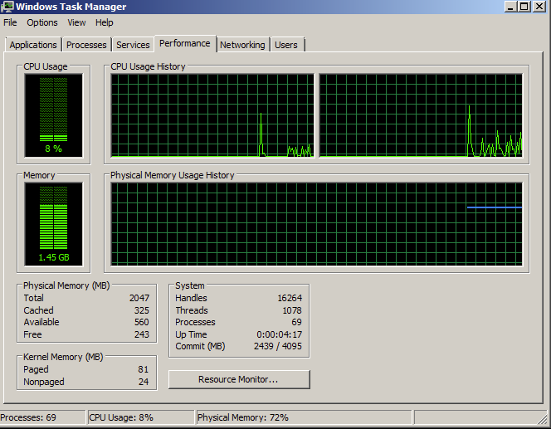
Command used:
sudo hping3 -c 15000 -d 500 -S -w 64 -p 80 --flood --rand-source 192.168.255.2
This sends 15,000 spoofed SYN packets to port 80 as fast as possible. Network usage after running it for about 30 seconds:
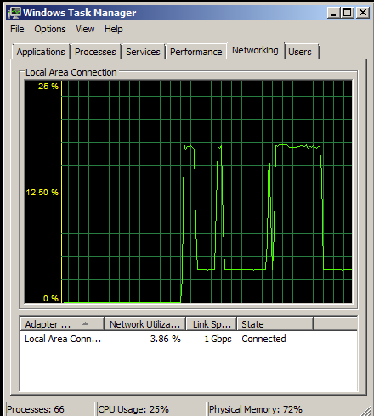
Exercise 2
1. How many packets does the capture contain?
2,195 packets.
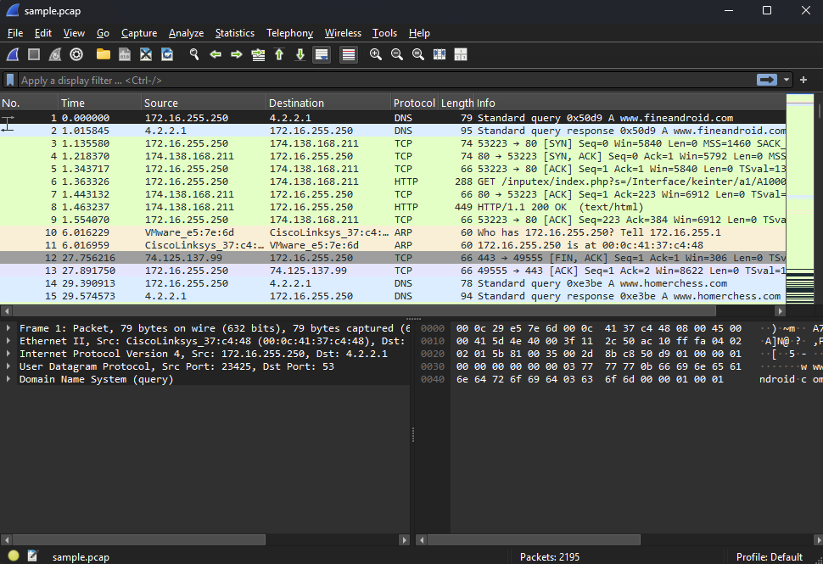
2. Find and record all the DNS domain requests and all the IP addresses returned.
- www.fineandroid.com → 174.138.168.211
- www.homerchess.com → 82.165.80.40
- market.android.com → 74.125.137.118
- twitter.com → 199.59.149.230, 199.59.150.7, 199.59.150.39
- clients1.google.com → 173.194.37.32–41, 46 (11 IPs)
- www.gstatic.com → 173.194.37.79
- fineandroid.com → 174.138.168.211
- north-america.pool.ntp.org → 173.255.193.172, 209.114.111.1, 169.229.70.95
- xtra2.gpsonextra.net → 72.51.26.219
- android.clients.google.com → 74.125.45.100–102, 113, 138, 139
- diaobaolediaobaole3.googlecode.com → 74.125.137.82
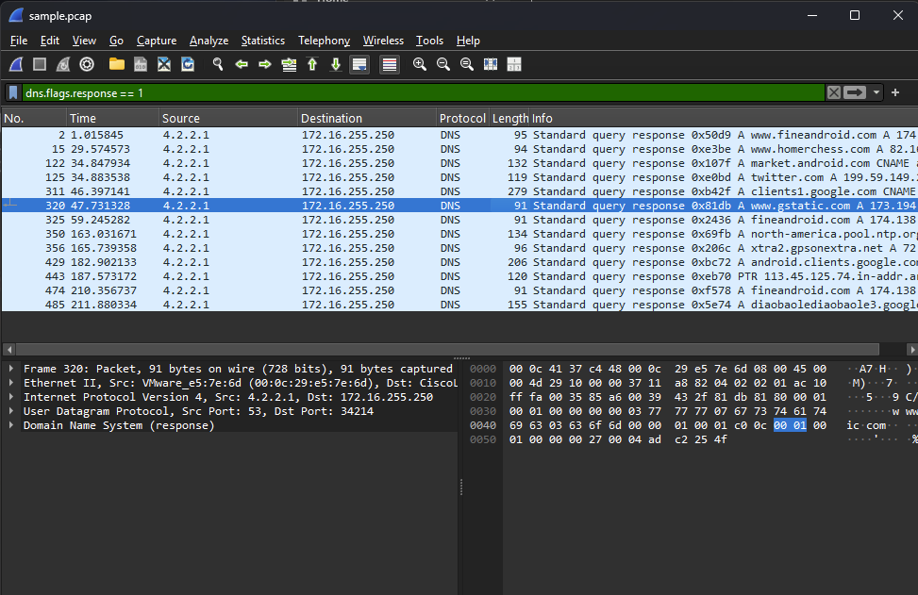
3. Record the full URI requests of all the GET requests.
- www.fineandroid.com/inputex/index.php?s=/Interface/keinter/a1/A1000012388937/a2/3100120000006441/a3/ERIS/index/xian1234
- www.google.com/webhp?client=ms-android-verizon-us&source=android-home&sky=mrdr&mnfst=1
- www.homerchess.com/sd-booster/SD-Booster-v1-eng.html
- www.google.com/images/nav_logo107.png
- www.homerchess.com/sd-booster/img/app_logo.png
- www.homerchess.com/favicon.ico
- www.google.com/m?client=ms-android-verizon-us&source=android-home
- www.google.com/images/nycli1.gif
- www.google.com/extern_js/f/... (long tracking script URL)
- clients1.google.com/generate_204
- fineandroid.com/InstallApk/php4sam.php (x2)
- xtra2.gpsonextra.net/xtra.bin
- diaobaolediaobaole3.googlecode.com/files/youni.apk (x2)
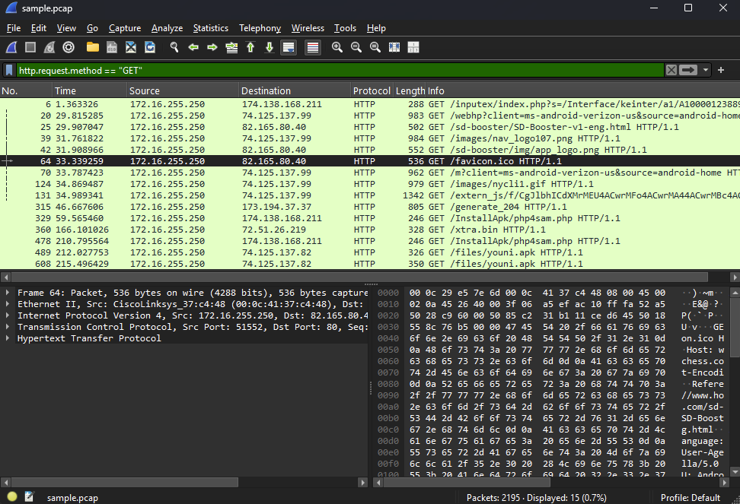
4. What kind of packet is packet number 1400?
NTP, Version 3, client request.
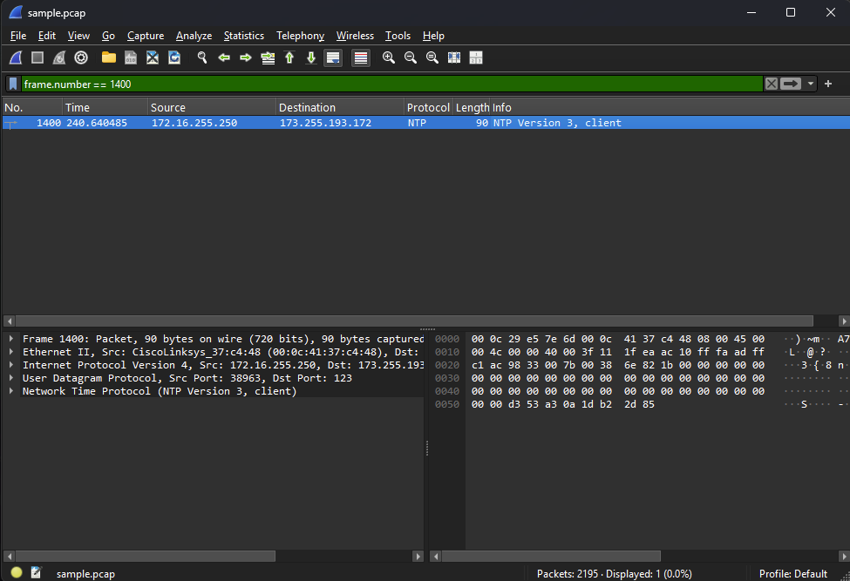
5. What is the reference time stamp of packet number 1404?
May 8, 2012 13:19:38.163578891 UTC.
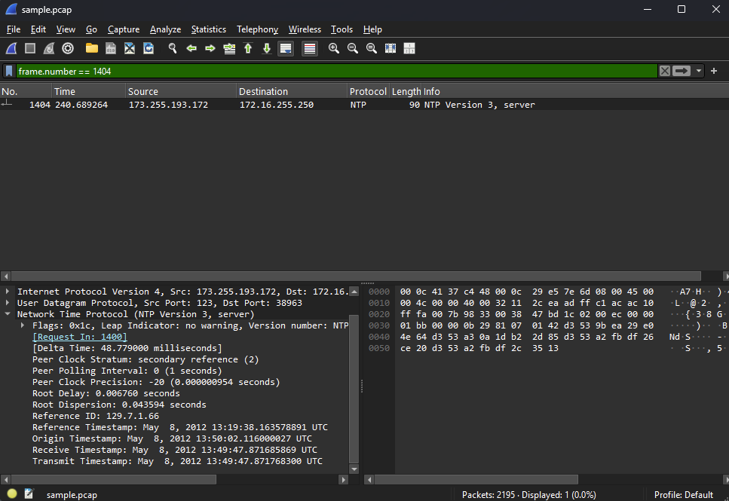
6. Export app_logo.png and find the MD5 hash of the file.
MD5: 43DD661754BA7A3B75F34999B3F54181
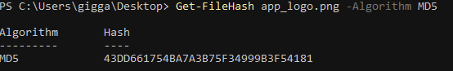
7. Export SD-Booster-v1-eng.html and then record the email and Twitter contacts in the document.
Email: daniel.mehrmann@gmx.de Twitter: twitter.com/akusari

