**PA Report**

Jian Chu (jc86537) & Yang Liu (yl34825)

**Mathematical approach:**

|  |  |
| --- | --- |
| PA 1 | From the lecture notes, W2-L1, W2-L2, W3-L1, W3-L2  Used formulas in the lecture to calculate the non-singular cases, if it is singular, we specify the value in the program comments |
| PA 2 | From the lecture notes, W3-L1, W3-L2  Used formulas in the lecture to calculate the non-singular cases, if it is singular, we specify the value in the program comments  We also add some Error Warning message if the input is not correct. |
| PA 3 | From the lecture notes, W3-L1, W3-L2  Use the formulas in the lecture to calculate the configuration, draw it by quiver3 function. |

Actually, all the formulas we use can be found in the formulas summary page.

**Programs Lists:**

|  |  |
| --- | --- |
| TransformRO3 (PA 1) | Transform to the equivalent axis-angle, quaternion, ZYZ and roll-pitch-yaw representation by given rotation matrix R |
| Transform2RO3 (PA 2) | Transform to the equivalent rotation matrix by given axis-angle or quaternion representation |
| TransformM (PA 3) | Calculate the equivalent rotation matrix by given q, s_hat, h and theta |
| Skewlog (PA 3) | Calculate the log by using rotation matrix |
| Skewmv (PA 3) | Calculate v by using theta,p,w_hat |
| PA3 (PA 3) | Main Program for PA 3, you can run it by sections |
| main | Test all the PA problems |

For PA 3:

Firstly (PA3 section 1), we use the function ‘TransformM’ to get the transform matrix, by using this matrix, we can directly calculate the configuration by given the distance. By using function ‘quiver3’, we can draw the coordinates as follows:

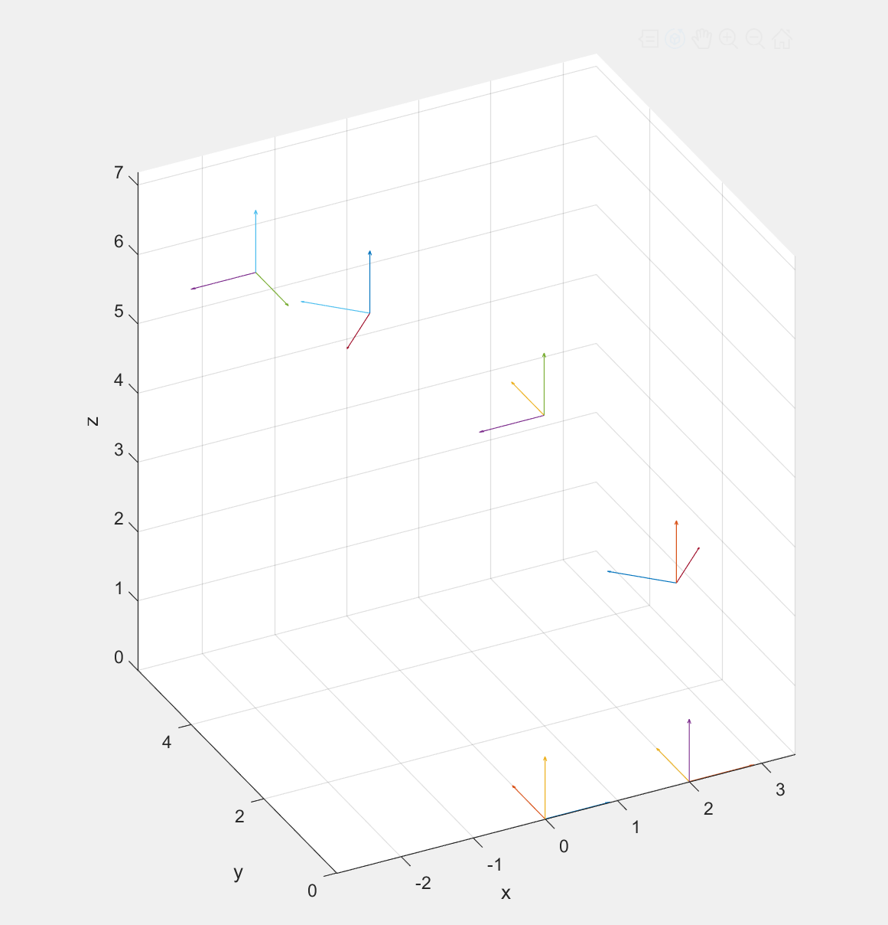

You can see the coordinates is ‘rising’ from the below to the final configuration.

Secondly (PA3 section 2), we use the formulas in the lecture to calculate the skew axis and the distance, and get the output as follows:

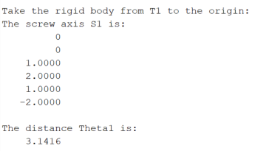

In the end (PA3 section 3), we use the skew axis and distance we get in section 2 to verify our answer, using the same function in section 1, we can test whether the coordinate go to the origin. We get the correct output as:

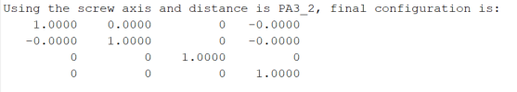

This implies we get the correct answer for section 2.

**Who did what:**

Jian Chu and Yang Liu wrote their own codes, when we finished, we talk with each other and checked our codes, then combined the codes together.