Khmer Sign Language — Algorithm Comparison
Does the choice of algorithm matter when the recording conditions change?

1. What we tested
Seven Khmer signs were recorded on a deliberate grid: twelve takes of each sign, crossing two lighting conditions, two distances and three standing positions. Because the grid is fixed, any one of those settings can be held back — the model is trained on one and tested on a setting it has never seen.
That is the question this report answers. Not "how accurate is it", but "how much accuracy survives a change in the room".
 | Detail
Signs | 7 — ជម្រាប់សួរ, អរគុណ, ខុស, ត្រូវ, គ្រួសារ, ប៉ា, ម៉ាក់
Recordings | 84 takes (12 per sign)
Grid | 2 lighting × 2 distance × 3 position
Input | Pose landmarks — 48 joints × 60 frames, not images
Features | 576 summary values (mean, std, min, max per joint)
Algorithms | 9 compared

2. Every algorithm compared
Each algorithm was scored two ways. The grey bar is a random split of takes — the familiar way to measure accuracy, where training and testing come from the same conditions. The blue bar averages three held-out-condition tests, where the test setting never appeared in training.
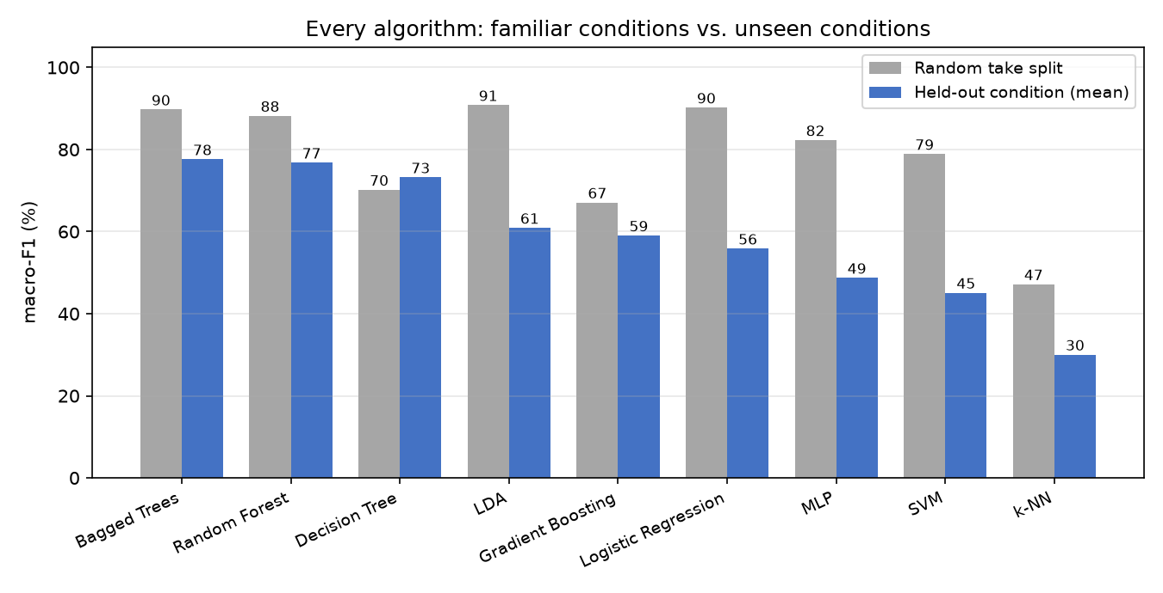
Figure 1 — Every algorithm under familiar conditions (grey) and unseen conditions (blue). The grey bars are close together; the blue bars are not.
Algorithm | Accuracy | Macro-F1 | Unseen conditions | Drop
Bagged Trees | 89.9% | 89.7% | 77.6% | +12.1
Random Forest | 88.7% | 88.2% | 76.8% | +11.4
Decision Tree | 72.6% | 70.2% | 73.2% | -3.0
LDA | 91.1% | 90.8% | 60.9% | +29.9
Gradient Boosting | 67.3% | 67.1% | 59.1% | +8.0
Logistic Regression | 91.1% | 90.2% | 55.9% | +34.4
MLP | 83.3% | 82.3% | 48.7% | +33.6
SVM | 79.2% | 78.9% | 45.1% | +33.8
k-NN | 51.2% | 47.2% | 30.0% | +17.2

Under familiar conditions almost everything scores well and the algorithms look interchangeable. Once the setting changes they separate sharply — from 78% down to 30%. A comparison run only on a random split would have reported that the choice barely matters, and that conclusion would be wrong.

3. Which change of setup actually hurts
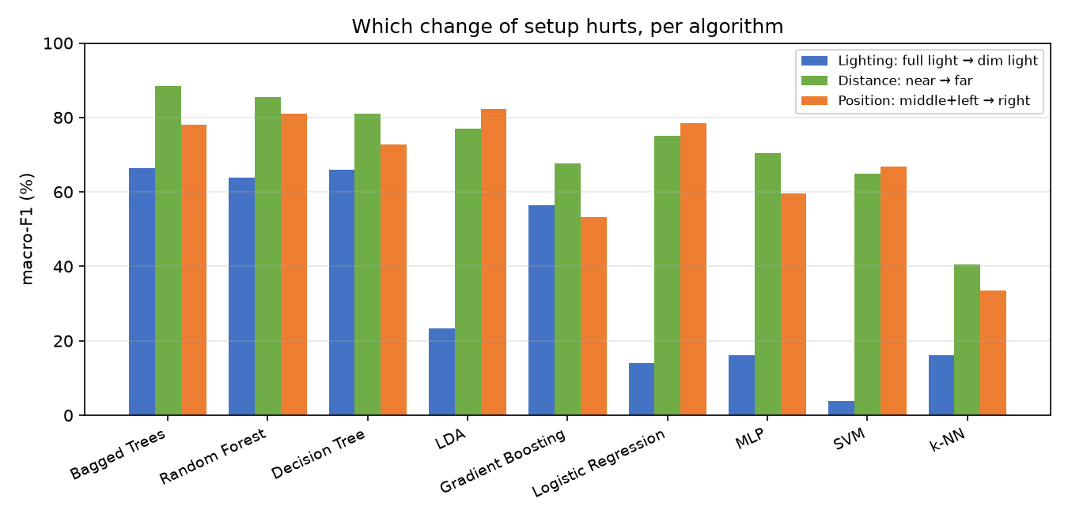
Figure 2 — The same algorithms broken down by which setting was held out.
Held-out setting | Average across algorithms
Lighting: full light → dim light | 36.2%
Distance: near → far | 72.3%
Position: middle+left → right | 67.3%

Standing position and distance transfer reasonably. Lighting is the one that breaks models, and it splits the field: the tree-based methods hold up while the linear and margin-based ones collapse.

4. The chosen algorithm: Bagged Trees
Bagged Trees was selected because it holds the most accuracy when conditions change — 77.6% against 76.8% for the next best (Random Forest) — not because it wins on the random split, where it is one of several near the top.
Held-out setting | Bagged Trees | Next best
Lighting: full light → dim light | 66.3% | 63.8%
Distance: near → far | 88.4% | 85.5%
Position: middle+left → right | 78.1% | 81.1%

It builds many decision trees, each on a different random sample of the takes, and has them vote. No single tree sees everything, so no single quirk of one recording decides the answer.
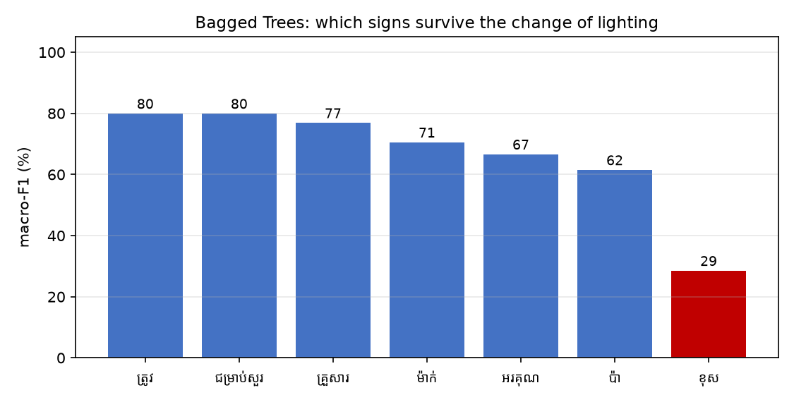
Figure 3 — Per-sign scores on the hardest test. Red marks signs that fall below 50%.
Weakest signs under changed lighting: ខុស. These are worth extra recordings before anything else.
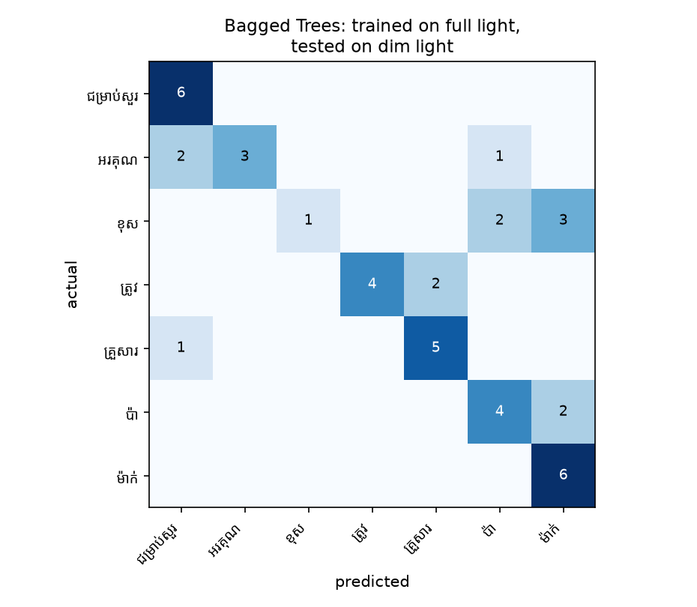
Figure 4 — Which signs get mistaken for which, on the hardest test. The diagonal is correct answers.

5. Conclusions
- Bagged Trees is the most robust of the 9 algorithms tested, keeping 78% macro-F1 when the recording setup changes.
- Algorithms that look equivalent on a random split are not equivalent. The gap only appears when the test conditions differ from the training conditions.
- lighting is the setting that matters most; position and distance are handled comparatively well.
- Tree-based methods degrade gracefully; linear and margin-based methods fail sharply. Robustness is a property of the model family, not of its headline accuracy.

6. Honest limitations
- One signer. These results say how well a model transfers across conditions, not across people — that needs recordings from more of the team.
- Lighting is confounded with recording order: the dim takes were always recorded after the bright ones, so fatigue or drift cannot be separated from the lighting itself. Having half the team record dim first would settle it.
- We assumed dim light would break hand detection. Measured directly, it does not — 62.1% of hand landmarks were missing in bright light and 60.8% in dim. The cause of the drop is still open.
- 84 takes is a small dataset. Differences of one or two points between neighbouring algorithms should not be read as meaningful.

7. Reproducing this
Every algorithm is seeded, so these numbers come out identical on any machine:
python algo_comparison/run_var_experiment.py
Scores average 8 random splits; the condition tests are fixed by the grid and need no averaging.

