Khmer Sign Language — Algorithm Comparison
9 algorithms on 4309 recordings of 7 signs

1. Data and method
Signs are recognised from pose landmarks rather than images. Each recording is 60 frames of 48 tracked joints — six body points plus 21 landmarks on each hand — which is summarised into 576 features (the mean, standard deviation, minimum and maximum of every joint coordinate over the clip).
 | Detail
Signs | 7 — ជម្រាប់សួរ, អរគុណ, ខុស, ត្រូវ, គ្រួសារ, ប៉ា, ម៉ាក់
Recordings | 4309 takes, 12 per sign
Features | 576 summary values per take
Split | 75% train / 25% test, split by take, averaged over 8 random splits
Algorithms | 9, each with the same feature scaling

The split is by take, not by sample, so no take appears on both sides. Every algorithm is seeded, so the numbers reproduce exactly.

2. Results
Macro-averaged metrics, so every sign counts equally regardless of how many recordings it has. Precision is how often a predicted sign is correct; recall is how often an actual sign is found; macro-F1 balances the two and is the headline number.
Algorithm | Accuracy | Precision | Recall | macro-F1 | s.d.
Logistic Regression | 95.4% | 95.7% | 95.4% | 95.3% | ± 2.7
Random Forest | 95.5% | 95.5% | 95.5% | 95.1% | ± 2.8
SVM | 95.2% | 95.3% | 95.3% | 95.0% | ± 2.9
Bagged Trees | 95.1% | 95.2% | 95.0% | 94.8% | ± 2.2
Gradient Boosting | 95.1% | 95.1% | 95.0% | 94.7% | ± 2.2
MLP | 94.8% | 94.8% | 94.6% | 94.4% | ± 2.2
LDA | 94.3% | 94.5% | 94.4% | 94.2% | ± 2.0
Decision Tree | 93.5% | 93.5% | 93.5% | 93.1% | ± 2.0
k-NN | 92.9% | 92.9% | 93.0% | 92.5% | ± 3.6

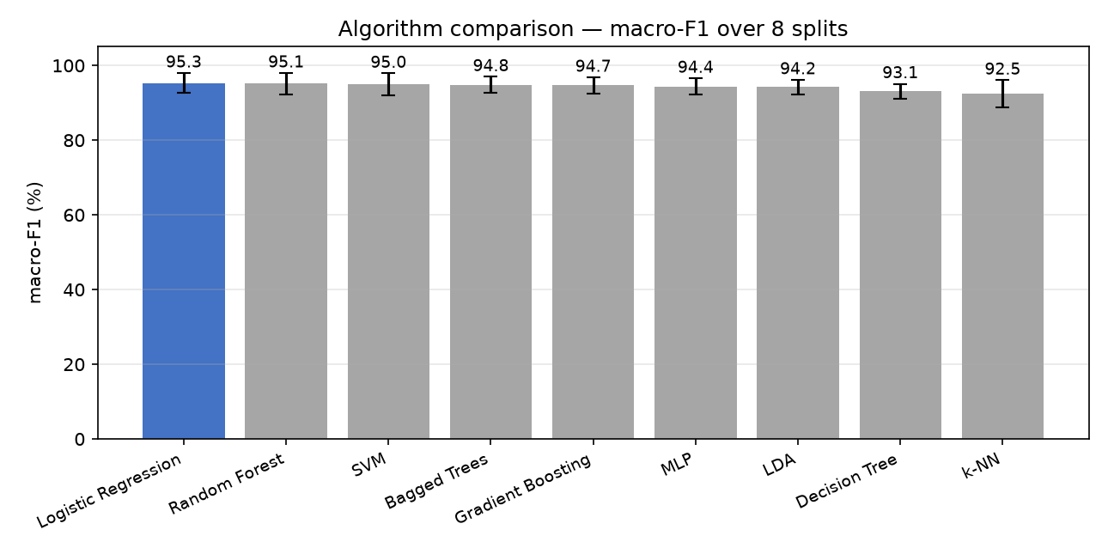
Figure 1 — macro-F1 by algorithm. Bars show the standard deviation across the 8 splits.
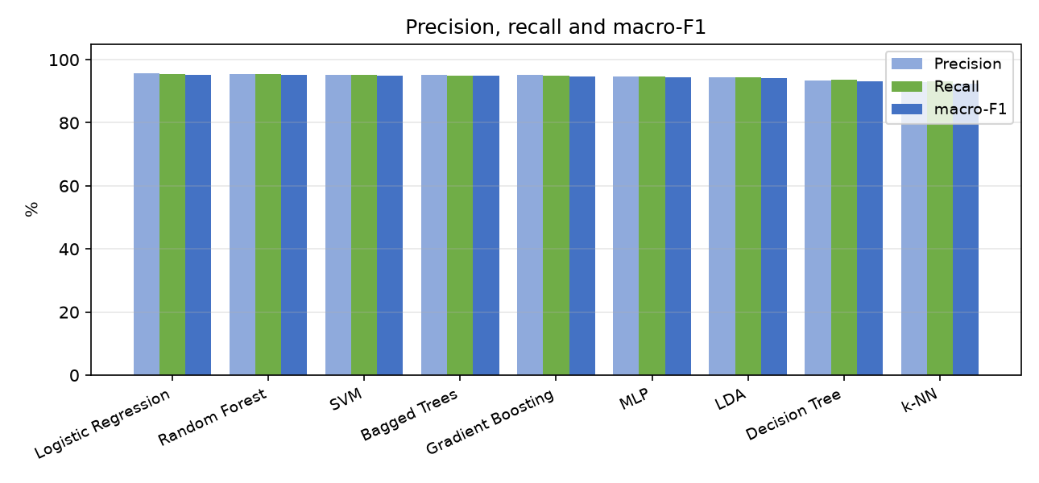
Figure 2 — precision, recall and macro-F1 side by side.
Logistic Regression scores highest at 95.3% macro-F1, but the top group — Logistic Regression, Random Forest, SVM, Bagged Trees, Gradient Boosting, MLP, LDA, k-NN — sits within one standard deviation of each other. On 4309 recordings that is a statistical tie: any of them is a defensible choice, and the ordering between them would likely change with more data.
The genuine separation is between that leading group and the rest: the field spans 3 points from best to worst, and k-NN at 92.5% is far outside any margin of error.
Precision and recall stay close together for the stronger algorithms, which means errors are spread across signs rather than one sign being systematically over-predicted.

3. Logistic Regression in detail
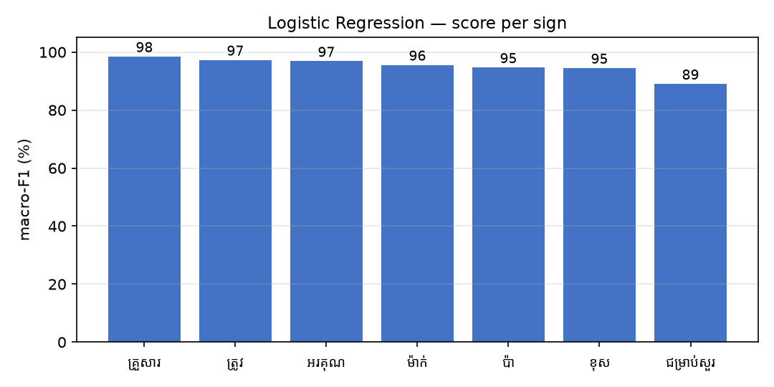
Figure 3 — score per sign. Red marks signs below 70%.
No sign falls below 70% — performance is even across the set.
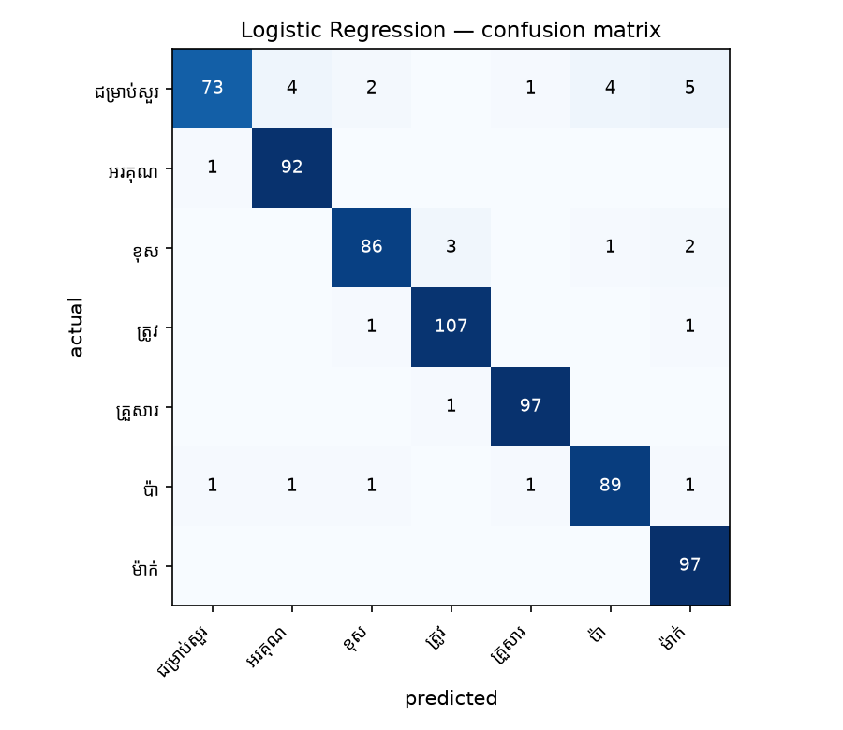
Figure 4 — confusion matrix. Rows are the true sign, columns the prediction; the diagonal is correct.
The most frequent single mistake is ជម្រាប់សួរ predicted as ម៉ាក់ (5 times).

4. Did the recording conditions matter?
The recordings were made on a deliberate grid: each sign was performed under two lighting levels, at two distances from the camera and in three standing positions. That lets us ask whether those choices affect recognition at all.
To test it, the model was trained on one setting and tested on the other — for example trained only on brightly lit takes and tested only on dim ones. If a setting made no difference, the score would stay near the 95% baseline from Section 2.
Trained on | Tested on | macro-F1 | vs baseline
full light | dim light | 97.6% | +2.3
near | far | 84.7% | -10.5
middle/left | right | 83.5% | -11.8

Yes, and unevenly. The gentlest change is full light → dim light, where the model still reaches 98% on a setting it never trained on. The hardest is middle/left → right, which drops to 84% — 12 points below the 95% baseline.
The practical reading is that the system copes with some changes better than others, and "middle/left → right" is the one to design around. Recordings intended for real use should cover the range the system will actually meet rather than assuming one session generalises.
Robustness to lighting does not have to follow overall accuracy, though here they agree: Logistic Regression is both the most accurate model and the one that holds up best when the lighting changes, at 98%. The ranking below is otherwise quite different from Section 2:
Algorithm | macro-F1, trained bright / tested dim | Rank in Section 2
Logistic Regression | 97.6% | #1
LDA | 97.5% | #7
MLP | 96.9% | #6
Gradient Boosting | 96.3% | #5
Random Forest | 96.2% | #2
Bagged Trees | 96.2% | #4
SVM | 95.7% | #3
k-NN | 95.7% | #9
Decision Tree | 94.4% | #8

The tree-based models hold up best. They classify by asking whether individual measurements fall above or below thresholds, which survives a shift affecting part of the input, whereas the linear models combine every feature into one weighted sum and are thrown off when those features move together. If the system has to work under lighting it has not seen, that difference matters more than the ranking in Section 2.
One caveat worth stating: the dim takes were always recorded after the bright ones, so tiredness or drift in how the signs were performed cannot be fully separated from the lighting itself. Recording half the session in the reverse order would settle that.

5. Conclusions
- Logistic Regression scores highest at 95.3% macro-F1 (95.4% accuracy), though 8 algorithms are tied within run-to-run variation.
- The spread between best and worst is 3 points, so the choice of algorithm materially affects results on this dataset.
- Lighting affects recognition noticeably; distance and standing position affect it far less.
- Logistic Regression is both the most accurate model and the most robust to a lighting change, keeping 98%.
- Recordings come from 4 different people, and the test set mixes them, so these figures describe recognition for people the model has seen before. How well it works for a complete stranger is a separate question, answered by holding one person out entirely.

6. Reproducing this
python algo_comparison/run_var_experiment.py
Averages 8 take-aware random splits with fixed seeds; the output is identical on any machine.

