Khmer Sign Language — Does Synthetic Data Help?
9 algorithms on 337 recordings of 7 signs, trained twice: with and without synthetic data

1. What we tested
Signs are recognised from pose landmarks, not images. Each recording is 60 frames of 48 tracked joints — 6 body points plus 21 on each hand — summarised into 576 numbers (the mean, spread, minimum and maximum of every joint coordinate over the clip).
 | Detail
Signs | 7 — ជម្រាប់សួរ, អរគុណ, ខុស, ត្រូវ, គ្រួសារ, ប៉ា, ម៉ាក់
Real recordings | 337 takes, 12 per sign per person
With synthetic added | 4309 training samples
Split | 75/25 by take, averaged over 8 random splits
Tested on | real recordings only, in both experiments

Synthetic recordings are made by mathematically stretching the skeleton of a real recording to different body proportions. The movement is untouched, so the sign is unchanged — only the body performing it differs. No camera, no new recording session.

2. The two experiments
Both experiments use the same algorithms, the same splits and the same test recordings. The only difference is what goes into training.
Algorithm | Real only | s.d. | Real + synthetic | s.d. | Change
Gradient Boosting | 81.8% | ± 3.2 | 94.7% | ± 2.2 | +12.9
Bagged Trees | 77.4% | ± 3.1 | 94.8% | ± 2.2 | +17.4
Random Forest | 74.4% | ± 2.5 | 95.1% | ± 2.8 | +20.7
LDA | 71.0% | ± 3.8 | 94.2% | ± 2.0 | +23.2
MLP | 70.1% | ± 4.0 | 94.4% | ± 2.2 | +24.3
Logistic Regression | 69.7% | ± 2.4 | 95.3% | ± 2.7 | +25.6
SVM | 67.0% | ± 2.6 | 95.0% | ± 2.9 | +28.0
Decision Tree | 62.2% | ± 2.8 | 93.1% | ± 2.0 | +30.9
k-NN | 45.1% | ± 5.1 | 92.5% | ± 3.6 | +47.4

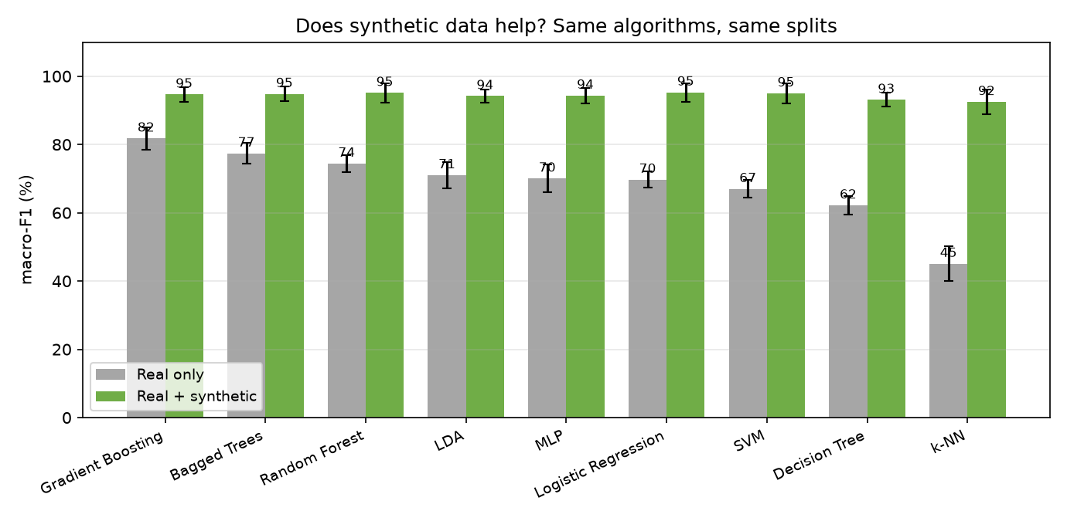
Figure 1 — every algorithm, trained without (grey) and with (green) synthetic data.

3. Does it improve things?
Yes, substantially. Every algorithm improved, by +12.9 to +47.4 points, averaging +25.6. Gradient Boosting led on real data alone at 81.8%; with synthetic added the best is Logistic Regression at 95.3%.
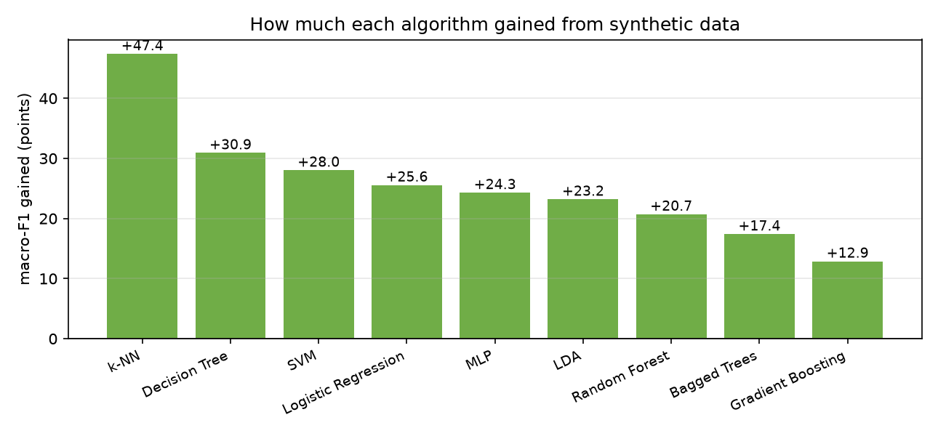
Figure 2 — points gained by each algorithm.
The most striking part is not the size of the gains but where everything ends up. On real data alone the nine algorithms are spread over 37 points, from 45% to 82%. With synthetic data added they all land between 92% and 95% — a spread of 3 points.
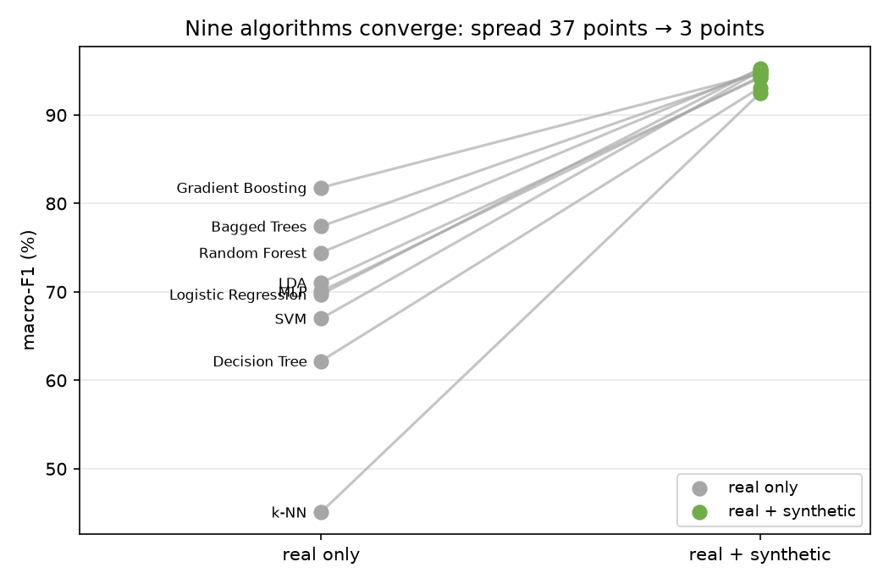
Figure 3 — every algorithm's score before and after. They converge.
So the algorithms converge. With only 12 takes per sign, the choice of algorithm was worth 37 points; with the synthetic data it is worth about 3. What looked like a question about algorithms turns out to have been a question about how much data we had.
This also explains the Change column. k-NN gained the most (+47.4) and was the weakest on real data; Gradient Boosting gained the least (+12.9) and was already the strongest. That is not a separate finding — once every algorithm finishes in the same narrow band, whoever started lowest necessarily gained most. It is the convergence restated.
Synthetic data does not teach the model anything new about the signs; every synthetic example is derived from a real one. It supplies examples, and with enough of them even the simplest algorithms find the same patterns the best ones were already finding.

4. Why this is a fair test
Two rules make the comparison honest, and both matter:
- **Testing is always on real recordings.** Scoring a model on synthetic data would only measure whether it can recognise our own geometry.
- **A recording's synthetic copies stay with it.** When a real take is held out for testing, all of its synthetic children are held out too. Otherwise the model trains on near-copies of the test data and the score means nothing.
The second rule was verified directly: the 337 real takes form 337 groups, each containing exactly one real recording and its synthetic children, and no group appears on both sides of any split.

5. Did the recording conditions matter?
The 12 recordings of each sign follow a deliberate grid: two lighting levels, two distances from the camera, three standing positions. That lets us hold back a whole condition — train only on bright recordings, test only on dim ones — and see what survives.
Trained on | Tested on | macro-F1 | vs baseline
full light | dim light | 82.0% | +0.2
near | far | 74.9% | -6.9
middle/left | right | 79.3% | -2.5

The mildest change is full light → dim light at 82%; the hardest is near → far at 75%.
Worth noting: when only one person had recorded, lighting was by far the worst condition. With four people recording in four different rooms it costs almost nothing — the variety arrived for free. The cheapest fix for a condition problem turned out to be more people, not tighter control of the condition.

6. Conclusions
- Synthetic data improved every algorithm, on average +25.6 points of macro-F1.
- The weakest algorithms gained the most; the strongest gained least. The benefit is data quantity, not new information.
- Best result overall: Logistic Regression at 95.3% macro-F1 with synthetic data, against 81.8% for the best real-only model.
- Distance and standing position cost more accuracy than lighting does.
- All 337 recordings come from 4 people and the test set mixes them, so these figures describe recognition for people the model has seen before. Recognising a complete stranger is a different question, answered by holding one person out entirely.
- 12 recordings per sign is a small dataset. Large differences are meaningful; one or two points between neighbouring algorithms are not.

7. Reproducing this
python algo_comparison/run_var_experiment.py --lang khmer_var --mode real
python algo_comparison/run_var_experiment.py --lang khmer_var --mode both
python algo_comparison/make_var_comparison.py
Every algorithm has a fixed seed, so these numbers come out identical on any machine.

