Khmer Sign Language Recognition
Comparison of Machine Learning Algorithms
SignLink project — experimental results

1. Objective
Compare machine-learning algorithms on the same Khmer Sign Language dataset under identical conditions, so that any difference in performance comes from the algorithm itself and not from the data, the split, or the evaluation procedure.
All eight algorithms below were trained and evaluated by a single script, on one dataset, using the same features, the same splits and the same metrics. Only real recordings were used — no synthetic or augmented data.

2. Dataset and method
Property | Value
Task | Isolated sign recognition, 7 Khmer signs
Signs | ជម្រាប់សួរ, អរគុណ, ខុស, ត្រូវ, គ្រួសារ, ប៉ា, ម៉ាក់
Signers | 2
Input | Body + hand landmarks (48 joints x 3 coords x 60 frames)
Features | Per-joint mean / std / min / max over time (576 features)
Training data | Real recordings only (no augmentation)
Evaluation | Held-out takes, mean of 5 random splits
Split rule | Split by take, so no take appears in both train and test
Metrics | Accuracy and macro-F1 (macro-F1 weights every sign equally)

Landmarks are used rather than raw video: the skeleton is unaffected by clothing, background and skin tone, which removes variation unrelated to the sign and keeps the input small enough to train every algorithm quickly.

3. Results
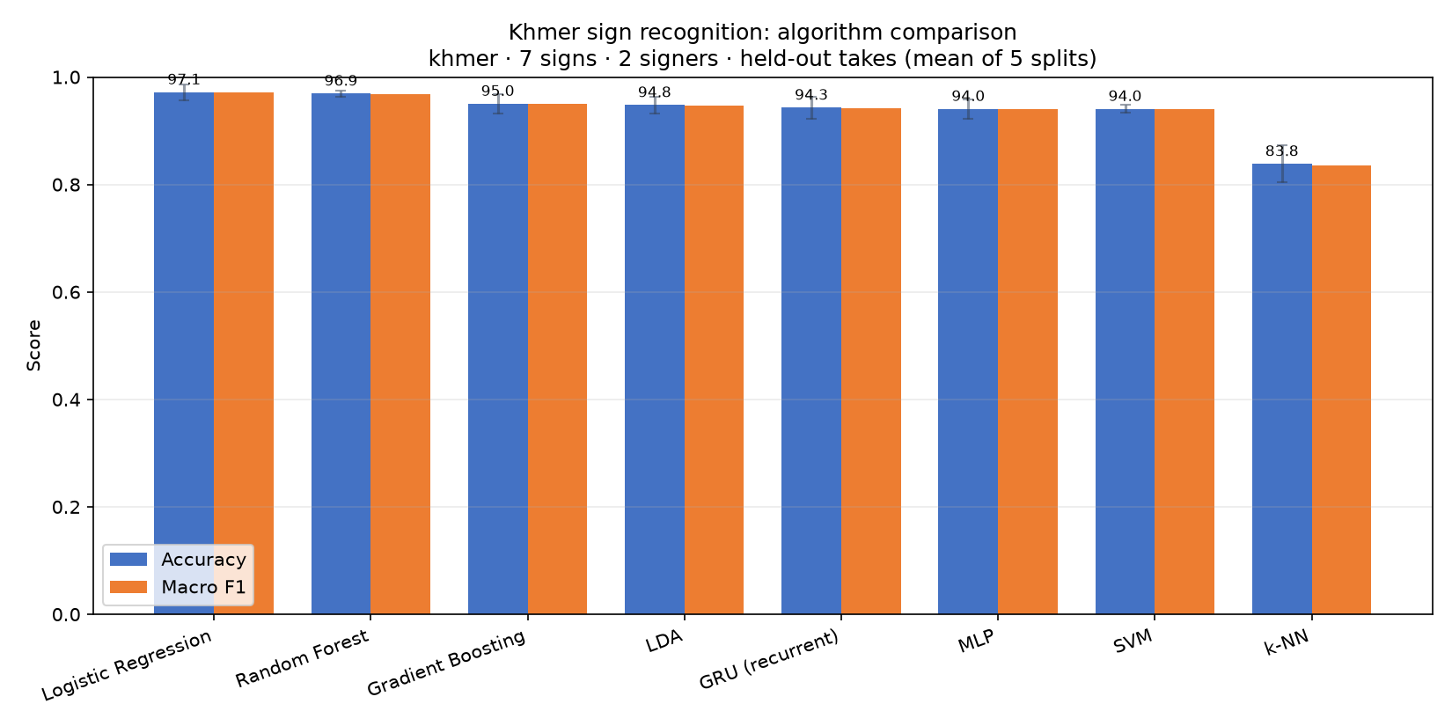
Figure 1 — Accuracy and macro-F1 by algorithm (held-out takes). Error bars show standard deviation across splits.
Algorithm | Accuracy (%) | Macro F1 (%) | Unseen signer (%)
Logistic Regression | 97.1 ± 1.6 | 97.1 | 43.6
Random Forest | 96.9 ± 0.7 | 96.9 | 59.3
Gradient Boosting | 95.0 ± 2.0 | 95.0 | 36.2
LDA | 94.8 ± 1.8 | 94.7 | 62.4
GRU (recurrent) | 94.3 ± 2.3 | 94.3 | 61.4
SVM | 94.0 ± 0.8 | 94.0 | 27.1
MLP | 94.0 ± 2.1 | 94.0 | 40.2
k-NN | 83.8 ± 3.8 | 83.5 | 31.0

Logistic Regression achieved the highest accuracy on held-out takes. Accuracy and macro-F1 are close for every algorithm, which indicates the dataset is balanced and no single sign dominates the score. The final column reports the same models evaluated on a signer who was absent from training — a harder and more realistic test, discussed next.

4. The generalization gap
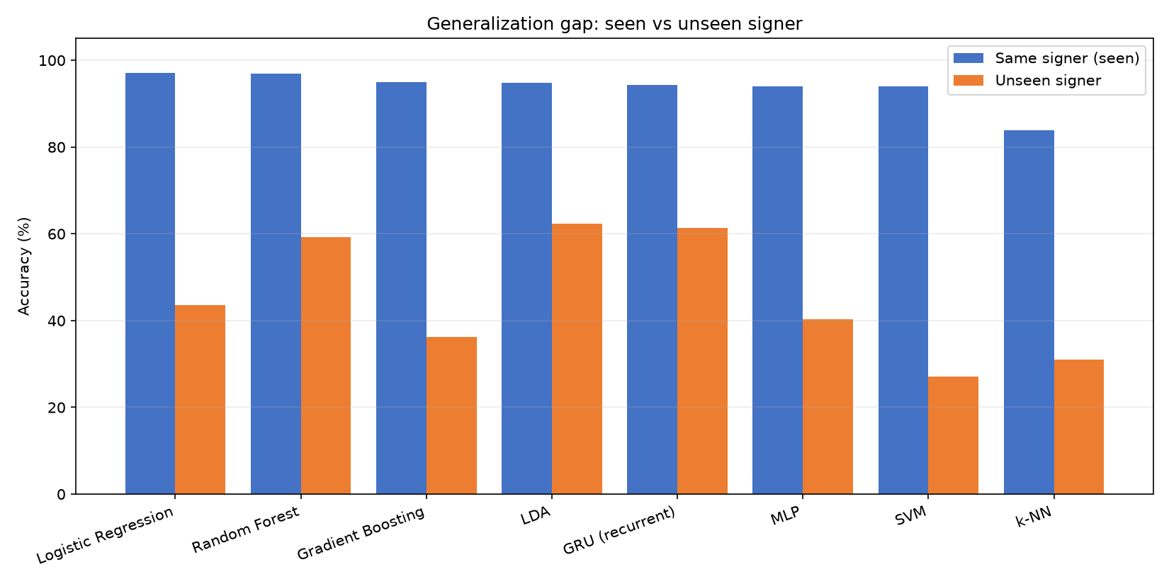
Figure 2 — Accuracy for a signer included in training versus a completely unseen signer.
Accuracy falls sharply for a person the model has never seen. This is the central difficulty of sign-language recognition: signing speed, amplitude and body proportions differ between people, so a model trained on few signers partly learns the individual rather than the sign.
The ranking also changes between the two tests. Logistic Regression leads on held-out takes from a known signer, while LDA generalizes best to an unseen signer. Choosing an algorithm on same-signer accuracy alone would therefore select the wrong model for real deployment.
For this reason both numbers are reported here. Publishing only the same-signer figure would substantially overstate real-world performance.

5. Error analysis
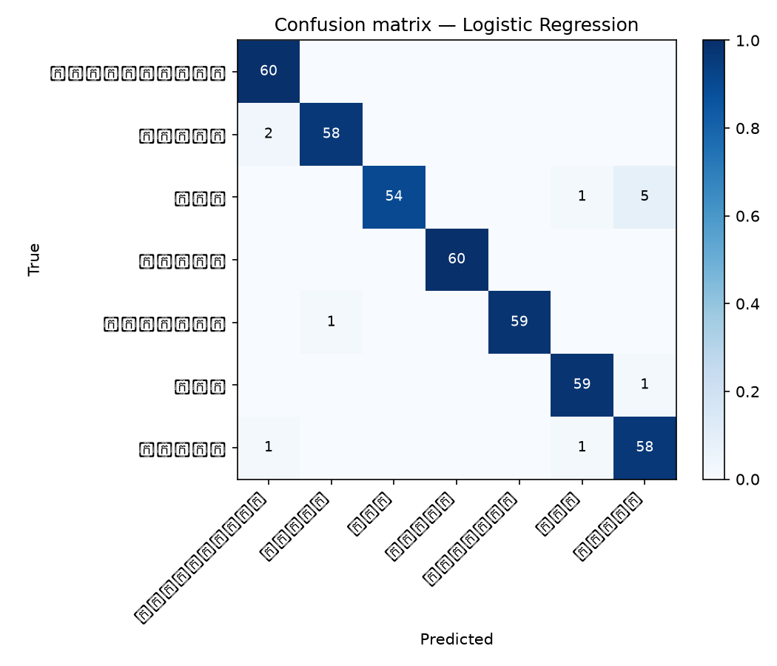
Figure 3 — Confusion matrix for Logistic Regression, summed over all splits.
The diagonal holds correct predictions; off-diagonal cells show which signs are mistaken for each other. Confusions concentrate on signs with similar arm trajectories. This is expected: hand landmarks are detected less reliably than body landmarks at webcam distance, so signs separated mainly by finger configuration are the hardest to distinguish.

6. Conclusions
- Logistic Regression gave the highest accuracy on held-out takes (97.1%).
- Most algorithms cluster within a few points of each other, so the choice of algorithm matters less than the quality and diversity of the data.
- Accuracy for an unseen signer is far lower than for a known signer, and the best algorithm differs between the two settings (LDA generalizes best).
- Cross-signer evaluation should always be reported alongside same-signer accuracy, since only the former reflects deployment conditions.
- Recording additional signers is expected to improve generalization more than further tuning of the algorithm.

7. Reproducing these results
python algo_comparison/run_comparison.py --lang khmer --seeds 5
A single script trains every algorithm on identical splits and writes both the charts and the underlying numbers, so the comparison can be regenerated or extended without repeating any step by hand.
Training times are not reported: they depend on the machine used and are not a property of the algorithm.

