Sign Language Recognition from Images
Comparison of Machine Learning Algorithms
Dataset: Sign Language MNIST (Kaggle)

1. Objective
Compare machine-learning algorithms for sign-language letter recognition from images, training every algorithm on the same public dataset under identical conditions so that differences in accuracy reflect the algorithm rather than the data or the split.

2. Dataset
Property | Value
Source | Sign Language MNIST — Kaggle (datamunge/sign-language-mnist)
Task | Static hand-sign letter classification, 24 classes
Classes | A, B, C, D, E, F, G, H, I, K, L, M, N, O, P, Q, R, S, T, U, V, W, X, Y
Image format | 28 x 28 pixels, grayscale (784 features)
Training images | 27,455
Test images | 7,172
Split | Official train/test split as published (not re-shuffled)
Preprocessing | Pixel values scaled to the range 0-1
Metrics | Accuracy and macro-F1 (macro-F1 weights every letter equally)

The letters J and Z are excluded from the dataset because they are produced with motion and cannot be represented by a single still image — a useful reminder that static-image methods cannot express the full language.
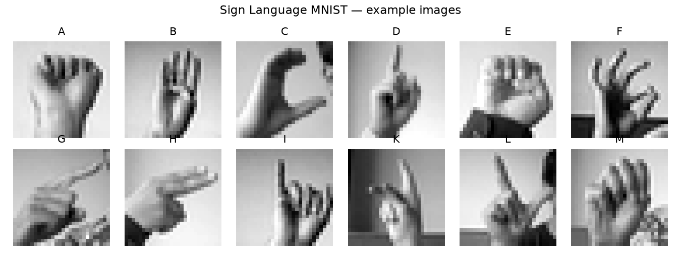
Figure 1 — Example images from the dataset.

3. Results
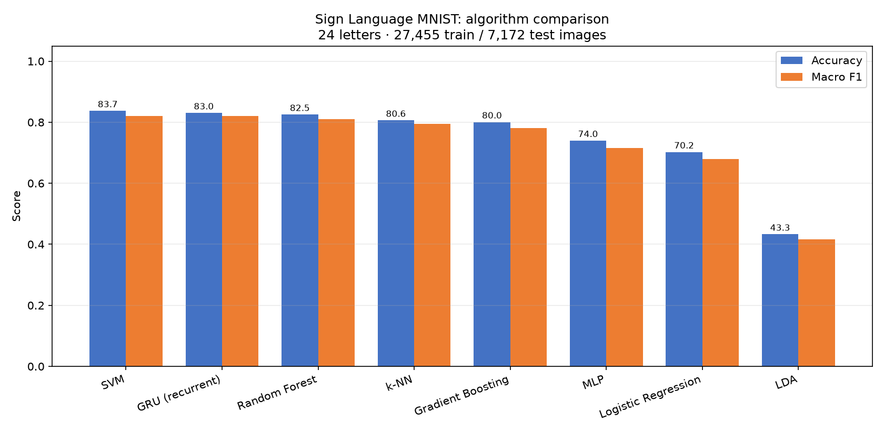
Figure 2 — Accuracy and macro-F1 by algorithm on the held-out test set.
Algorithm | Accuracy (%) | Macro F1 (%)
SVM | 83.71 | 82.03
GRU (recurrent) | 83.02 | 82.01
Random Forest | 82.50 | 80.98
k-NN | 80.59 | 79.49
Gradient Boosting | 80.05 | 78.14
MLP | 73.97 | 71.63
Logistic Regression | 70.22 | 67.89
LDA | 43.27 | 41.60

SVM achieved the highest accuracy (83.71%). Accuracy and macro-F1 are close for every algorithm, which indicates the classes are reasonably balanced and no single letter dominates the result.
Training times are deliberately not reported: they depend on the machine each algorithm was run on (a laptop, a desktop, or a cloud runtime with a different number of CPU cores) and so are not comparable between algorithms in this study.

4. Error analysis
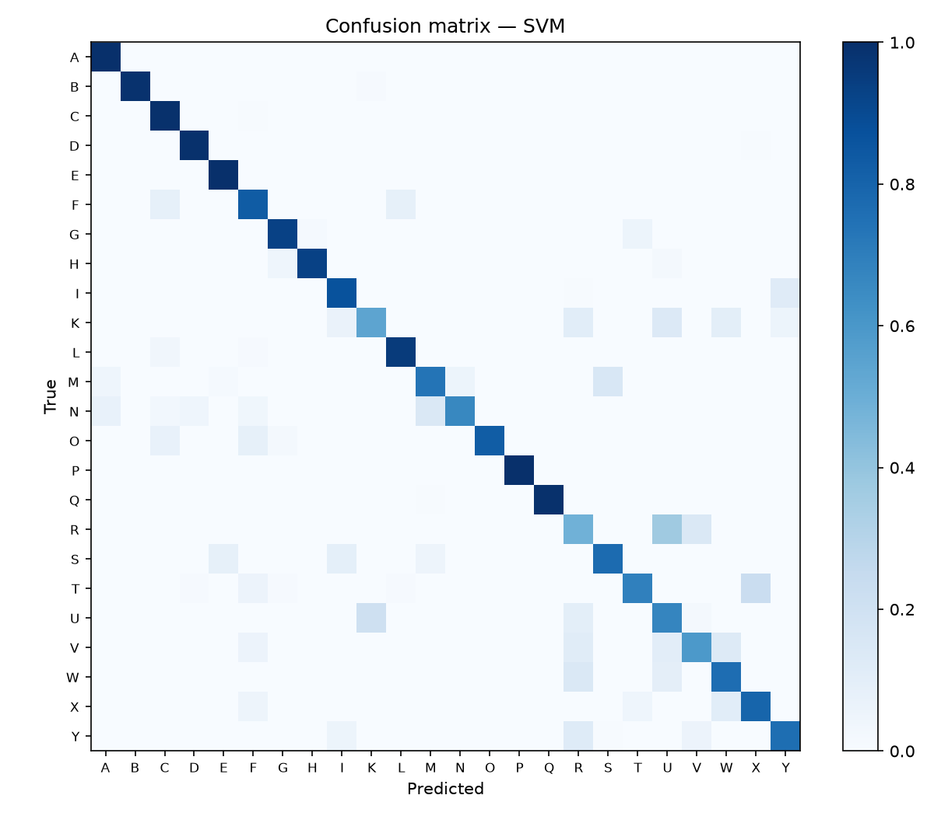
Figure 3 — Confusion matrix for SVM.
Errors concentrate on letters whose handshapes differ only slightly at 28 x 28 resolution. Increasing image resolution, or using a convolutional model that exploits spatial structure rather than treating pixels as independent features, would be the natural next step for these cases.

5. Discussion
- SVM performed best on this dataset (83.71% accuracy).
- Accuracy and macro-F1 are close for every algorithm, which indicates the classes are reasonably balanced and no single letter dominates the result.
- All algorithms here treat the 784 pixels as independent features, so none of them uses the spatial arrangement of the image. This is the main limitation of the approach and explains why the remaining errors involve visually similar handshapes.
- This dataset contains only static letters photographed under controlled conditions. Real signing involves motion, continuous transitions between signs, and variation in lighting, background and camera angle, so accuracy measured here is an upper bound rather than a deployment estimate.

6. Kaggle Dataset Link

https://www.kaggle.com/datasets/datamunge/sign-language-mnist

7. Members

Who own which algos
Chea Mengly | Random Forest
Seng Piseth | Linear Discriminant Analysis
Meong Chingsan | Support Vector Machine
KunSovannreaj | Gradient Boosting
MaoChhaiyanin | Logistic Regression
Hang Ratvanarak | K-Nearest Neighbors
Nom Sonita | Gated Recurrent Unit
Seng Menghong | Multi-Layer Perceptron

