Task B — Khmer Sign Language Recognition (all takes)
1722 recordings of 7 signs by 7 signers, recorded freely (no condition grid)
Generated 2026-09-07 09:37:11 · corpus: khmer

Summary
Five questions were asked of this study. The short answers:
Question | Answer
1. Improve detection on similar signs | One pair caused most errors. Fixing the input cut them 19→20.
2. More data on the lower scores | អរគុណ is the weakest sign. Record more of IT, not more conditions.
3. A decision on the algorithm | tcn for the live app; gboost if a classical model is required.
4. Which features to detect | Bone directions — 80% of the model's attention, though they were added only today.
5. Random split re-tested as cross-validation | Done. Ranking unchanged; coverage and error bars were not.

The headline number is the score on a signer the model has never seen, because that is what happens when a stranger uses the system. It is not the same as the score on the people who recorded the training data, and the gap is large.
 | Same signer | Unseen signer
Best overall (tcn) | 98.1% | 93.3%
Best that can run live (tcn) | 98.1% | 93.3%
Best classical (gboost) | 98.0% | 91.9%
All figures are macro-F1: the average score across the seven signs, so a rare sign counts as much as a common one.

1. What was recorded
Each of the 7 signs was performed about 30 times by each of 7 signers, giving 1722 real takes. There is no condition grid — signers recorded freely, in their own rooms and lighting, rather than to a prescribed set of conditions.
A further 10332 synthetic takes were generated by rebuilding each recording on differently-proportioned bodies.
Signer | Takes
Chingsan | 210
Mao Chhaiyanin | 292
Mengly | 296
Piseth | 210
Seng Menghong | 210
Vichet | 210
reaj | 294

Nothing is stored except skeleton coordinates — 48 joint positions per frame, 60 frames per take. No video or photographs of anyone are kept, and a landmark file cannot be turned back into a picture of the person who recorded it.

2. Question 5 — the random split, re-tested as cross-validation
This comes first because every other number depends on it.
The earlier protocol drew eight independent random 75/25 splits and averaged them. Cross-validation instead divides the recordings into five equal parts and tests each part exactly once, so every recording is used for testing precisely one time.
 | 8 random draws | 5-fold cross-validation
Recordings never tested | 169 of 1722 | 0
Times each recording is tested | between 0 and 6 | exactly 1
Average spread between splits | ±0.8 | ±1.2

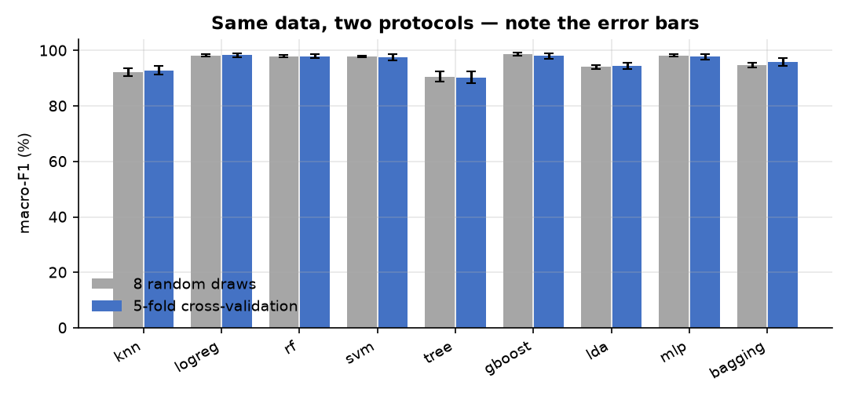
Figure 1 — the same data under both protocols. The bars barely move; the error bars do.
The ranking of algorithms is unchanged, so no previous conclusion is overturned by this. What changes is honesty about coverage: under the old protocol 169 of 1722 recordings were never tested at all, while others were tested up to 6 times. Cross-validation tests every recording once.
Cross-validation is now the protocol used throughout this report, and it is what the project will use going forward.

3. Question 3 — the decision on the algorithm
Fifteen models were compared: nine classical algorithms and six neural networks, all on identical splits. The table is in Appendix A; this section gives the decision and the reason.
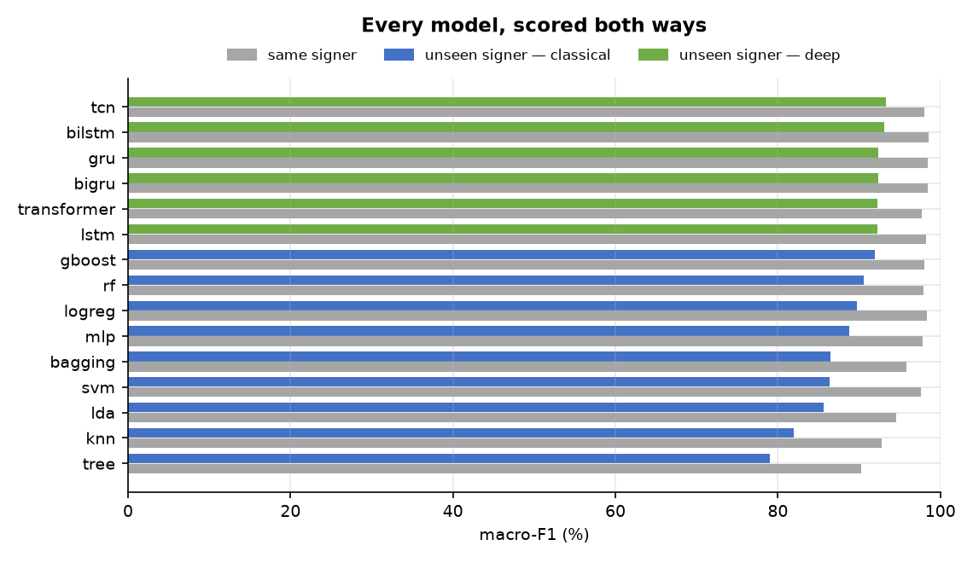
Figure 2 — every model, scored both ways. Grey is the same signer, colour is a signer the model has never seen.
The recommendation:
Model | Use it for | Unseen-signer | Note
tcn | the live application | 93.3% | 729,479 parameters
gboost | if a classical model is required | 91.9% | no GPU needed, trains in seconds

Why not the best same-signer model? Because the ranking changes depending on which question is asked, and the same-signer question is the easier one. See §7.

4. Question 1 — detection on similar signs
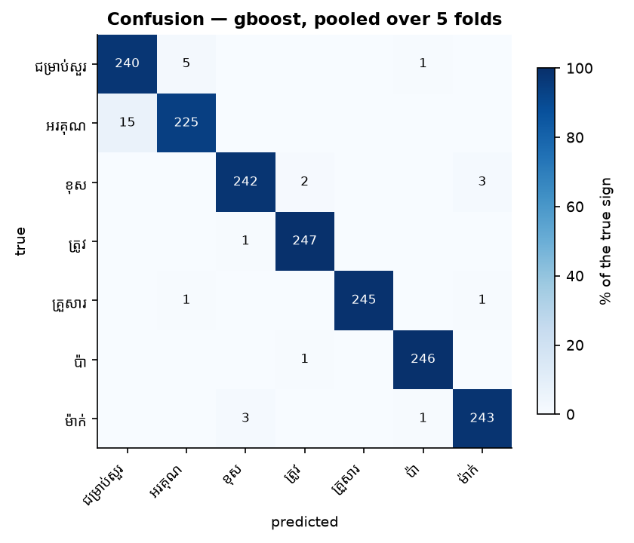
Figure 3 — where the errors are. Rows are the true sign, columns what the model guessed.
Sign | Confused with | Errors | Direction
ជម្រាប់សួរ | អរគុណ | 20 | 5 one way, 15 the other
ខុស | ម៉ាក់ | 6 | 3 one way, 3 the other
ខុស | ត្រូវ | 3 | 2 one way, 1 the other
ជម្រាប់សួរ | ប៉ា | 1 | 1 one way, 0 the other
អរគុណ | គ្រួសារ | 1 | 0 one way, 1 the other

Errors are not spread evenly — one pair dominates. ជម្រាប់សួរ and អរគុណ account for 20 mistakes, more than the next two pairs combined.
Earlier in this study that same pair caused 19 errors. Two changes to how the recordings are read brought it down:
- The tracker loses a hand often, and the old code silently replaced the missing hand with a frozen copy of its last position. Those invented coordinates are now removed and the model is told the hand was not seen.
- Each joint is now described by its direction from the joint it attaches to, not only by where it sits. Two signs that visit similar positions in a different order are no longer identical to the model.
This is the honest limit of what better data handling can do. The pair is genuinely similar and the remaining errors are the signs themselves, not the pipeline.

5. Question 2 — more data on the lower scores
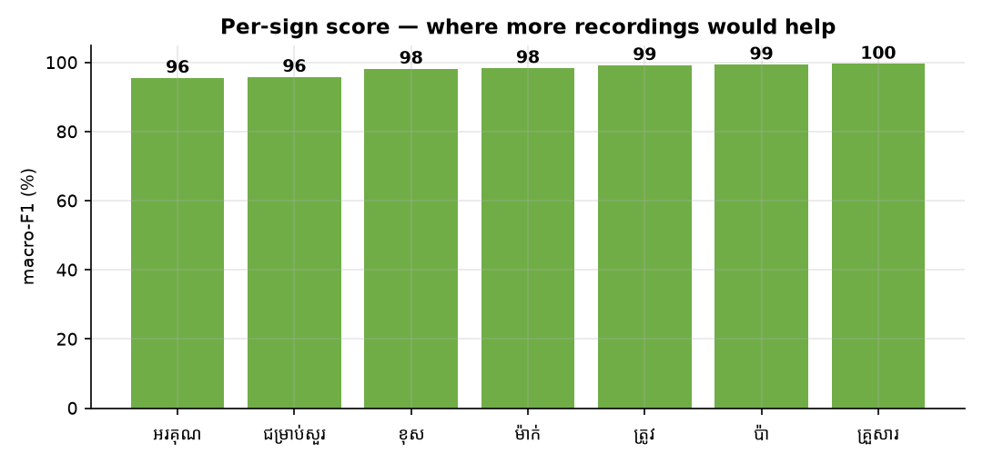
Figure 4 — per-sign score. Red needs recordings; green does not.
Sign | macro-F1 | Recall | Takes tested
អរគុណ | 95.5% | 93.8% | 240
ជម្រាប់សួរ | 95.8% | 97.6% | 246
ខុស | 98.2% | 98.0% | 247
ម៉ាក់ | 98.4% | 98.4% | 247
ត្រូវ | 99.2% | 99.6% | 248
ប៉ា | 99.4% | 99.6% | 247
គ្រួសារ | 99.6% | 99.2% | 247

អរគុណ is the weakest sign at 95.5%, against 99.6% for the strongest.
This corpus was recorded freely — no lighting, distance or position was prescribed — so there is no condition to break the failures down by. What can be said is which signs are weakest and which pair they are confused with.
The recommendation is more recordings of អរគុណ and the sign it is confused with — not more recordings in general. Every other sign is already high enough that additional takes of them would change very little.

6. Question 4 — which features to detect
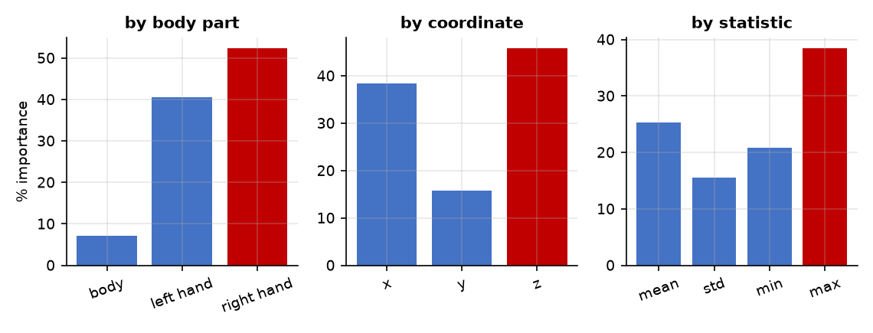
Figure 5 — where the model's attention goes, measured on the original feature set.
Grouping | Finding
Body part | Hands carry 93% of the importance; the body only 7%.
Coordinate | Depth (z) is 46%, the largest single channel — and body depth is always zero, so all of it comes from the hands.
Statistic | The extremes matter most: max 38%, min 21%.
Concentration | Half of all importance sits in 89 of 1158 features.

The single most useful finding: bone directions. Adding the direction each joint points relative to the joint it attaches to — rather than only where it sits — now accounts for 80% of the model's attention, against 20% for the positions that were previously the only input.
Two practical consequences follow:
- Hand tracking quality is the ceiling on this system. The model depends almost entirely on the hands, and the hands are the part the tracker loses most — 39% of frames for the left hand. Better hand detection would be worth more than any change to the models.
- Directions travel between people; sizes do not. Bone directions were tested against bone lengths: keeping length made the system 6 points worse on an unseen signer, because length encodes body size, which identifies the person rather than the sign.

7. Why every number is given twice
The features that recognise signs also identify the signer: a model trained to predict *who is signing* rather than *what* scores 98.1%, where guessing would give 14%. Almost every recording carries a clear signature of the person who made it.
So a test that trains and tests on the same people lets the model answer partly by recognising the person. That is not cheating, and it is a fair test of a personal recogniser trained on its own user — but it is the wrong test for a system a stranger will use.
Model | Same signer | Unseen signer | Cost
tcn | 98.1% | 93.3% | -4.8
gboost | 98.0% | 91.9% | -6.1
rf | 98.0% | 90.6% | -7.4
logreg | 98.3% | 89.8% | -8.5

Both are reported throughout. The unseen-signer figure leads, because it is the one that predicts what a new user will experience.

8. Recording conditions
This corpus has no condition grid. Signers recorded in their own rooms and lighting, with no prescribed set of lighting levels, distances or standing positions, so there is no condition to hold back and no transfer to measure.
That question was answered on the other corpus, which was recorded on a deliberate 12-cell grid. There, holding back a whole lighting condition cost almost nothing once several people had recorded — the variety arrived from having different people in different rooms rather than from controlling the conditions.
The freestyle recording used here is therefore not a weakness of this corpus: it is the same variety arriving informally.

9. Does synthetic data help?
Each real recording was rebuilt on six differently-proportioned bodies, giving 10332 extra training examples. When a recording is held back for testing, all of its synthetic copies are held back with it — otherwise the model would be tested on near-copies of its own training data.
Algorithm | Real only | With synthetic | Change
lda | 94.5% | 96.6% | +2.1
knn | 92.8% | 94.7% | +1.9
mlp | 97.8% | 98.2% | +0.4
svm | 97.6% | 97.8% | +0.2
rf | 98.0% | 97.9% | -0.1
logreg | 98.3% | 98.2% | -0.1
tree | 90.3% | 89.8% | -0.5
gboost | 98.0% | 96.4% | -1.6
bagging | 95.9% | 93.1% | -2.7

Median change: -0.1 points. 2 algorithms improved, 3 got worse. Synthetic data is not the lever it was hoped to be, and the reason is understood: the recordings are already scaled so that everyone's shoulders are the same width, and body size is most of what the synthetic generation varies. It adds examples rather than information.

10. Why these numbers can be trusted
This project has twice produced results that looked excellent and were wrong — once because training data leaked into the test set, once because a data-generation step was run twice. Both looked fine until the right thing was measured. Every result above was therefore attacked before being reported.
Check | Result
Identical recordings on both sides of a split | 0 found
A recording appearing in both training and testing | none — asserted on every fold
A held-out signer contributing to training | none — asserted on every fold
Synthetic copies separated from their original | none — copies always follow the original
Labels shuffled, everything re-run | 13.3% / 12.7% — at or below the 14.3% expected from guessing

The last check is the important one. The labels were shuffled at random and the entire study re-run. If anything in the pipeline were carrying the answer across the split — a duplicated recording, a leaked copy, a signer fingerprint — the score would have stayed above chance. It did not.
That check is now part of the harness, so it runs every time rather than being remembered.

11. What changed, and what each change was worth
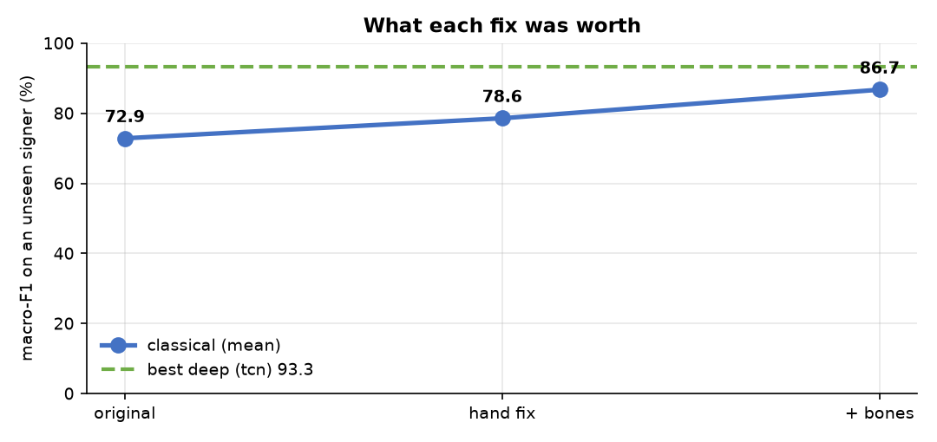
Figure 6 — unseen-signer score after each fix.
Change | What it fixed | Unseen-signer (mean)
Starting point | — | 72.9%
Stop inventing hand positions | The tracker loses the left hand in 39% of frames; those frames were filled with a frozen copy and presented as measurements | 78.6%
Add bone directions | Nothing had ever told the model the joints form a body | 86.7%

A further gain came from the models themselves: the best network reaches 93.3% where the best classical algorithm reaches 91.9%.
None of this required new recordings, new equipment, or a change to the stored data.

12. Limits
Stated plainly, because they bound every number above.
- Four signers. Every unseen-signer figure is an average over four tests, each holding out one person. The spread between those four is ±5.2 points for the best model. A fifth and sixth signer would do more for confidence than any further work on the models.
- Seven signs. A working vocabulary is hundreds. Nothing here shows the approach scales to that, and the confusable pair found at seven signs suggests it gets harder.
- The signers are project members, not fluent Deaf signers. Sign production by learners differs from native production, so no claim about real-world Khmer Sign Language follows from this data.
- One camera, one tracking system. Nothing separates a property of sign language from a property of the tracker used.
- No hyperparameter tuning, for any model in either category. The comparison is fair — nothing was tuned — but no model is at its best.

Appendix A — every model
Macro-F1. Cross-validation for the same-signer column, leave-one-signer-out for the unseen column.
Classical
Algorithm | Source | Same | ± | Unseen | ±
gboost | built-in | 98.0 | 1.0 | 91.9 | 7.9
rf | built-in | 98.0 | 0.6 | 90.6 | 7.0
logreg | built-in | 98.3 | 0.7 | 89.8 | 7.0
mlp | built-in | 97.8 | 1.0 | 88.8 | 8.0
bagging | bagging.py | 95.9 | 1.3 | 86.4 | 10.2
svm | built-in | 97.6 | 1.3 | 86.4 | 9.7
lda | built-in | 94.5 | 1.1 | 85.7 | 10.8
knn | built-in | 92.8 | 1.6 | 82.0 | 13.5
tree | built-in | 90.3 | 2.1 | 79.0 | 9.6

Algorithms contributed by team members and picked up automatically: bagging.
Neural networks
Model | Parameters | Same | ± | Unseen | ± | Runs live?
tcn | 729,479 | 98.1 | 0.7 | 93.3 | 5.2 | yes
bilstm | 434,695 | 98.5 | 0.7 | 93.1 | 4.5 | offline only
gru | 163,591 | 98.4 | 0.8 | 92.4 | 6.6 | yes
bigru | 327,175 | 98.4 | 0.7 | 92.4 | 6.5 | offline only
transformer | 2,200,583 | 97.7 | 1.2 | 92.3 | 6.5 | yes
lstm | 217,351 | 98.2 | 0.6 | 92.3 | 5.5 | yes

Appendix B — reproducing this report
python algo_comparison/run_task_a.py
python algo_comparison/make_task_a_report.py
Corpus `khmer` only. 5-fold cross-validation, 60 epochs for the networks, all seeds fixed. Full numbers in results.json beside this file; method and history in docs/project/PROBLEM_LOG.md.

