PERFORMANCE VARIATIONS IN EMULATED GPGPU KERNELS

Eric Nilsson and Martin Fredriksson
Department of Creative Technologies
Blekinge Institute of Technology
37179, Karlskrona
Sweden
E-mail: EricNNilsson@gmail.com and martin.fredriksson@bth.se

KEYWORDS
GPGPU, GPU, Simulation, Emulation, DirectCompute, WARP.

ABSTRACT

A convenient approach toward debugging or profiling GPU-kernels is to emulate the kernel on a CPU. This approach is also applicable in situations where the target hardware is simply not available, as is often the case with server-side applications (see Microsoft’s reference on WARP (Microsoft, 2013)). When performing such emulation, however, one may experience severe performance loss due to computational overhead. Consequently, the subject of this study is performance variations between three different driver types from the DirectX-framework; using DirectCompute and the high speed software rasterizer WARP. As such, the performance of WARP is compared to that of traditional GPU hardware acceleration and the standard driver for software rasterization - the Reference Device Driver. Our experimental results show a major performance boost when compared to that of software rasterization using the Reference Device Driver, indicating that performance losses traditionally obstructing GPU-kernel emulation may be sufficiently amended by technologies, such as WARP, to the degree that such emulation can be considered viable for use in retail applications.

INTRODUCTION

When developing GPU-kernels, relatively small modifications in code may induce large deviations in performance due to massively parallelized instruction sets and architectural differences in-between on-chip hardware (See Performance Considerations by Kirk & Hwu (Kirk & Hwu, 2010; ch. 6) for an analyis on the volatility of GPGPU-performance). The increased utilization of complex GPU-kernels has brought forth the need of more extensive debugging- and profiling-possibilities involving access of data that may be hard to retrieve from hardware. Therefore, it may be desirable for the developer to be able to view the data being computed on the graphics card - a possibility often limited in terms of GPGPU-technologies, possibly due to architectural differences in-between chip manufacturers.
A preferred solution to this problem has been to emulate such GPU-kernels on the CPU (see Microsoft's reference on DirectX Driver Types (Microsoft, 2013)), such as described by Kerr et al. (Hwu, 2011; p. 416-419) concerning the implementation of the GPU Ocelot compilation framework (see GPU Ocelot (GPU Ocelot, 2013)), often in exchange for substantial performance-losses. Other resons to emulate GPU-kernels may concern pre-silicon development - that is, development for hardware not yet existant, when hardware is busy, or otherwize unavailable (see Microsoft’s reference on WARP (Microsoft, 2013)). This study comprises an investigation into the performance of software emulation of hardware accelerated GPGPU-kernels, by the means of analyzing several software rasterizers.

Furthermore, this material concerns inquiry into the DirectCompute-framework on the Windows-platform, analyzing the performance of a GPGPU-kernel on-chip, using the DirectX standard software rasterizer, and utilizing the DirectX 11.1-addition Microsoft WARP-technology (Windows Advanced Rasterization Platform) - which promises high-speed software emulation (see Microsoft’s reference on WARP (Microsoft, 2013)).

This paper concludes that the performance losses inflicted by such emulation may be reduced enough for that emulation to be considered viable for retail use, as originally proposed by Microsoft (see Microsoft’s reference on WARP (Microsoft, 2013)). Thus, this study proposes use of Microsoft WARP-technology in industry rasterization if graphics hardware is unavailable, not sufficient, or busy.

As such, the study concerns the fields of simulation, emulation and GPU-technologies - respectively, with the purpose of facilitating debugging and profiling of GPU-kernels, whilst maintaining acceptable performance.
The remainder of this document presents the method and process to acquire the data used, the technologies using which it has been acquired, the results in and of their own, the conclusions based off the results and finally; the author's personal reflections surrounding future work in the area along with propositions of further study.

CONTRIBUTION

Object of Study

Due to the nature of the experiment, it is important that the Object of Study is measurable and deterministic. For the purpose of this study, the data computed corresponds to a square matrix multiplication, since such an operation is highly parallelizable, as demonstrated by Kirk & Hwu (Kirk & Hwu, 2010; ch. 3). Additionally, verifying the result of such an operation is trivial, and potential losses in computational precision may be computed from the expected data-type. The operation was therefore considered suitable for the purpose of this experiment.

The dimension 200x200 was selected for the respective matrices as it is big enough to execute efficiently on the GPU, but yet reasonably sized to keep measurements collected by the means of emulation comparable to the hardware accelerated reference case.
Throughout this material, the compiled data will be referred to as AB=C, and thus make out the Object of this experiment.

Method of Study
In order to establish the Object of Study, AB=C, the experiment utilizes GPGPU-kernels using which the result is calculated, in it’s entirety, in aforementioned kernel using some target Subject (see Section Subjects of Study). The experiment is devised of the following approximate steps in order to compile the Object of Study AB=C:

- Randomize two matrices A & B using desired data-type.
- Establish the product-matrix AB=Ref. The resulting matrix will be used as a reference matrix to verify the final result.
- Start a synchronized high-precision timer.
- Dispatch GPU-kernel calculating the product matrix AB=C.
- Stop the timer once the kernel has finished execution.
- Establish possible deviation in-between resulting matrix C and previously established matrix Ref.

The process described above make out the Method of this study.

Subjects of Study

The GPU-kernels described in Section Method of Study are comprised of HLSL-syntax and are compiled & executed using Microsoft DirectCompute. These kernels are run using three types of acceleration technologies with varying strategies of GPU-kernel emulation. These are comprised of the following:

Hardware-Acceleration (GPU)
The execution of a DirectCompute-kernel on a graphics card. This is the common case, and involves no emulation of the kernel. Thus, this case will act as a reference for the emulated Subjects.
During hardware acceleration on the GPU, one may expect high performance.

Software Rasterization (CPU)
The emulated execution of a DirectCompute-kernel using the DirectX Reference Device Driver. The Reference Driver was developed for the purpose of testing and debugging, and is - although it does support some CPU-optimizations - not intended to be used in retail applications (see Microsoft’s reference on DirectX Driver Types (Microsoft, 2013)).
As the Reference Driver is designed for the purpose of accuracy, rather than speed, one may expect poor performance.

Windows Advanced Rasterization Platform (CPU)
The emulated execution of a DirectCompute-kernel using a special software rasterizer devised by Microsoft in their latest revision of the DirectX-framework. The driver is based off the DirectX Reference Driver and uses thread pooling to distribute tasks efficiently on the CPU, along with grouping execution in batches for optimum performance. Microsoft describes WARP as a high-performance software rasterizer, and recommends using the driver for retail applications, such as casual games (see Microsoft’s reference on WARP (Microsoft, 2013)).
As there are, as of yet, few studies performed on Microsoft WARP; expectations are unclear, but the driver is expected to perform better than standard software rasterization.

Theese three DirectX driver-types make out the Subjects of this study.

Kernels

In addition to the Subject drivers mentioned in Section Subjects of Study, two kernels with varying level of optimization are examined. The kernels have been implemented in accordance to the CUDA-kernels as described by Kirk & Hwu (Kirk & Hwu, 2010; p. 67, p. 87). These kernels are presented below.

Matrix mult. w. Thread Blocks
A kernel producing AB=C from two given matrices, writing back C for further analysis. The kernel is executed with one thread for each element in the square matrices, and likewize each produce a lone element of the resulting matrix.
Execution is performed in blocks of 16x16 threads since this was the block dimension, out of samples 8, 16, and 32, that performed optimally whilst hardware accelerated on the system described in Section Equipment.
This kernel will be referred to as the Basic Kernel throughout this material.

Matrix mult. w. Thread Blocks & Shared Memory
Similar to the previous kernel, but further optimized to utilize shared memory in order to reduce time-consuming reading of global memory, as presented by Kirk & Hwu (Kirk & Hwu, 2010; p. 77-93).
Stratton et al. (Stratton, Stone, & Hwu, 2008; p. 1-3) instructs that the CUDA GPGPU-model may be applied onto multicore CPUs, including locality-wize execution of logical thread-blocks (all threads in a block limited to a single core), with the utilization of local- and shared-memory approximately corresponding to a core's L1-cache. Hence, the kernel is presented as a scenario due to the preconditions of WARP - stating that a kernel optimized for GPU-execution is likewize optimized for execution with WARP (see Microsoft’s reference on WARP (Microsoft, 2013)). Thus, we investigate a more optimized kernel to see whether or not this behaviour may be replicated in the experiment.
This kernel will be referred to as the Tiled Kernel throughout this material.

Furthermore, aforementioned kernels both support integer- and floating-point precision. These kernels are attached, in their entirety, under Section APPENDIX.

Tools

The experiment process has been subdivided into three major components, all of which use Microsoft Visual Studio 2012 for compilation. These are presented below.

matrixgen
Denotes a utility developed to generate matrices of different dimensions and data-types. Furthermore, matrixgen compiles the reference matrix Ref used when comparing the result returned from the DirectCompute-dispatch described in the next paragraph.
matrixgen is written in C++ and utilizes C++ AMP to generate and multiply matrices A & B into product matrix Ref. In order to achieve random values in a C++ AMP-kernel the solution includes the random number generator-library C++ AMP RNG. As matrixgen utilizes Microsoft C++ AMP-technology, Windows 7 or later is required.

experiment
Making out the primary component of the study, experiment uses DirectCompute to compile the product matrix C from the matrices A & B generated by matrixgen. The application outputs data surrounding the execution of said kernel, such as it's execution time in milliseconds, to an intermediate file.
experiment is written in C++ with it's respective DirectCompute-kernels written in HLSL-syntax. As experiment is developed using the Windows 8 SDK, Windows 8.0 or later is required. Furthermore, experiment requires a DirectX 11.0- or DirectX 11.1}-compatible graphics card.

analytics
analytics is a utility developed to compose data surrounding possible precisional deviations in-between matrices C & Ref. analytics compiles the minimum- and maximum-deviation encountered, as well as to calculate the standard deviation of said precisional deviation. In turn, analytics outputs this information to an intermediate file.
analytics is written in C++.

These three applications are, in turn, run as subprocesses in a script specifying the various configurations and number of times to run each program. This script, written in Python, then compiles the assorted results of these applications and outputs a range of files suitably formatted for interpretation by Gnuplot.
The source code manufactured for the sake of this study is freely available via an online Git repository (Nilsson, 2013), along with a guide on how to compile and run the solution in order to replicate the experiment. Furthermore, the complete results collected and used throughout this study is also available for download, and may be acquired for further analysis.

Equipment

The results presented in this study is gathered from experiments performed on a system with the following specifications:

CPU Intel Q9550 Quad Core 2.83GHz
GPU ATI Radeon HD 5800
OS Windows 8.0

This system setup was selected for use, for the purpose of this study, as Microsoft claims that the WARP driver performs best on modern quad-core CPUs (see Microsoft’s reference on WARP (Microsoft, 2013)).

Process of Study

For the purpose of this study, the Object of Study - being 200x200 matrices - were randomized with numbers in-between zero and ten. The product matrix of these matrices was then computed 100 times for each configuration. In this way, the Basic Kernel was run with each Subject of Study - being Hardware Acceleration, Software Rasterization and WARP - respectively, likewize as with the Tiled Kernel. For each execution, data surrounding the dispatch-time of each kernel (meaning the time taken to execute corresponding kernel, regardless of program initialization.) was garnered along with precision-wize deviational data.
The process described above was then repeated for integer- and floating point-precision.

The measurements gathered from these executions make out the Results presented in this study.

Results

Based off the average of the collected execution times described in Section Process of Study; results indicate an improvement in the performance of the kernels when using Microsoft WARP, compared to the performance of the DirectX Reference Device Driver from which WARP is derived. Table 1 demonstrates a performance gain with the Hardware Accelerated Subject when utilizing shared memory amongst blocks; with varying results for the other Subjects - either increasing or decreasing execution time (see Table 2).

Table 1: Average execution time in milliseconds of a 200x200 integer matrix multiplication.
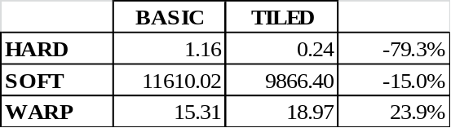

Table 2: Average execution time in milliseconds of a 200x200 floating point matrix multiplication.
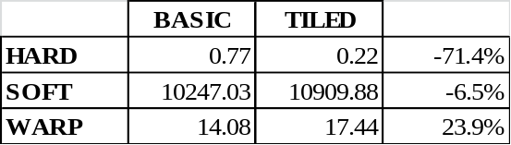

Using both integer- and floating point-precision, the performance of WARP is impaired by the kernel utilizing shared memory according to the data presented in Tables 1 & 2. In Microsoft's guide on WARP (see Microsoft’s reference on WARP (Microsoft, 2013)), the author claims that an application, if tuned to run efficiently on hardware, will run efficiently on WARP - and vice versa. However, the data collected for this study rather indicates an increase in execution time of 23.9%, independant of precision, even though the same kernel accelerates the hardware accelerated Subject by roughly 70%. The floating point scenario of this effect is visualized in Figure 1.

Figure 1: WARP execution time with float-precision for the Basic- and Tiled-kernel, with visualized mean and standard deviations. Values outside of their respective standard deviations have been clipped for the sake of clarity.
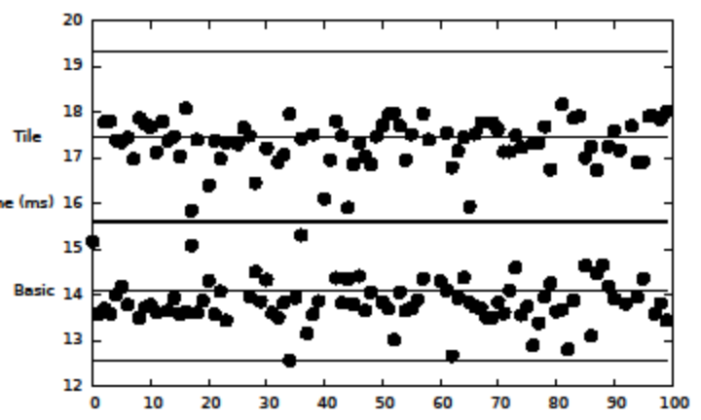
Integer precision calculation showed no sign of precisonal loss whatsoever. Meanwhile, all floating point-experiments experienced an equal average loss of computational precision. However, the data collected indicates no divergence in the precisional loss of respective Subject. The average deviations in precision experienced equally with each configuration, in relation to the Ref-matrix descibed in Section Method of Study, are presented in Table 3.

Table 3: Average precisional deviations in floating point-operations for all Subjects.
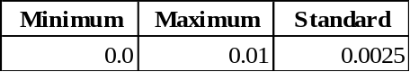

These results are expected as WARP conforms to the precision requirements of the Direct3D 10- and 10.1-specification (see Microsoft’s reference on WARP (Microsoft, 2013)). See Microsoft's documentation on Floating-point Rules (Microsoft, 2013) for more information surrounding floating point-precision in the Direct3D-framework.

CONCLUSION

Based on the results presented in Section Results, using WARP to emulate the kernels presented in this study has magnitudes greater performance than if one were to apply the DirectX Reference Device Driver in the same manner. Hence, if one were to compare the execution of WARP & the Reference Device Driver side-by-side, and assume the same area of application, WARP is superior in terms of execution time - assuming the same preconditions as those presented in this material.
However, keeping in mind the major performance improvements offered by Microsoft WARP, it is important to consider that the two may be appropriate for different purposes. The DirectX Reference Device Driver is primarily proposed by Microsoft as a debugging-/pre-silicon-development tool, whereas WARP is intended for use in a broader sense (see Microsoft’s reference on WARP (Microsoft, 2013)) - such as to render graphics for casual games - in addition to debugging and error-profiling purposes. This calls for further inquiry into what the flaws of using Microsoft WARP may be.

In conclusion; this study proposes, pursuant to the established performance of Microsoft WARP, that WARP-technologies are feasable for extended use in applications - for purposes other than debugging and profiling.

Future Work

For the sake of brevity, the author suggests complementary elaboration into double precision calculations in DirectCompute-kernels, with the intent of examining whether or not the Subjects detailed in Section Subjects of Study may have differentiating effects on computational precision.

Additionally, the use of more complex kernels in coagency with the WARP-driver should be examined in order to study the effects of more demanding emulation on the CPU.

APPENDIX

Matrix mult. w. Blocks

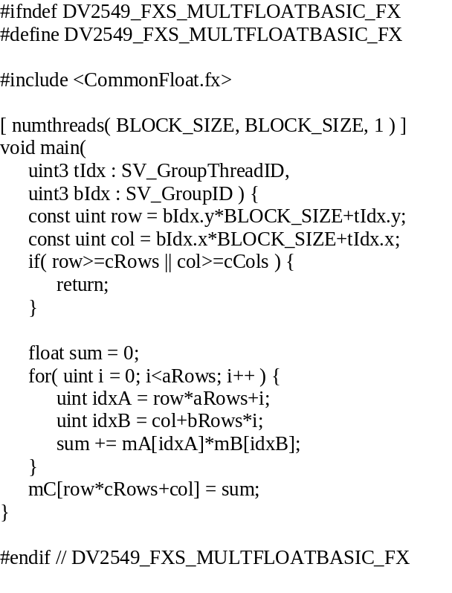

Matrix mult. w. Blocks & Shared Memory

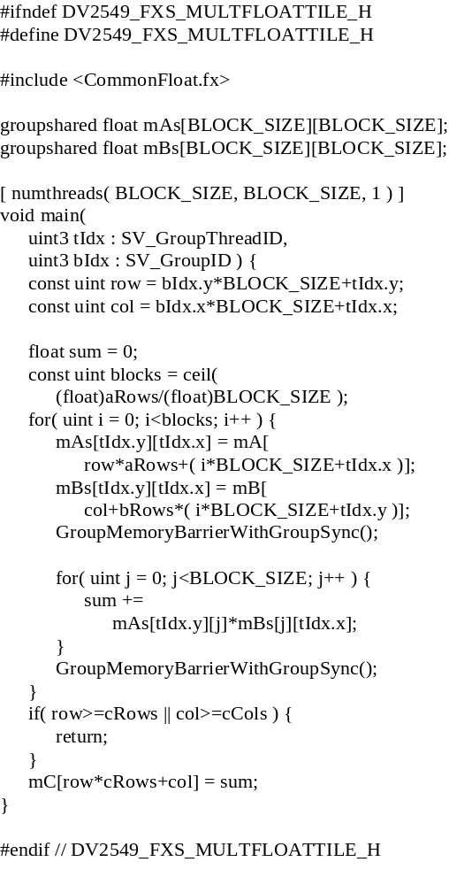

REFERENCES

Hwu, W.-m. W. (2011). GPU Computing Gems Jade Edition (1st ed.). San Francisco, CA, USA: Morgan Kaufmann Publishers Inc.

Kirk, D. B., & Hwu, W.-m. W. (2010). Programming Massively Parallel Processors: A Hands-on Approach (1st ed.). San Francisco, CA, USA: {Morgan Kaufmann Publishers Inc.
Stratton, J. A., Stone, S. S., & Hwu, W.-m. W. (2008). MCUDA: An Efficient Implementation of CUDA Kernels for Multi-core CPUs. (J. N. Amaral, Ed.) Languages and Compilers for Parallel Computing, 16-30.

WEB REFERENCES

GPU Ocelot. (2013). GPU Ocelot. Retrieved 10 21, 2013, from http://b.gatech.edu/1a489L1
Microsoft. (2013, 11 26). Microsoft's reference on DirectX Driver Types. Retrieved 10 21, 2013, from MSDN: http://bit.ly/1b63NiX
Microsoft. (2013, 11 16). Microsoft's reference on Floating-Point Rules. Retrieved 11 16, 2013, from MSDN: http://bit.ly/1bOQnZu
Microsoft. (2013, 11 16). Microsoft's reference on WARP. Retrieved 10 21, 2013, from MSDN: http://bit.ly/19hiwrZ
Nilsson, E. (2013). dv2549. Retrieved 10 21, 2013, from Github: http://bit.ly/1c4wd20

