COMPATIBILITIES

see drivers available for your graphic card: https://www.nvidia.es/Download/index.aspx?lang=es

Table 1. CUDA Toolkit and Compatible Driver Versions
CUDA Toolkit | Linux x86_64 Driver Version
CUDA 11.0 (11.0.171) | >= 450.36.06
CUDA 10.2 (10.2.89) | >= 440.33
CUDA 10.1 (10.1.105) | >= 418.39
CUDA 10.0 (10.0.130) | >= 410.48
CUDA 9.2 (9.2.88) | >= 396.26
CUDA 9.1 (9.1.85) | >= 390.46
CUDA 9.0 (9.0.76) | >= 384.81
CUDA 8.0 (8.0.61 GA2) | >= 375.26
CUDA 8.0 (8.0.44) | >= 367.48
CUDA 7.5 (7.5.16) | >= 352.31
CUDA 7.0 (7.0.28) | >= 346.46

* tensorflow 1.15 → CUDA 10.2 CUDNN 7.6

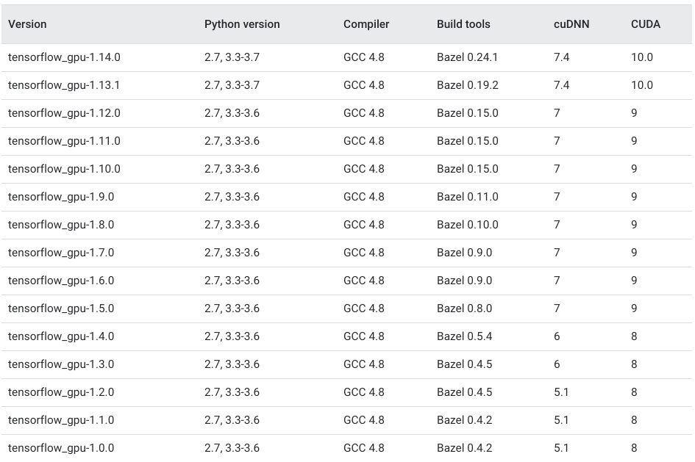
INSTALL DRIVER CUDA AND CUDNN

https://medium.com/repro-repo/install-cuda-and-cudnn-for-tensorflow-gpu-on-ubuntu-79306e4ac04e

