The mvc application has a web api controller to save the user uploaded mp4 files to a folder called mp4files in the server wwwroot.

1. The user can click any file in the table and the video will auto play

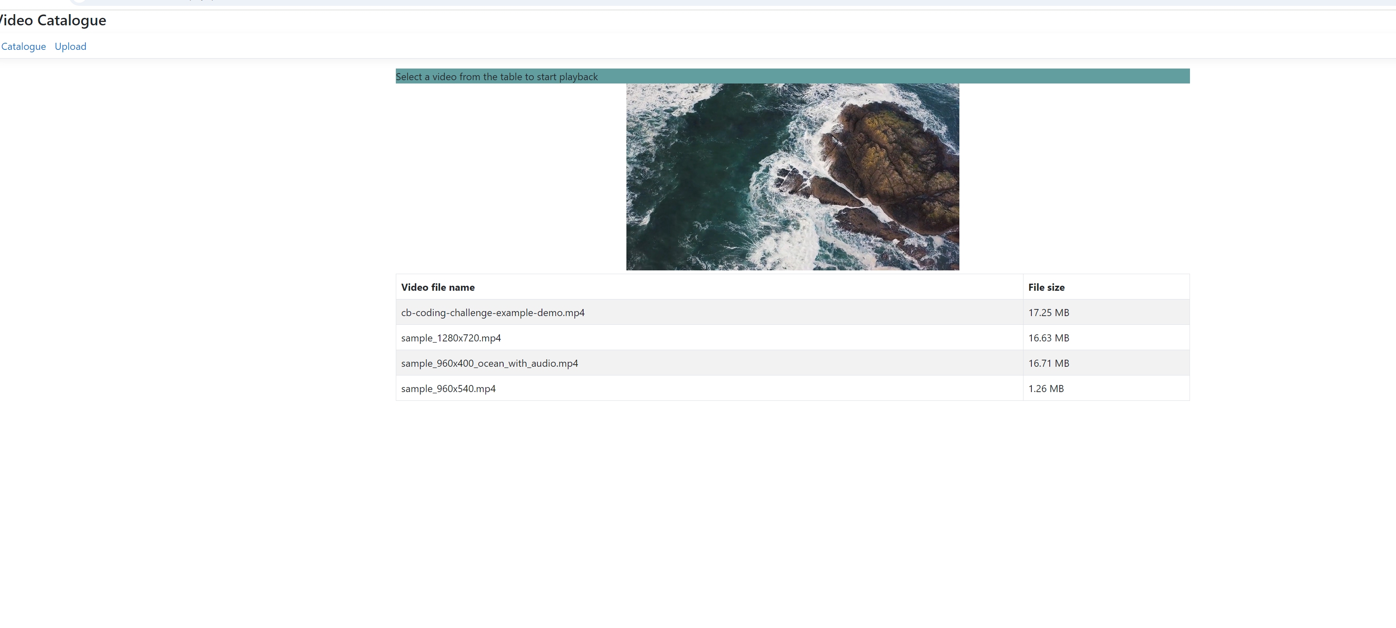

1. The user can choose multiple mp4 files to upload

