**Based on Your IP Address, It Appears That You Are Visiting From The United States of America**

In order to comply with U.S. regulations, we have decided that, until there is clarity on the treatment of cryptocurrency in the U.S., XYO is only available for sale internationally.

However, here's the good news...

**XY Has Obtained an SEC Reg A+ Equity Qualification!**

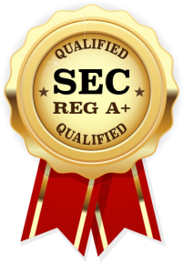



**SEC REG A+ Equity Offering**

An SEC Reg A+ Equity offering enables everyday investors to participate in investment opportunities previously only available to large private equity firms or funds.

On March 25, 2015, the Securities and Exchange Commission adopted final rules to implement Section 401 of the Jumpstart Our Business Startups Act ("JOBS Act"), creating Regulation A.

Regulation A (or Reg A) contains rules providing exemptions from the registration requirements, allowing some companies to use equity crowdfunding to offer and sell their securities without having to register the securities with the SEC. Regulation A offerings are intended to make access to capital possible for small and medium-sized companies that could not otherwise bear the costs of a normal SEC registration and to allow non-accredited investors to participate in the offering.

**XY is proud to announce that it has qualified for the SEC's Reg A+ Equity Offering!**

[**INVEST IN XY NOW!**Purchase Shares in XY'S SEC REG A+ Equity Offering](https://invest.xyfindables.com/xyo-equity-funnelhb3qydz5)

# invest.xyfindables.com

<https://invest.xyfindables.com/xy-equity-notification24293530?cid=w89C740MIN8S6KOI1S5I59FU>

## WHAT YOU NEED TO KNOW

### 需要说明的概念

### 重要原文摘录

*“XYO tokens are necessary to manage the cryptoeconomic incentives of the XYO Network. By purchasing equity in XY, you gain exposure to the success of XY's blockchain platform, the XY Oracle Network ("XYO Network")”*

### 重点