thinkPHP 利用PHPExcel导入excel表格数据到数据库

一、下载PHPExcel包，并放在thinkPHP文件中

PHPExcel包：

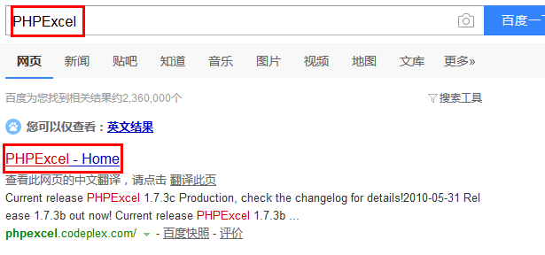

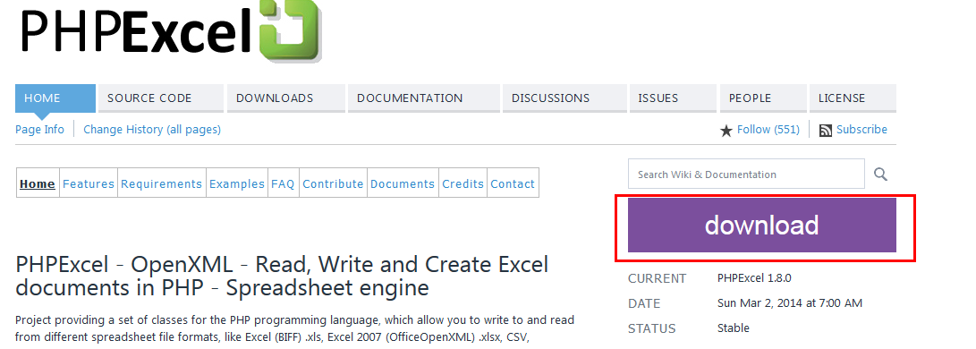

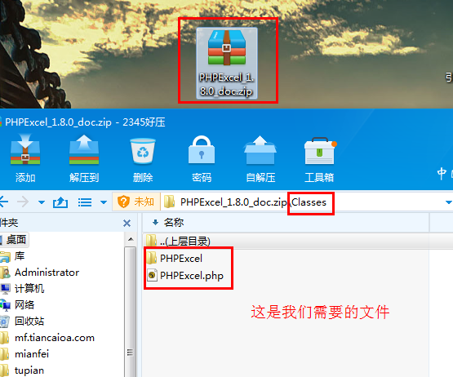

新建文件夹，命名为PHPExcel，将上面两个文件PHPExcel，PHPExcel.php放到我们新建的PHPExcel文件夹下面；然后将此文件夹放在thinkPHP核心包里面，路径如下：C:\Users\Administrator\Desktop\你的项目\ThinkPHP\Library\Vendor

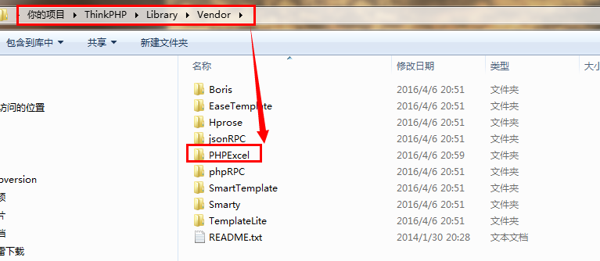

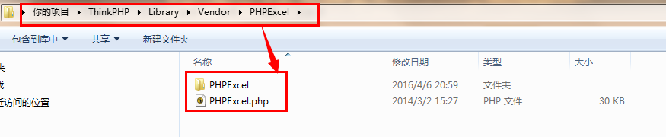

二、前端界面代码

前端界面：

<div style="margin-left: 100px;margin-top: -33px;">

<form action="{:U('upload')}" enctype="multipart/form-data" method="post" >

<input type="file" name="photo" />

<input type="submit" value="导入数据" style="background-color: #337AB7;color: white;">

</form>

</div>窗体顶端

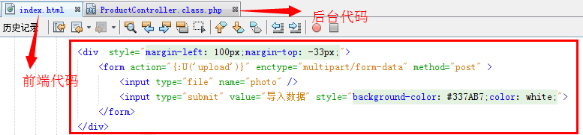窗体底端

三、后台代码：

function upload() {

if (!empty($_FILES)) {

$config = array(

'exts' => array('xlsx', 'xls'),

'maxSize' => 3145728,

'rootPath' => "./Public/",

'savePath' => 'Uploads/',

'subName' => array('date', 'Ymd'),

);

$upload = new \Think\Upload($config);

if (!$info = $upload->upload()) {

$this->error($upload->getError());}

vendor("PHPExcel.PHPExcel");

$file_name=$upload->rootPath.$info['photo']['savepath'].$info['photo']['savename'];

$extension = strtolower(pathinfo($file_name, PATHINFO_EXTENSION));//判断导入表格后缀格式

if ($extension == 'xlsx') {

$objReader = \PHPExcel_IOFactory::createReader('Excel2007');

$objPHPExcel = $objReader->load($file_name, $encode = 'utf-8');

} else if ($extension == 'xls') {

$objReader = \PHPExcel_IOFactory::createReader('Excel5');

$objPHPExcel = $objReader->load($file_name, $encode = 'utf-8');

}

$sheet = $objPHPExcel->getSheet(0);

$highestRow = $sheet->getHighestRow(); // 取得总行数

$highestColumn = $sheet->getHighestColumn(); // 取得总列数

for ($i = 2; $i <= $highestRow; $i++) {

$data['product_id'] = $objPHPExcel->getActiveSheet()->getCell("A" . $i)->getValue();

$data['title'] = $objPHPExcel->getActiveSheet()->getCell("B" . $i)->getValue();

$data['img_url'] = $objPHPExcel->getActiveSheet()->getCell("C" . $i)->getValue();

$data['price'] = $objPHPExcel->getActiveSheet()->getCell("D" . $i)->getValue();

$data['product_url'] = $objPHPExcel->getActiveSheet()->getCell("E" . $i)->getValue();

$data['long_url'] = $objPHPExcel->getActiveSheet()->getCell("F" . $i)->getValue();

$data['input_time'] = time();

$data['promotion_type'] = mt_rand(3, 5);

M('product')->add($data);

}

$this->success('导入成功！');

} else {

$this->error("请选择上传的文件");

}

}

