# 点击功能报错

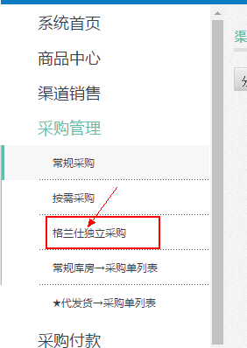 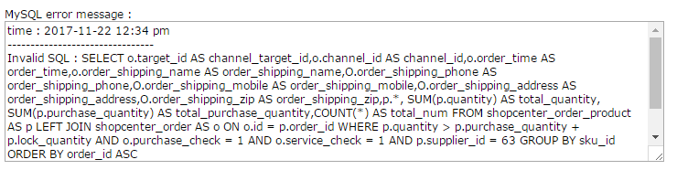

反馈：大小写

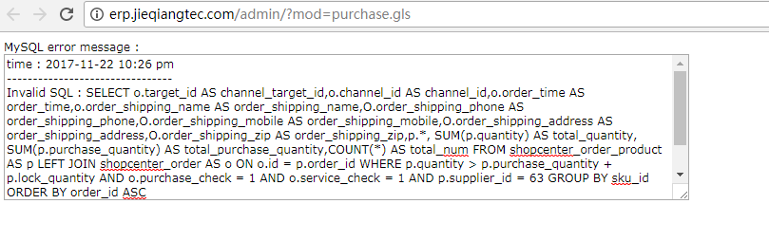

SELECT

o.target_id AS channel_target_id,

o.channel_id AS channel_id,

o.order_time AS order_time,

o.order_shipping_name AS order_shipping_name,

O.order_shipping_phone AS order_shipping_phone,

O.order_shipping_mobile AS order_shipping_mobile,

O.order_shipping_address AS order_shipping_address,

O.order_shipping_zip AS order_shipping_zip,

p.*, SUM(p.quantity) AS total_quantity,

SUM(p.purchase_quantity) AS total_purchase_quantity,

COUNT(*) AS total_num

FROM

shopcenter_order_product AS p

LEFT JOIN shopcenter_order AS o ON o.id = p.order_id

WHERE

p.quantity > p.purchase_quantity + p.lock_quantity

AND o.purchase_check = 1

AND o.service_check = 1

AND p.supplier_id = 63

GROUP BY

sku_id

ORDER BY

order_id ASC

# **点击下面的子菜单后，可能因为刷新的缘故，左边菜单点击的位置会自动跳回到顶部。**所以要重新下拉滚动条找刚才点击的位置。

反馈：小朱js定位current

比如点击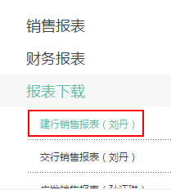然后看不到了，需要下拉滚动条找。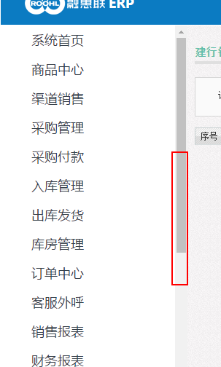

# 点击保存等操作，左边菜单展开没有保持位置，而是被刷新了：

http://erp.jieqiangtec.cn/admin/?mod=product.edit&id=%2011629

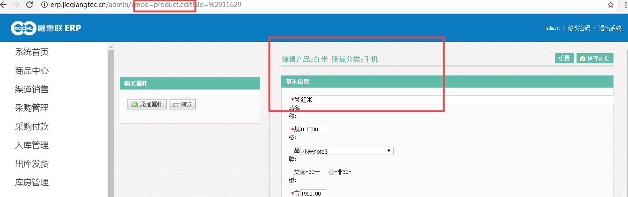

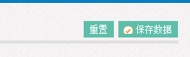

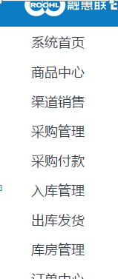

# 4.背景图换一个和系统协调的颜色？

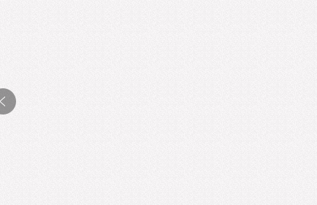

# 5.去掉最底下的横条

C:\Users\ADMINI~1\AppData\Local\Temp\WeChat Files\33229b8a227fd036e6bc22aec465e8e.png