# **20180421**

兑换中心后台管理入口_20180421

## 登录后台

<http://shop.rongec.com/web/index.php?c=user&a=login&>

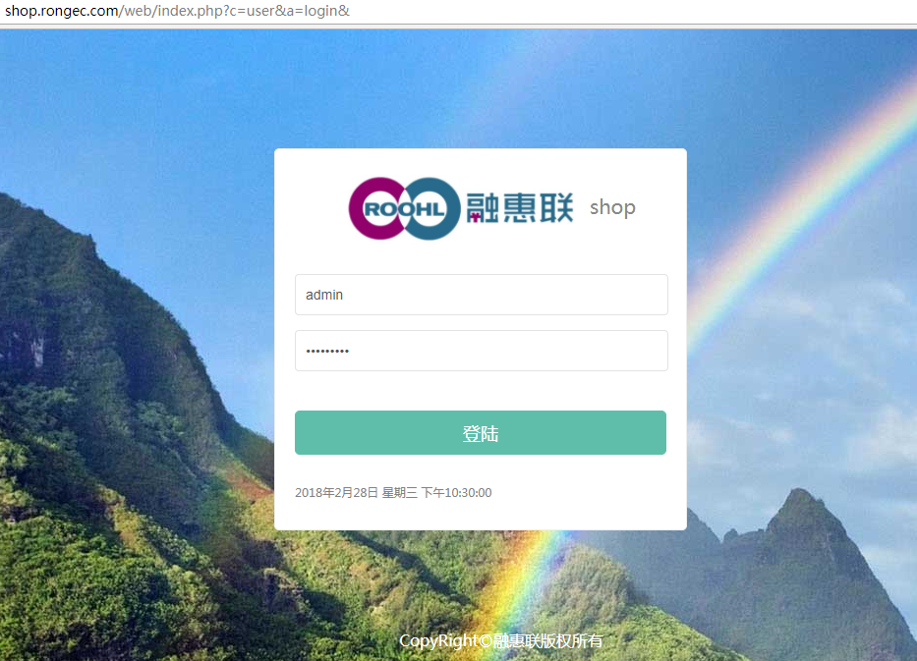

## **选择对应公众号进入**

<http://shop.rongec.com/web/index.php?c=account&a=manage&>

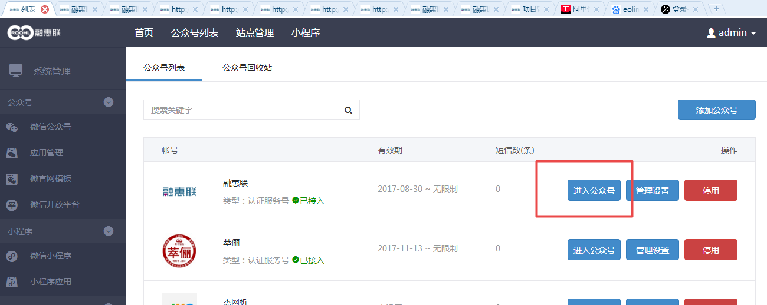

## **进入到惠惠城**

<http://shop.rongec.com/web/index.php?c=site&a=entry&m=ewei_shopv2&do=web&r=shop.adv>

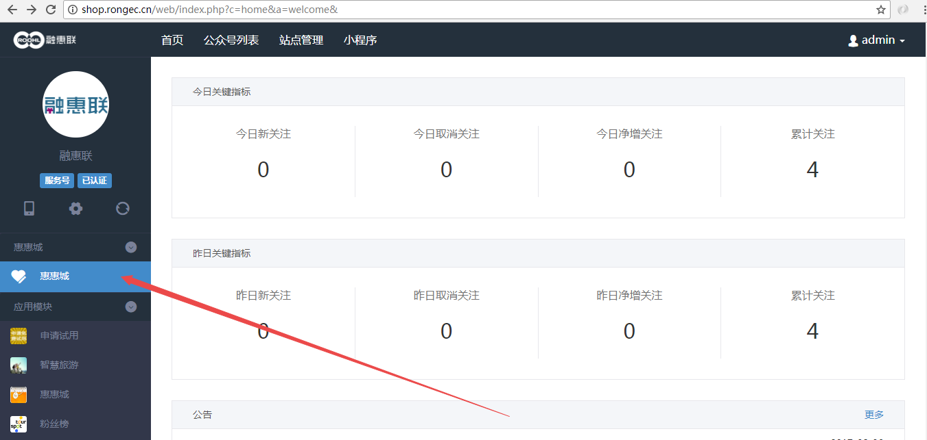

## **进入应用=》兑换中心**

[http://shop.rongec.com/web/index.php?c=site&a=entry&m=ewei_shopv2&do=web&r=plugins](http://shop.rongec.cn/web/index.php?c=site&a=entry&m=ewei_shopv2&do=web&r=plugins)

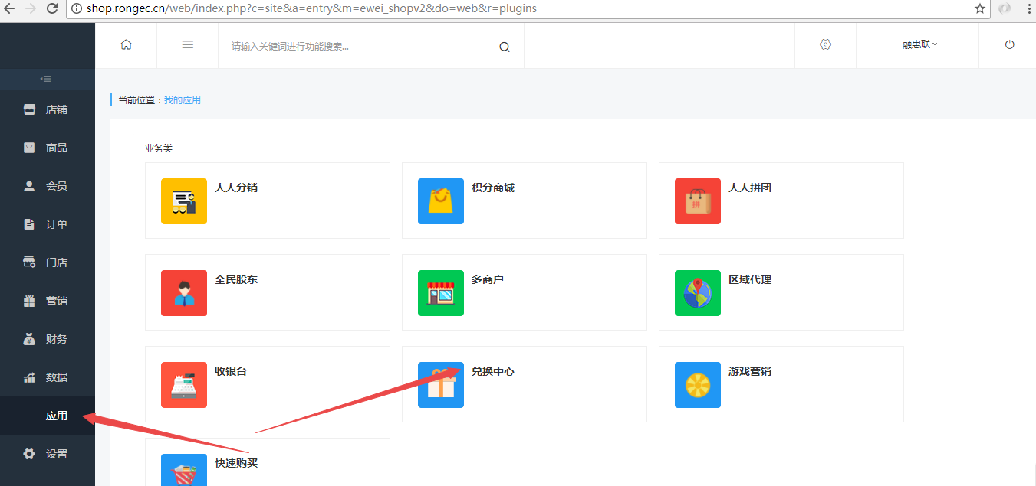

## 添加商品

<http://shop.rongec.com/web/index.php?c=site&a=entry&m=ewei_shopv2&do=web&r=exchange.goods.setting&id=4>

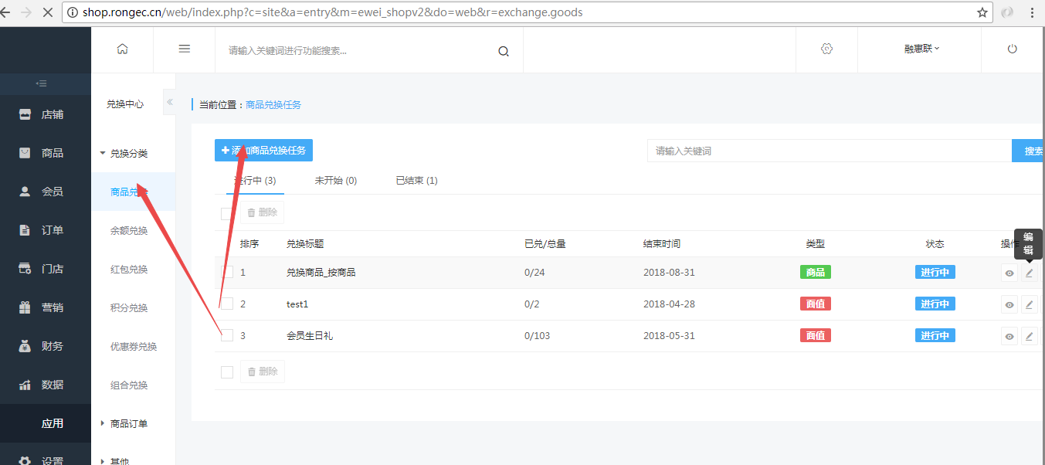

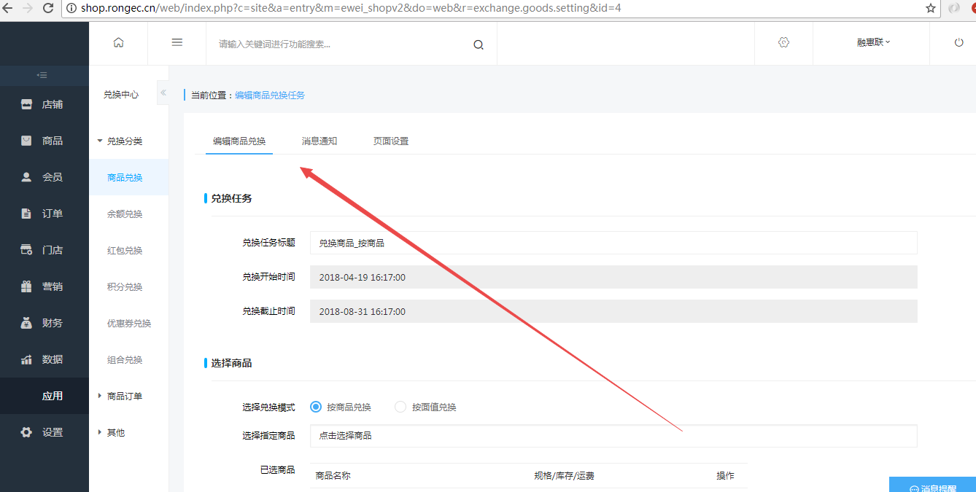

## 生成兑换码

http://shop.rongec.com/web/index.php?c=site&a=entry&m=ewei_shopv2&do=web&r=exchange.goods.dno&id=4

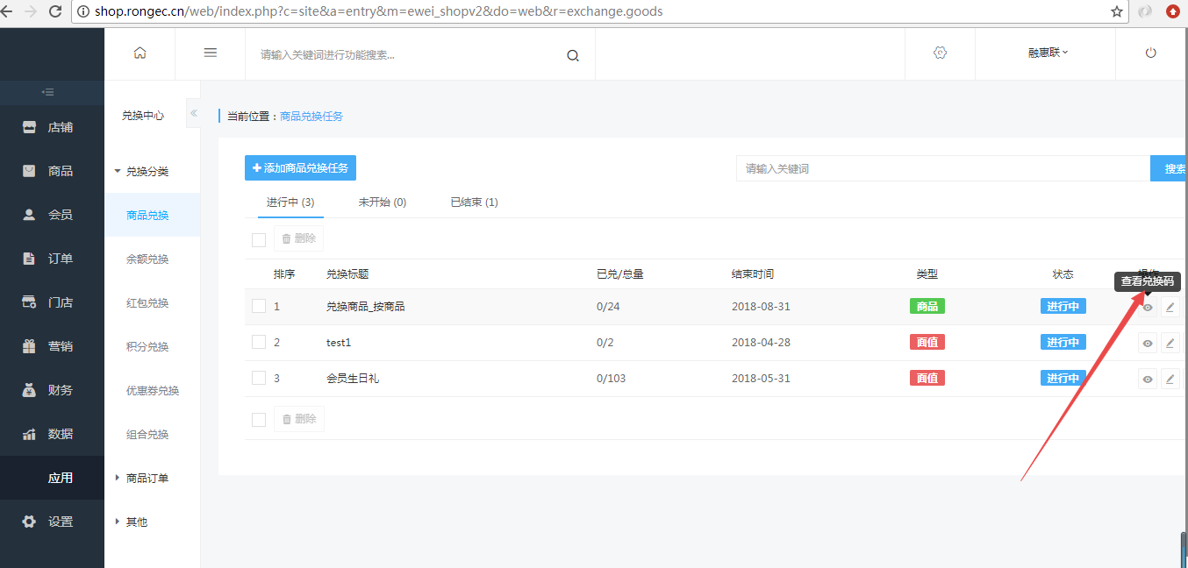

填写：兑换码有效期和请输入兑换码生成数量

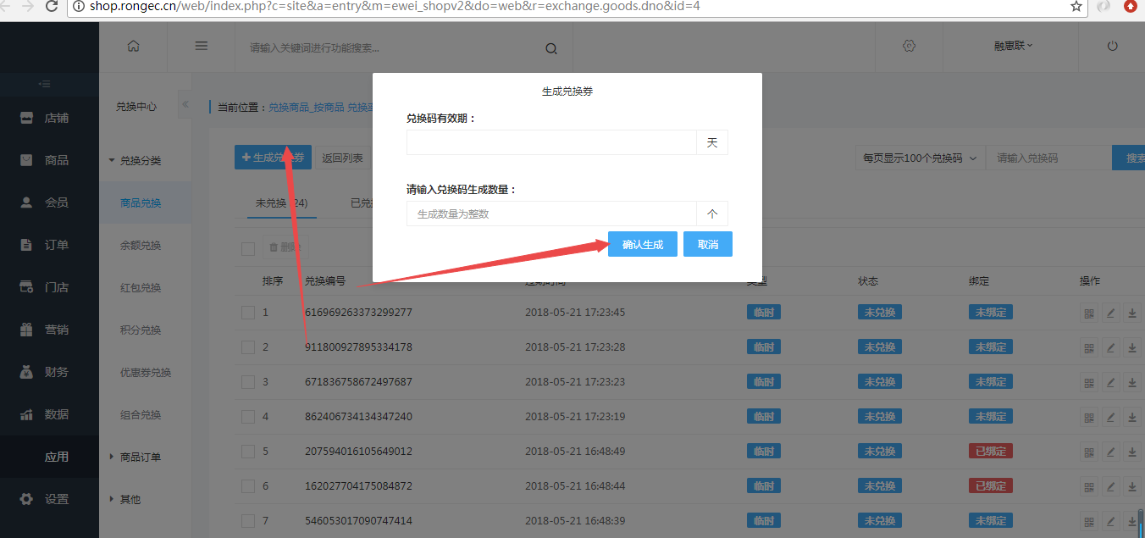

## 手机前端

[http://shop.rongec.com/app/index.php?i=10&c=entry&m=ewei_shopv2&do=mobile&r=exchange&codetype=1&id=4](http://shop.rongec.cn/app/index.php?i=10&c=entry&m=ewei_shopv2&do=mobile&r=exchange&codetype=1&id=4)

