# **20171210**

**程序执行文件流程**:

$traces = debug\_backtrace();

商城首页

<http://shop.rongec.cn/app/index.php?i=6&c=entry&eid=1&wxref=mp.weixin.qq.com#wechat_redirect>

# **20171210**

**程序执行文件流程**:

$traces = debug\_backtrace();

商城品牌,仿分类

[http://shop.rongec.cn/app/index.php?i=6&c=entry&m=ewei\_shopv2&do=mobile&r=shop.b](http://shop.rongec.cn/app/index.php?i=6&c=entry&m=ewei_shopv2&do=mobile&r=shop.category)rand

D:\www\users\wc.jieqiangtec.com\addons\ewei\_shopv2\core\mobile\shop\brand.php

D:\www\users\wc.jieqiangtec.com\addons\ewei\_shopv2\core\model\route.php L188

$global\_set = m('cache')->getArray('globalset');  
  
**if** (**empty**($global\_set)) {  
 $global\_set = m('common')->setGlobalSet();  
}

// var\_dump('*TODO jieqiangtest $global\_set==',$global\_set,debug\_backtrace());exit;*

SELECT \* FROM `ims\_ewei\_shop\_sysset` LIMIT 0, 1000

Js引入

D:\www\users\wc.jieqiangtec.com\addons\ewei\_shopv2\static\js\app\biz\shop\category.js

解密：

<https://tool.lu/js>

# 关于人人商城源码Template Error

## 商城分类

<http://shop.rongec.cn/app/index.php?i=6&c=entry&m=ewei_shopv2&do=mobile&r=shop.category>

D:\www\users\wc.jieqiangtec.com\addons\ewei\_shopv2\core\mobile\shop\category.php

商城品牌,仿分类

[http://shop.rongec.cn/app/index.php?i=6&c=entry&m=ewei\_shopv2&do=mobile&r=shop.b](http://shop.rongec.cn/app/index.php?i=6&c=entry&m=ewei_shopv2&do=mobile&r=shop.category)rand

D:\www\users\wc.jieqiangtec.com\addons\ewei\_shopv2\core\mobile\shop\brand.php

跟踪来源

$\_W['shopset']

D:\www\users\wc.jieqiangtec.com\addons\ewei\_shopv2\core\mobile\shop\brand.php

编辑商品品牌属性

<http://shop.rongec.cn/web/index.php?c=site&a=entry&m=ewei_shopv2&do=web&r=goods.edit&id=202&goodsfrom=sale>

D:\www\users\wc.jieqiangtec.com\addons\ewei\_shopv2\core\web\goods\post.php

D:\www\users\wc.jieqiangtec.com\addons\ewei\_shopv2\template\web\_v3\goods\tab\basic.html

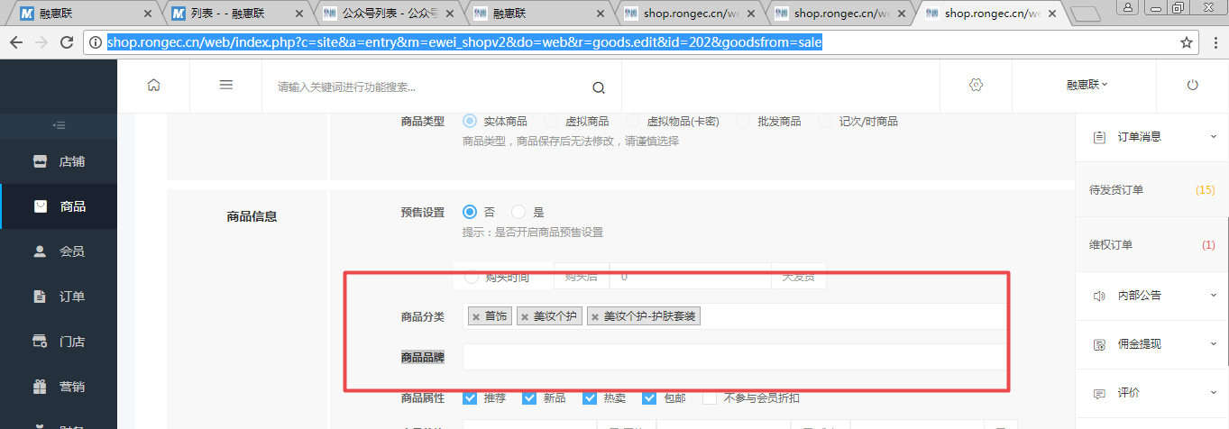

品牌管理

<http://shop.rongec.cn/web/index.php?c=site&a=entry&m=ewei_shopv2&do=web&r=goods.brand>

<http://shop2.jieqiangtec.com/>

<http://shop2.jieqiangtec.com/>[admin/brand.php?act=list](http://localhost/users/ecshop3.jieqiangtec.com/admin/brand.php?act=list)

admin

admin888

[http://shop2.jieqiangtec.cn/admin/index.php/admin/brand.php?act=list](http://localhost/users/ecshop3.jieqiangtec.com/admin/brand.php?act=list)

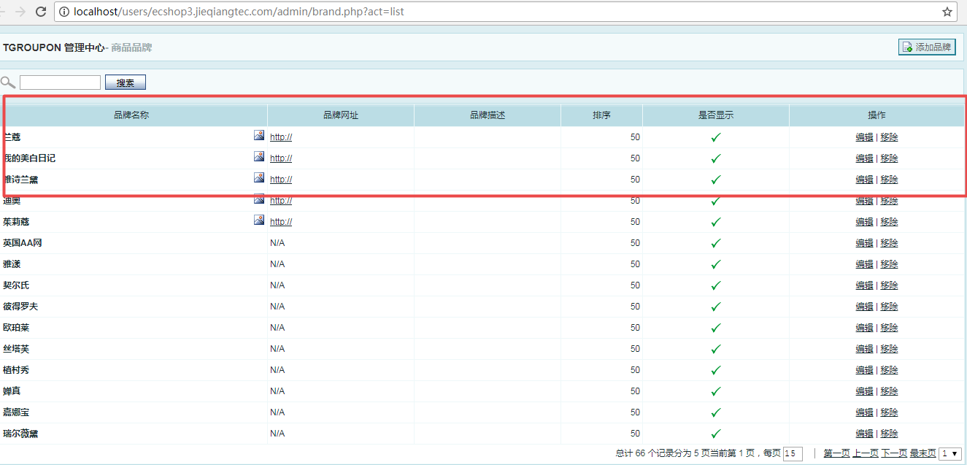

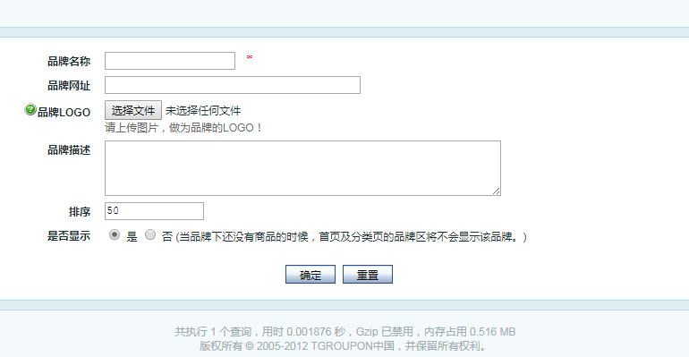

|  |  |
| --- | --- |
| **品牌名称** | \* |
| **品牌网址** |  |
| **[IMG_256](http://localhost/users/ecshop3.jieqiangtec.com/admin/javascript:showNotice('warn_brandlogo');)品牌LOGO** | 请上传图片，做为品牌的LOGO！ |
| **品牌描述** |  |
| **排序** |  |
| **是否显示** | 是  否 (当品牌下还没有商品的时候，首页及分类页的品牌区将不会显示该品牌。) |
|  |  |

左侧导航：

D:\www\users\wc.jieqiangtec.com\addons\ewei\_shopv2\core\model\system.php

## 仿照分类管理

**category=》brand**

**分类=》品牌**

**advimg=》logo**

<http://shop.rongec.cn/web/index.php?c=site&a=entry&m=ewei_shopv2&do=web&r=goods.category>

链接：

<http://shop.rongec.cn/web/index.php?c=site&a=entry&m=ewei_shopv2&do=web&r=goods.brand>

程序：

D:\www\users\wc.jieqiangtec.com\addons\ewei\_shopv2\core\web\goods\brand.php

Error: template source 'web/goods/brand' is not exist!  
模板：

D:\www\users\wc.jieqiangtec.com\addons\ewei\_shopv2\template\web\_v3\goods\brand

路由：

D:\www\users\wc.jieqiangtec.com\addons\ewei\_shopv2\core\model\route.php

2017-12-10 20:55:46 SQL Error ：来源:

http://shop.rongec.cn/web/index.php?c=site&a=entry&m=ewei\_shopv2&do=web&r=goods.brand

------------

String:

SQL: <br/>SELECT \* FROM `ims\_ewei\_shop\_brand` WHERE uniacid = '6' ORDER BY parentid ASC, displayorder DESC<hr/>Params: <br/>array (

)<hr/>SQL Error: <br/>Table 'wc2.ims\_ewei\_shop\_brand' doesn't exist<hr/>Traces: <br/>file: /framework/class/db.class.php; line: 227; <br />file: /framework/function/pdo.func.php; line: 44; <br />file: /addons/ewei\_shopv2/core/web/goods/brand.php; line: 70; <br />file: /addons/ewei\_shopv2/core/model/route.php; line: 207; <br />file: /addons/ewei\_shopv2/site.php; line: 47; <br />file: /web/source/site/entry.ctrl.php; line: 84; <br />file: /web/index.php; line: 184; <br />

建表

CREATE TABLE `ims\_ewei\_shop\_brand` (

`brand\_id` smallint(5) unsigned NOT NULL AUTO\_INCREMENT,

`brand\_name` varchar(60) NOT NULL DEFAULT '',

`brand\_logo` varchar(80) NOT NULL DEFAULT '',

`brand\_desc` text NOT NULL,

`site\_url` varchar(255) NOT NULL DEFAULT '',

`sort\_order` tinyint(3) unsigned NOT NULL DEFAULT '50',

`is\_show` tinyint(1) unsigned NOT NULL DEFAULT '1',

`brand\_banner` varchar(80) NOT NULL COMMENT '商品品牌banner',

PRIMARY KEY (`brand\_id`),

KEY `is\_show` (`is\_show`)

) ENGINE=MyISAM AUTO\_INCREMENT=73 DEFAULT CHARSET=utf8;

**删除记录ims\_ewei\_shop\_perm\_log**

2017-12-10 23:05:54 TODO debug3 ：来源:

http://shop.rongec.cn/web/index.php?c=site&a=entry&m=ewei\_shopv2&do=web&r=goods.brand.delete&id=72

------------

Array:

file : D:\www\users\wd2.jieqiangtec.com\framework\class\db.class.php query($sql, $params = array()) ;

sql2 : DELETE FROM `ims\_ewei\_shop\_brand` WHERE `id` = '72' ;

$params ==Array:

:\_\_id : 72 ;

2017-12-10 23:05:54 TODO debug3 ：来源:

http://shop.rongec.cn/web/index.php?c=site&a=entry&m=ewei\_shopv2&do=web&r=goods.brand.delete&id=72

------------

Array:

file : D:\www\users\wd2.jieqiangtec.com\framework\class\db.class.php query($sql, $params = array()) ;

sql2 : INSERT INTO `ims\_ewei\_shop\_perm\_log` SET `uniacid` = '6' , `uid` = '1' , `name` = '' , `type` = 'shop.brand.delete' , `op` = '删除品牌 ID: 72 品牌名称: 牛栏' , `ip` = '127.0.0.1' , `createtime` = '1512918354' ;

$params ==Array:

:uniacid : 6 ;

:uid : 1 ;

:name : ;

:type : shop.brand.delete ;

:op : 删除品牌 ID: 72 品牌名称: 牛栏 ;

:ip : 127.0.0.1 ;

:createtime : 1512918354 ;

图片上传

http://shop.rongec.cn/web/index.php?c=utility&a=file&do=upload&type=image

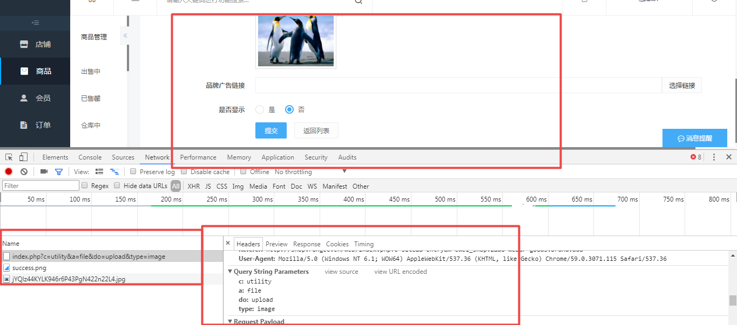

获取全部品牌

D:\www\users\wc.jieqiangtec.com\addons\ewei\_shopv2\core\model\shop.php L44

$brands = m('shop')->getFullBrand(**true**);

商品表添加栏位：

ALTER TABLE `ims\_ewei\_shop\_goods`

ALTER COLUMN `brand` `brands` text CHARACTER SET utf8 COLLATE utf8\_general\_ci NULL COMMENT '品牌' AFTER `cates`;

商品编辑

string 'D:\www\users\wc.jieqiangtec.com\addons\ewei\_shopv2\core\web\goods/post.php' *(length=74)*

数据表:商品

CREATE TABLE `ims\_ewei\_shop\_goods` (

`id` int(11) NOT NULL AUTO\_INCREMENT,

`uniacid` int(11) DEFAULT '0',

`pcate` int(11) DEFAULT '0',

`ccate` int(11) DEFAULT '0',

`type` tinyint(1) DEFAULT '1',

`status` tinyint(1) DEFAULT '1',

`displayorder` int(11) DEFAULT '0',

`title` varchar(100) DEFAULT '',

`thumb` varchar(255) DEFAULT '',

`unit` varchar(5) DEFAULT '',

`description` varchar(1000) DEFAULT NULL,

`content` text,

`goodssn` varchar(50) DEFAULT '',

`productsn` varchar(50) DEFAULT '',

`productprice` decimal(10,2) DEFAULT '0.00',

`marketprice` decimal(10,2) DEFAULT '0.00',

`costprice` decimal(10,2) DEFAULT '0.00',

`originalprice` decimal(10,2) DEFAULT '0.00',

`total` int(10) DEFAULT '0',

`totalcnf` int(11) DEFAULT '0',

`sales` int(11) DEFAULT '0',

`salesreal` int(11) DEFAULT '0',

`spec` varchar(5000) DEFAULT '',

`createtime` int(11) DEFAULT '0',

`weight` decimal(10,2) DEFAULT '0.00',

`credit` varchar(255) DEFAULT NULL,

`maxbuy` int(11) DEFAULT '0',

`usermaxbuy` int(11) DEFAULT '0',

`hasoption` int(11) DEFAULT '0',

`dispatch` int(11) DEFAULT '0',

`thumb\_url` text,

`isnew` tinyint(1) DEFAULT '0',

`ishot` tinyint(1) DEFAULT '0',

`isdiscount` tinyint(1) DEFAULT '0',

`isrecommand` tinyint(1) DEFAULT '0',

`issendfree` tinyint(1) DEFAULT '0',

`istime` tinyint(1) DEFAULT '0',

`iscomment` tinyint(1) DEFAULT '0',

`timestart` int(11) DEFAULT '0',

`timeend` int(11) DEFAULT '0',

`viewcount` int(11) DEFAULT '0',

`deleted` tinyint(3) DEFAULT '0',

`hascommission` tinyint(3) DEFAULT '0',

`commission1\_rate` decimal(10,2) DEFAULT '0.00',

`commission1\_pay` decimal(10,2) DEFAULT '0.00',

`commission2\_rate` decimal(10,2) DEFAULT '0.00',

`commission2\_pay` decimal(10,2) DEFAULT '0.00',

`commission3\_rate` decimal(10,2) DEFAULT '0.00',

`commission3\_pay` decimal(10,2) DEFAULT '0.00',

`score` decimal(10,2) DEFAULT '0.00',

`taobaoid` varchar(255) DEFAULT '',

`taotaoid` varchar(255) DEFAULT '',

`taobaourl` varchar(255) DEFAULT '',

`updatetime` int(11) DEFAULT '0',

`share\_title` varchar(255) DEFAULT '',

`share\_icon` varchar(255) DEFAULT '',

`cash` tinyint(3) DEFAULT '0',

`commission\_thumb` varchar(255) DEFAULT '',

`isnodiscount` tinyint(3) DEFAULT '0',

`showlevels` text,

`buylevels` text,

`showgroups` text,

`buygroups` text,

`isverify` tinyint(3) DEFAULT '0',

`storeids` text,

`noticeopenid` varchar(255) DEFAULT '',

`tcate` int(11) DEFAULT '0',

`noticetype` text,

`needfollow` tinyint(3) DEFAULT '0',

`followtip` varchar(255) DEFAULT '',

`followurl` varchar(255) DEFAULT '',

`deduct` decimal(10,2) DEFAULT '0.00',

`virtual` int(11) DEFAULT '0',

`ccates` text,

`discounts` text,

`nocommission` tinyint(3) DEFAULT '0',

`hidecommission` tinyint(3) DEFAULT '0',

`pcates` text,

`tcates` text,

`cates` text,

`brands` text COMMENT '品牌',

`artid` int(11) DEFAULT '0',

`detail\_logo` varchar(255) DEFAULT '',

`detail\_shopname` varchar(255) DEFAULT '',

`detail\_btntext1` varchar(255) DEFAULT '',

`detail\_btnurl1` varchar(255) DEFAULT '',

`detail\_btntext2` varchar(255) DEFAULT '',

`detail\_btnurl2` varchar(255) DEFAULT '',

`detail\_totaltitle` varchar(255) DEFAULT '',

`saleupdate42392` tinyint(3) DEFAULT '0',

`deduct2` decimal(10,2) DEFAULT '0.00',

`ednum` int(11) DEFAULT '0',

`edmoney` decimal(10,2) DEFAULT '0.00',

`edareas` text,

`diyformtype` tinyint(1) DEFAULT '0',

`diyformid` int(11) DEFAULT '0',

`diymode` tinyint(1) DEFAULT '0',

`dispatchtype` tinyint(1) DEFAULT '0',

`dispatchid` int(11) DEFAULT '0',

`dispatchprice` decimal(10,2) DEFAULT '0.00',

`manydeduct` tinyint(1) DEFAULT '0',

`shorttitle` varchar(255) DEFAULT '',

`isdiscount\_title` varchar(255) DEFAULT '',

`isdiscount\_time` int(11) DEFAULT '0',

`isdiscount\_discounts` text,

`commission` text,

`saleupdate37975` tinyint(3) DEFAULT '0',

`shopid` int(11) DEFAULT '0',

`allcates` text,

`minbuy` int(11) DEFAULT '0',

`invoice` tinyint(3) DEFAULT '0',

`repair` tinyint(3) DEFAULT '0',

`seven` tinyint(3) DEFAULT '0',

`money` varchar(255) DEFAULT '',

`minprice` decimal(10,2) DEFAULT '0.00',

`maxprice` decimal(10,2) DEFAULT '0.00',

`province` varchar(255) DEFAULT '',

`city` varchar(255) DEFAULT '',

`buyshow` tinyint(1) DEFAULT '0',

`buycontent` text,

`saleupdate51117` tinyint(3) DEFAULT '0',

`virtualsend` tinyint(1) DEFAULT '0',

`virtualsendcontent` text,

`verifytype` tinyint(1) DEFAULT '0',

`diyfields` text,

`diysaveid` int(11) DEFAULT '0',

`diysave` tinyint(1) DEFAULT '0',

`quality` tinyint(3) DEFAULT '0',

`groupstype` tinyint(1) unsigned NOT NULL DEFAULT '0',

`showtotal` tinyint(1) unsigned NOT NULL DEFAULT '0',

`subtitle` varchar(255) DEFAULT '',

`minpriceupdated` tinyint(1) DEFAULT '0',

`sharebtn` tinyint(1) NOT NULL DEFAULT '0',

`catesinit3` text,

`showtotaladd` tinyint(1) DEFAULT '0',

`merchid` int(11) DEFAULT '0',

`checked` tinyint(3) DEFAULT '0',

`thumb\_first` tinyint(3) DEFAULT '0',

`merchsale` tinyint(1) DEFAULT '0',

`keywords` varchar(255) DEFAULT '',

`catch\_id` varchar(255) DEFAULT '',

`catch\_url` varchar(255) DEFAULT '',

`catch\_source` varchar(255) DEFAULT '',

`saleupdate40170` tinyint(3) DEFAULT '0',

`saleupdate35843` tinyint(3) DEFAULT '0',

`labelname` text,

`autoreceive` int(11) DEFAULT '0',

`cannotrefund` tinyint(3) DEFAULT '0',

`saleupdate33219` tinyint(3) DEFAULT '0',

`bargain` int(11) DEFAULT '0',

`buyagain` decimal(10,2) DEFAULT '0.00',

`buyagain\_islong` tinyint(1) DEFAULT '0',

`buyagain\_condition` tinyint(1) DEFAULT '0',

`buyagain\_sale` tinyint(1) DEFAULT '0',

`buyagain\_commission` text,

`saleupdate32484` tinyint(3) DEFAULT '0',

`saleupdate36586` tinyint(3) DEFAULT '0',

`diypage` int(11) DEFAULT NULL,

`cashier` tinyint(1) DEFAULT '0',

`saleupdate53481` tinyint(3) DEFAULT '0',

`saleupdate30424` tinyint(3) DEFAULT '0',

`isendtime` tinyint(3) NOT NULL DEFAULT '0',

`usetime` int(11) NOT NULL DEFAULT '0',

`endtime` int(11) NOT NULL DEFAULT '0',

`merchdisplayorder` int(11) NOT NULL DEFAULT '0',

`exchange\_stock` int(11) DEFAULT '0',

`exchange\_postage` decimal(10,2) NOT NULL DEFAULT '0.00',

`ispresell` tinyint(3) NOT NULL DEFAULT '0',

`presellprice` decimal(10,2) NOT NULL DEFAULT '0.00',

`presellover` tinyint(3) NOT NULL DEFAULT '0',

`presellovertime` int(11) NOT NULL,

`presellstart` tinyint(3) NOT NULL DEFAULT '0',

`preselltimestart` int(11) NOT NULL DEFAULT '0',

`presellend` tinyint(3) NOT NULL DEFAULT '0',

`preselltimeend` int(11) NOT NULL DEFAULT '0',

`presellsendtype` tinyint(3) NOT NULL DEFAULT '0',

`presellsendstatrttime` int(11) NOT NULL DEFAULT '0',

`presellsendtime` int(11) NOT NULL DEFAULT '0',

`edareas\_code` text NOT NULL,

`unite\_total` tinyint(3) NOT NULL DEFAULT '0',

`buyagain\_price` decimal(10,2) DEFAULT '0.00',

`threen` varchar(255) DEFAULT '',

`intervalfloor` tinyint(1) DEFAULT '0',

`intervalprice` varchar(512) DEFAULT '',

`isfullback` tinyint(3) NOT NULL DEFAULT '0',

`isstatustime` tinyint(3) NOT NULL DEFAULT '0',

`statustimestart` int(10) NOT NULL DEFAULT '0',

`statustimeend` int(10) NOT NULL DEFAULT '0',

`nosearch` tinyint(1) NOT NULL DEFAULT '0',

`showsales` tinyint(3) NOT NULL DEFAULT '1',

`islive` int(11) NOT NULL DEFAULT '0',

`liveprice` decimal(10,2) NOT NULL DEFAULT '0.00',

`opencard` tinyint(1) DEFAULT '0',

`cardid` varchar(255) DEFAULT '',

`verifygoodsnum` int(11) DEFAULT '1',

`verifygoodsdays` int(11) DEFAULT '1',

`verifygoodslimittype` tinyint(1) DEFAULT '0',

`verifygoodslimitdate` int(11) DEFAULT '0',

`minliveprice` decimal(10,2) NOT NULL DEFAULT '0.00',

`maxliveprice` decimal(10,2) NOT NULL DEFAULT '0.00',

`dowpayment` decimal(10,2) NOT NULL DEFAULT '0.00',

`tempid` int(11) NOT NULL DEFAULT '0',

`isstoreprice` tinyint(11) NOT NULL DEFAULT '0',

`beforehours` int(11) NOT NULL DEFAULT '0',

PRIMARY KEY (`id`),

KEY `idx\_uniacid` (`uniacid`),

KEY `idx\_pcate` (`pcate`),

KEY `idx\_ccate` (`ccate`),

KEY `idx\_isnew` (`isnew`),

KEY `idx\_ishot` (`ishot`),

KEY `idx\_isdiscount` (`isdiscount`),

KEY `idx\_isrecommand` (`isrecommand`),

KEY `idx\_iscomment` (`iscomment`),

KEY `idx\_issendfree` (`issendfree`),

KEY `idx\_istime` (`istime`),

KEY `idx\_deleted` (`deleted`),

KEY `idx\_tcate` (`tcate`),

KEY `idx\_scate` (`tcate`),

KEY `idx\_merchid` (`merchid`),

KEY `idx\_checked` (`checked`),

FULLTEXT KEY `idx\_buylevels` (`buylevels`),

FULLTEXT KEY `idx\_showgroups` (`showgroups`),

FULLTEXT KEY `idx\_buygroups` (`buygroups`)

) ENGINE=MyISAM AUTO\_INCREMENT=222 DEFAULT CHARSET=utf8;