## 2018年1月14沟通总结

4个紧要功能

1.商城试用功能：用户申请=》后台审核=》供应商发货=》用户反馈试用报告

2.商城白名单：特权加表，针对不同银行

3.商城广告管理：竞价排名，针对供应商产品

4.商城后台银行登陆：看到不同界面：如（活动选择商品）频道 活动 商品 订单

**erp和商城对接**

价格：

1. 供应商成本：不可修改
2. 购销成本：不可修改，供应商和erp定价
3. 银行价格：不同的银行不同价格，不可修改，银行和erp定价

供应商权限：

1. 商品管理（商品录入，excel导入）
2. 物流订单导入

商品导入到商城接口：定时任务同步，商城运营人员手动审核确认上架

1. 供应商看到自己的商品
2. 银行看到和erp有定价的商品
3. ERP自有商城

淘宝助手:

<http://shop.rongec.cn/web/index.php?c=site&a=entry&m=ewei_shopv2&do=web&r=taobao>

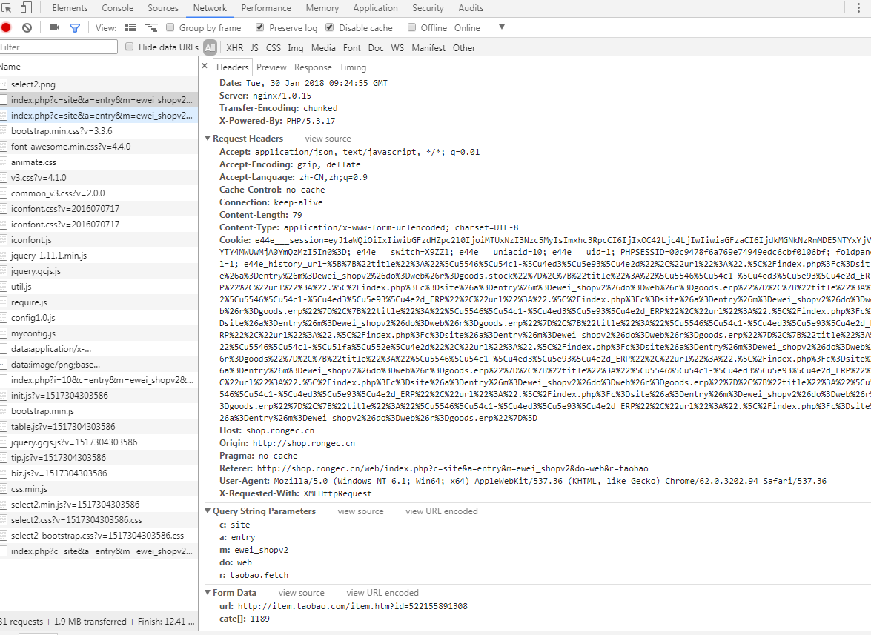

接口：

<http://shop.rongec.cn/web/index.php?c=site&a=entry&m=ewei_shopv2&do=web&r=taobao.fetch>

D:\www\users\wc.jieqiangtec.com\addons\ewei_shopv2\plugin\taobao\core\web\index.php

fetch

D:\www\users\wc.jieqiangtec.com\addons\ewei_shopv2\plugin\taobao\core\model.php

get_item_taobao

D:\www\users\wc.jieqiangtec.com\addons\ewei_shopv2\plugin\taobao\core\model.php L542

save_taobao_goods(

仓库中：

<http://shop.rongec.cn/web/index.php?c=site&a=entry&m=ewei_shopv2&do=web&r=goods.stock>

确定上架：

<http://shop.rongec.cn/web/index.php?c=site&a=entry&m=ewei_shopv2&do=web&r=goods.status&status=1&id=224>

2018-01-29 16:44:26 TODO debug3 runtime=0.044s ：来源:

http://shop.rongec.cn/web/index.php?c=site&a=entry&m=ewei_shopv2&do=web&r=taobao.fetch

------------

Array:

file : db.class.php query() ;

sql2 : INSERT INTO `ims_ewei_shop_goods` SET `uniacid` = '10' , `merchid` = '0' , `checked` = '' , `catch_source` = 'taobao' , `catch_id` = '522155891308' , `catch_url` = 'http://item.taobao.com/item.htm?id=522155891308' , `title` = '【限时低价抢】Apple/苹果 iPhone 6s 32G 全网通4G智能手机' , `total` = '0' , `marketprice` = '' , `pcate` = '1188' , `ccate` = '0' , `tcate` = '0' , `cates` = '1188' , `sales` = '45' , `createtime` = '1517215465' , `updatetime` = '1517215465' , `hasoption` = '1' , `status` = '0' , `deleted` = '0' , `buylevels` = '' , `showlevels` = '' , `buygroups` = '' , `showgroups` = '' , `noticeopenid` = '' , `storeids` = '' , `merchsale` = '1' , `discounts` = '{"type":"0","default":"","default_pay":""}' , `thumb` = 'images/10/2018/01/U6f576OZf2O584tr9IN52lN4Qol2EOtO.jpg' , `thumb_url` = 'images/10/2018/01/U6f576OZf2O584tr9IN52lN4Qol2EOtO.jpg'_url ;

$params ==Array:

:uniacid : 10 ;

:merchid : 0 ;

:checked : ;

:catch_source : taobao ;

:catch_id : 522155891308 ;

:catch_url : http://item.taobao.com/item.htm?id=522155891308 ;

:title : 【限时低价抢】Apple/苹果 iPhone 6s 32G 全网通4G智能手机 ;

:total : 0 ;

:marketprice : ;

:pcate : 1188 ;

:ccate : 0 ;

:tcate : 0 ;

:cates : 1188 ;

:sales : 45 ;

:createtime : 1517215465 ;

:updatetime : 1517215465 ;

:hasoption : 1 ;

:status : 0 ;

:deleted : 0 ;

:buylevels : ;

:showlevels : ;

:buygroups : ;

:showgroups : ;

:noticeopenid : ;

:storeids : ;

:merchsale : 1 ;

:discounts : {"type":"0","default":"","default_pay":""} ;

:thumb : images/10/2018/01/U6f576OZf2O584tr9IN52lN4Qol2EOtO.jpg ;

:thumb_url : a:4:{i:0;s:54:"images/10/2018/01/OxO0uuij370h1limx0I17UA1AMme0LEL.jpg";i:1;s:54:"images/10/2018/01/WAN1alE5z7EQe5EhaonwaN1O6zaATal6.jpg";i:2;s:54:"images/10/2018/01/RW76y1LZXC1s19L1DDZl288s6l1swHdw.jpg";i:3;s:54:"images/10/2018/01/it6qBT7QJvvg60BO6L5USVO2Sb25Nz5L.png";} ;

## 商城

addons\ewei_shopv2\core\model\system.php

addons\ewei_shopv2\core\web\goods\index.php

doc\品牌管理.docx

doc\微橙微信开发日志20170901.docx

添加一个模块：

Erp商品

<http://shop.rongec.cn/web/index.php?c=site&a=entry&m=ewei_shopv2&do=web&r=goods.erp>

$list[$key]['title'] = $value['name'];  
$list[$key]['catch_source'] = 'erp';  
$list[$key]['catch_id'] = $value['id'];  
$list[$key]['catch_url'] = $value['name'];  
  
$list[$key]['uniacid'] = $value['name'];  
$list[$key]['merchid'] = $value['name'];  
$list[$key]['checked'] = $value['name'];  
  
$list[$key]['total'] = $value['name'];  
$list[$key]['marketprice'] = $value['name'];  
$list[$key]['pcate'] = $value['name'];  
$list[$key]['ccate'] = $value['name'];  
$list[$key]['tcate'] = $value['name'];  
$list[$key]['sales'] = $value['name'];  
$list[$key]['createtime'] = $value['name'];  
$list[$key]['updatetime'] = $value['name'];  
$list[$key]['hasoption'] = $value['name'];  
$list[$key]['status'] = $value['name'];  
$list[$key]['deleted'] = $value['name'];  
$list[$key]['buylevels'] = $value['name'];  
$list[$key]['showlevels'] = $value['name'];  
$list[$key]['buygroups'] = $value['name'];  
$list[$key]['showgroups'] = $value['name'];  
$list[$key]['noticeopenid'] = $value['name'];  
$list[$key]['storeids'] = $value['name'];  
$list[$key]['merchsale'] = $value['name'];  
$list[$key]['discounts'] = $value['name'];  
$list[$key]['thumb'] = $value['name'];  
$list[$key]['thumb_url'] = $value['name'];

if (!empty($total)) {  
 */*$sql = 'SELECT g.* FROM ' . tablename('ewei_shop_goods') . 'g' . $sqlcondition . $condition . $groupcondition . " ORDER BY g.`status` DESC, g.`displayorder` DESC,\r\n g.`id` DESC LIMIT " . (($pindex - 1) * $psize) . ',' . $psize;*/* $list = $res['productList'];  
 *// var_dump($list);exit;* foreach ($list as $key => &$value) {  
 */*$url = mobileUrl('goods/detail', array('id' => $value['id']), true);  
 $value['qrcode'] = m('qrcode')->createQrcode($url);*/* $list[$key]['title'] = $value['name'];  
 $list[$key]['catch_source'] = 'erp';  
 $list[$key]['catch_id'] = $value['id'];  
 $list[$key]['catch_url'] = 'erp';  
  
 $list[$key]['uniacid'] = $_W['uniacid'];  
 $list[$key]['merchid'] = $_W['merchid'];  
 $list[$key]['checked'] = '';  
  
 *// 价格* $list[$key]['total'] = 0;  
 $list[$key]['marketprice'] = $value['market_price'];  
 $list[$key]['cost_price'] = $value['cost_price'];  
 $list[$key]['pcate'] = $value['cid'];  
 $list[$key]['ccate'] = $value['cid'];  
 $list[$key]['tcate'] = $value['cid'];  
 $list[$key]['sales'] = $value['sales'];  
 $list[$key]['createtime'] = $value['add_time'];  
 $list[$key]['updatetime'] = $value['updatetime'];  
 $list[$key]['hasoption'] = $value['hasoption'];  
 $list[$key]['status'] = '0';  
 $list[$key]['deleted'] = '0';  
 $list[$key]['buylevels'] = $value['buylevels'];  
 $list[$key]['showlevels'] = $value['showlevels'];  
 $list[$key]['buygroups'] = $value['buygroups'];  
 $list[$key]['showgroups'] = $value['showgroups'];  
 $list[$key]['noticeopenid'] = $value['noticeopenid'];  
 $list[$key]['storeids'] = $value['storeids'];  
 $list[$key]['merchsale'] = $value['merchsale'];  
 $list[$key]['discounts'] = $value['discounts'];  
 $list[$key]['thumb'] = $value['image_source_url'];  
 $list[$key]['thumb_url'] = $value['image_source_url'];  
  
 }  
 $psize = $res['onePage'];  
 $pager = pagination2($total, $pindex, $psize);  
  
 */*if ($merch_plugin) {  
 $merch_user = $merch_plugin->getListUser($list, 'merch_user');  
 if (!empty($list) && !empty($merch_user)) {  
 foreach ($list as &$row) {  
 $row['merchname'] = $merch_user[$row['merchid']]['merchname'] ? $merch_user[$row['merchid']]['merchname'] : $_W['shopset']['shop']['name'];  
 }  
 }  
 }*/*}

## Erp:

admin\app\Front.inc.php

admin\app\module\product\edit.php

admin\app\module\product\list.php

开放两个接口：

1. 商品列表

<http://erp.rongec.cn/admin/index.php?mod=product.list&api=1>

1. 商品详情

<http://erp.rongec.cn/admin/index.php?mod=product.edit&id=12875&cid=0&api=1>

**array** *(size=33)*

'id' => string '12875' *(length=5)*

'cid' => string '2101' *(length=4)*

'name' => string '测试数码产品' *(length=18)*

'supplier_now' => string '462' *(length=3)*

'summary' => string '测试数码产品简介' *(length=24)*

'price' => null

'market_price' => string '1299.00' *(length=7)*

'cost_price' => string '999.00' *(length=6)*

'brand_id' => string '0' *(length=1)*

'image_list' => string '0' *(length=1)*

'add_time' => string '1515940978' *(length=10)*

'update_time' => string '1515940978' *(length=10)*

'supplier_id' => string '' *(length=0)*

'weight' => string '0.0000' *(length=6)*

'buy_attribute_template_id' => string '-1' *(length=2)*

'import_pid' => null

'import_category' => null

'user_id' => string '162' *(length=3)*

'user_name' => string 'admin' *(length=5)*

'user_real_name' => string 'admin' *(length=5)*

'manager_user_id' => string '0' *(length=1)*

'manager_user_name' => string '' *(length=0)*

'manager_user_real_name' => string '' *(length=0)*

'board' => string '1' *(length=1)*

'scope' => null

'image_list_url' => string './resource/product_picture/7/5/12875_list.jpg' *(length=45)*

'image_grid_url' => string './resource/product_picture/7/5/12875_grid.jpg' *(length=45)*

'image_source_url' => string './resource/product_picture/7/5/12875_source.jpg' *(length=47)*

'sort_name' => string '测试数码产品' *(length=18)*

'sort_summary' => string '测试数码产品简介' *(length=24)*

'seo_uri' => string '-_' *(length=2)*

'detail_link' => string '/product/detail-12875.html' *(length=26)*

'detail_link_seo' => string '/product/-_detail-12875.html' *(length=28)*

2018-01-29 16:44:26 TODO debug3 runtime=0.045s ：来源:

http://shop.rongec.cn/web/index.php?c=site&a=entry&m=ewei_shopv2&do=web&r=taobao.fetch

------------

Array:

file : db.class.php query() ;

sql2 : INSERT INTO `ims_ewei_shop_goods_param` SET `uniacid` = '10' , `goodsid` = '223' , `title` = 'CPU品牌' , `value` = 'Apple/苹果' , `displayorder` = '0' ;

$params ==Array:

:uniacid : 10 ;

:goodsid : 223 ;

:title : CPU品牌 ;

:value : Apple/苹果 ;

:displayorder : 0 ;

2018-01-29 16:44:26 TODO debug3 runtime=0.044s ：来源:

http://shop.rongec.cn/web/index.php?c=site&a=entry&m=ewei_shopv2&do=web&r=taobao.fetch

------------

Array:

file : db.class.php query() ;

sql2 : INSERT INTO `ims_ewei_shop_goods_param` SET `uniacid` = '10' , `goodsid` = '223' , `title` = 'CPU型号' , `value` = '其他' , `displayorder` = '1' ;

$params ==Array:

:uniacid : 10 ;

:goodsid : 223 ;

:title : CPU型号 ;

:value : 其他 ;

:displayorder : 1 ;

2018-01-29 16:44:29 TODO debug3 runtime=0.049s ：来源:

http://shop.rongec.cn/web/index.php?c=site&a=entry&m=ewei_shopv2&do=web&r=taobao.fetch

------------

Array:

file : db.class.php query() ;

sql2 : INSERT INTO `ims_ewei_shop_goods_spec` SET `uniacid` = '10' , `goodsid` = '223' , `title` = '网络类型' , `displayorder` = '0' , `propId` = '10004' ;

$params ==Array:

:uniacid : 10 ;

:goodsid : 223 ;

:title : 网络类型 ;

:displayorder : 0 ;

:propId : 10004 ;

2018-01-29 16:44:29 TODO debug3 runtime=0.045s ：来源:

http://shop.rongec.cn/web/index.php?c=site&a=entry&m=ewei_shopv2&do=web&r=taobao.fetch

------------

Array:

file : db.class.php query() ;

sql2 : INSERT INTO `ims_ewei_shop_goods_spec_item` SET `uniacid` = '10' , `specid` = '108' , `title` = '无需合约版' , `thumb` = '' , `valueId` = '709990523' , `show` = '1' , `displayorder` = '0' ;

$params ==Array:

:uniacid : 10 ;

:specid : 108 ;

:title : 无需合约版 ;

:thumb : ;

:valueId : 709990523 ;

:show : 1 ;

:displayorder : 0 ;

2018-01-29 16:44:31 TODO debug3 runtime=0.043s ：来源:

http://shop.rongec.cn/web/index.php?c=site&a=entry&m=ewei_shopv2&do=web&r=taobao.fetch

------------

Array:

file : db.class.php query() ;

sql2 : INSERT INTO `ims_ewei_shop_goods_option` SET `uniacid` = '10' , `displayorder` = '2' , `goodsid` = '223' , `title` = '无需合约版+深空灰色+官方标配+32GB' , `specs` = '317_321_322_323' , `stock` = '0' , `marketprice` = '4588.00' , `skuId` = '3426488195544' ;

$params ==Array:

:uniacid : 10 ;

:displayorder : 2 ;

:goodsid : 223 ;

:title : 无需合约版+深空灰色+官方标配+32GB ;

:specs : 317_321_322_323 ;

:stock : 0 ;

:marketprice : 4588.00 ;

:skuId : 3426488195544 ;