#### Scope 参数错误或没有 Scope 权限

https://open.weixin.qq.com/connect/oauth2/authorize?appid=wx606b4470e54ff82d&redirect_uri=http%3A%2F%2Fwd.jieqiangtec.com%2Fapp%2Findex.php%3Fi%3D4%26c%3Dauth%26a%3Doauth%26scope%3Dsnsapi_base&response_type=code&scope=snsapi_base&state=we7sid-d2dac648acde014841179e6e03cb7c54#wechat_redirect

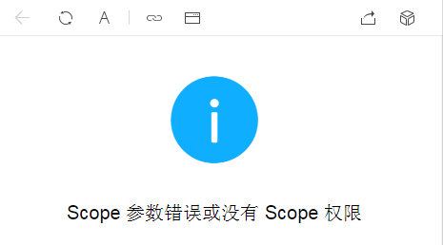

商城报错20170222

<http://wd.jieqiangtec.com/app/index.php?i=4&c=entry&p=cart&mid=1&do=shop&m=ewei_shop>

数据导入报错：Got a packet bigger than‘max_allowed_packet’bytes的问题

<http://www.2cto.com/database/201204/127371.html>

2个解决方法：

1.临时修改：[mysql](http://www.2cto.com/database/MySQL/" \t "http://www.2cto.com/database/201204/_blank)>set global max_allowed_packet=524288000;修改 #512M

2.修改my.cnf，需重启mysql。  www.2cto.com

  在 [MySQLd] 部分添加一句（如果存在，调整其值就可以）：

  max_allowed_packet=10M

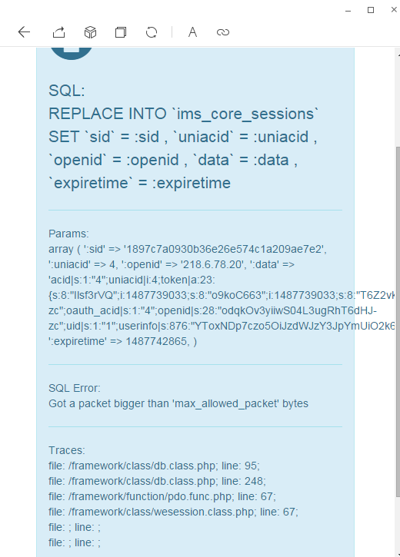  
SQL:   
REPLACE INTO `ims_core_sessions` SET `sid` = :sid , `uniacid` = :uniacid , `openid` = :openid , `data` = :data , `expiretime` = :expiretime

Params:   
array ( ':sid' => '1897c7a0930b36e26e574c1a209ae7e2', ':uniacid' => 4, ':openid' => '218.6.78.20', ':data' => 'acid|s:1:"4";uniacid|i:4;token|a:23:{s:8:"Ilsf3rVQ";i:1487739033;s:8:"o9koC663";i:1487739033;s:8:"T6Z2vkXO";i:1487739034;s:8:"b279bY4W";i:1487739035;s:8:"RewJQZQv";i:1487739035;s:8:"MKX8dZKk";i:1487739035;s:8:"k0o4nK08";i:1487739054;s:8:"Dzsn0Tg6";i:1487739059;s:8:"G1Q39HO2";i:1487739220;s:8:"szXjcPbj";i:1487739220;s:8:"mg8Kjg3S";i:1487739220;s:8:"YtyY7vJU";i:1487739220;s:8:"bjY9rBSG";i:1487739222;s:8:"DNqRq3fn";i:1487739222;s:8:"x6hjqSHm";i:1487739234;s:8:"zp9lndl7";i:1487739234;s:8:"YXlHRs26";i:1487739234;s:8:"UoXdxkgF";i:1487739234;s:8:"sZ7T7X4n";i:1487739236;s:8:"L4n5465B";i:1487739240;s:8:"AcydBm21";i:1487739240;s:8:"o2nOZ102";i:1487739240;s:8:"P9er7SCU";i:1487739265;}dest_url|s:111:"http%3A%2F%2Fwd.jieqiangtec.com%2Fapp%2Findex.php%3Fi%3D4%26c%3Dentry%26do%3Dshop%26m%3Dewei_shop%26winzoom%3D1";oauth_openid|s:28:"odqkOv3yiiwS04L3ugRhT6dHJ-zc";oauth_acid|s:1:"4";openid|s:28:"odqkOv3yiiwS04L3ugRhT6dHJ-zc";uid|s:1:"1";userinfo|s:876:"";', ':expiretime' => 1487742865, )

SQL Error:   
Got a packet bigger than 'max_allowed_packet' bytes

Traces:   
file: /framework/class/db.class.php; line: 95;   
file: /framework/class/db.class.php; line: 248;   
file: /framework/function/pdo.func.php; line: 67;   
file: /framework/class/wesession.class.php; line: 67;   
file: ; line: ;   
file: ; line: ;

[[点击这里返回上一页](http://wd.jieqiangtec.com/app/javascript:history.go(-1);)]