微橙微信

赵六的推广链接：

<http://shop.rongec.com/app/index.php?i=6&c=entry&m=ewei_shopv2&do=mobile&r=goods.detail&id=204&sid=22&item_id=204&commission_id=21&con_id=&shop_id=11&bank_id=12&bank_subid=14>

点击立即支付，和cps发生订单关系

<http://shop.rongec.com/app/index.php?i=6&c=entry&m=ewei_shopv2&do=mobile&r=order.pay&id=195&wxref=mp.weixin.qq.com#wechat_redirect>

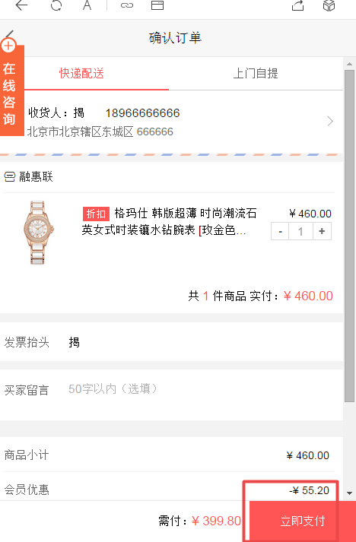

**后台管理演示：  [888.v-888.com](alires:///offlinepkg/ww/recent/src/888.v-888.com" \t "_blank)   admin888 admin888  
演示公众号：  
微橙人人店，微，信号:huanlenc  
pc商城展示页：  [http://77.v-888.com](http://77.v-888.com/" \t "_blank)    
您需要有认证服务号+微,信支付才可以使用的**

Pc首页:

<http://wx.adjyc.com/app/index.php?i=6&c=entry&m=ewei_shopv2&do=mobile&r=pc>

string 'D:/www/users/wc.jieqiangtec.com/app/source/entry/site.ctrl.php' (length=62)

Wap首页:

<http://wx.adjyc.com/app/index.php?i=6&c=entry&m=ewei_shopv2&do=mobile>

版本更新：

<http://shop.rongec.com/web/index.php?c=site&a=entry&m=ewei_shopv2&do=web&r=system.auth.upgrade>

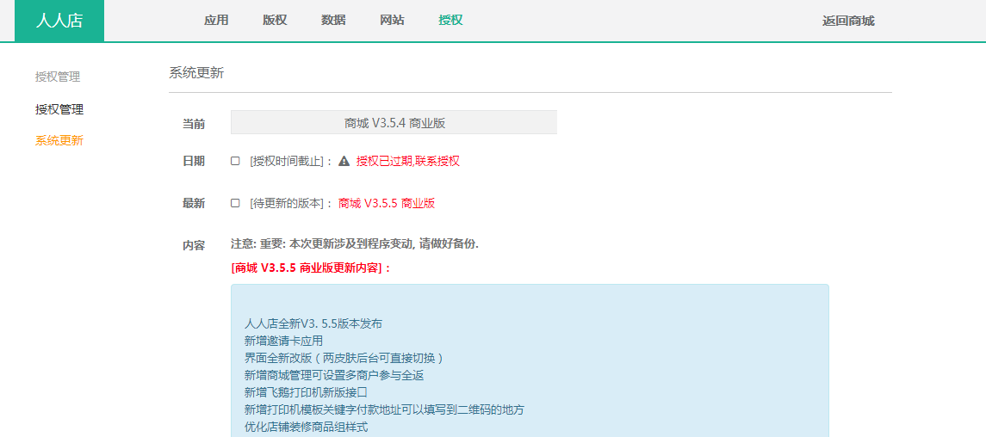

<http://gx.v-888.com/forum.php?mod=viewthread&tid=865&extra=page%3D1>

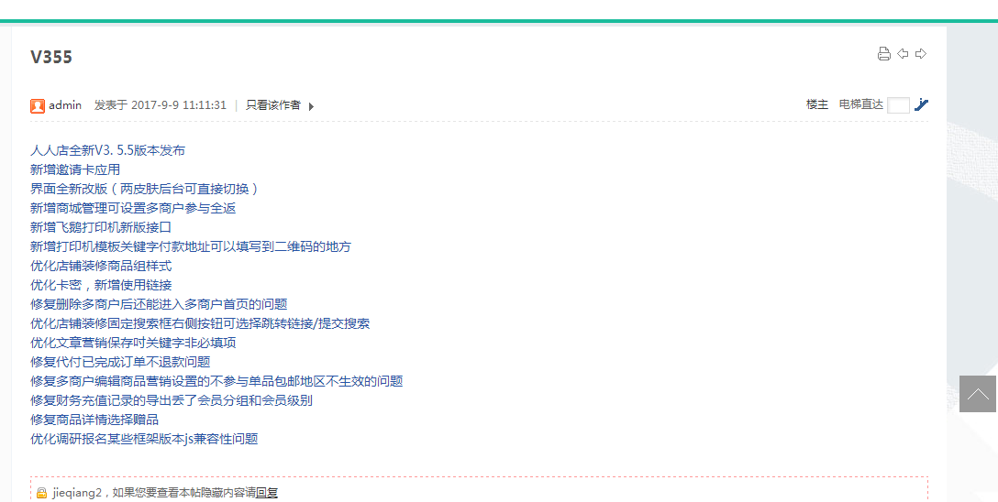

# **常用文件修改路径**

<http://gx.v-888.com/forum.php?mod=viewthread&tid=371&extra=page%3D1>

jieqiang

jieqiang0830

# 上线

查看备份文件是否成功(文件列表是否和update.lst一致，除新增文件外)

tar ztvf /data/backups/20170615-18-02-30.tar.gz

root@roohl wc.jieqiangtec.com]# tar ztvf /data/backups/wc.jieqiangtec.com/20180130-23-15-49.tar.gz

#一品威客还原备份

#sudo tar zxvf /data/backups/wc.jieqiangtec.com/20180130-23-15-49.tar.gz -C /www/docs/wc.jieqiangtec.com

控制器

D:\www\users\wc.jieqiangtec.com\web\source\profile\payment.ctrl.php

模板页

D:\www\users\wc.jieqiangtec.com\web\themes\default\profile\payment.html

本帖隐藏的内容

默认会员中心  addons\ewei\_shopv2\template\mobile\color\member       index.html               addons\ewei\_shopv2\template\mobile\default\member    index.html  
  
自定义会员中心    addons\ewei\_shopv2\plugin\diypage\template\mobile\default\template    tpl\_member.html  
  
默认会员中心底部菜单   addons\ewei\_shopv2\template\mobile\color   \_menu.html   
                               addons\ewei\_shopv2\template\mobile\default    \_menu.html  
  
默认分销中心    addons\ewei\_shopv2\plugin\commission\template\mobile\default     index.html  
  
默认分销中心底部菜单  addons\ewei\_shopv2\plugin\commission\template\mobile\default   \_menu.html  
  
默认产品详情页   addons\ewei\_shopv2\template\mobile\color\goods    detail.html                             addons\ewei\_shopv2\template\mobile\default\goods    detail.html

http://wx.adjyc.com/web/index.php?c=user&a=profile&

admin

admin0830

adjyc

adjyc888

jieqiang

jieqiang888

# 数据库

用户表

ims\_ewei\_shop\_member

# 调试

**程序执行文件流程**:

$traces = debug\_backtrace();

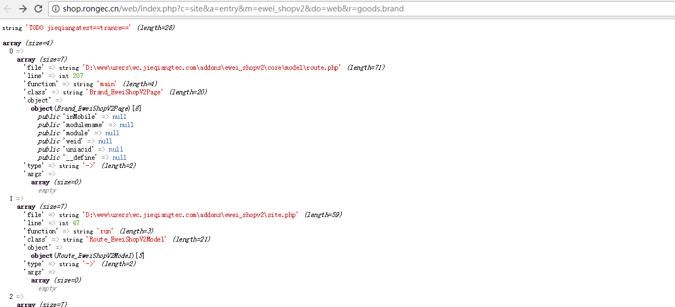

WeUtility::logging('TODO debug23', array('file'=>'D:\www\users\wd2.jieqiangtec.com\addons\ewei\_shop\core\mobile\order\confirm.php ','sql2'=>$sql2,'prom'=>$\_SESSION['prom']));

var\_dump('TODO jieqiangtest==D:\www\users\wc.jieqiangtec.com\addons\ewei\_shopv2\plugin\pc\core\mobile\account\index.php==',is\_weixin(),$\_GPC['\_\_ewei\_shopv2\_member\_session\_' . $\_W['uniacid']]);**exit**;

D:\www\users\wc.jieqiangtec.com\addons\ewei\_shopv2\defines.php

define('EWEI\_SHOPV2\_DEBUG', **false**);

D:\www\users\wc.jieqiangtec.com\addons\ewei\_shopv2\core\inc\functions.php

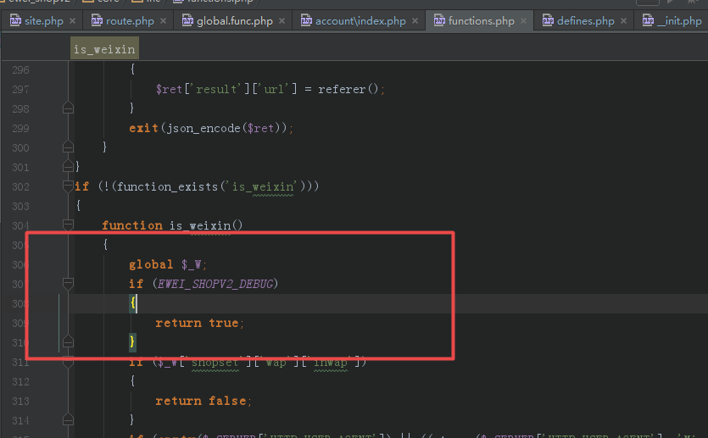

1.和银行的价格

2.权限问题

3.供应商

4.导出条数限制

**5.erp和商城对接的时间评估**

**erp和商城接口需写好相关接口说明文档：包括表结构、后台导入和客户端excel导入模板等说明，希望周二前完成**

**:**

**商品的品牌上次回退弄没了吧?**

**:**

**添加商品中：http://shop.rongec.com/web/index.php?c=site&a=entry&m=ewei\_shopv2&do=web&r=goods.add**

**和品牌管理中：http://shop.rongec.com/web/index.php?c=site&a=entry&m=ewei\_shopv2&do=web&r=goods**

# **请在微信客户端打开链接**

D:\www\users\wc.jieqiangtec.com\addons\ewei\_shopv2\core\model\member.php L350

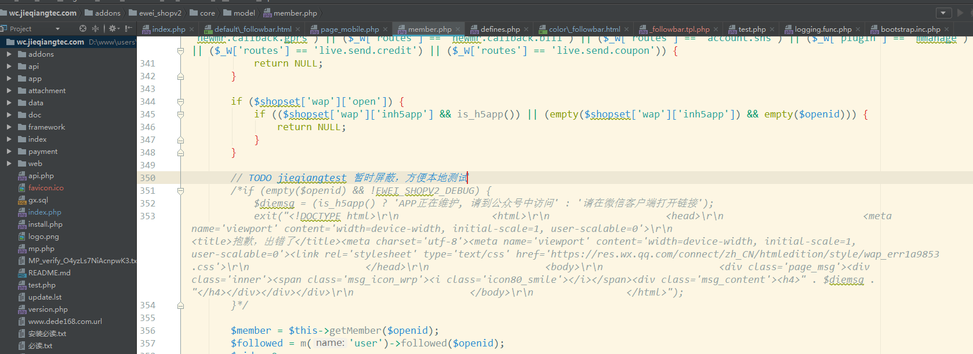

## 模块绑定

SELECT \* FROM `ims\_modules\_bindings` ORDER BY `eid` DESC LIMIT 0, 1000

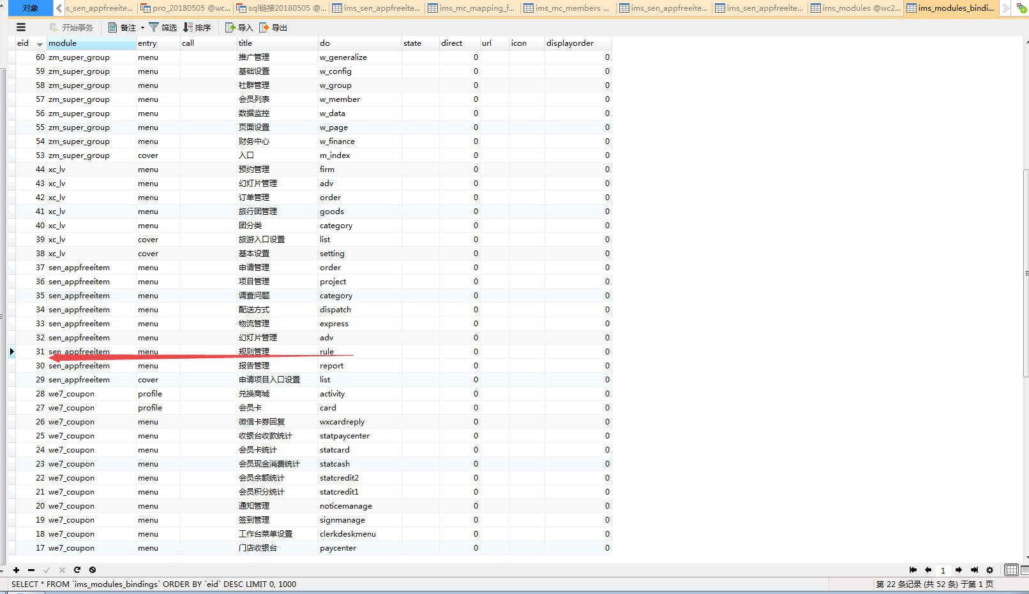

D:\www\users\wc.jieqiangtec.com\web\source\site\entry.ctrl.php 12

入口调度

load()->model('module');  
load()->model('extension');  
  
$eid = *intval*($\_GPC['eid']);  
  
  
if (!empty($eid)) {  
 $entry = module\_entry($eid);  
} else {  
 $entry = pdo\_get('modules\_bindings', array('module' => *trim*($\_GPC['m']), 'do' => *trim*($\_GPC['do'])));  
 if (empty($entry)) {  
 $entry = array(  
 'module' => $\_GPC['m'],  
 'do' => $\_GPC['do'],  
 'state' => $\_GPC['state'],  
 'direct' => $\_GPC['direct']  
 );  
 }  
}  
if (empty($entry) || empty($entry['do'])) {  
 itoast('非法访问.', '', '');  
}

# **20180505**

样式渲染问题

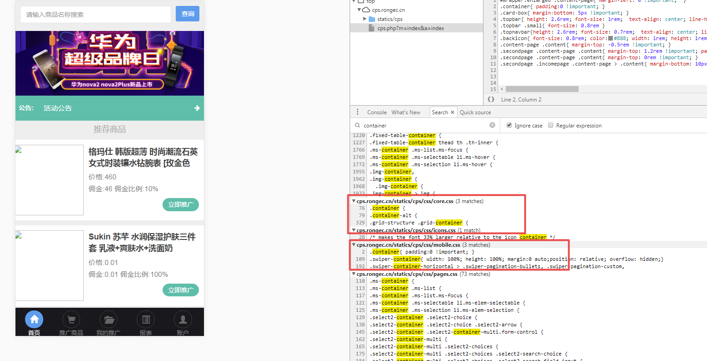

lisi a123456，志伟为什么加载的时候会从右侧开始呢？

<http://cps.rongec.com/cps.php?m=index&a=index>

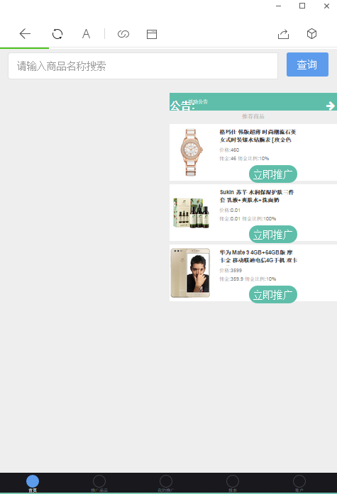

# **20180422**

个人中心

<http://shop.rongec.com/app/index.php?i=10&c=entry&m=ewei_shopv2&do=mobile&r=member>

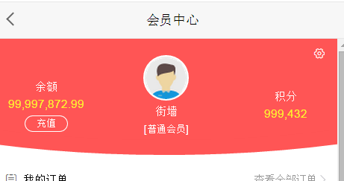

99,997,872.99

付完99

99,997,773.99

会员中心

余额

99,997,872.99

[充值](http://shop.rongec.com/app/index.php?i=10&c=entry&m=ewei_shopv2&do=mobile&r=member.recharge)

[IMG_256](http://shop.rongec.com/app/index.php?i=10&c=entry&m=ewei_shopv2&do=mobile&r=member.info.face)

[街墙](http://shop.rongec.com/app/index.php?i=10&c=entry&m=ewei_shopv2&do=mobile&r=member.info.face)

[普通会员]

积分

99

D:\www\docs\epweike.me\lib\inc\keke\_base\_class.php L150

message('包含敏感词'.$res, referer(), "error");

*// 检测敏感词*function check\_work($key = '',$content = ''){  
 $user\_arr = *explode*('|', $key);  
 $r = array();  
 foreach ($user\_arr as $value) {  
 if (*strpos*($content, $value) !== false){  
 $r[] = $value;  
 }  
 }  
 if ($r){  
 return *implode*(",", $r);  
 }else {  
 return false;  
 }  
}

$ban\_res = kekezu::check\_work('小姐|吸毒','小姐222');  
*var\_dump*('$ban\_res==',$ban\_res);exit;

class keke\_base\_class {  
 */\*\*  
 \* 方法功能的描述与说明  
 \* 返回具体关键字  
 \*/* static function check\_work($key = '',$content = ''){  
 $user\_arr = *explode*('|', $key);  
 $r = array();  
 foreach ($user\_arr as $value) {  
 if (*strpos*($content, $value) !== false){  
 $r[] = $value;  
 }  
 }  
 if ($r){  
 return *implode*(",", $r);  
 }else {  
 return false;  
 }  
 }

kekezu::ban\_forbid($\_r);

$\_R = kekezu::k\_input($\_REQUEST);

ban\_forbid

inner\_checkban

*// #42637 发布任务的时候，标题或者内容包含有敏感字，需要直接指出哪些是敏感字*$check = self::check\_work($ban\_content,$v);

*// #42637 发布任务的时候，标题或者内容包含有敏感字，需要直接指出哪些是敏感字*$check = self::check\_work($ban\_content,$v);  
*var\_dump*('todo==',1112,$check);exit;  
$warn = '输入中包含敏感字:'.$check.',请重新输入';

static function check\_work($key = '',$content = ''){  
 $user\_arr = *explode*('|', $key);  
 $r = array();  
 foreach ($user\_arr as $value) {  
 if (*strpos*($content, $value) !== false){  
 $r[] = $value;  
 }  
 }  
 if ($r){  
 return *implode*(",", $r);  
 }else {  
 return false;  
 }  
}

D:\www\docs\epweike.me\lib\inc\keke\_base\_class.php L97

*/\*\*  
 \* 挡住非法关键字  
 \** ***@param*** *mix $content 要过滤的内容  
 \** ***@param*** *string $output normal正常输出，boolean输出，json  
 \*/*static public function ban\_forbid($content, $output = 'normal') {  
 global $kekezu;  
 *//过滤敏感字,暂时不把用户中心发送站内信写进来，以后再修改* if ($kekezu->\_sys\_config['ban\_content'] && $content) {  
 $result = self::inner\_checkban($content, $kekezu->\_sys\_config['ban\_content'], $output);  
 if ($result === false) {  
 return false;  
 }  
 } else {  
 return true;  
 }  
}

D:\www\users\wc.jieqiangtec.com\addons\ewei\_shopv2\plugin\creditshop\template\web\_v3\set\tab\_comment.html

<http://shop.rongec.cn/web/index.php?c=site&a=entry&m=ewei_shopv2&do=web&r=creditshop.set>

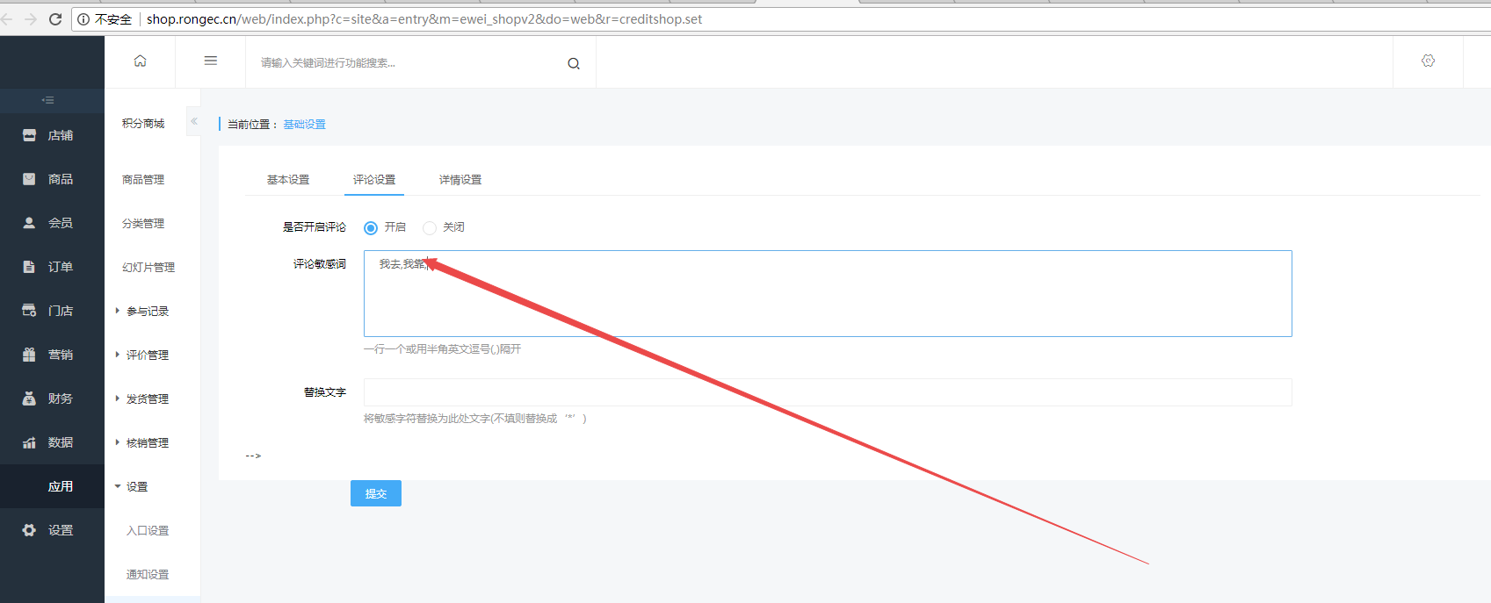

D:\www\users\wc.jieqiangtec.com\addons\ewei\_shopv2\plugin\creditshop\core\mobile\detail.php

$logtotal = 0;  
$logtotal = pdo\_fetchcolumn('select *count*(1) from ' . tablename('ewei\_shop\_creditshop\_log') . ' where uniacid = ' . $uniacid . ' and goodsid = ' . $id . ' and status > 0 ');  
$replys = array();  
$replys = pdo\_fetchall('select *\** from ' . tablename('ewei\_shop\_creditshop\_comment') . "**\r\n** where uniacid = " . $uniacid . ' and goodsid = ' . $id . ' and checked = 1 and deleted = 0 order by `time` desc limit 2 ');  
$replykeywords = *explode*(',', $set['desckeyword']);  
$replykeystr = *trim*($set['replykeyword']);  
  
if (empty($replykeystr)) {  
 $replykeystr = '\*\*';  
}  
  
foreach ($replys as $key => $value) {  
 foreach ($replykeywords as $k => $val) {  
 if (!empty($value['content'])) {  
 if (!*strstr*($val, $value['content'])) {  
 $value['content'] = *str\_replace*($val, $replykeystr, $value['content']);  
 }  
 }  
  
 if (!empty($value['reply\_content'])) {  
 if (!*strstr*($val, $value['reply\_content'])) {  
 $value['reply\_content'] = *str\_replace*($val, $replykeystr, $value['reply\_content']);  
 }  
 }  
  
 if (!empty($value['append\_content'])) {  
 if (!*strstr*($val, $value['append\_content'])) {  
 $value['append\_content'] = *str\_replace*($val, $replykeystr, $value['append\_content']);  
 }  
 }  
  
 if (!empty($value['append\_reply\_content'])) {  
 if (!*strstr*($val, $value['append\_reply\_content'])) {  
 $value['append\_reply\_content'] = *str\_replace*($val, $replykeystr, $value['append\_reply\_content']);  
 }  
 }  
 }  
  
 $replys[$key]['content'] = $value['content'];  
 $replys[$key]['reply\_content'] = $value['reply\_content'];  
 $replys[$key]['append\_content'] = $value['append\_content'];  
 $replys[$key]['append\_reply\_content'] = $value['append\_reply\_content'];  
 $replys[$key]['time\_str'] = *date*('Y/m/d', $value['time']);  
 $replys[$key]['images'] = set\_medias(iunserializer($value['images']));  
 $replys[$key]['reply\_images'] = set\_medias(iunserializer($value['reply\_images']));  
 $replys[$key]['append\_images'] = set\_medias(iunserializer($value['append\_images']));  
 $replys[$key]['append\_reply\_images'] = set\_medias(iunserializer($value['append\_reply\_images']));  
 $replys[$key]['nickname'] = cut\_str($value['nickname'], 1, 0) . '\*\*' . cut\_str($value['nickname'], 1, -1);  
 $replys[$key]['content'] = *str\_replace*('=', '\*\*', $value['content']);  
}  
  
$replytotal = 0;  
$replytotal = pdo\_fetchcolumn('select *count*(1) from ' . tablename('ewei\_shop\_creditshop\_comment') . "**\r\n** where uniacid = " . $uniacid . ' and goodsid = ' . $id . ' and checked = 1 and deleted = 0 order by `time` desc ');

2018-04-25 20:01:21 TODO debug3 runtime=0.043s ：来源:

http://shop.rongec.cn/web/index.php?c=site&a=entry&m=ewei\_shopv2&do=web&r=creditshop.set

------------

Array:

file : db.class.php query() ;

sql2 : UPDATE `ims\_ewei\_shop\_sysset` SET `plugins` = 'a:1:{s:10:"creditshop";a:20:{s:12:"set\_realname";i:0;s:10:"set\_mobile";i:0;s:15:"exchangekeyword";s:0:"";s:8:"sendname";s:0:"";s:7:"wishing";s:0:"";s:10:"centeropen";s:1:"0";s:9:"followurl";s:0:"";s:9:"crediturl";s:0:"";s:11:"share\_title";s:0:"";s:10:"share\_icon";s:0:"";s:10:"share\_desc";s:0:"";s:15:"importantdetail";s:0:"";s:7:"isreply";s:1:"1";s:11:"desckeyword";s:17:"我去,我靠,222";s:12:"replykeyword";s:0:"";s:8:"isdetail";i:0;s:6:"detail";s:0:"";s:14:"isnoticedetail";i:0;s:12:"noticedetail";s:0:"";s:5:"style";s:7:"default";}}' WHERE `id` = '14' ;

$params ==Array:

:plugins : a:1:{s:10:"creditshop";a:20:{s:12:"set\_realname";i:0;s:10:"set\_mobile";i:0;s:15:"exchangekeyword";s:0:"";s:8:"sendname";s:0:"";s:7:"wishing";s:0:"";s:10:"centeropen";s:1:"0";s:9:"followurl";s:0:"";s:9:"crediturl";s:0:"";s:11:"share\_title";s:0:"";s:10:"share\_icon";s:0:"";s:10:"share\_desc";s:0:"";s:15:"importantdetail";s:0:"";s:7:"isreply";s:1:"1";s:11:"desckeyword";s:17:"我去,我靠,222";s:12:"replykeyword";s:0:"";s:8:"isdetail";i:0;s:6:"detail";s:0:"";s:14:"isnoticedetail";i:0;s:12:"noticedetail";s:0:"";s:5:"style";s:7:"default";}} ;

:\_\_id : 14 ;

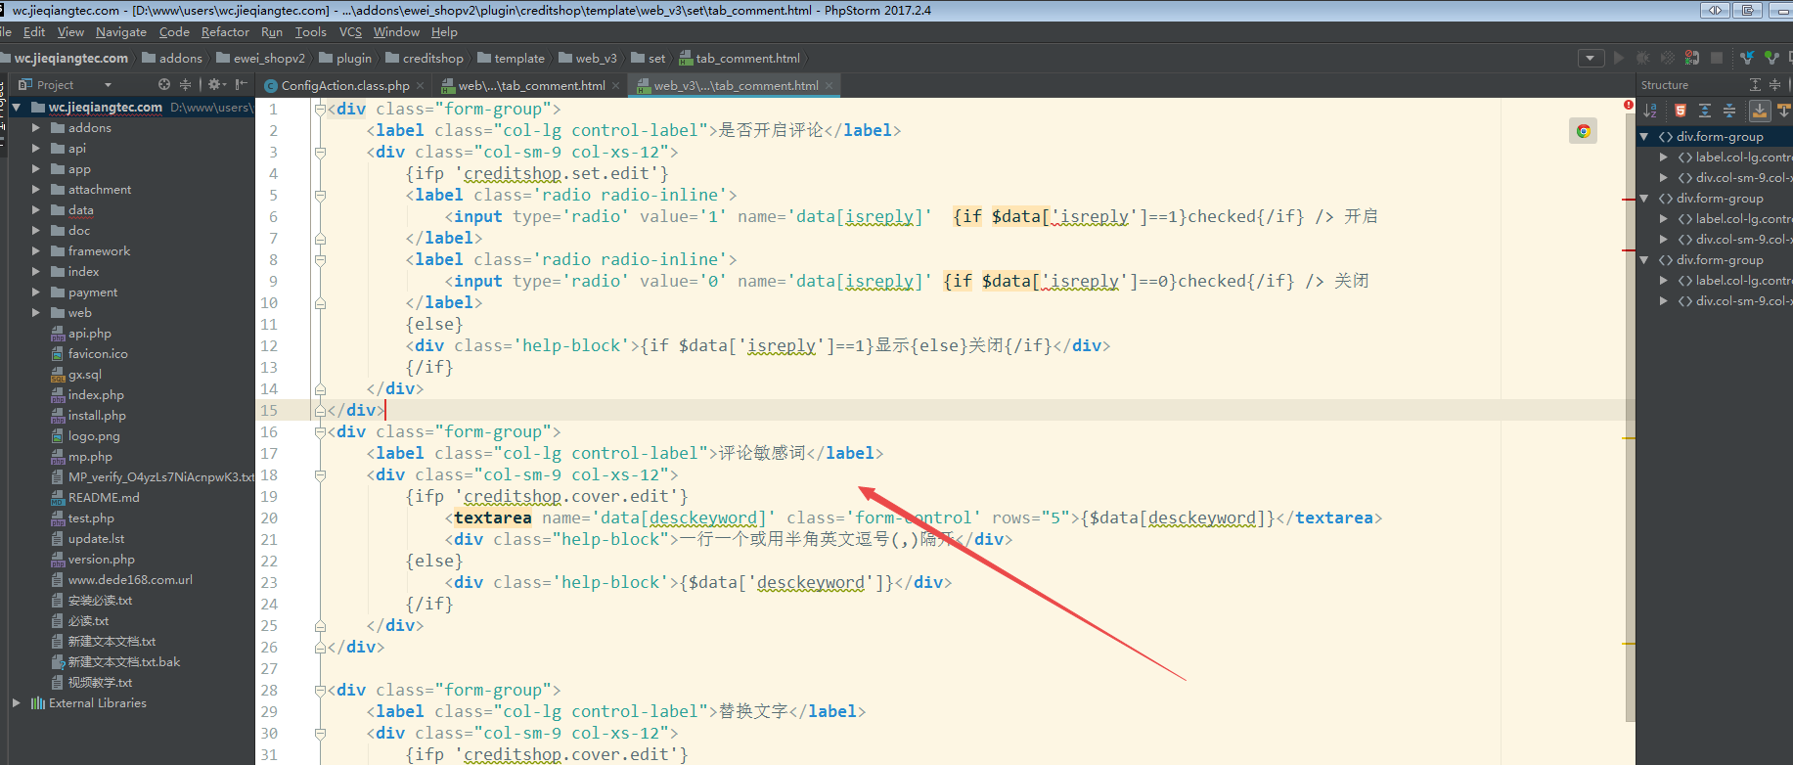

D:\www\users\wc.jieqiangtec.com\addons\zm\_super\_group\template\w\_config.html:

82

83 <div class="panel panel-default">

84: <div class="panel-heading">敏感词设置（每个词之前请以英文符合逗号隔开，如：我去,王八蛋,龟儿子...）</div>

85 <div class="panel-body">

86 <form action="" method="post" name="sensitive-form">

<http://shop.rongec.cn/web/index.php?c=site&a=entry&doing=poster&do=w_config&m=zm_super_group>

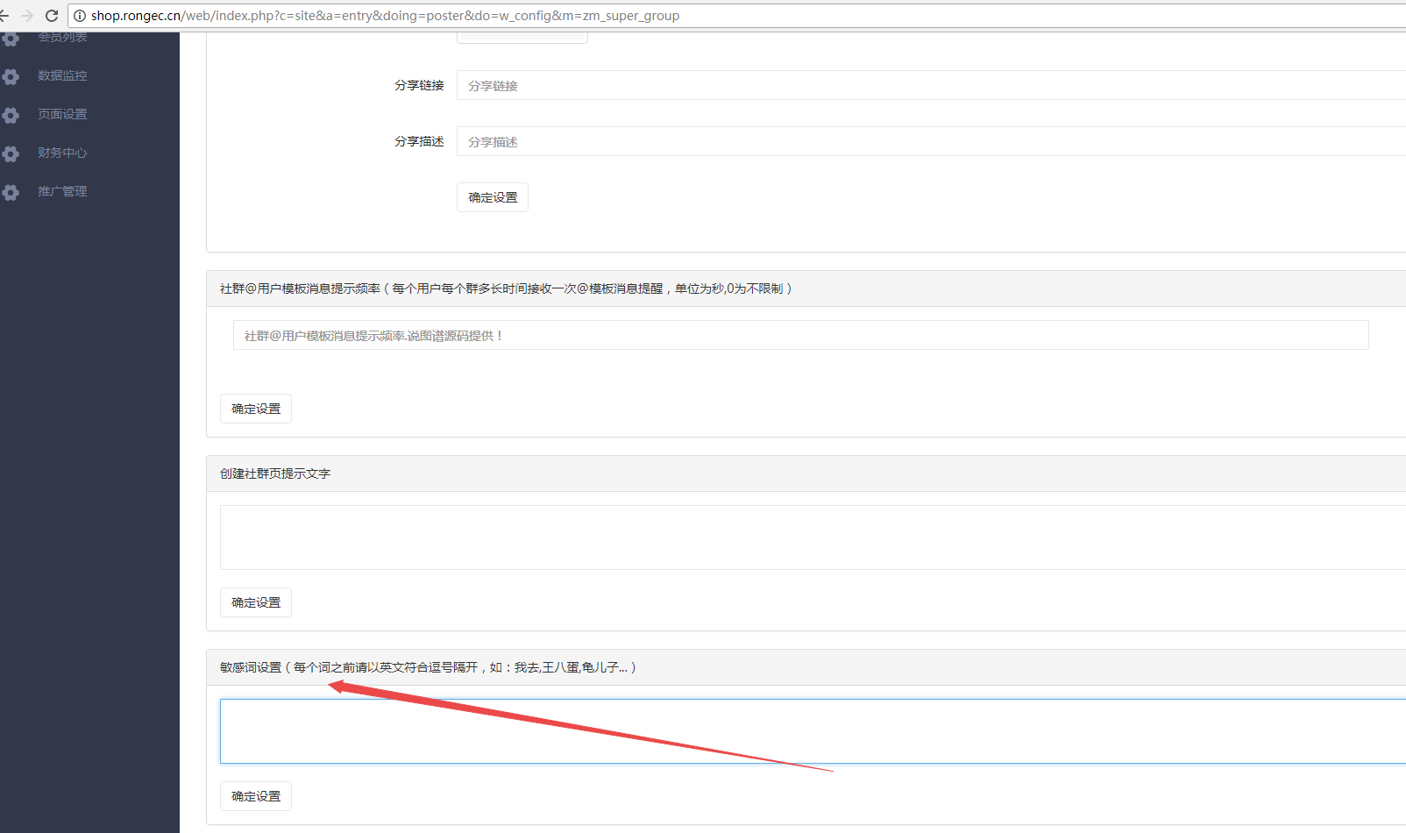

2018-04-25 19:42:08 TODO debug3 runtime=0.043s ：来源:

http://shop.rongec.cn/web/index.php?c=site&a=entry&doing=poster&do=w\_config&m=zm\_super\_group

------------

Array:

file : db.class.php query() ;

sql2 : INSERT INTO `ims\_zm\_super\_group\_config` SET `sensitive` = '我去，靠，' , `edit\_time` = '1524656528' , `uniacid` = '10' ;

$params ==Array:

:sensitive : 我去，靠， ;

:edit\_time : 1524656528 ;

:uniacid : 10 ;

余额

# **20180421**

积分签到

<http://shop.rongec.com/app/index.php?i=10&c=entry&m=ewei_shopv2&do=mobile&r=sign>

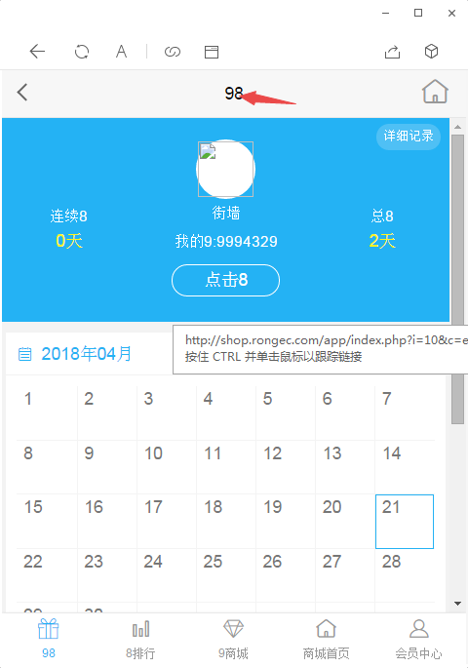

文字有问题

D:\www\users\wc.jieqiangtec.com\addons\ewei\_shopv2\plugin\sign\core\model.php

$set = pdo\_fetch('select \* from ' . tablename('ewei\_shop\_sign\_set') . ' where uniacid=:uniacid limit 1 ', **array**(':uniacid' => $\_W['uniacid']));

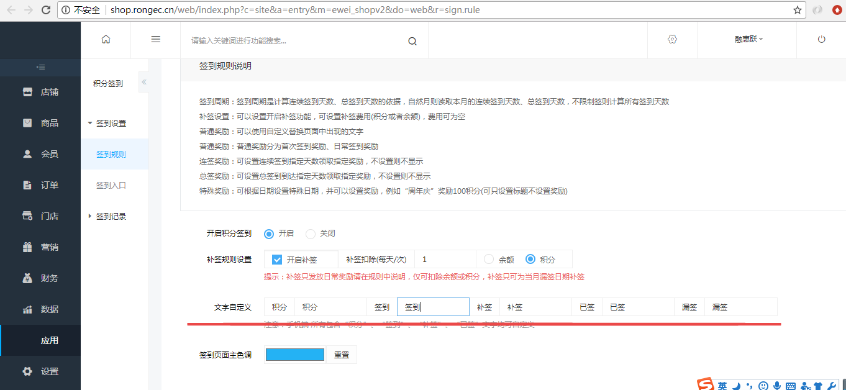

# **20180216**

申请试用

<http://shop.rongec.com/app/index.php?i=6&c=entry&do=rule&m=sen_appfreeitem>

阿里试用

<https://pages.tmall.com/wow/baihuo/act/trial?spm=a1z0i.8295104.300.1>

添加商品分类和品牌属性

退款问题

<http://shop.rongec.com/web/index.php?c=site&a=entry&m=ewei_shopv2&do=web&r=finance.log.recharge>

certificate not match

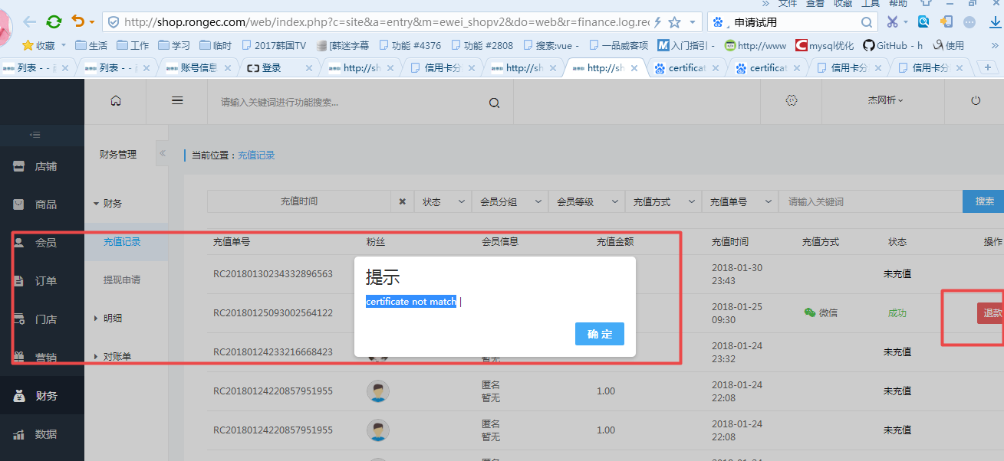

# **20180131**

addons\ewei\_shopv2\core\web\goods\index.php

addons\ewei\_shopv2\template\web\_v3\goods\index.html

// 图片 'http://erp.rongec.' . $suffix.'/admin/'.$res['productInfo']['image\_source\_url']

$list[$key]['thumb'] = 'http://erp.rongec.' . $suffix.'/admin/'. $value['image\_source\_url'];

$list[$key]['thumb\_url'] = 'http://erp.rongec.' . $suffix.'/admin/'. $value['image\_source\_url'];

{if $goodsfrom == 'erp' }

<img src="{$item['thumb']}" style="width:72px;height:72px;padding:1px;border:1px solid #efefef;margin: 7px 0" onerror="this.src='../addons/ewei\_shopv2/static/images/nopic.png'" />

{else}

<img src="{php echo tomedia($item['thumb'])}" style="width:72px;height:72px;padding:1px;border:1px solid #efefef;margin: 7px 0" onerror="this.src='../addons/ewei\_shopv2/static/images/nopic.png'" />

{/if}

# **20180129**

替换erp登录背景

[root@roohl admin]# cp -R /www/docs/wc.jieqiangtec.com/web/resource/images/admin/\* /www/docs/erp.jieqiangtec.com/admin/CAT/

# **20180125**

<https://www.kancloud.cn/donknap/we7/134631>

开发者模式

<https://www.kancloud.cn/donknap/we7/134660>

<http://blog.csdn.net/haibo0668/article/details/72781781>

解决办法：

 首先打开程序的开发模式：把问题显示出来

 微擎目录/data/config.php里面的development值把0改成1

  $config['setting']['development'] = 0; 值改为1；

数据库访问很慢，

支付不了

1.数据库配置：

本地限制：localhost

改成

6 $config['db']['master']['host'] = 'localhost';

2.代码更新问题

nginx php error log 配置 查找500 错误

http://blog.csdn.net/joshua1830/article/details/52217837

php 500 错误调试

http://blog.csdn.net/elves766/article/details/51902614

error\_reporting(E\_ALL);

ini\_set("display\_errors", 1);

# **20180121**

-- 按年月分组

select DATE\_FORMAT(FROM\_UNIXTIME(add\_time),"%Y-%m"),count(1) from shopcenter\_order group by DATE\_FORMAT(FROM\_UNIXTIME(add\_time),"%Y-%m")

-- 按年月日分组

select DATE\_FORMAT(FROM\_UNIXTIME(add\_time),"%Y-%m-%d") AS time,count(1) from shopcenter\_order group by DATE\_FORMAT(FROM\_UNIXTIME(add\_time),"%Y-%m%d")

ORDER BY time DESC

// *TODO jieqiang调试***foreach** ($params **as** $key => $val) {  
 $arr1[] = $key;  
 $arr2[] = '\'' . $val . '\'';  
}  
$sql2 = str\_replace($arr1, $arr2, $sql);  
WeUtility::*logging*('TODO debug2', **array**('file' => 'fetch() ', 'sql2' => $sql2, '$params' => $params));

# **UNIX时间戳 按月分组 按年月分组 按日分组 mysql语句**

<http://blog.csdn.net/w263756314/article/details/51595911>

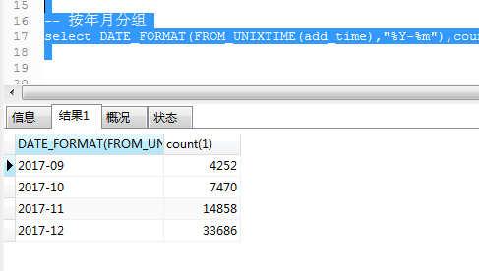

## [php 获取代码执行时间和消耗的内存](http://www.cnblogs.com/zqifa/p/php-19.html)

做一些php性能测试的时候，要获取代码执行时间和消耗的内存，查了一下资料，发现php有自带的函数可以实现这个功能，具体实现代码如下：

$t1 = microtime(true);  
// ... 执行代码 ...  
$t2 = microtime(true);  
echo '耗时'.round($t2-$t1,3).'秒<br>';  
echo 'Now memory\_get\_usage: ' . memory\_get\_usage() . '<br />';

# **20180115**

1.看看试用的能否整合进来用。

2.旅游那个看是否可以下来，部署一个看看效果。

1. 看看试用的能否整合进来用。

试用模块。

http://www.shuotupu.com/forum.php?mod=viewthread&tid=18591&highlight=%E8%AF%95%E7%94%A8

申请试用

<http://www.0516city.com/thread-663222-1-1.html>

<http://s.we7.cc/module-3091.html>

2.旅游那个看是否可以下来，部署一个看看效果。

<http://www.shuotupu.com/forum.php?mod=viewthread&tid=18010&extra=page%3D6%26filter%3Dtypeid%26typeid%3D5>

<https://item.taobao.com/item.htm?spm=a230r.1.14.38.2e5fb365h11fpm&id=563987166443&ns=1&abbucket=6#detail>

# **[[人人分销]](http://www.shuotupu.com/forum.php?mod=forumdisplay&fid=81&filter=typeid&typeid=16) [linux下进行Redis的安装使人人商城秒杀模块得到支持](http://www.shuotupu.com/forum.php?mod=viewthread&tid=17937&fromuid=16960)**

<http://www.shuotupu.com/forum.php?mod=viewthread&tid=17937&extra=page%3D1>

# **[[主要业务]](http://www.shuotupu.com/forum.php?mod=forumdisplay&fid=81&filter=typeid&typeid=2) [认证服务号公众号平台配置接入框架教程微擎微赞微图人人一键版通用](http://www.shuotupu.com/forum.php?mod=viewthread&tid=18650&fromuid=16960)**

<http://www.shuotupu.com/forum.php?mod=viewthread&tid=18650&fromuid=1>

|  |
| --- |
| ****人人一键版配置步骤****  1.设置好模块参数设置内的所有参数和选项。  2.在微信公众号后台——公众号设置——功能选项中设置‘JS接口安全域名’，域名为:你的域名  3.在微信公众号后台——公众号设置——功能选项中设置‘网页授权域名’，域名为:你的域名  4.在微擎系统后台——功能选项——支付参数中设置‘微信支付’内的参数。  5.在微信公众号后台——微信支付——开发配置中设置‘支付授权目录’，目录为:http://你的域名/payment/wechat/  6.在微信公众号后台——基本配置中设置‘IP白名单’，ip是你的服务器ip  ****微赞微擎等以上系统配置步骤****  1.设置好模块参数设置内的所有参数和选项。  2.在微信公众号后台——公众号设置——功能选项中设置‘JS接口安全域名’，域名为:你的域名  3.在微信公众号后台——公众号设置——功能选项中设置‘网页授权域名’，域名为:你的域名  4.在微擎系统后台——系统管理——公众号列表——进入公众号——支付参数中设置‘微信支付’内的参数。  5.在微信支付商户后台——产品中心——开发配置中设置‘支付授权目录’，目录为:http://你的域名/  6.在微信公众号后台——基本配置中设置‘IP白名单’，ip是你的服务器ip |

# **[[营销及活动]](http://www.shuotupu.com/forum.php?mod=forumdisplay&fid=81&filter=typeid&typeid=3) [修改微擎微赞云平台白名单方法，提示应用需要通过云平台安装](http://www.shuotupu.com/forum.php?mod=viewthread&tid=17332&fromuid=16960)**

<http://www.shuotupu.com/thread-17332-1-1.html>

# **20180118**

Erp数据梳理

导入数据过多，超时

后期限制导入条数。

商城申请试用模块

# **20180114**

1.试用功能：用户申请=》后台审核=》供应商发货=》用户反馈试用报告

2.白名单：特权，加表，针对不同银行

3.广告管理（竞价排名，针对供应商产品）

4.商城后台银行登陆（活动选择商品）频道 活动 商品 订单

5.拼团理财

1.商城试用功能：用户申请=》后台审核=》供应商发货=》用户反馈试用报告

2.商城白名单：特权加表，针对不同银行

3.商城广告管理：竞价排名，针对供应商产品

4.商城后台银行登陆：看到不同界面：如（活动选择商品）频道 活动 商品 订单

**erp和商城对接**

价格：

1. 供应商成本：不可修改
2. 购销成本：不可修改，供应商和erp定价
3. 银行价格：不同的银行不同价格，不可修改，银行和erp定价

供应商权限：

1. 商品管理（商品录入，excel导入）
2. 物流订单导入

商品导入到商城接口：定时任务同步，商城运营人员手动审核确认上架

1. 供应商看到自己的商品
2. 银行看到和erp有定价的商品
3. ERP自有商城

和银行的价格

D:\www\users\erp.jieqiangtec.com\Core\Dom\CenterProductDom.class.php L68

D:\www\users\erp.jieqiangtec.com\Core\Extra\CenterProductExtra.class.php 获取sku

**function** Id2Sku( $id )  
{  
 **return** 'S' . sprintf( '%09d', $id );  
}  
  
**function** Sku2Id( $sku )  
{  
 **return** intval( substr( $sku, 1 ) );  
}

[SQL]SELECT \* FROM shopcenter\_supplier ORDER BY is\_good DESC,id LIMIT 0 , 200

受影响的行: 0

时间: 3.650s

[Err] 1055 - Expression #1 of ORDER BY clause is not in GROUP BY clause and contains nonaggregated column 'information\_schema.PROFILING.SEQ' which is not functionally dependent on columns in GROUP BY clause; this is incompatible with sql\_mode=only\_full\_group\_by

# **MySQL5.7 group by新特性，报错1055**

<http://blog.csdn.net/u283056051/article/details/52463948>

sql\_mode=STRICT\_TRANS\_TABLES,NO\_AUTO\_CREATE\_USER,NO\_ENGINE\_SUBSTITUTION

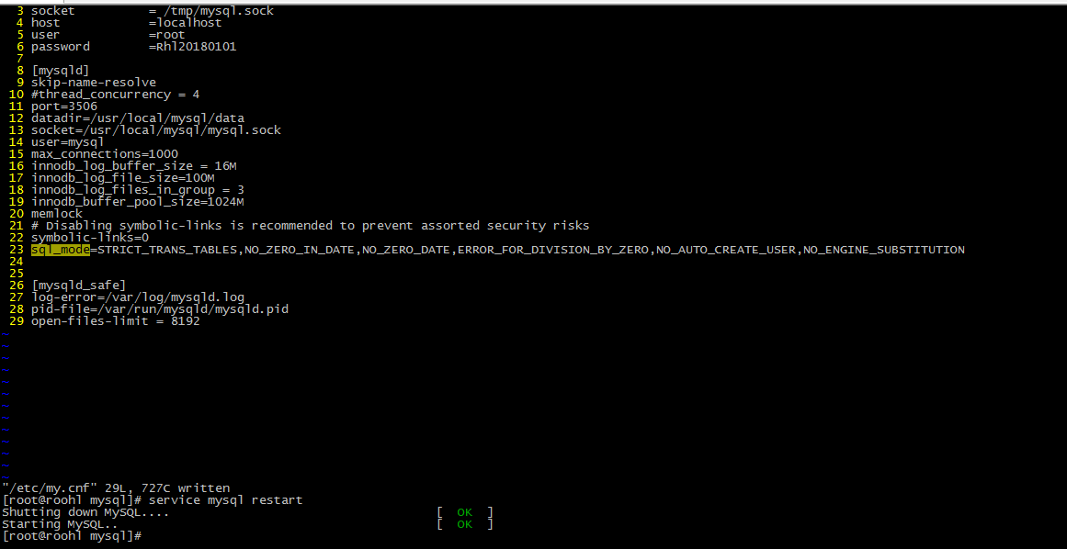

sql\_mode=STRICT\_TRANS\_TABLES,NO\_ZERO\_IN\_DATE,NO\_ZERO\_DATE,ERROR\_FOR\_DIVISION\_BY\_ZERO,NO\_AUTO\_CREATE\_USER,NO\_ENGINE\_SUBSTITUTION

D:\www\users\erp.jieqiangtec.com\Core\Core.class.php L275

[ 2018-01-14T18:40:24+08:00 ] /admin/?mod=purchase.supplier.add

NOTICE sql 查询 $queryid:1: NEATMySQL.class.php ==Query==

SET character\_set\_connection=utf8, character\_set\_results=utf8, character\_set\_client=binary

[ 2018-01-14T18:40:24+08:00 ] /admin/?mod=purchase.supplier.add

NOTICE sql 查询 $queryid:1: NEATMySQL.class.php ==Query==

SET sql\_mode=''

# **20180113**

1.和银行的价格

2.权限问题

3.供应商

**5.erp和商城对接的时间评估**

6.底部去除

4.导出条数限制

1. **erp和商城商品和订单的对接（表）**

Erp和商城是独立的系统

商城可自营商品和运营外部商品（关联外部id,比如erp中的）,若要实现完全同步

需要接口化

D:\www\users\erp.jieqiangtec.com\admin\app\Common.class.php

session

var\_dump('TODO jieqiangtest $this->authData==',$this->authData);exit;

**function** IsLogin()  
{  
 $ClientAuth = Core::*ImportBaseClass*('ClientAuth');  
  
 **if** (!$ClientAuth->CheckAuth())  
 **return false**;  
  
 var\_dump('TODO jieqiangtest $ClientAuth->GetAuthData()==',$ClientAuth->GetAuthData());**exit**;  
 $GLOBALS['\_\_Session'] = $ClientAuth->GetAuthData();  
  
 **return** $GLOBALS['\_\_Session'];  
}

string 'TODO jieqiangtest $ClientAuth->GetAuthData()==' *(length=46)*

**array** *(size=4)*

'user\_id' => string '162' *(length=3)*

'user\_name' => string 'admin' *(length=5)*

'user\_real\_name' => string 'admin' *(length=5)*

'group' => null

**function** ClientAuth($filedPrefix, $authCode, $fileds, $cookieTime = 0, $cookieDomain = '')  
{  
 $this->filedPrefix = $filedPrefix;  
 $this->authCode = $authCode;  
 $this->cookieTime = $cookieTime;  
 $this->cookieDomain = $cookieDomain;  
 $this->fileds = $fileds;  
}

**function** SetAuthData($data)  
{  
 // var\_dump('*TODO jieqiangtest $this->authData==',$this->authData);exit;* **foreach** ($this->fileds **as** $filed) {  
 $mixString .= $data[$filed];  
 }

D:\www\users\erp.jieqiangtec.com\Core\Core.class.php L 303

**case** "ClientAuth":  
 Core::*LoadLib*( 'ClientAuth.class.php' );  
  
 $GLOBALS['\_\_BaseClass'][$objName] = **new** ClientAuth( Core::*GetConfig*( 'client\_auth\_prefix' ), Core::*GetConfig*( 'client\_auth\_hash' ), Core::*GetConfig*( 'client\_auth\_field' ) );  
**break**;

D:\www\users\erp.jieqiangtec.com\admin\config\config.php

$\_\_Config['client\_auth\_field'] = **array**( 'user\_id', 'user\_name', 'user\_real\_name', 'group' );

# **20180107**

1.和银行的价格

2.权限问题

3.供应商

4.导出条数限制

**5.erp和商城对接的时间评估**

6.底部去除

1. **erp和商城商品和订单的对接（表）**

Erp和商城是独立的系统

商城可自营商品和运营外部商品（关联外部id,比如erp中的）

1. 导出条数限制

解决方案，添加时间筛选，限制条数200条

[ 2018-01-21T21:59:36+08:00 ] /admin/?mod=order.service&excel=1&id=283564%E3%80%80%E3%80%80&order\_service=&channel\_id=&target\_id=&product\_name=&order\_shipping\_name=&phone=

NOTICE sql 查询 $queryid:Resource id #55: NEATMySQL.class.php ==Query==

SELECT \* FROM shopcenter\_supplier WHERE id = '450' LIMIT 1

太多sql查询，导出一条订单需要1s,10条需要11s左右，

正常超时限制30s

http://erp.jieqiangtec.cn/admin/?mod=order.service&excel=1&id=&order\_service=1&channel\_id=&target\_id=&product\_name=&order\_shipping\_name=&phone=

D:\www\users\erp.jieqiangtec.com\admin\app\module\order\service.php

D:\www\users\erp.jieqiangtec.com\admin\app\block\order\list\_3.block.php

太多foreach

# 504 Gateway Time-out

nginx/1.0.15

# 如何解决nginx 504 Gateway Time-out错误

<https://jingyan.baidu.com/article/fc07f9896a491212ffe519e6.html>

# **[nginx 504 Gateway Time-out错误解决办法](http://www.cnblogs.com/xiamidong/p/4105583.html)**

<https://www.cnblogs.com/xiamidong/p/4105583.html>

2018/01/21 22:31:54 [error] 3032#2940: \*103 CreateFile() "D:\usr\local\nginx/html/messenger-front/get" failed (3: The system cannot find the path specified), client: 127.0.0.1, server: \_, request: "GET /messenger-front/get?c=uBdKp40P4k173UArKb4cZ47BsBfDqhw3JJrjfGILmDhbU9nNjQpeoAZZeToKziTMZpbYbmOByiC%2FXziS8H8%2FpEnY%2B%2B4DHakcGmMsvsoFUYxD7KtIonsi6oGV02xgPTRDYihX3Ho3iYsqSnfiglFdQUsMLKBcOohg3BV6PuPMxJatU%2BhUv4Rtljk1jJZI2xvC9UI4fixq5Eg%3D&v=1 HTTP/1.1", host: "msg-push.duba.net"

# 502 Bad Gateway

nginx/1.0.15

# **[Nginx 502 bad gateway问题的解决方法](http://www.cnblogs.com/feng18/p/5148985.html)**

<https://www.cnblogs.com/feng18/p/5148985.html>

2018/01/21 22:33:05 [error] 3032#2940: \*104 upstream timed out (10060: A connection attempt failed because the connected party did not properly respond after a period of time, or established connection failed because connected host has failed to respond) while reading response header from upstream, client: 127.0.0.1, server: erp.jieqiangtec.cn, request: "GET /admin/?mod=order.service&excel=1&id=&order\_service=&channel\_id=&target\_id=&product\_name=&order\_shipping\_name=&phone= HTTP/1.1", upstream: "fastcgi://127.0.0.1:9000", host: "erp.jieqiangtec.cn", referrer: "http://erp.jieqiangtec.cn/admin/?mod=order.service&excel=0&id=&order\_service=&channel\_id=&target\_id=&product\_name=&order\_shipping\_name=&phone="

2018/01/21 22:42:41 [error] 21384#21376: \*1 WSARecv() failed (10054: An existing connection was forcibly closed by the remote host) while reading response header from upstream, client: 127.0.0.1, server: erp.jieqiangtec.cn, request: "GET /admin/?mod=order.service&excel=1&id=&order\_service=&channel\_id=&target\_id=&product\_name=&order\_shipping\_name=&phone= HTTP/1.1", upstream: "fastcgi://127.0.0.1:9000", host: "erp.jieqiangtec.cn", referrer: "http://erp.jieqiangtec.cn/admin/?mod=order.service&excel=0&id=&order\_service=&channel\_id=&target\_id=&product\_name=&order\_shipping\_name=&phone="

[ 2018-01-07T22:17:28+08:00 ] NOTICE sql 查询 $queryid:Resource id #16: NEATMySQL.class.php ==Query==

SELECT \* FROM shopcenter\_order WHERE order\_service = '1' ORDER BY service\_begin desc

|  |  |  |  |  |
| --- | --- | --- | --- | --- |
| **( ! ) Fatal error: Maximum execution time of 30 seconds exceeded in D:\www\users\erp.jieqiangtec.com\Core\Lib\NEATMySQL.class.php on line *128*** | | | | |
| **Call Stack** | | | | |
| **#** | **Time** | **Memory** | **Function** | **Location** |
| 1 | 0.0002 | 336840 | {main}( ) | ..\index.php**:**0 |
| 2 | 0.3696 | 516760 | Controller->Run( ) | ..\index.php**:**74 |
| 3 | 0.4679 | 533552 | include( 'D:\www\users\erp.jieqiangtec.com\admin\app\module\order\service.php' ) | ..\Controller.class.php**:**63 |
| 4 | 0.4680 | 533824 | include( 'D:\www\users\erp.jieqiangtec.com\admin\app\block\order\list\_3.block.php' ) | ..\service.php**:**9 |
| 5 | 29.9522 | 8993312 | AdminModel->GetAdministrator( ) | ..\list\_3.block.php**:**155 |
| 6 | 29.9522 | 8993784 | Model->Get( ) | ..\AdminModel.class.php**:**41 |
| 7 | 29.9522 | 8994856 | NEATMySQL->Query( ) | ..\Model.class.php**:**74 |

1.erp上下结构导航，两行定位，白底，蓝色点缀，模仿cps

反馈：待定

3.市场价和银行的价格

反馈：待客户反馈确认

4.权限不起作用

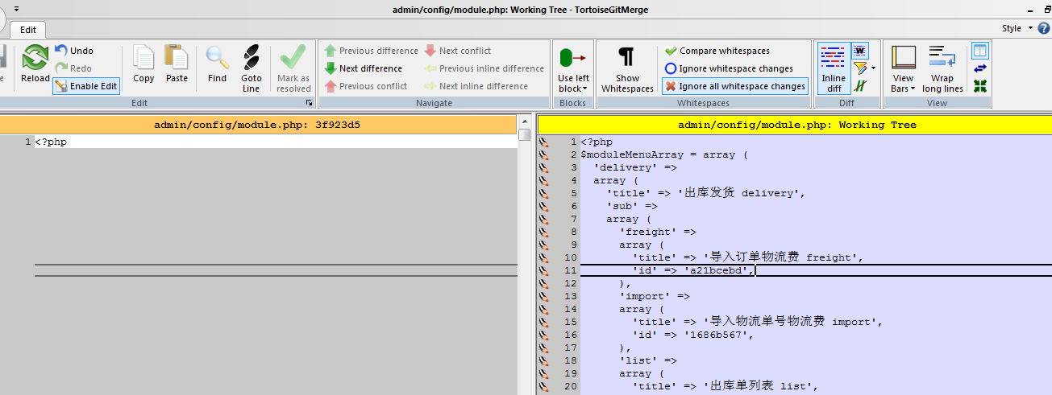

D:\www\users\erp.jieqiangtec.com\admin\config\module.php

反馈：已解决

6.底部去除

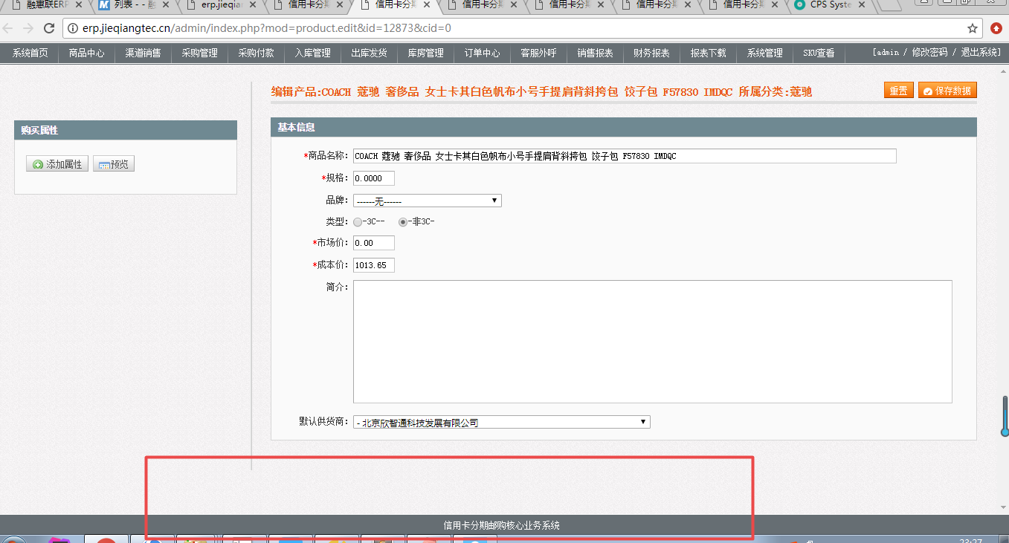

unzip /data/backups/erp.jieqiangtec.com\_20171223.zip -d /www/docs/erp.jieqiangtec.com

反馈：已解决

商城商品列表打不开

反馈：添加php gd库扩展

<http://shop.jieqiangtec.com/web/index.php?c=site&a=entry&m=ewei_shopv2&do=web&r=goods>

Fatal error: Call to undefined function ImageCreate() in /www/docs/wc.jieqiangtec.com/framework/library/qrcode/phpqrcode.php on line 985

添加php gd库扩展

**[centos下为php添加gd扩展](http://blog.csdn.net/chenghuikai/article/details/50904152)**

<http://blog.csdn.net/chenghuikai/article/details/50904152>

[root@roohl ext]# ll /usr/local/php55/lib/php/extensions/no-debug-non-zts-20121212/gd.so

-rwxr-xr-x 1 root root 1288986 Jan 7 16:46 /usr/local/php55/lib/php/extensions/no-debug-non-zts-20121212/gd.so

# **20180106**

# **20180105**

# **20180104**

# **20180103**

# **20180102**

# **20171231**

Core/Function/function.inc.php

Core/Lib/Model.class.php

Core/Lib/NEATMySQL.class.php

admin/app/Front.inc.php

admin/data/logs/17\_12\_31.log

/\*\*  
 \* 日志直接写入  
 \* @access public  
 \* @param string $message 日志信息  
 \* @param string $level 日志级别  
 \* @param integer $type 日志记录方式  
 \* // 日志记录方式  
 \* const SYSTEM = 0;  
 \* const MAIL = 1;  
 \* const FILE = 3;  
 \* const SAPI = 4;  
 \* 'LOG\_FILE\_SIZE' => 2097152, // 日志文件大小限制  
 \* @param string $destination 写入目标  
 \* @param string $extra 额外参数  
 \* @return void  
 \*/  
function log\_write($message, $level = 'ERR', $type = 3, $destination = '', $extra = '')  
{  
 $now = date('[ c ]');  
 if (3 == $type) { // 文件方式记录日志  
 if (empty($destination)) {  
 // mkdirs(dirname($\_SERVER['SCRIPT\_FILENAME']) . '/data/logs/');  
 // $destination = C('LOG\_PATH').date('y\_m\_d').'.log';  
 $destination = dirname($\_SERVER['SCRIPT\_FILENAME']) . '/data/logs/' . date('y\_m\_d') . '.log';  
 // var\_dump($destination);exit;  
 }  
 //检测日志文件大小，超过配置大小则备份日志文件重新生成  
 $log\_file\_size = 2097152;  
 if (is\_file($destination) && floor($log\_file\_size) <= filesize($destination))  
 rename($destination, dirname($destination) . '/' . time() . '-' . basename($destination));  
 } else {  
 $destination = $destination ? $destination : '';  
 $extra = $extra ? $extra : '';  
 }  
 error\_log("{$now} {$level}: {$message}\r\n\r\n", $type, $destination, $extra);  
 //clearstatcache();  
}

# **20171228**

1.erp上下结构导航，两行定位，白底，蓝色点缀，模仿cps

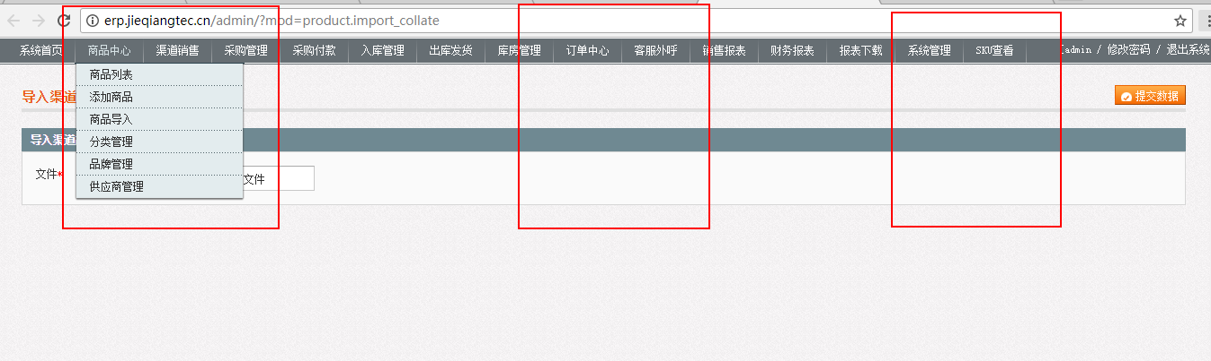

2.登录界面保持，模仿cps

3.市场价和银行的价格

4.权限不起作用



1. erp和商城商品和订单的对接（表）

6.底部去除



1.和银行的价格

2.权限问题

3.供应商

4.导出条数限制

**5.erp和商城对接的时间评估**

<http://erp.jieqiangtec.cn/admin/index.php?mod=order.list_all>

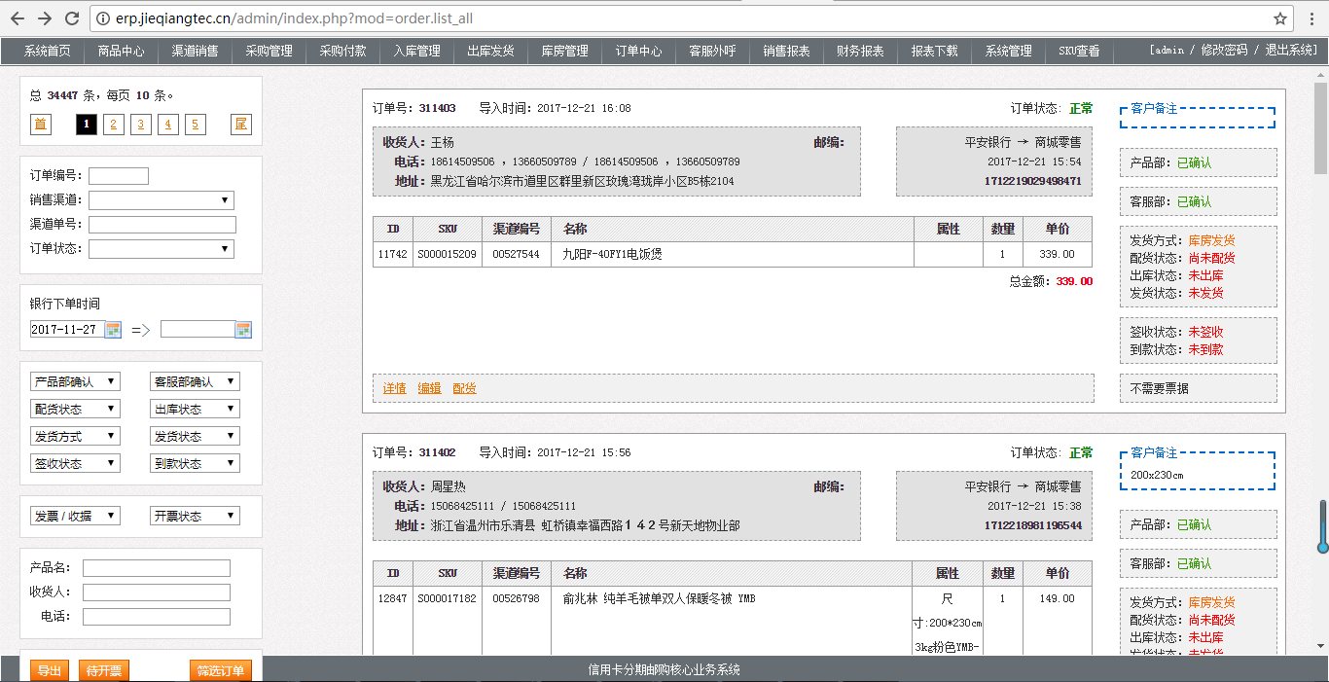

由于业务需要：

1.erp由于之前改的菜单样式界面，还有问题，用户操作体验不行。

所以建议先保留原来的系统界面，先只替换登录界面和背景颜色吧？后续有时间再研究菜单框架问题。

2.目前cps和商城对接没问题吧？

3.目前商城的功能开发先停下，重点先研究cps,erp和商城的对接，这个看需要多长时间？

晚上我们沟通一下。

[root@roohl member]# pwd

/www/docs/wc.jieqiangtec.com/data/tpl/web\_v3/default/ewei\_shopv2/web/member

string(19) "TODO jieqiangtest==" string(88) "**/www/docs/wc.jieqiangtec.com/data/tpl/web\_v3/default/ewei\_shopv2/web/member/list.tpl.php**" bool(true) array(5) { [0]=> array(7) { ["file"]=> string(72) "/www/docs/wc.jieqiangtec.com/addons/ewei\_shopv2/core/web/member/list.php" ["line"]=> int(182) ["function"]=> string(8) "template" ["class"]=> string(4) "Page" ["object"]=> object(List\_EweiShopV2Page)#8 (6) { ["inMobile"]=> NULL ["modulename"]=> NULL ["module"]=> NULL ["weid"]=> NULL ["uniacid"]=> NULL ["\_\_define"]=> NULL } ["type"]=> string(2) "->" ["args"]=> array(0) { } } [1]=> array(7) { ["file"]=> string(68) "/www/docs/wc.jieqiangtec.com/addons/ewei\_shopv2/core/model/route.php" ["line"]=> int(209) ["function"]=> string(4) "main" ["class"]=> string(19) "List\_EweiShopV2Page" ["object"]=> object(List\_EweiShopV2Page)#8 (6) { ["inMobile"]=> NULL ["modulename"]=> NULL ["module"]=> NULL ["weid"]=> NULL ["uniacid"]=> NULL ["\_\_define"]=> NULL } ["type"]=> string(2) "->" ["args"]=> array(0) { } } [2]=> array(7) { ["file"]=> string(56) "/www/docs/wc.jieqiangtec.com/addons/ewei\_shopv2/site.php" ["line"]=> int(47) ["function"]=> string(3) "run" ["class"]=> string(21) "Route\_EweiShopV2Model" ["object"]=> object(Route\_EweiShopV2Model)#6 (0) { } ["type"]=> string(2) "->" ["args"]=> array(0) { } } [3]=> array(7) { ["file"]=> string(59) "/www/docs/wc.jieqiangtec.com/web/source/site/entry.ctrl.php" ["line"]=> int(84) ["function"]=> string(8) "doWebWeb" ["class"]=> string(21) "Ewei\_shopv2ModuleSite" ["object"]=> object(Ewei\_shopv2ModuleSite)#5 (6) { ["inMobile"]=> bool(false) ["modulename"]=> string(11) "ewei\_shopv2" ["module"]=> array(28) { ["mid"]=> string(2) "12" ["name"]=> string(11) "ewei\_shopv2" ["type"]=> string(8) "business" ["title"]=> string(9) "惠惠城" ["version"]=> string(5) "3.5.4" ["ability"]=> string(9) "惠惠城" ["description"]=> string(9) "惠惠城" ["author"]=> string(12) "weichengtech" ["url"]=> string(12) "weichengtech" ["settings"]=> string(1) "0" ["subscribes"]=> array(14) { [0]=> string(4) "text" [1]=> string(5) "image" [2]=> string(5) "voice" [3]=> string(5) "video" [4]=> string(10) "shortvideo" [5]=> string(8) "location" [6]=> string(4) "link" [7]=> string(9) "subscribe" [8]=> string(11) "unsubscribe" [9]=> string(2) "qr" [10]=> string(5) "trace" [11]=> string(5) "click" [12]=> string(4) "view" [13]=> string(14) "merchant\_order" } ["handles"]=> array(12) { [0]=> string(4) "text" [1]=> string(5) "image" [2]=> string(5) "voice" [3]=> string(5) "video" [4]=> string(10) "shortvideo" [5]=> string(8) "location" [6]=> string(4) "link" [7]=> string(9) "subscribe" [8]=> string(2) "qr" [9]=> string(5) "trace" [10]=> string(5) "click" [11]=> string(14) "merchant\_order" } ["isrulefields"]=> string(1) "0" ["issystem"]=> string(1) "0" ["target"]=> string(1) "0" ["iscard"]=> string(1) "0" ["permissions"]=> string(6) "a:0:{}" ["title\_initial"]=> string(1) "R" ["wxapp\_support"]=> string(1) "1" ["app\_support"]=> string(1) "2" ["isdisplay"]=> int(1) ["logo"]=> string(68) "http://shop.jieqiangtec.com/addons/ewei\_shopv2/icon.jpg?v=1514436549" ["main\_module"]=> bool(false) ["plugin\_list"]=> array(0) { } ["is\_relation"]=> bool(false) ["config"]=> array(0) { } ["enabled"]=> string(1) "1" ["shortcut"]=> string(1) "0" } ["weid"]=> int(6) ["uniacid"]=> int(6) ["\_\_define"]=> string(56) "/www/docs/wc.jieqiangtec.com/addons/ewei\_shopv2/site.php" } ["type"]=> string(2) "->" ["args"]=> array(0) { } } [4]=> array(4) { ["file"]=> string(42) "/www/docs/wc.jieqiangtec.com/web/index.php" ["line"]=> int(184) ["args"]=> array(1) { [0]=> string(59) "/www/docs/wc.jieqiangtec.com/web/source/site/entry.ctrl.php" } ["function"]=> string(7) "require" } }

# **20171225**

数据库引擎替换

Myisam替换innodb

Erp兼容版本 php5.3

# **20171221**

2017-12-21 22:03:09 TODO debug4 ：来源:

http://shop.rongec.cn/app/index.php?i=6&c=entry&m=ewei\_shopv2&do=mobile&r=goods.get\_list&keywords=&isrecommand=&ishot=&isnew=&isdiscount=&issendfree=&istime=&cate=&brand=71&order=&by=&merchid=&page=1&frommyshop=0&\_=1513864986319

------------

Array:

file : D:\www\users\wd2.jieqiangtec.com\framework\class\db.class.php fetchall($sql, $params = array()) ;

sql2 : SELECT id,title,subtitle,thumb,marketprice,productprice,minprice,maxprice,isdiscount,isdiscount\_time,isdiscount\_discounts,sales,salesreal,total,description,bargain,`type`,ispresell,hasoption

FROM `ims\_ewei\_shop\_goods` where 1 and `uniacid` = '6' AND `deleted` = 0 and status=1 and `merchid` = 0 and type !=10 AND FIND\_IN\_SET(71,brands) and ( ifnull(showlevels,'')='' or FIND\_IN\_SET( 0,showlevels)<>0 ) and ( ifnull(showgroups,'')='' or FIND\_IN\_SET( 0,showgroups)<>0 ) ORDER BY displayorder desc,createtime desc LIMIT 0,10 ;

$params ==Array:

:uniacid : 6 ;

# **20171220**

解码

https://tool.lu/js

# **20171219**

登陆页面仿erp

后台背景图片 1440\*900 最好暗色,要平铺适应大屏

D:\www\users\wc.jieqiangtec.com\web\resource\images\admin

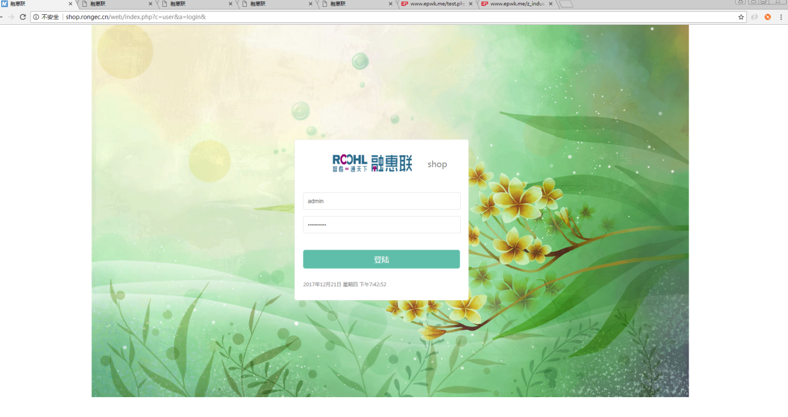

CopyRightIMG_256融惠联版权所有

登陆图片

D:\www\users\erp.jieqiangtec.com\admin\CAT

登陆程序

D:\www\users\erp.jieqiangtec.com\admin\app\module\login.php

登陆模板

D:\www\users\erp.jieqiangtec.com\admin\template\LoginCAT.html

商城站点配置

<http://shop.rongec.cn/web/index.php?c=system&a=site&>

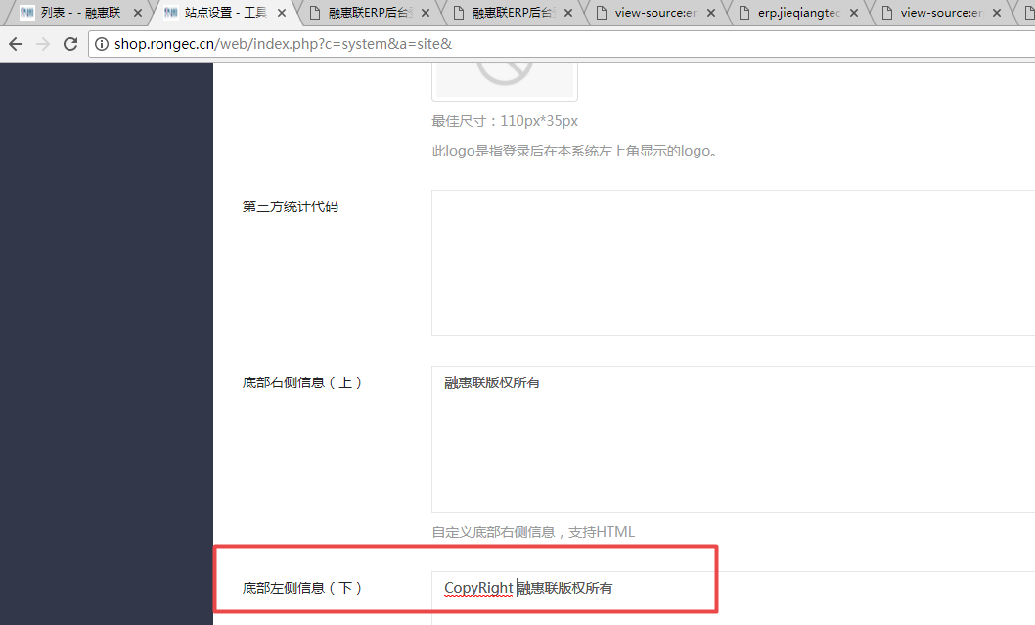

# **20171214**

人人店=》惠惠城

今天先抽时间把登录页和人人店这两个地方改一下吧？

http://shop.rongec.com/web/index.php?c=home&a=welcome&

人人店，改成“惠惠城”，包括人人店图标也改下。所有带有“人人店”的地方都改哦。

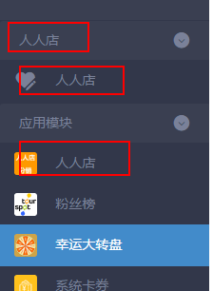

修改配置;

D:\www\users\wc.jieqiangtec.com\web\common\frames.inc.php

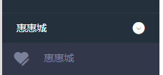

修改数据库：

UPDATE `ims\_modules` SET `title`='惠惠城', `ability`='惠惠城', `description`='惠惠城' WHERE (`mid`='12')

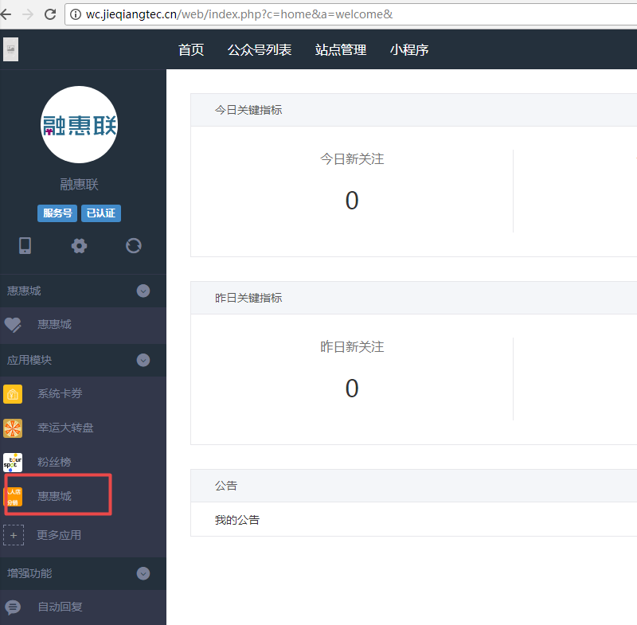

图标更改：

<http://wc.jieqiangtec.cn/addons/ewei_shopv2/icon.jpg>

更新缓存

http://wc.jieqiangtec.cn/web/index.php?c=system&a=updatecache&

# **20171212**

切换后台模板 default

D:\www\users\wc.jieqiangtec.com\web\themes\default\user

Affordable=>default

Path Filename Extension Status Lines added Lines removed Last Modified Size

web\themes\affordable\user\login.html login.html .html Modified 37 5

后台设置

站点设置

http://shop.rongec.cn/web/index.php?c=system&a=site&

web\themes\default\system\site.html

web\themes\default\user\login.html

<div class="logo text-center">

<a href="javascript:void(0);"><img src="{if !empty($\_W['setting']['copyright']['flogo1'])}{php echo tomedia($\_W['setting']['copyright']['flogo1'])}{else}./resource/images/logo/logo-219.png{/if}" width="220px" height="50px"></a>

</div>

# **20171211**

去除： 网站 授权

<http://shop.rongec.cn/web/index.php?c=site&a=entry&m=ewei_shopv2&do=web&r=system.auth.upgrade>

D:\www\users\wc.jieqiangtec.com\addons\ewei\_shopv2\template\web\_v3\\_header.html

<span class="wb-nav-title">{$sysmenu['text']}</span>

D:\www\users\wc.jieqiangtec.com\addons\ewei\_shopv2\core\model\system.php

m('system')->getMenu(**true**)

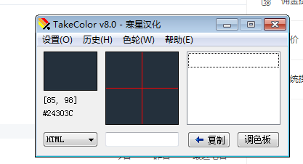

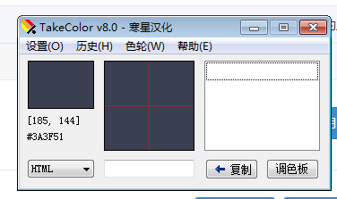

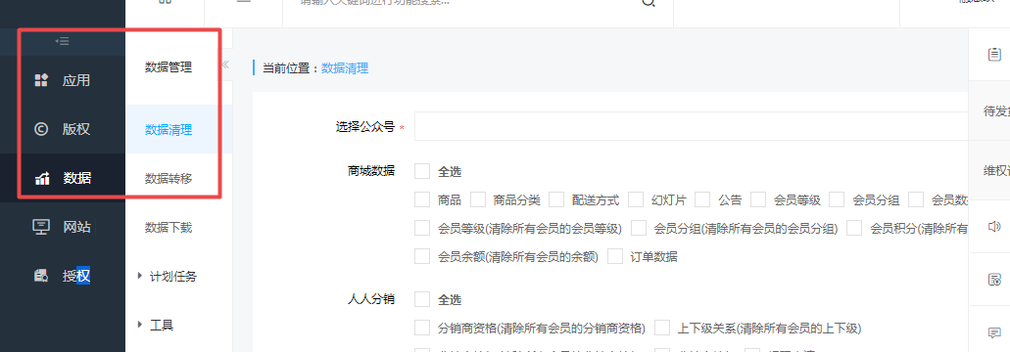

# **20171210**

**程序执行文件流程**:

$traces = debug\_backtrace();

品牌管理

<http://shop.rongec.cn/web/index.php?c=site&a=entry&m=ewei_shopv2&do=web&r=goods.brand>

<http://shop2.jieqiangtec.com/>

<http://shop2.jieqiangtec.com/>[admin/brand.php?act=list](http://localhost/users/ecshop3.jieqiangtec.com/admin/brand.php?act=list)

admin

admin888

[http://shop2.jieqiangtec.cn/admin/index.php/admin/brand.php?act=list](http://localhost/users/ecshop3.jieqiangtec.com/admin/brand.php?act=list)

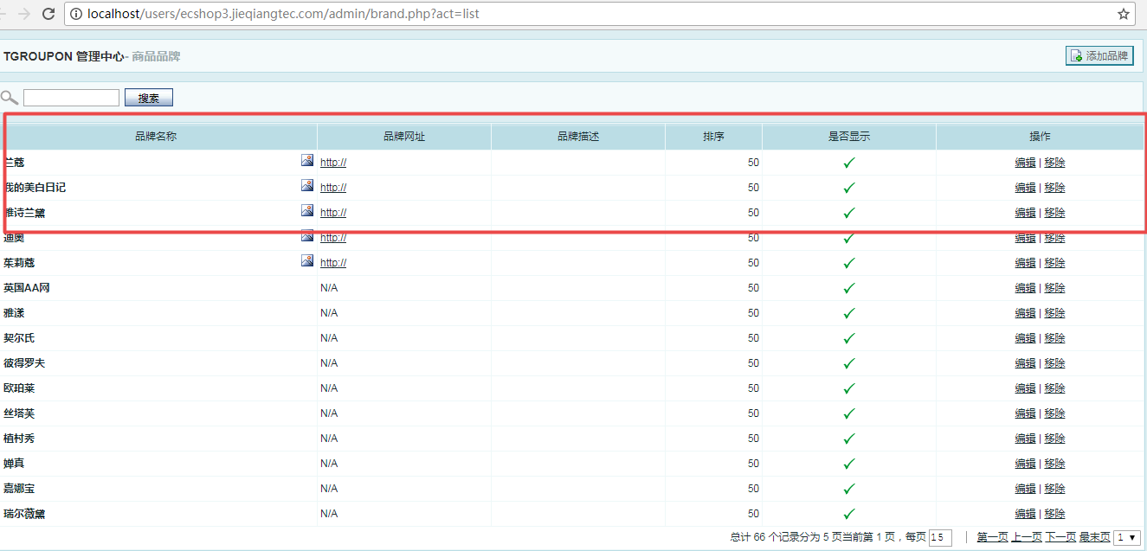

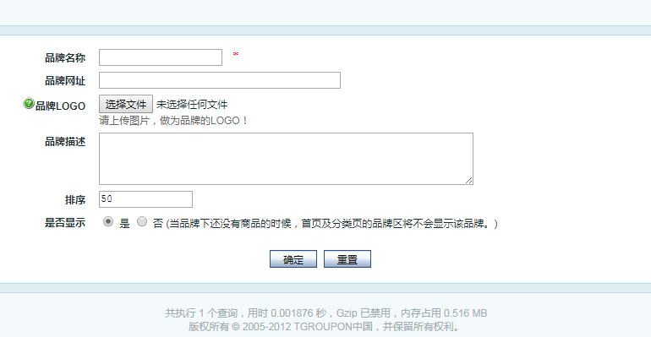

|  |  |
| --- | --- |
| **品牌名称** | \* |
| **品牌网址** |  |
| **[IMG_256](http://localhost/users/ecshop3.jieqiangtec.com/admin/javascript:showNotice('warn_brandlogo');)品牌LOGO** | 请上传图片，做为品牌的LOGO！ |
| **品牌描述** |  |
| **排序** |  |
| **是否显示** | 是  否 (当品牌下还没有商品的时候，首页及分类页的品牌区将不会显示该品牌。) |
|  |  |

左侧导航：

D:\www\users\wc.jieqiangtec.com\addons\ewei\_shopv2\core\model\system.php

仿照分类管理

**category=》brand**

**分类=》品牌**

**advimg=》logo**

<http://shop.rongec.cn/web/index.php?c=site&a=entry&m=ewei_shopv2&do=web&r=goods.category>

链接：

<http://shop.rongec.cn/web/index.php?c=site&a=entry&m=ewei_shopv2&do=web&r=goods.brand>

程序：

D:\www\users\wc.jieqiangtec.com\addons\ewei\_shopv2\core\web\goods\brand.php

Error: template source 'web/goods/brand' is not exist!  
模板：

D:\www\users\wc.jieqiangtec.com\addons\ewei\_shopv2\template\web\_v3\goods\brand

路由：

D:\www\users\wc.jieqiangtec.com\addons\ewei\_shopv2\core\model\route.php

2017-12-10 20:55:46 SQL Error ：来源:

http://shop.rongec.cn/web/index.php?c=site&a=entry&m=ewei\_shopv2&do=web&r=goods.brand

------------

String:

SQL: <br/>SELECT \* FROM `ims\_ewei\_shop\_brand` WHERE uniacid = '6' ORDER BY parentid ASC, displayorder DESC<hr/>Params: <br/>array (

)<hr/>SQL Error: <br/>Table 'wc2.ims\_ewei\_shop\_brand' doesn't exist<hr/>Traces: <br/>file: /framework/class/db.class.php; line: 227; <br />file: /framework/function/pdo.func.php; line: 44; <br />file: /addons/ewei\_shopv2/core/web/goods/brand.php; line: 70; <br />file: /addons/ewei\_shopv2/core/model/route.php; line: 207; <br />file: /addons/ewei\_shopv2/site.php; line: 47; <br />file: /web/source/site/entry.ctrl.php; line: 84; <br />file: /web/index.php; line: 184; <br />

建表

CREATE TABLE `ims\_ewei\_shop\_brand` (

`brand\_id` smallint(5) unsigned NOT NULL AUTO\_INCREMENT,

`brand\_name` varchar(60) NOT NULL DEFAULT '',

`brand\_logo` varchar(80) NOT NULL DEFAULT '',

`brand\_desc` text NOT NULL,

`site\_url` varchar(255) NOT NULL DEFAULT '',

`sort\_order` tinyint(3) unsigned NOT NULL DEFAULT '50',

`is\_show` tinyint(1) unsigned NOT NULL DEFAULT '1',

`brand\_banner` varchar(80) NOT NULL COMMENT '商品品牌banner',

PRIMARY KEY (`brand\_id`),

KEY `is\_show` (`is\_show`)

) ENGINE=MyISAM AUTO\_INCREMENT=73 DEFAULT CHARSET=utf8;

**删除记录ims\_ewei\_shop\_perm\_log**

2017-12-10 23:05:54 TODO debug3 ：来源:

http://shop.rongec.cn/web/index.php?c=site&a=entry&m=ewei\_shopv2&do=web&r=goods.brand.delete&id=72

------------

Array:

file : D:\www\users\wd2.jieqiangtec.com\framework\class\db.class.php query($sql, $params = array()) ;

sql2 : DELETE FROM `ims\_ewei\_shop\_brand` WHERE `id` = '72' ;

$params ==Array:

:\_\_id : 72 ;

2017-12-10 23:05:54 TODO debug3 ：来源:

http://shop.rongec.cn/web/index.php?c=site&a=entry&m=ewei\_shopv2&do=web&r=goods.brand.delete&id=72

------------

Array:

file : D:\www\users\wd2.jieqiangtec.com\framework\class\db.class.php query($sql, $params = array()) ;

sql2 : INSERT INTO `ims\_ewei\_shop\_perm\_log` SET `uniacid` = '6' , `uid` = '1' , `name` = '' , `type` = 'shop.brand.delete' , `op` = '删除品牌 ID: 72 品牌名称: 牛栏' , `ip` = '127.0.0.1' , `createtime` = '1512918354' ;

$params ==Array:

:uniacid : 6 ;

:uid : 1 ;

:name : ;

:type : shop.brand.delete ;

:op : 删除品牌 ID: 72 品牌名称: 牛栏 ;

:ip : 127.0.0.1 ;

:createtime : 1512918354 ;

图片上传

http://shop.rongec.cn/web/index.php?c=utility&a=file&do=upload&type=image

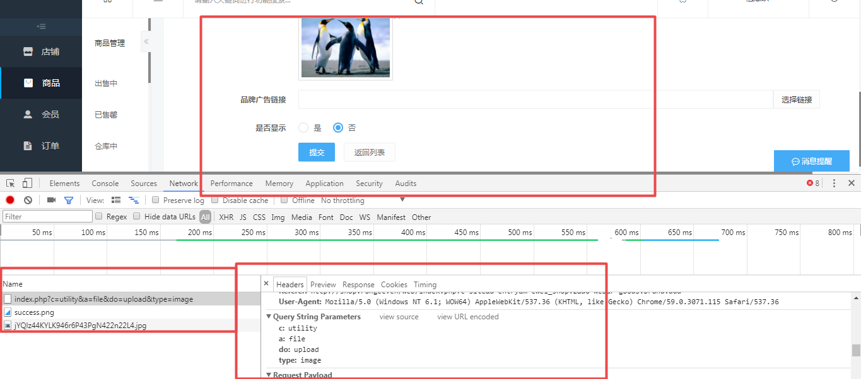

获取全部品牌

D:\www\users\wc.jieqiangtec.com\addons\ewei\_shopv2\core\model\shop.php L44

$brands = m('shop')->getFullBrand(**true**);

商品表添加栏位：

ALTER TABLE `ims\_ewei\_shop\_goods`

ALTER COLUMN `brand` `brands` text CHARACTER SET utf8 COLLATE utf8\_general\_ci NULL COMMENT '品牌' AFTER `cates`;

商品编辑

string 'D:\www\users\wc.jieqiangtec.com\addons\ewei\_shopv2\core\web\goods/post.php' *(length=74)*

# **20171122**

大小写

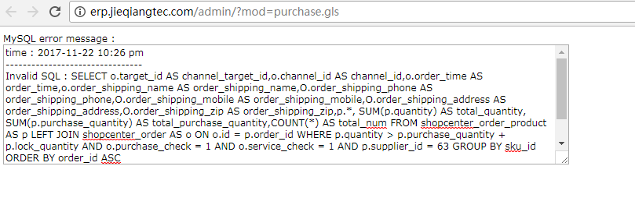

SELECT

o.target\_id AS channel\_target\_id,

o.channel\_id AS channel\_id,

o.order\_time AS order\_time,

o.order\_shipping\_name AS order\_shipping\_name,

O.order\_shipping\_phone AS order\_shipping\_phone,

O.order\_shipping\_mobile AS order\_shipping\_mobile,

O.order\_shipping\_address AS order\_shipping\_address,

O.order\_shipping\_zip AS order\_shipping\_zip,

p.\*, SUM(p.quantity) AS total\_quantity,

SUM(p.purchase\_quantity) AS total\_purchase\_quantity,

COUNT(\*) AS total\_num

FROM

shopcenter\_order\_product AS p

LEFT JOIN shopcenter\_order AS o ON o.id = p.order\_id

WHERE

p.quantity > p.purchase\_quantity + p.lock\_quantity

AND o.purchase\_check = 1

AND o.service\_check = 1

AND p.supplier\_id = 63

GROUP BY

sku\_id

ORDER BY

order\_id ASC

# **20171115**

切换版本

<http://wc.jieqiangtec.cn/web/index.php?c=site&a=entry&m=ewei_shopv2&do=web&r=switchversion&route=shop.adv>

管理首页

<http://wc.jieqiangtec.cn/web/index.php?c=site&a=entry&m=ewei_shopv2&do=web>

system.php

D:\www\users\wc.jieqiangtec.com\addons\ewei\_shopv2\core\model\system.php L1336

*/\*\*  
 \* 设置用户版本  
 \*/*public function set\_version($type = 0)  
{  
 global $\_W;  
 $uid = $\_W['uid'];  
  
 if ($type == 1) {  
 $uid = $\_W['merchuid'];  
 }  
 else {  
 if ($type == 2) {  
 $uid = $\_W['newstoreuid'];  
 }  
 }  
  
 *// TODO jieqiangtest 默认为1  
 // $set = pdo\_fetch('SELECT \* FROM ' . tablename('ewei\_shop\_version') . ' WHERE uid=:uid AND `type`=:type limit 1', array(':type' => $type, ':uid' => $uid));  
 // $GLOBALS['\_W']['shopversion'] = intval($set['version']);* $GLOBALS['\_W']['shopversion'] = 1;  
}

# **20171114**

http://shop.rongec.com/app/index.php?i=6&c=entry&m=ewei\_shopv2&do=mobile&r=mmanage

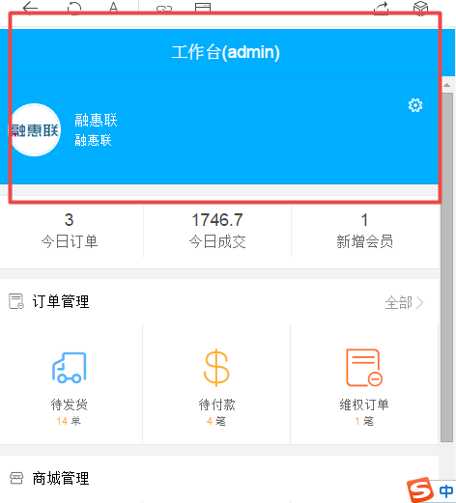

无效路径

<http://shop.rongec.com/payment/wechat/>

<http://shop.rongec.cn/web/index.php?c=profile&a=payment&>

控制器

D:\www\users\wc.jieqiangtec.com\web\source\profile\payment.ctrl.php

模板页

D:\www\users\wc.jieqiangtec.com\web\themes\default\profile\payment.html

默认模板affordable=》default

string 'TODO jieqiangtest template==affordable==$source2==D:/www/users/wc.jieqiangtec.com/web/themes/default/profile/payment.html==$compile2==D:/www/users/wc.jieqiangtec.com/data/tpl/web/default/profile/payment.tpl.php' *(length=210)*

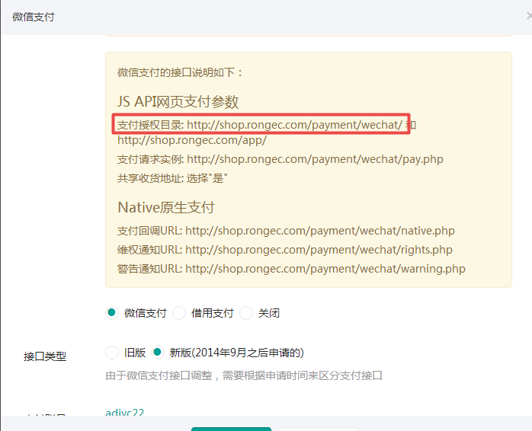

<http://shop.rongec.com/web/index.php?c=account&a=post-step&>

隐藏

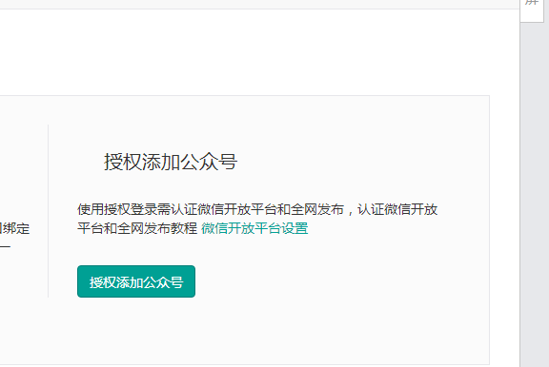

# 20171112

商城后台首页

<http://wc.jieqiangtec.cn/web/index.php?c=site&a=entry&m=ewei_shopv2&do=web>

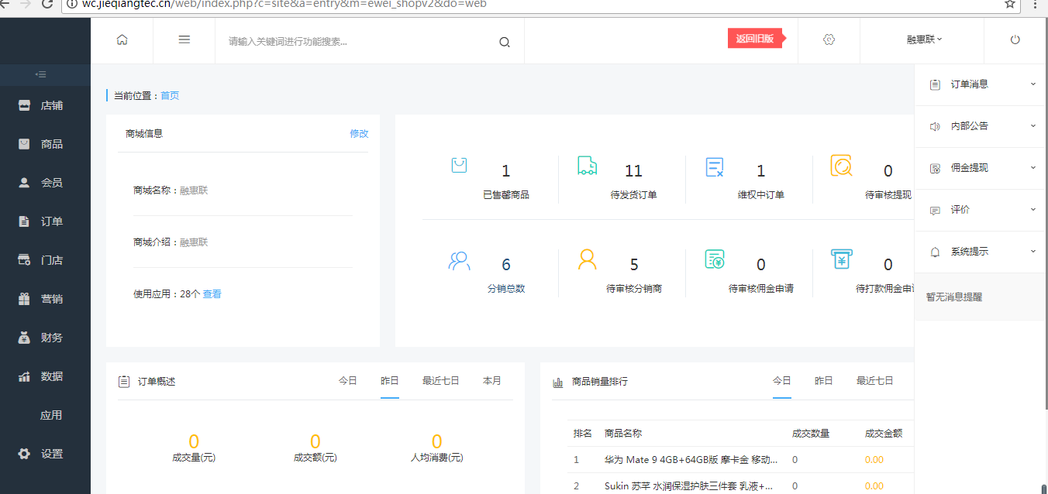

# 20171111

微信账号表

--

-- Dumping data for table `ims\_account\_wechats`

--

LOCK TABLES `ims\_account\_wechats` WRITE;

/\*!40000 ALTER TABLE `ims\_account\_wechats` DISABLE KEYS \*/;

INSERT INTO `ims\_account\_wechats` VALUES (1,1,'omJNpZEhZeHj1ZxFECKkP48B5VFbk1HP','','',0,'weizan','','','','','','','','',0,'','',1,'','','','','',''),(2,2,'u35ambyoahgg4g13dntuhohw5nbpxb4l','','',4,'默认测试(不用管可删除)','','','','','','','','',0,'wx570bc396a51b8ff8','',0,'','','','','',''),(3,3,'S73MpP3M5Cn17lGOjg15L71V3r7JMOVo','M3o5n2nNVCO3MJ1mO7uN31VmoNmjMc5Vc5Uuo3lgzJJ','',1,'路路达物流','设置微信号','gh\_b345808ae94f','','','','','','',0,'wxb1da03ae5242275b','',1,'','','','','',''),(4,4,'OkOm2n4Ov6nv47N5zWnz08MG5vM47XX5','t756UJJn256Z6224mz44VUn2644674nUvGvG4X622Mm','',4,'连城县冠客隆商行支付平台','lc-gklzfpt2016','gh\_2187ab593506','','','','','gkl','ad371ee5f71a7105642f68a8a58fcfee',0,'wx606b4470e54ff82d','837e0027bbf42205565d4f1735944102',1,'','http://mp.weixin.qq.com/s?\_\_biz=MzIwNTQwOTE0Mg==&mid=100000001&idx=1&sn=1b7ba5a7083cb031cfc401ad74ad2a32&scene=0&preview','','','',''),(5,5,'Cp24H00K0vrZ27AgjZgJZ77I22Hl400j','AqiTUqsgaitDuIuMisIMqUq52WDp5sudigd5umo3w3p','',1,'微商小秘书','dexpoi0908','gx3413412341234','','','','','','',0,'3241234','13421234123412341234134',1,'','','','','','');

/\*!40000 ALTER TABLE `ims\_account\_wechats` ENABLE KEYS \*/;

UNLOCK TABLES;

--

# 20170928

用户登录

18959663663

123456

bc9b5718afdffe85fb13555347969ff5

2017-09-28 20:54:34 TODO debug2 ：来源:

http://wx.adjyc.cn/app/index.php?i=6&c=entry&m=ewei\_shopv2&do=mobile&r=pc.account.login

------------

Array:

file : D:\www\users\wd2.jieqiangtec.com\framework\class\db.class.php fetch($sql, $params = array()) ;

sql2 : select id,openid,mobile,pwd,salt from `ims\_ewei\_shop\_member` where mobile='18999999999' and mobileverify=1 and uniacid='6' limit 1 ;

$params ==Array:

:mobile : 18999999999 ;

:uniacid : 6 ;

Request URL:

<http://wx.adjyc.cn/app/index.php?i=6&c=entry&m=ewei_shopv2&do=mobile&r=pc.account.login>

<http://wx.adjyc.cn/app/index.php?i=6&c=entry&m=ewei_shopv2&do=mobile&r=pc.account.logout>

D:\www\users\wc.jieqiangtec.com\addons\ewei\_shopv2\plugin\pc\core\mobile\account\index.php

L161

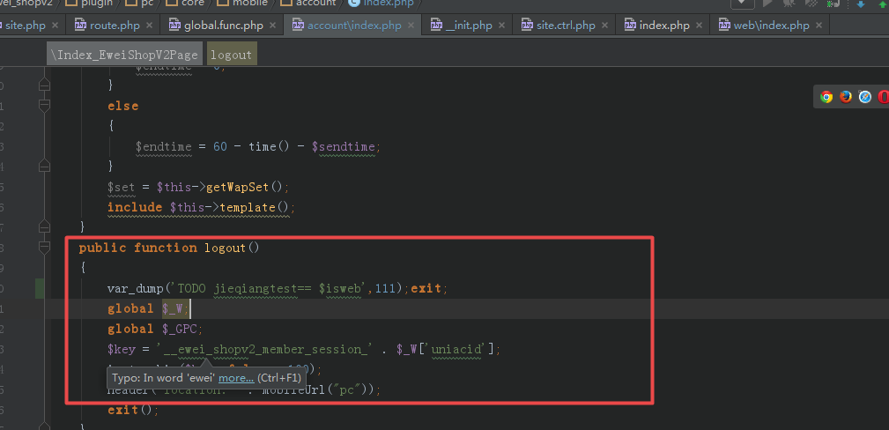

Request Method:

GET

Status Code:

302 Moved Temporarily

Remote Address:

127.0.0.1:80

# 20170919

D:\usr\local\php\php.ini

extension=php\_redis.dll

加载慢，504是因为开启了redis

D:\www\users\wc.jieqiangtec.com\addons\ewei\_shopv2\core\model\cache.php L25

<http://wx.adjyc.cn/web/index.php?c=site&a=entry&m=ewei_shopv2&do=web&r=util.task>

开启 504

string 'is\_error($redis)==' *(length=18)*

boolean true

string '$redis==' *(length=8)*

**array** *(size=2)*

'errno' => int -1

'message' => string 'redis 连接失败, 请检查 data/config.php 中参数设置' *(length=61)*

boolean true

不开启 流程ok

string 'is\_error($redis)==' *(length=18)*

boolean true

string '$redis==' *(length=8)*

**array** *(size=2)*

'errno' => int -1

'message' => string 'PHP 未安装 redis 扩展' *(length=26)*

boolean true

http://wx.adjyc.cn/web/index.php?c=site&a=entry&m=ewei\_shopv2&do=web&r=shop

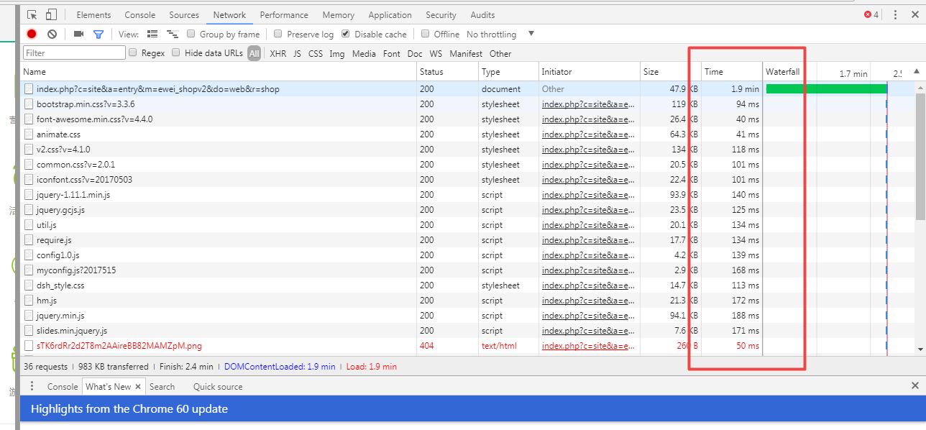

2mins

<http://wx.adjyc.cn/web/index.php?c=site&a=entry&m=ewei_shopv2&do=web&r=shop>

25.6s

<http://wx.adjyc.cn/web/index.php?c=site&a=entry&m=ewei_shopv2&do=web&r=util.task>

D:\www\users\wc.jieqiangtec.com\addons\ewei\_shopv2\core\web\util\task.php

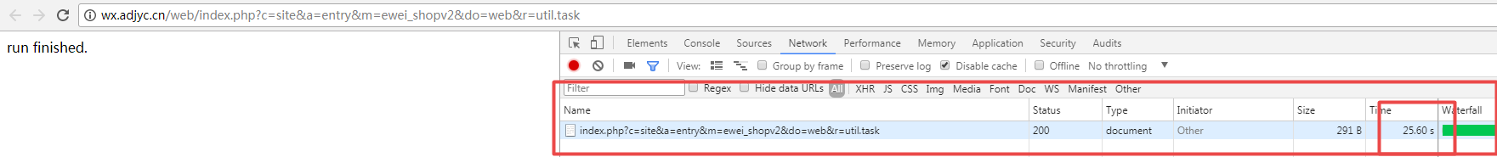

# 20170913

D:\www\users\wc.jieqiangtec.com\addons\ewei\_shopv2\site.php

<http://wx.adjyc.cn/web/index.php?c=site&a=entry&m=ewei_shopv2&do=web&r=shop>

D:\www\users\wc.jieqiangtec.com\addons\ewei\_shopv2\site.php

public function doWebWeb()  
{  
 m('route')->run();  
}

D:\www\users\wc.jieqiangtec.com\addons\ewei\_shopv2\core\model\route.php

D:\www\users\wc.jieqiangtec.com\addons\ewei\_shopv2\core\web\shop\index.php

模板页：

D:\www\users\wc.jieqiangtec.com\addons\ewei\_shopv2\core\inc\page.php L129

template(

m('cache') 方法很耗时。

D:\www\users\wc.jieqiangtec.com\addons\ewei\_shopv2\core\model\route.php L172

$global\_set = m('cache')->getArray('globalset');

string 'D:/www/users/wc.jieqiangtec.com/addons/ewei\_shopv2/core/model/cache.php' *(length=71)*

D:\www\users\wc.jieqiangtec.com\addons\ewei\_shopv2\core\model\cache.php

if (*function\_exists*('redis')) {

# 20170910

店铺装修设置

替换默认首页

<http://wx.adjyc.com/web/index.php?c=site&a=entry&m=ewei_shopv2&do=web&r=diypage.shop.page>

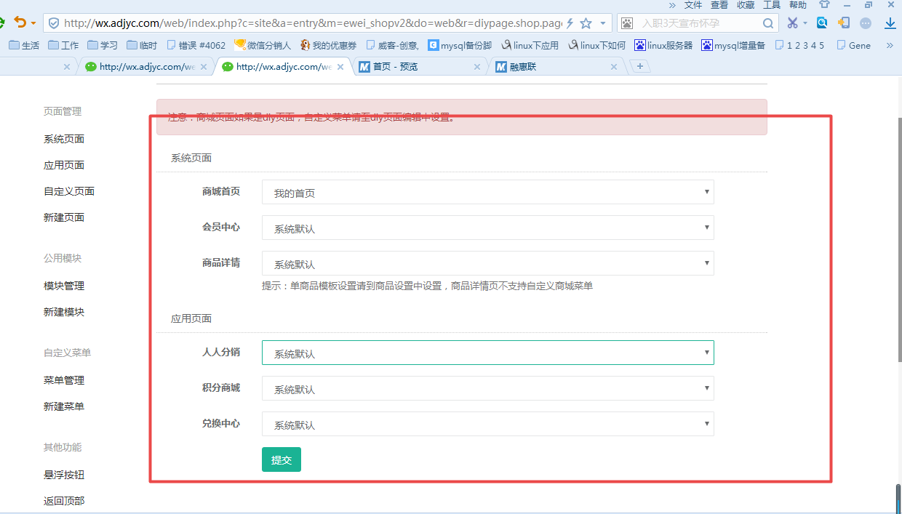

图片素材

../addons/ewei\_shopv2/plugin/diypage/static/template/default7/picture\_1.jpg

# 20170905

同一商品可以设置多个分类

店铺装修：

<http://wx.adjyc.com/web/index.php?c=site&a=entry&m=ewei_shopv2&do=web&r=diypage.page.sys.add&type=2>

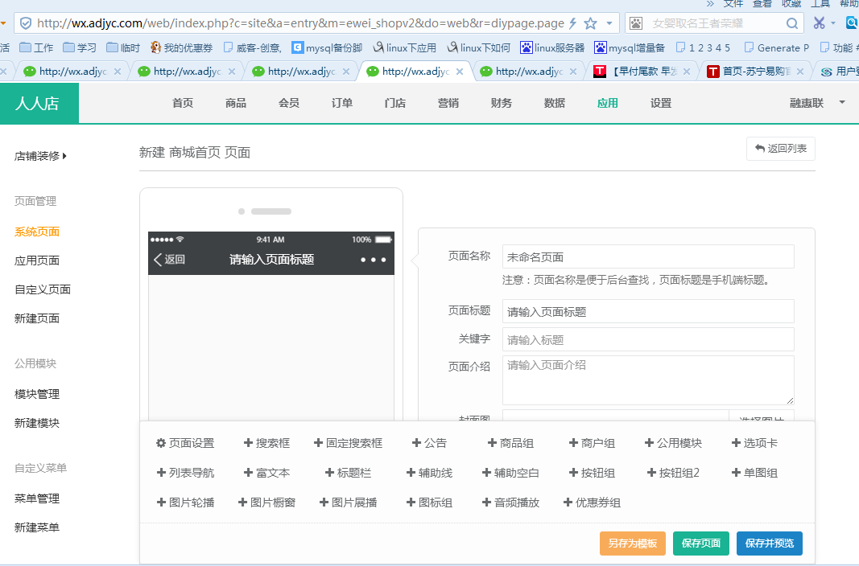

商品助手

<http://wx.adjyc.com/web/index.php?c=site&a=entry&m=ewei_shopv2&do=web&r=taobao>

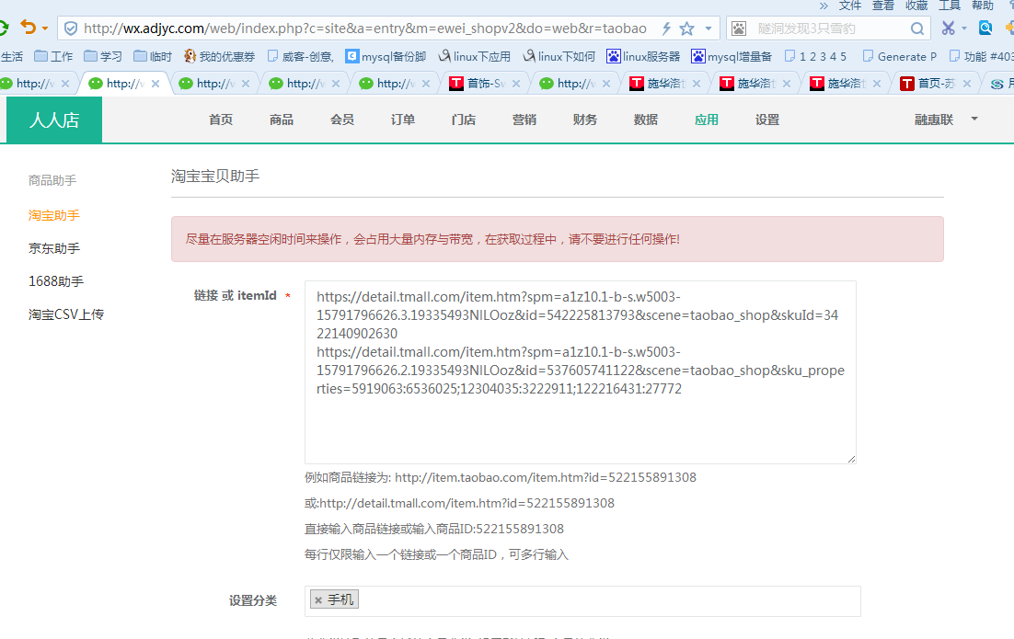

# 20170904

商城操作日志：

SELECT \* FROM `ims\_ewei\_shop\_perm\_log` ORDER BY `id` DESC LIMIT 0, 1000

D:\www\users\wc.jieqiangtec.com\web\common\template.func.php

// 模板引擎  
**function** template($filename, $flag = *TEMPLATE\_DISPLAY*) {  
 **global** $\_W;

用户中心

<http://wx.adjyc.cn/web/index.php?c=user&a=profile&>

D:\www\users\wc.jieqiangtec.com\web\themes\default\user\profile.html

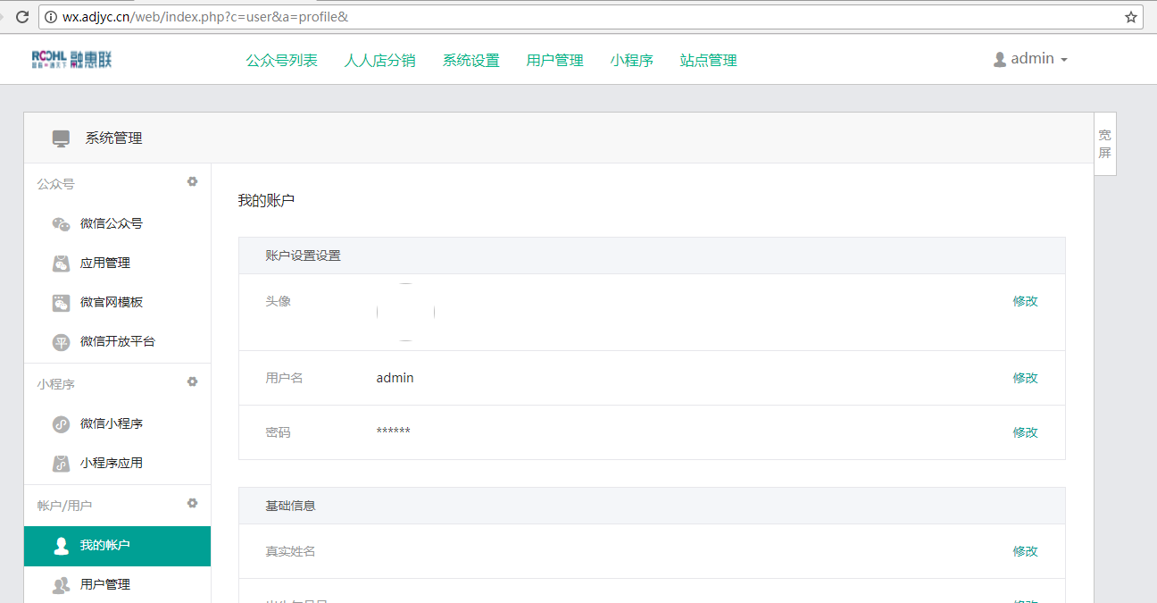

默认无图：

<http://wx.adjyc.cn/web/resource/images/nopic-107.png>

**微擎密码找回工具 For 0.6、0.7、0.8、1.0**

**<http://bbs.we7.cc/forum.php?mod=viewthread&tid=4521&highlight=%C3%DC%C2%EB%D5%D2%BB%D8>**

使用方法:

1，下载附件 password.php  
2，使用文本编辑器修改第一行 $auth = '你的访问密码, 如 :123456';  
3，上传至你的微擎根目录  
4，访问password.php文件  
5，删除 password.php (重要)  
  
重置密码完成后需要尽快删除 password.php 避免资料泄露

2017-09-01

商城首页：

<http://wx.adjyc.com/app/index.php?i=6&c=entry&m=ewei_shopv2&do=mobile&r=goods.detail&id=199>

[http://wc.jieqiangtec.cn/app/index.php?i=6&c=entry&m=ewei\_shopv2&do=mobile&r=goods.detail&id=199](http://wx.adjyc.com/app/index.php?i=6&c=entry&m=ewei_shopv2&do=mobile&r=goods.detail&id=199)

// TODO jieqiang 通知商城

$\_SESSION['prom']['m'] = 'desk';

$\_SESSION['prom']['a'] = 'buy';

// $\_SESSION['prom']['item\_id'] = $order\_goods['goodsid'];

$\_SESSION['prom']['order\_id'] = $orderid;

// $\_SESSION['prom']['shop\_id'] = '11';

$\_SESSION['prom']['status'] = '1';

unset($\_SESSION['prom']['id']);

// WeUtility::logging('TODO debug23', array('file'=>'D:\www\users\wd2.jieqiangtec.com\addons\ewei\_shop\core\mobile\order\confirm.php ','sql2'=>$sql2,'prom'=>$\_SESSION['prom']));

if ($\_SESSION['prom']['sid'] && $\_SESSION['prom']['item\_id'] && $\_SESSION['prom']['shop\_id'] && $\_SESSION['prom']['bank\_subid'] && $\_SESSION['prom']['bank\_id'] ){

$res = http\_request(CPS\_API,$\_SESSION['prom']);

}

$curl = CPS\_API . '?' . http\_build\_query($\_SESSION['prom']);

WeUtility::logging('TODO debug2345', array('file'=>'D:\www\users\wd2.jieqiangtec.com\addons\ewei\_shop\core\mobile\order\confirm.php ','res'=>$res,'curl'=>$curl,'prom'=>$\_SESSION['prom']));

// 通知商城

/\*订单号 order\_id bigint

商品名称 title varchar

单价(元) item\_price decimal

数量 item\_count int

佣金比例 rate int

总金额 sum\_price decimal

结算金额(预留) settle\_price decimal

结算状态 status tinyint

推广人 seller\_id int

子机构 bank\_subid int

推广分行 bank\_id int

商品id item\_id bigint

合同id con\_id int

商品类别id category\_id int

商品类别名称 category\_name int\*/

// $http\_params['shop\_id'] =$order['shop\_id'];

// $http\_params['item\_id'] =$order['item\_id'];

/\* $http\_params['order\_id'] =$order['id'];

$http\_params['title'] =$order['id'];

$http\_params['item\_price'] =$order['id'];

$http\_params['item\_count'] =$order['id'];

// $http\_params['rate'] =$order['rate'];

// $http\_params['sum\_price'] =$order['id'];

$http\_params['status'] = 1 ;

$http\_params['seller\_id'] =$order['seller\_id'];

$http\_params['bank\_subid'] =$order['bank\_subid'];

// $http\_params['item\_id'] =$order['id'];

$http\_params['con\_id'] =$order['con\_id'];

// $http\_params['category\_id'] =$order['id'];

// $http\_params['category\_name'] =$order['id'];\*/

// TODO jieqiang 通知商城

$\_SESSION['prom']['m'] = 'desk';

$\_SESSION['prom']['a'] = 'buy';

// $\_SESSION['prom']['item\_id'] = $order\_goods['goodsid'];

$\_SESSION['prom']['order\_id'] = $order['id'];

$\_SESSION['prom']['shop\_id'] = '11';

$\_SESSION['prom']['status'] = '1';

unset($\_SESSION['prom']['id']);

WeUtility::logging('TODO debug23', array('file'=>'D:\www\users\wd2.jieqiangtec.com\addons\ewei\_shop\core\mobile\order\pay.php ','sql2'=>$sql2,'prom'=>$\_SESSION['prom']));

http\_request(CPS\_API,$\_SESSION['prom']);

**怎么打开微擎的调试模式**<http://bbs.we7.cc/forum.php?mod=viewthread&tid=20112&highlight=%B5%F7%CA%D4>

|  |
| --- |
| 设置【开发者模式】: 在 pro/data/config.php 中设置 $config['setting']['development'] = 1; 查看微信的通信日志, 打开开发者模式, 在目录 pro/data/logs/ 下查看 \*.log。 |

http://wx.adjyc.com/web/index.php?c=system&a=updatecache&

INSERT INTO `ims\_users` VALUES ('1', '0', 'admin', '22b31f04dd8b4cd4e4c087ad634e2fb7ddc96f83', '0cdc7671', '0', '0', '1504111321', '', '1504111340', '27.154.183.97', '', '0', '0');

INSERT INTO `ims\_users` VALUES ('1', '0', 'admin', '22b31f04dd8b4cd4e4c087ad634e2fb7ddc96f83', '0cdc7671', '0', '0', '1504111321', '', '1504111340', '27.154.183.97', '', '0', '0');

INSERT INTO `ims\_users` (`uid`, `groupid`, `username`, `password`, `salt`, `type`, `status`, `joindate`, `joinip`, `lastvisit`, `lastip`, `remark`, `starttime`, `endtime`) VALUES ('1', '0', 'admin', 'a6f70742794a7674e6ebc45a30c9440e87e2686a', '22be8259', '0', '0', '1504027711', '', '1504102601', '27.154.183.97', '', '0', '0');

微擎是一款免费开源的微信公众号管理系统，基于目前最流行的WEB2.0架构（php+mysql），支持在线升级和安装模块及模板，拥有良好的开发框架、成熟稳定的技术解决方案、活跃的第三方开发者及开发团队，依托微擎开放的生态系统，提供丰富的扩展功能。除了Master外其它分支皆为不稳定的开发版。欢迎大家Fork [http://www.we7.cc/](http://www.we7.cc/" \t "http://git.oschina.net/we7coreteam/_blank)

QQ群：32385562

<http://git.oschina.net/we7coreteam/pros>

开发手册

<https://www.we7.cc/manual/>

百度搜索

pdo\_update site:we7.cc

<https://www.kancloud.cn/donknap/we7/136556>

# [微擎 功能模块](http://bbs.we7.cc/forum-64-1.html)

<http://bbs.we7.cc/forum-64-1.html>

微擎论坛

<http://bbs.we7.cc/index.html#>

<http://video.tudou.com/v/XMTc4NjA3MDk2NA==.html?spm=a2h28.8313471.fl.dlink_1_10&f=35553197>

<https://shop126163303.taobao.com/p/rd452866.htm?spm=2013.1.0.0.4b556901WOJBzs>

<http://77.v-888.com/app/index.php?i=3&c=entry&m=ewei_shopv2&do=mobile&r=pc>

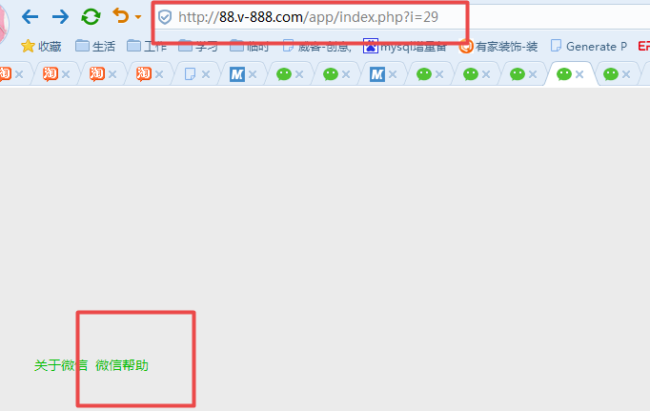

最后跳转到微擎

<https://www.we7.cc/>

费用说明

<http://s.we7.cc/store-static-buy.html>

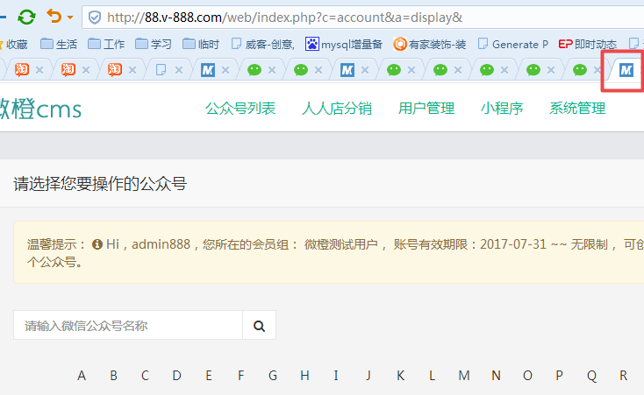

街墙2(2017-08-24 23:29:36):

前台账号给个，pc的

微橙集团:小小美(2017-08-24 23:29:46):

稍等

微橙集团:小小美(2017-08-24 23:30:41):

13888888888

微橙集团:小小美(2017-08-24 23:30:43):

123456

后台管理演示：88.v-888.com admin888 admin888

演示公众号：

1、微橙人人店，微，信号:huanlenc

2、微橙信息科技，微，信号:weichengtech

pc商城展示页：<http://77.v-888.com>

最新版是8月14日的v3.5.3，https://item.taobao.com/item.htm?spm=a230r.1.14.8.RoopKT&id=529034618321&ns=1&abbucket=16#detail

<https://item.taobao.com/item.htm?spm=a1z09.2.0.0.2ed6e797Ea4jEU&id=530947493980&_u=omll0je8592>

:

咱们当前的是

:

建议买1套？才50块

:

http://gx.v-888.com/forum.php?mod=viewthread&tid=845&extra=page%3D1

:

淘宝上你抽时间买一下

:

在这个最新版基础上改，最为合适。

:

最新版是8月14日的v3.5.3淘宝店，https://item.taobao.com/item.htm?spm=a230r.1.14.8.RoopKT&id=529034618321&ns=1&abbucket=16#detail

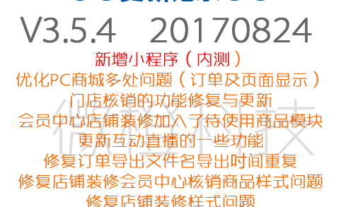

目录 [隐藏]

[入口脚本](https://www.we7.cc/manual/structure:bootstrap" \l "入口脚本)

[系统配置文件](https://www.we7.cc/manual/structure:bootstrap" \l "系统配置文件)

[Web端入口](https://www.we7.cc/manual/structure:bootstrap" \l "web端入口)

[App端入口](https://www.we7.cc/manual/structure:bootstrap" \l "app端入口)

[微信Api入口](https://www.we7.cc/manual/structure:bootstrap" \l "微信api入口)

[目录结构](https://www.we7.cc/manual/structure:bootstrap" \l "目录结构)

## 入口脚本

入口脚本是应用启动流程中的第一环，入口文件根据“**系统配置文件**”初始化了系统的常量、全局变量及全局对象，并将终端用户的请求通过入口脚本将请求转发到各自的功能模块中。  
微擎系统中分为三个入口，分别是“**Web端入口**”、“**App端入口**”、“**微信Api入口**”

## 系统配置文件

系统配置文件存放着微擎系统重要的启动数据，文件是“/data/config.php”。此文件禁止普通用户修改。

## Web端入口

Web端入口主要负责微擎系统的后台管理功能，入口文件是 “/web/index.php”。访问此入口有严格的权限判断，需要需要用户进行登录。此入口主要完成以下工作：

登录用户的身份验证

初始化登录用户的身份信息，分派管理员权限或是操作员权限

权限菜单划分及权限判断

加载系统配置

路由用户的请求

## App端入口

App端入口主要负责微擎系统的前端“微站”、“个人中心”及其它普通用户访问的功能。入口文件是 “/app/index.php”。访问“微站”无需身份验证，访问“个人中心”则要求用户进行登录。此入口主要完成以下工作：

初始化当前公众号的数据

初始化微站站点信息、风格、模板、导航等数据

初始化粉丝&会员的身份信息（如果有权限获取）

加载系统配置

路由用户的请求

## 微信Api入口

微信Api入口主要负责处理微信公众平台请求微擎系统的关键字、图片、语音等数据，入口文件是 “api.php”。此入口只用于公众平台访问。此入口主要完成以下工作：

初始化当前公众号的数据

解析公众平台推送过来的数据结构，转化为微擎消息结构

根据消息结构中的关键字或是事件匹配到相应的模块

调用模块的processor类返回数据给微信公共平台

## 目录结构

<https://www.we7.cc/manual/structure:bootstrap>

pro

├─ addons ………………………………………… 【模块安装目录】 (意为附加组件)

│ ├─ business …………………………………… 模块的名称 (示例)

│ │ ├─ images 建议 css 文件也放此目录.

│ │ ├─ template 模板目录

│ │ │ ├─ mobile APP 端模板目录

│ │ │ │ └─ ... \*.html APP 端模板文件

│ │ │ └─ ... \*.html Web 端模板文件

│ │ ├─ inc 引用的 php 文件目录

│ │ │ ├─ mobile Mobile端目录

│ │ │ │ ├─ xxx.inc.php 微站入口

│ │ │ │ └─ ... .

│ │ │ └─ web Web端模板目录

│ │ │ ├─ xxx.inc.php 微站管理入口

│ │ │ └─ ... .

│ │ ├─ icon.jpg 模块图标

│ │ ├─ preview.jpg 模块预览

│ │ ├─ manifest.xml 安装清单

│ │ ├─ module.php 模块设置

│ │ ├─ processor.php 消息处理

│ │ ├─ receiver.php 消息订阅

│ │ └─ site.php 微站页面

│ └─ ... …………………………………………… 其他扩展模块

├─ api ………………………………………………… .

│ └─ uc.php .

├─ attachment ……………………………………… 附件文件夹

│ ├─ audios ……………………………………… 音频附件文件夹

│ └─ images ……………………………………… 图片附件文件夹

│ ├─ global ………………………………… 系统公共文件夹

│ │ └─ 上传年份

│ │ └─上传月份

│ │ └─ 随机文件名

│ └─ $uniacid ... ……………………………按公众号年月组织的图片文件

├─ app ……………………………………………【微站(Mobile)入口】

│ ├─ common .

│ │ ├─ bootstrap.app.inc.php .

│ │ ├─ common.func.php .

│ │ └─ template.func.php .

│ ├─ resource .

│ │ ├─ css .

│ │ ├─ fonts .

│ │ └─ js .

│ ├─ source 控制器

│ ├─ themes 微站皮肤

│ │ ├─ default 系统默认

│ │ └─ ... 自定义皮肤

│ └─ index.php 微站入口

├─ data ……………………………………………… .

│ ├─ config.php.default .

│ ├─ config.php 系统配置

│ └─ db.php .

├─ framework ………………………………………【微擎系统通用的工具类和方法】

│ ├─ builtin ……………………………………【微擎内建模块】

│ │ ├─ basic 文字回复模块

│ │ ├─ core 会话消息统计

│ │ │ └─ receiver.php .

│ │ ├─ cover 通用封面回复

│ │ ├─ default 默认回复模块

│ │ ├─ music 音乐回复模块

│ │ ├─ news 图文回复模块

│ │ ├─ userapi 自定义接口回复模块

│ │ └─ ... .

│ ├─ class ………………………………………… 系统功能类 .

│ ├─ function …………………………………… 系统功能函数

│ ├─ library ……………………………………… 其他函数库

│ ├─ model ………………………………………… 业务功能model

│ ├─ bootstrap.inc.php .

│ ├─ const.inc.php .

│ └─ version.inc.php

├─ payment …………………………………………… 支付

├─ web ……………………………………………… 【后台管理(Web)入口】

│ ├─ common ……………………………………… 公用文件

│ │ ├─ bootstrap.sys.inc.php .

│ │ ├─ common.func.php .

│ │ ├─ frames.inc.php .

│ │ └─ template.func.php .

│ ├─ resource …………………………………… 资源文件

│ │ ├─ components JS组件

│ │ ├─ css 样式文件

│ │ ├─ fonts 字体资源

│ │ ├─ images 图片文件

│ │ └─ js

│ │ ├─ app ………………………………… 系统js功能

│ │ ├─ lib ………………………………… js第三方库文件

│ │ └─ require.js ……………………… .

│ ├─ source ……………………………………… 后台管理控制器

│ ├─ themes ……………………………………… 后台管理视图

│ │ ├─ default ………………………………… 内建后台管理样式

│ │ └─ ... ……………………………………… 定制界面样式

│ └─ index.php 后台入口

├─ api.php ………………………………………… 【公众平台与微擎系统通信的接口】

├─ index.php ………………………………………… 微擎入口

└─ install.php ……………………………………… 微擎安装程序

# 产品中心

## 后台

<http://wc.jieqiangtec.cn/web/index.php?c=site&a=entry&m=ewei_shopv2&do=web&r=goods>

D:\www\users\wc.jieqiangtec.com\addons\ewei\_shopv2\core\web\goods\index.php L12

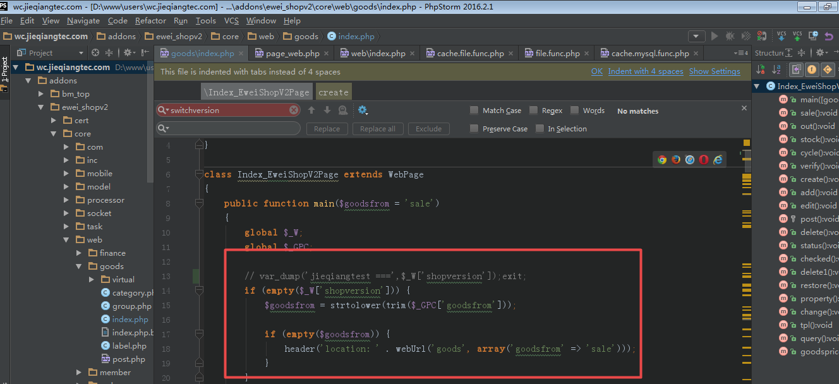

## 前台

<http://wc.jieqiangtec.cn/app/index.php?i=6&c=entry&m=ewei_shopv2&do=mobile&mid=2191>

D:\www\users\wc.jieqiangtec.com\addons\ewei\_shopv2\core\mobile\index.php L6

<http://wc.jieqiangtec.cn/app/index.php?i=6&c=entry&m=ewei_shopv2&do=mobile&r=bargain.detail&id=1>

D:\www\users\wc.jieqiangtec.com\addons\ewei\_shopv2\defines.php L7

// 调试模式  
//define('EWEI\_SHOPV2\_DEBUG', false);  
define('EWEI\_SHOPV2\_DEBUG', **true**);